Supplementary table 1. Sex-specific crude and weighted proportion of national YRBS respondents reporting ‘ever had sex’ with and without age-adjustment*, 2011-2023
Study year |  |  |  |  | % reporting ever had sex without age adjustment ┼ | % reporting ever had sex with age adjustment §
Study year |  | Row total |  |  | % reporting ever had sex without age adjustment ┼
Female students
2011 |  | 7056 |  |  | 45.6% | 45.8%
2013 |  | 6560 |  |  | 46.0% | 45.1%
2015 |  | 6901 |  |  | 39.2% | 39.0%
2017 |  | 6711 |  |  | 37.7% | 37.7%
2019 |  | 5806 |  |  | 37.6% | 37.6%
2021 |  | 7281 |  |  | 30.6% | 34.1%
2023 |  | 8243 |  |  | 31.0% | 31.1%
Male students
2011 |  | 7339 |  |  | 49.2% | 48.8%
2013 |  | 6360 |  |  | 47.5% | 46.0%
2015 |  | 7099 |  |  | 43.2% | 42.3%
2017 |  | 6465 |  |  | 41.4% | 40.9%
2019 |  | 5775 |  |  | 39.2% | 39.1%
2021 |  | 7394 |  |  | 29.3% | 32.2%
2023 |  | 8820 |  |  | 32.1% | 32.2%

* Data included in Figure 3. A weight was applied to each student record to adjust for student nonresponse and the distribution of students by grade, biological sex, and race/ethnicity in each jurisdiction.
┼ YRBS data reported in 2021 report for ‘ever had sex’
§Direct standardization using 2019 age distribution as the reference population

Supplementary figure 1. Study population of YRBS population included in the primary and sensitivity analyses to assess sexual risk behaviors, 2011-2023
Sensitivity analysis population
N= 100,305
Additional inclusions I:

Non-missing data on ‘age at first sex’
(N= 7,259)
Exclusions I:

Participants with missing age or biological sex

(N = 1,143)

Exclusions II:

Participants with missing data on ‘ever had sex’ (N= 16,220)
Surveyed participants during YRBS study years 2011-2023
N= 110,409
Participants with valid age and sex values
N = 109,266
Primary analysis population
N = 93,046

Supplementary figure 2. Sensitivity analysis demonstrating the attribution of change in ever had sexual intercourse, before and after age-adjustment┼ by gender, national YRBS, 2019-2021

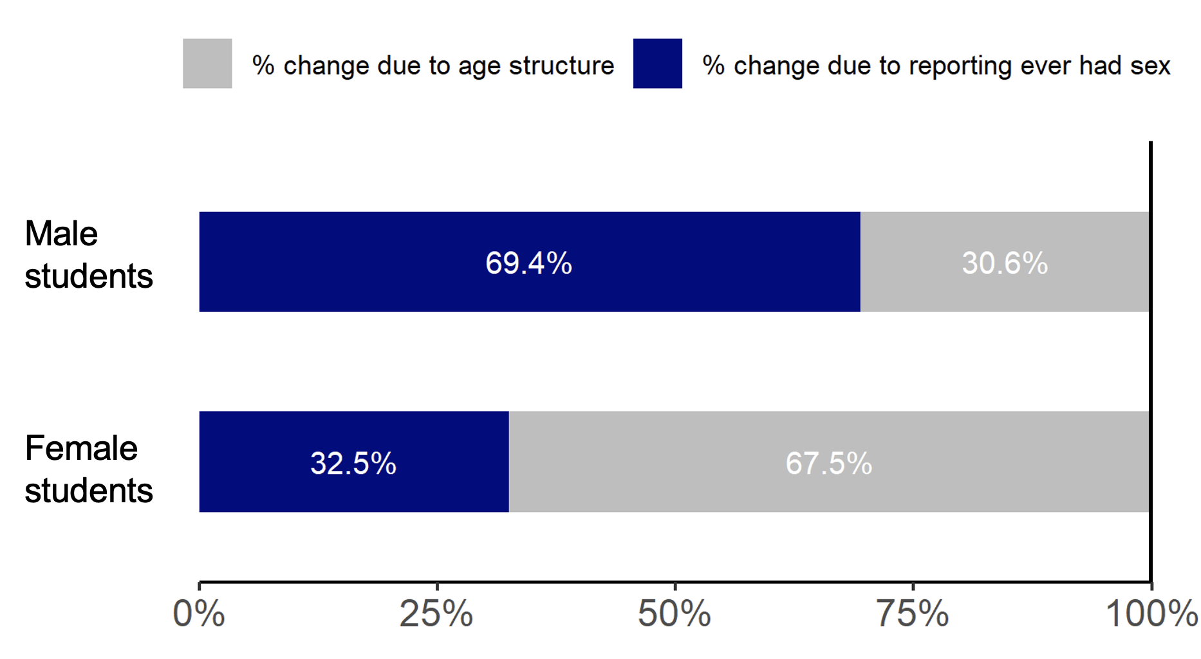

When ‘ever has sex” was missing, age at first sex was used to impute the missing values.
* A weight was applied to each student record to adjust for student nonresponse and the distribution of students by grade, gender, and race/ethnicity in each jurisdiction.
┼ Age-adjusted by direct standardization using 2019 age distribution as the reference population

