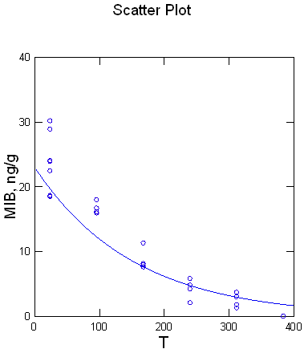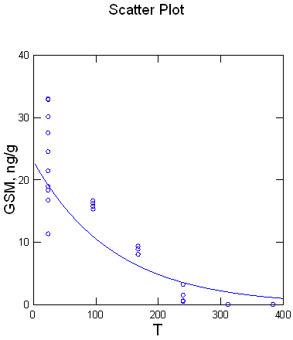
MIB, neck k₂ 0.007 h⁻¹, R² 0.916 GSM, neck k₂ 0.008 h⁻¹, R² 0.855

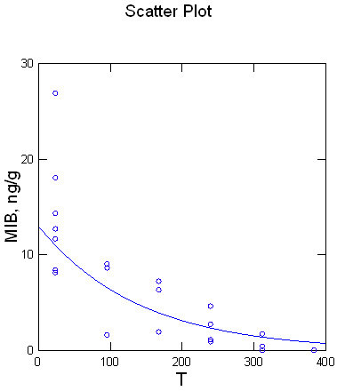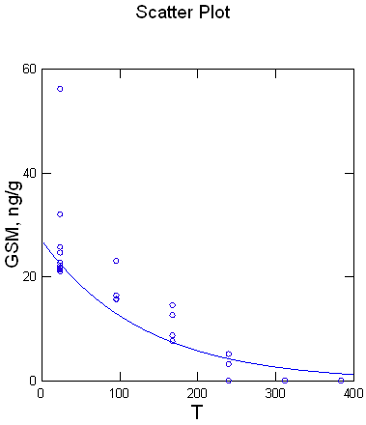
MIB, belly, k₂ 0.007 h⁻¹, R² 0.779 GSM, belly, k₂ 0.008 h⁻¹, R² 0.824

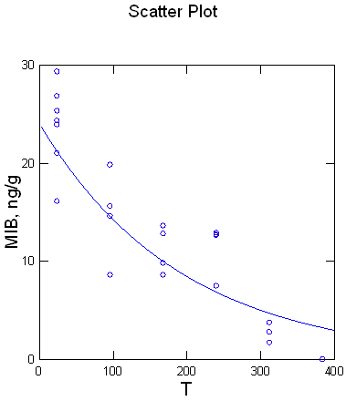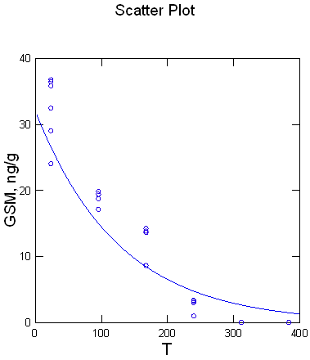
MIB, fillet, k₂ 0.005 h⁻¹, R² 0.856 GSM, fillet k₂ 0.008 h⁻¹, R² 0.884

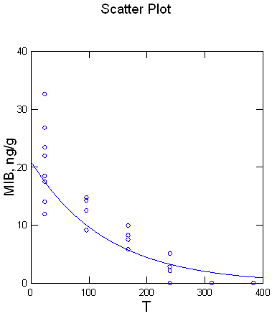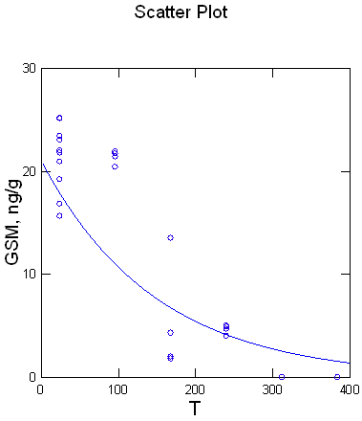
MIB, tail, k₂ 0.008 h⁻¹, R² 0.860 GSM, tail, k₂ 0.007 h⁻¹, R² 0.784
Supplementary Table S1. Constant k₂ showing the rate of decrease of GSM and MIB in each body part (neck, belly, fillet, and tail) of whitefish Coregonus lavaretus.

