SUPPLEMENTARY MATERIAL

Synbiotic performance of Bacillus coagulans: inhibition of E. coli in coculture and organic-acid/2,3-butanediol production

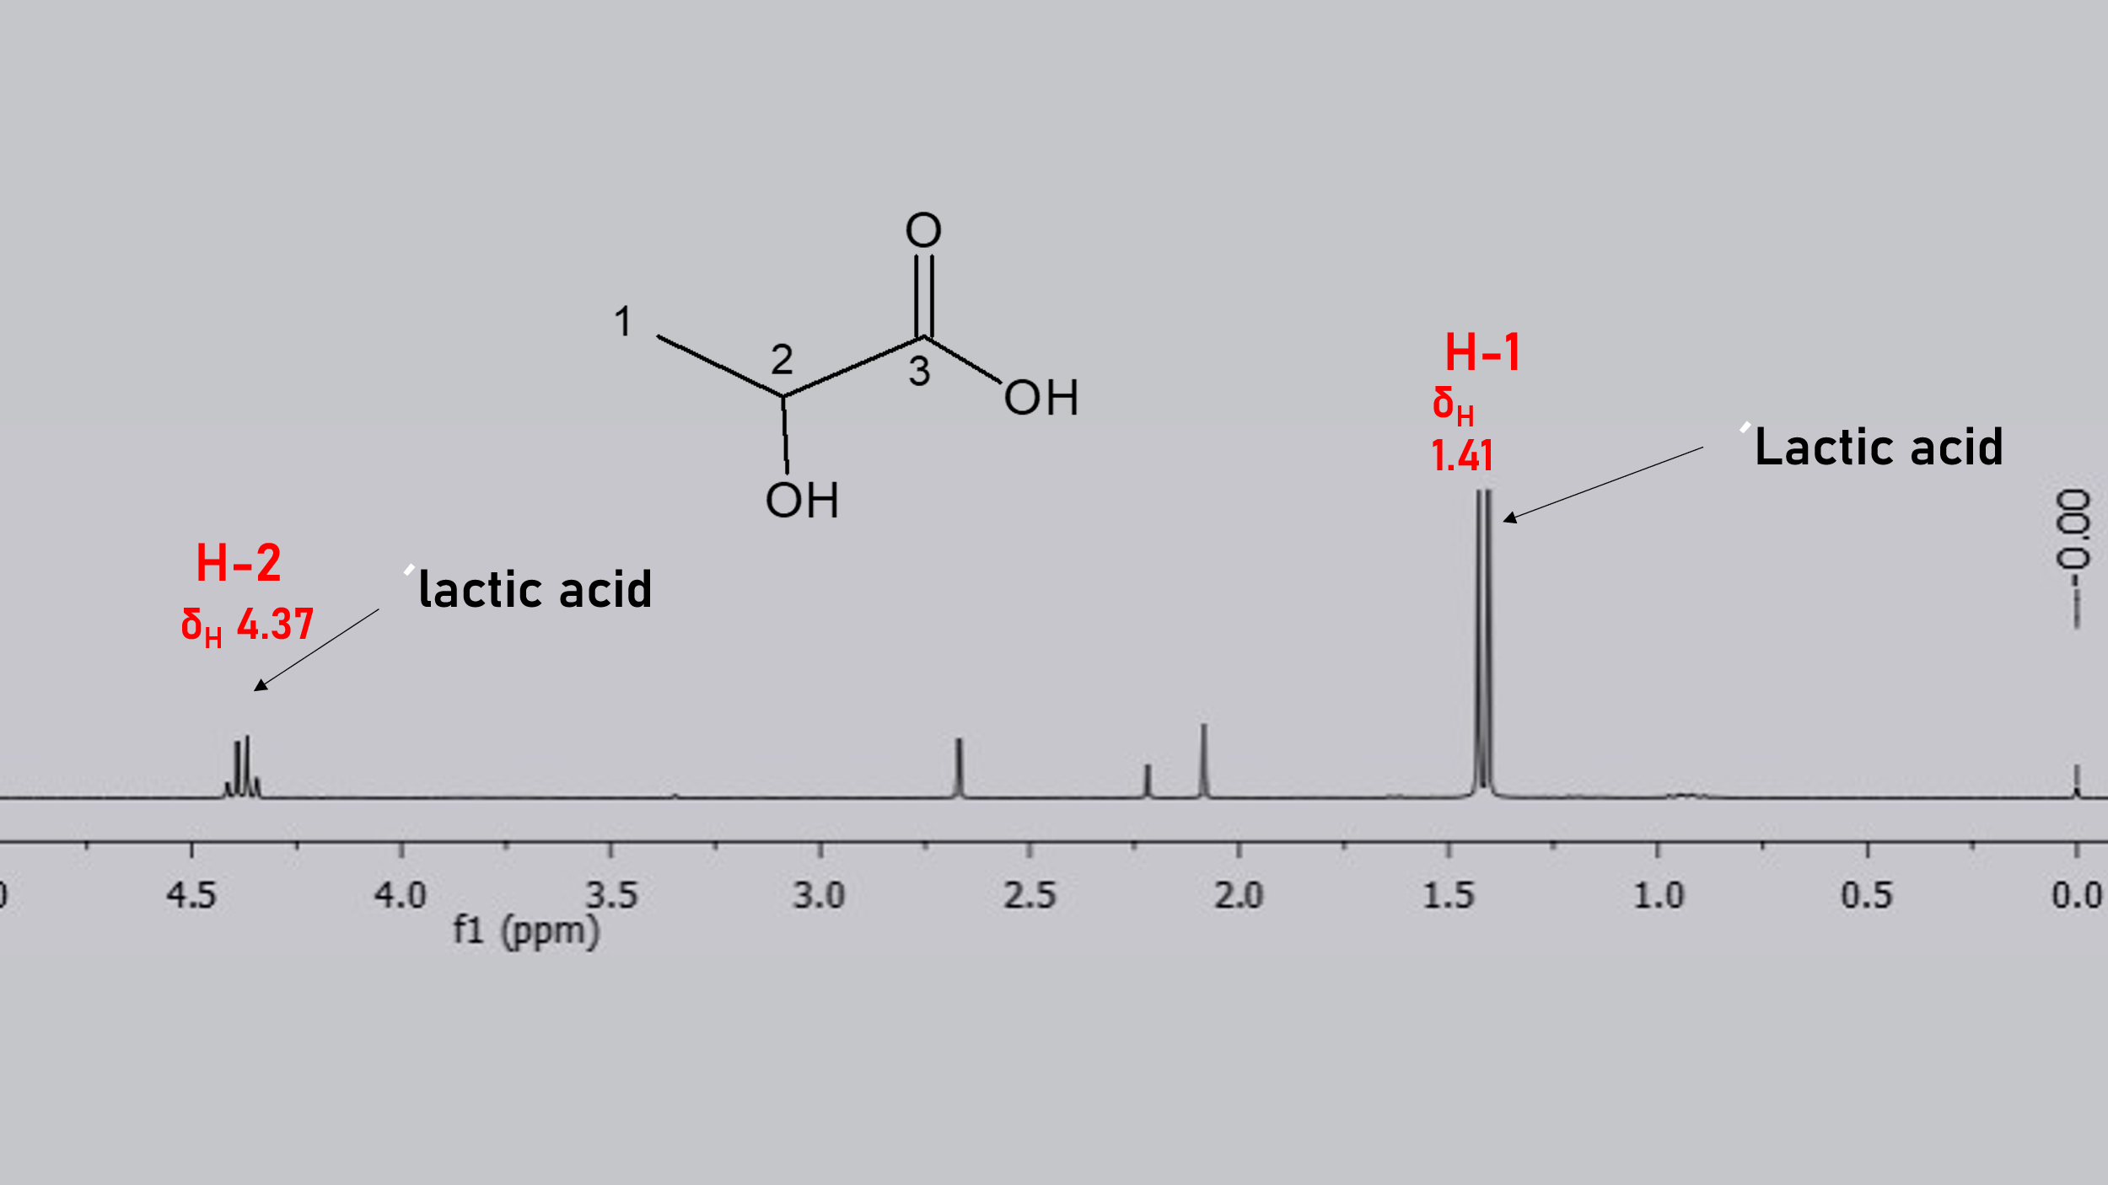

Fig. S1. ¹H NMR spectrum at 500.0 MHz in CDCl₃ of spectrum of lactic acid.

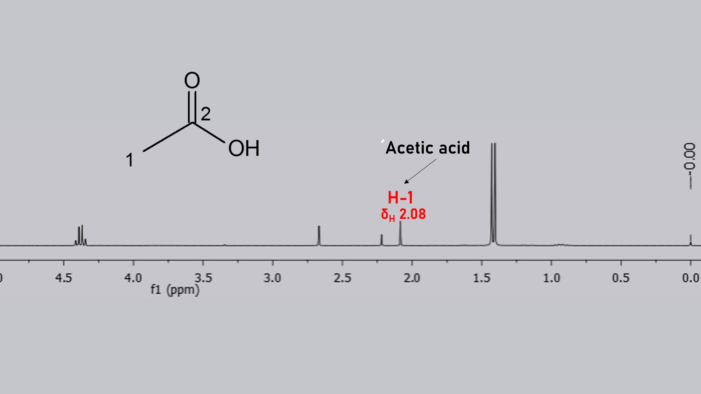

Fig. S2. ¹H NMR spectrum at 500.0 MHz in CDCl₃ of spectrum of acetic acid.

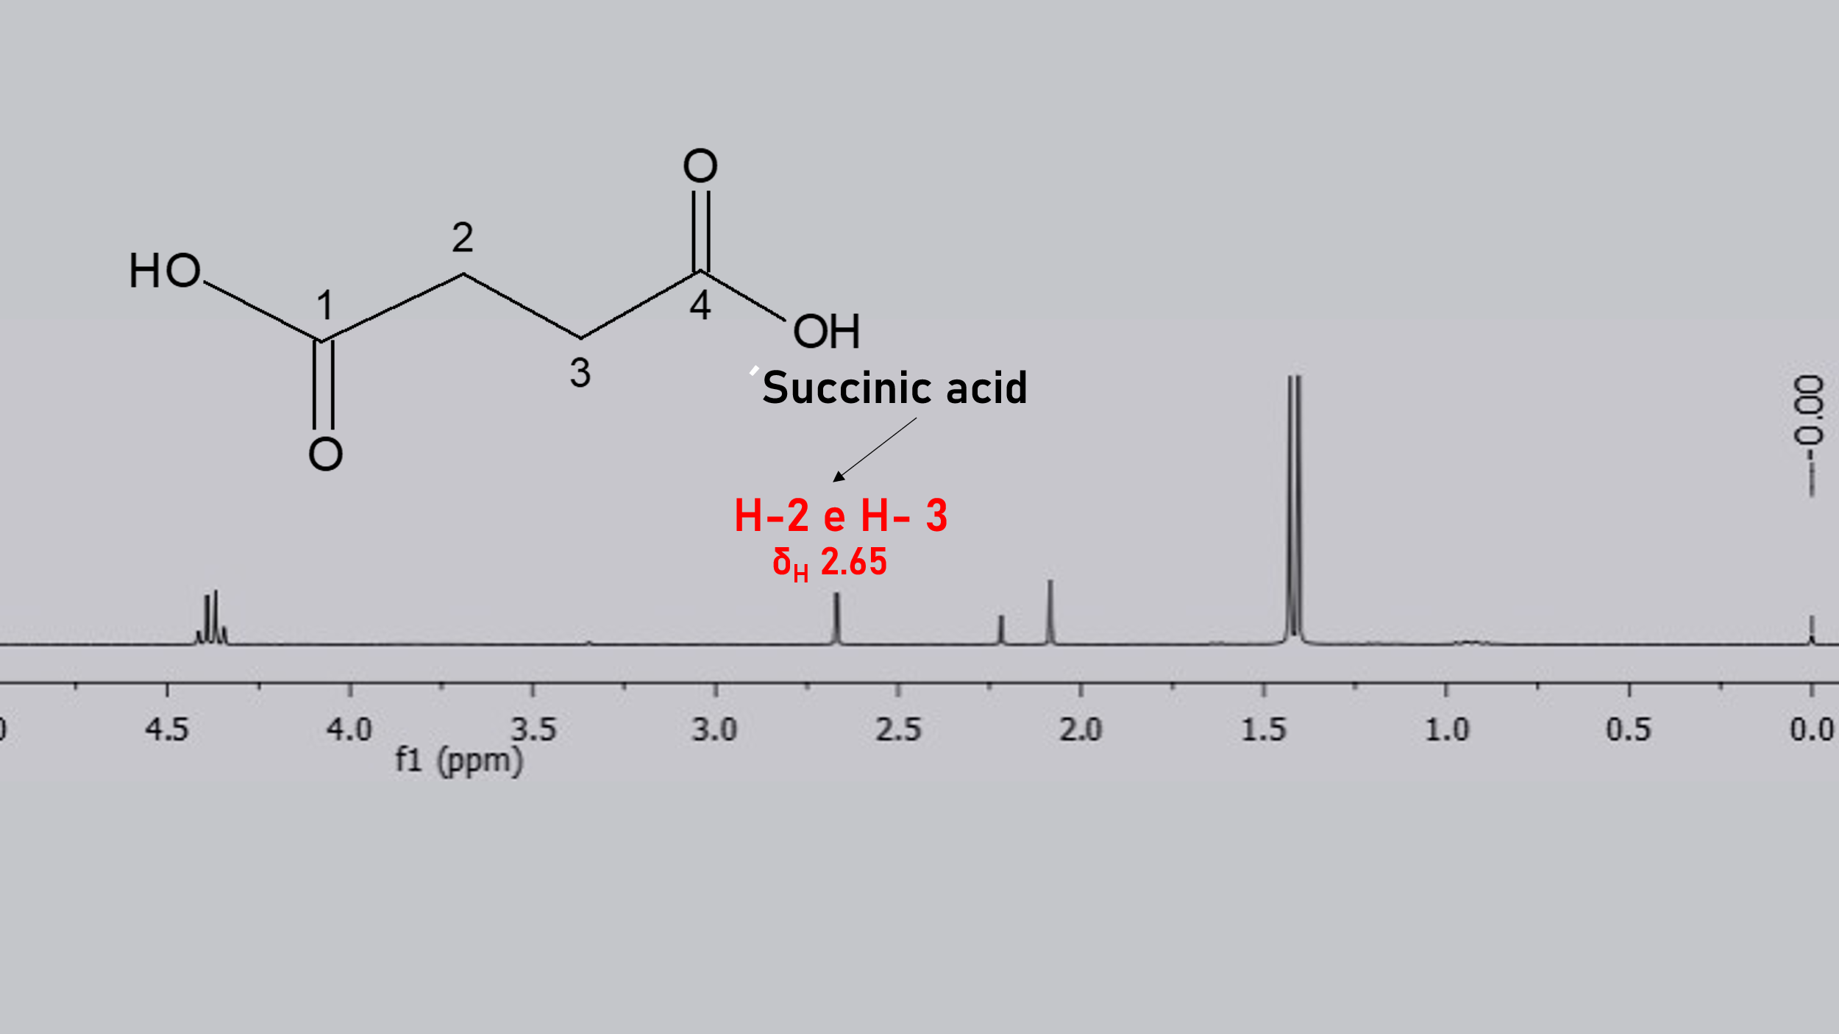

Fig. S3. ¹H NMR spectrum at 500.0 MHz in CDCl₃ of spectrum of succinic acid.

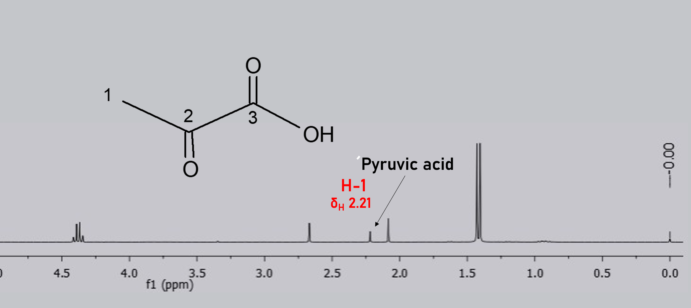

Fig. S4. ¹H NMR spectrum at 500.0 MHz in CDCl₃ of spectrum of pyruvic acid.

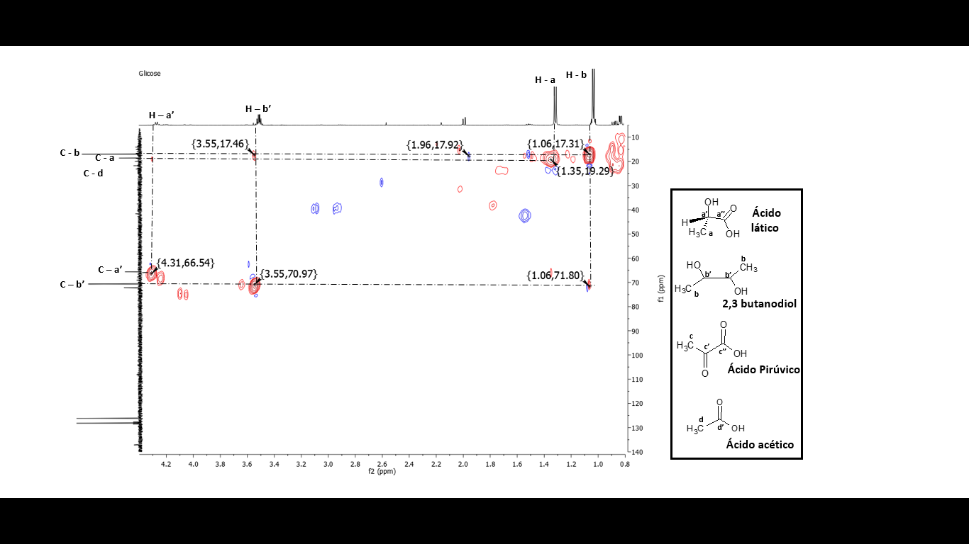
AA
PA
2,3-BD
LA

Fig. S5. HSQC correlation map of the B. coagulans fermentation medium extract: LA – Lactic acid; 2,3-BD – 2,3-butenediol; PA – Pyruvic acid; AA – Acetic acid.

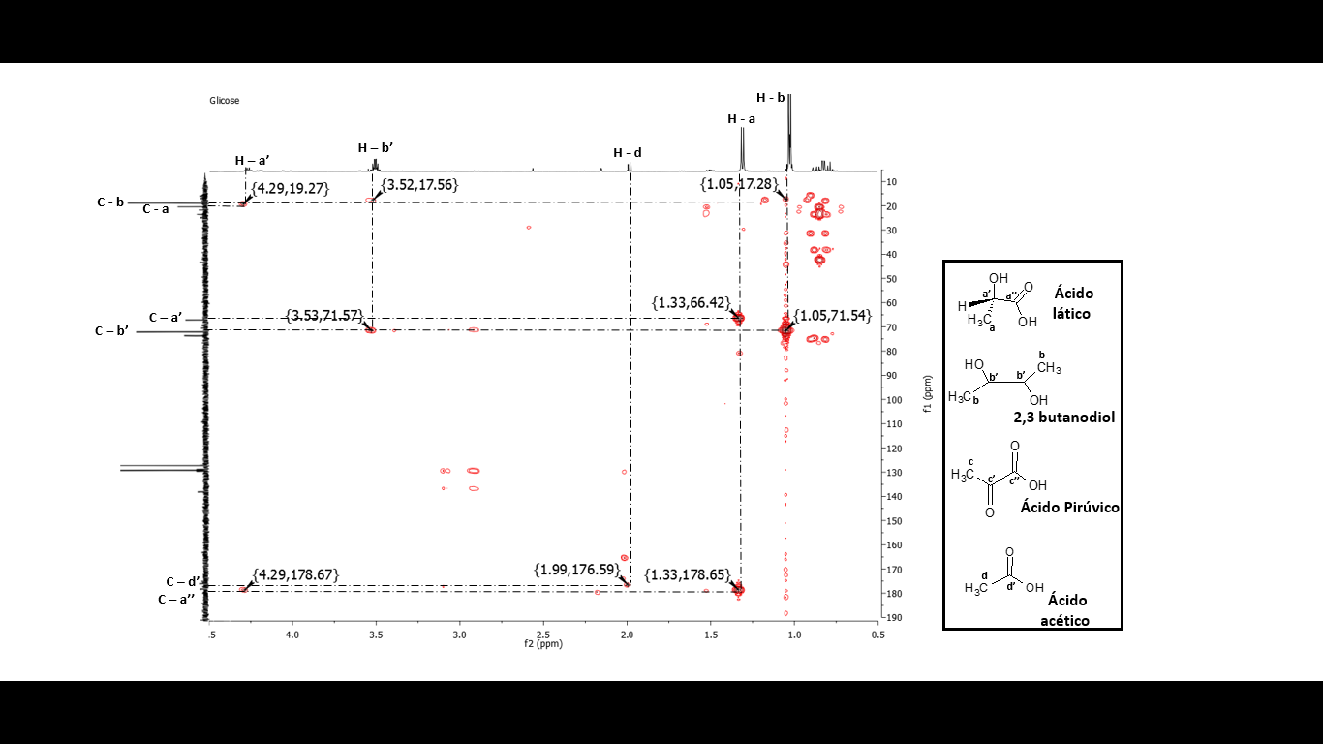
AA
PA
2,3-BD
LA

Fig. S6. HMBC correlation map of the B. coagulans fermentation medium extract: LA – Lactic acid; 2,3-BD – 2,3-butenediol; PA – Pyruvic acid; AA – Acetic acid.

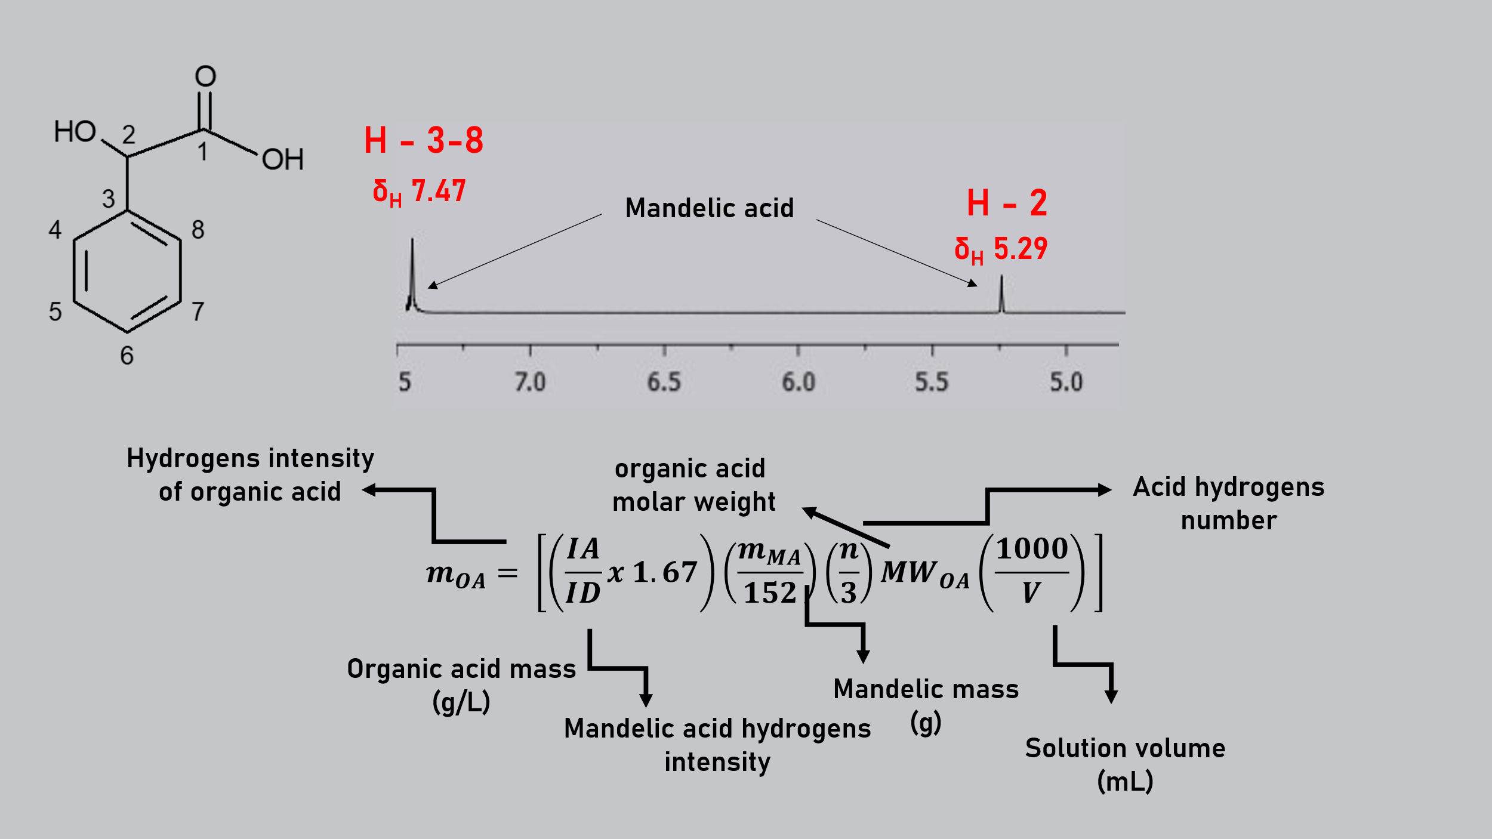

Fig. S7. Equation for calculation of organic acids concentrations in g/L.

