Supplementary material

Title:
Bradyrhizobia associated with Laburnum anagyroides, an exotic legume grown in Poland
Journal name:

Symbiosis
Author(s) names:
Ewa Sajnagaª, Monika Elżbieta Jach^{b*}
Affiliations:
ª Laboratory of Biocontrol, Application and Production of EPN, Centre for Interdisciplinary Research, Faculty of Biotechnology and Environment Sciences, John Paul II Catholic University of Lublin, Konstantynów 1J, 20-708 Lublin, Poland
^{b} Department of Molecular Biology, Faculty of Biotechnology and Environment Sciences, John Paul II Catholic University of Lublin, Konstantynów 1H, 20-708 Lublin, Poland
Corresponding author:
M. E. Jach; monijach@kul.lublin.pl

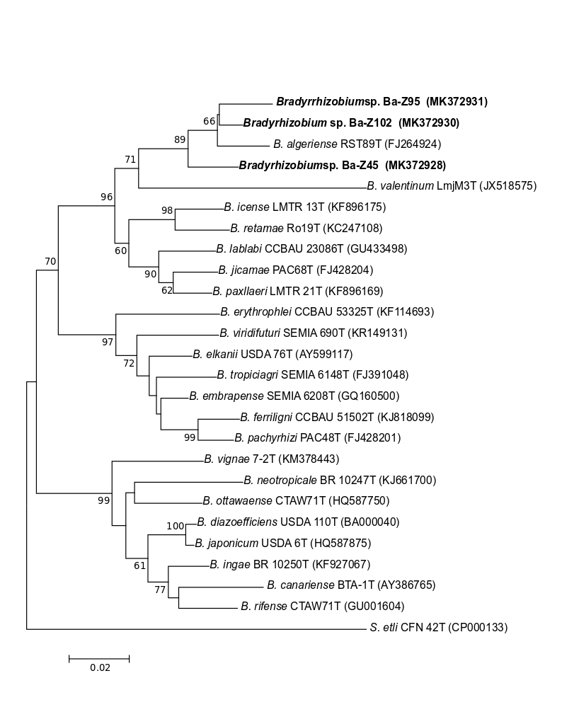
Fig. S1 Maximum likelihood tree showing the phylogenetic relationships of L. anagyroides symbionts studied (bolded) with Bradyrhizobium type strains of recognized species based on glnII gene sequences. Bootstrap values based on 1000 replicates >50% are indicated at the branching points. The scale bar presents the number of nucleotide substitutions per site. The sequence of Sinorhizobium etli was used as an outgroup
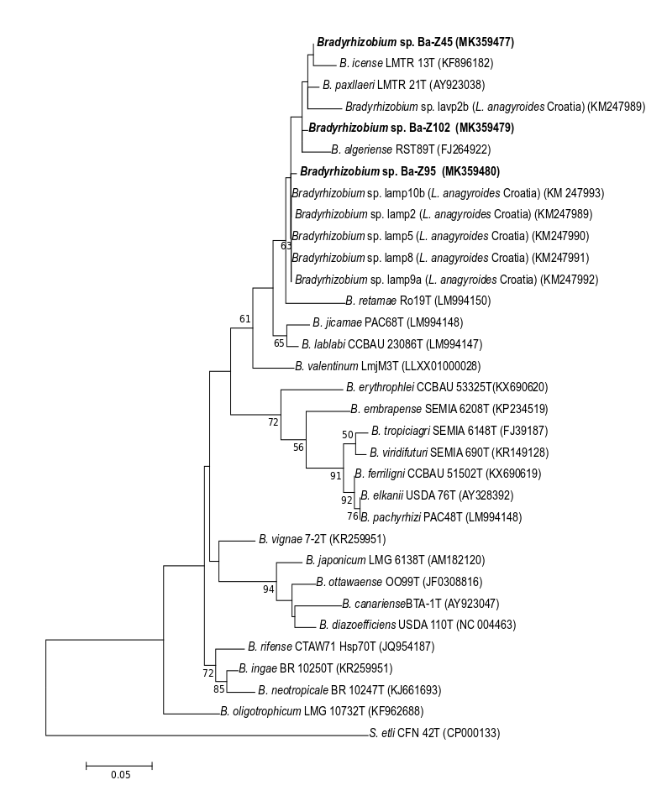
Fig. S2 Maximum likelihood tree showing the phylogenetic relationships of L. anagyroides symbionts studied (bolded) with Bradyrhizobium type strains of recognized species based on dnaK gene sequences. Bootstrap values based on 1000 replicates >50% are indicated at the branching points. The scale bar presents the number of nucleotide substitutions per site. The sequence of Sinorhizobium etli was used as an outgroup.
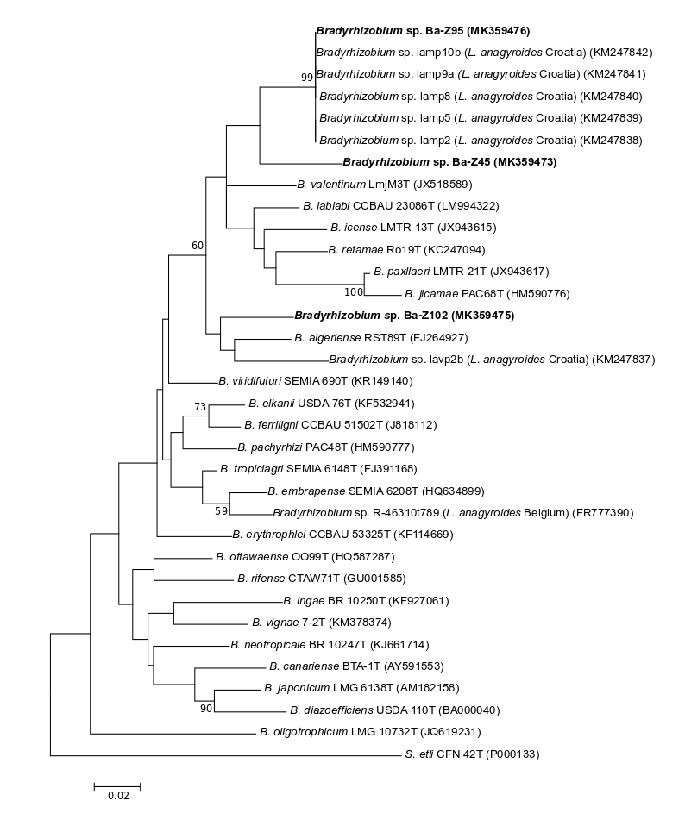Fig. S3 Maximum likelihood tree showing the phylogenetic relationships of L. anagyroides symbionts studied (bolded) with Bradyrhizobium type strains of recognized species based on recA gene sequences. Bootstrap values based on 1000 replicates >50% are indicated at the branching points. The scale bar presents the number of nucleotide substitutions per site. The sequence of Sinorhizobium etli was used as an outgroup.
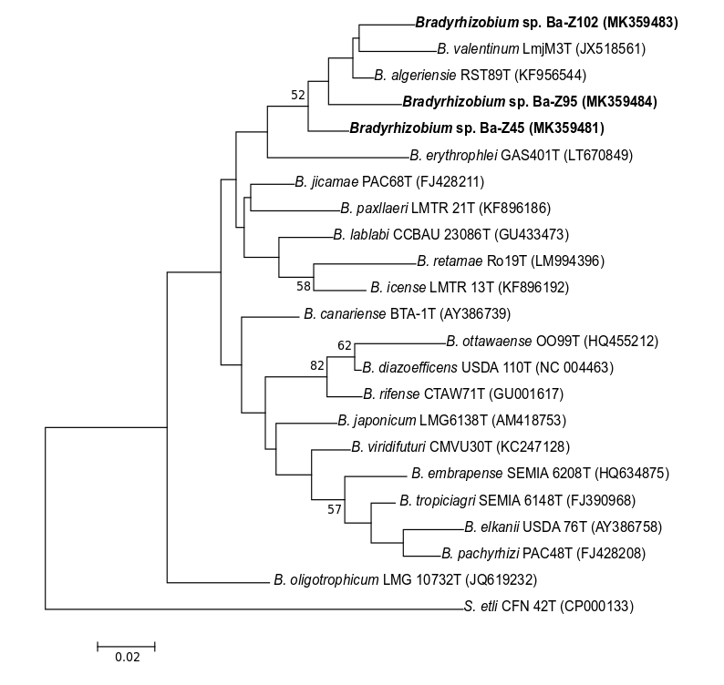
Fig. S4 Maximum likelihood tree showing the phylogenetic relationships of L. anagyroides symbionts studied (bolded) with Bradyrhizobium type strains of recognized species based on atpD gene sequences. Bootstrap values based on 1000 replicates >50% are indicated at the branching points. The scale bar presents the number of nucleotide substitutions per site. The sequence of Sinorhizobium etli was used as an outgroup.

