SUPPLEMENTARY FIGURES
a PAR (umol/m2/s)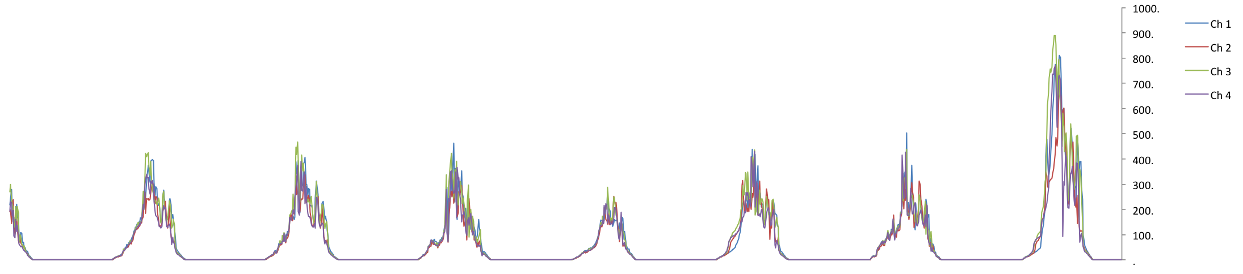
b Relative humidity %
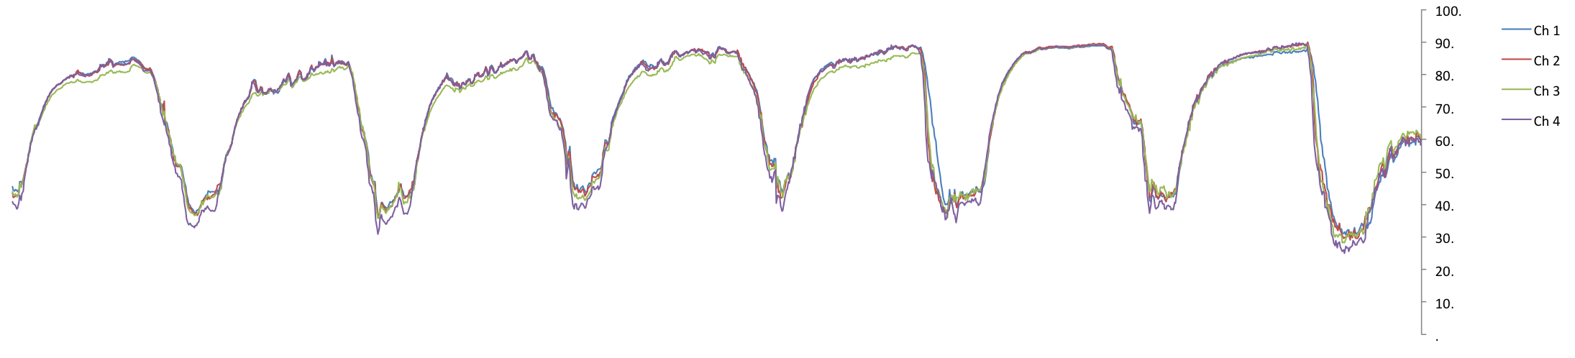
c Temperature Celsius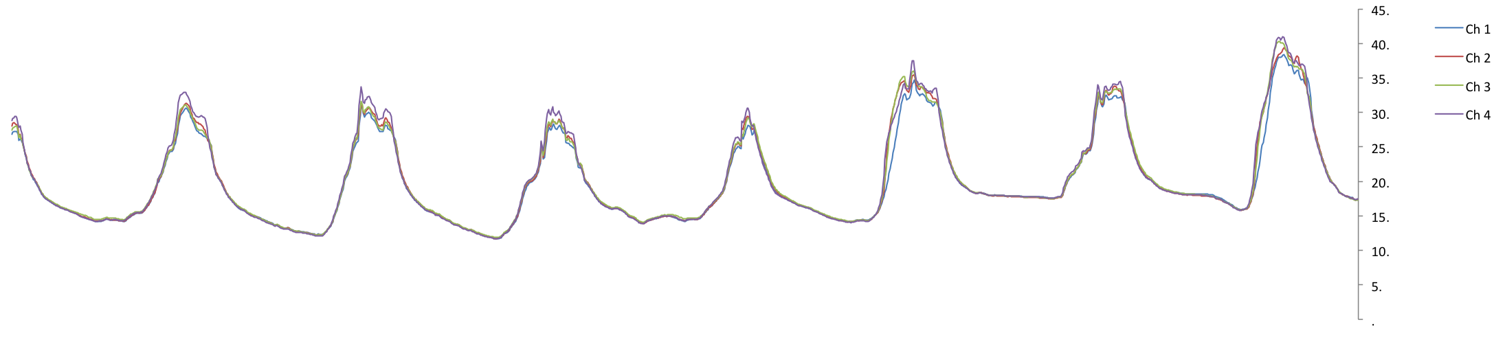
d CO₂ concentration (ppm)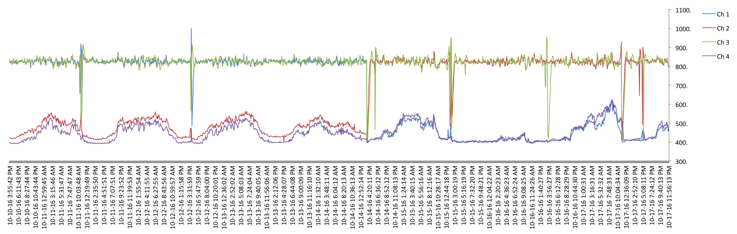
Suppl. Fig 1 A snapshot of CO₂ concentrations in the four CSTR chambers over a typical week On Oct-14-2016, elevated CO₂ chambers switched from chambers 1 & 3 to 2 & 3. CO₂ concentrations increase slightly during the day in ambient CO₂ treatments, likely due to photosynthesis and because the chambers cannot decrease CO₂ concentrations. CO₂ concentrations are adjusted automatically every eight minutes in a series. The elevated CO₂ chambers occasionally fluctuate in CO₂ concentrations due to opening and closing of the chambers during watering or regular plant check-ups.

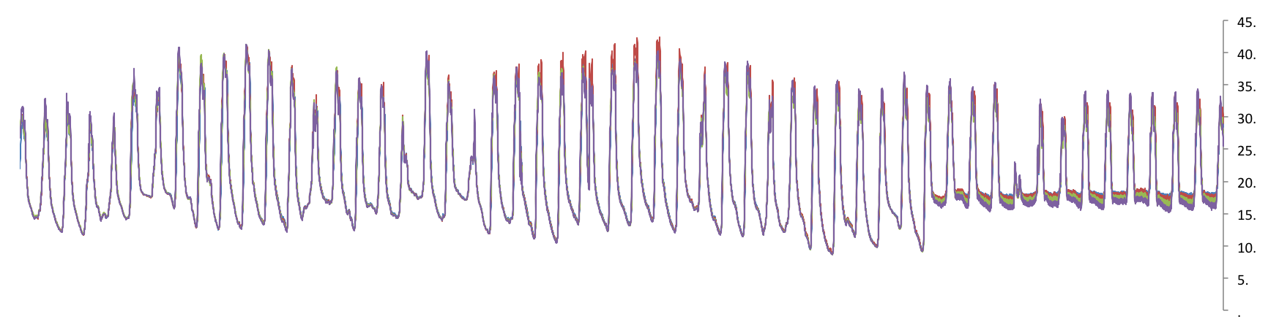
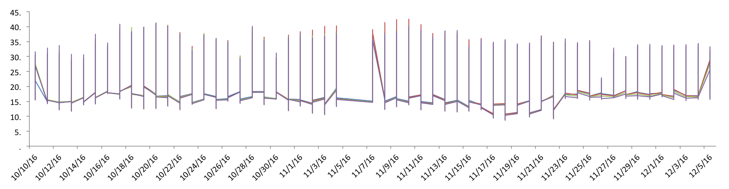
Suppl Fig 2 Range of temperatures in the CSTR chambers during the experiment
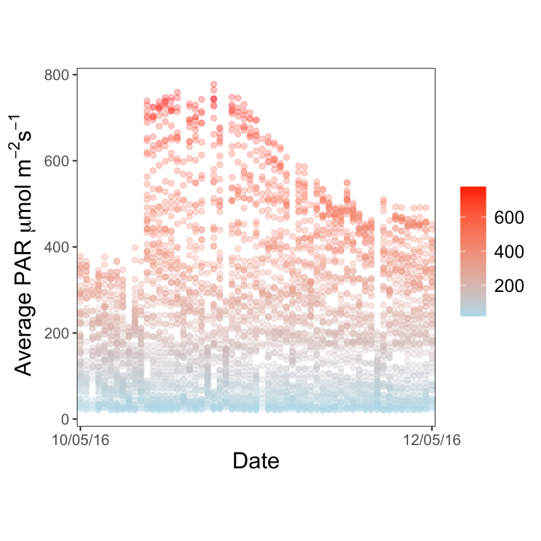
Suppl Fig 3 Range of average PAR in the CSTR chambers during the experiment

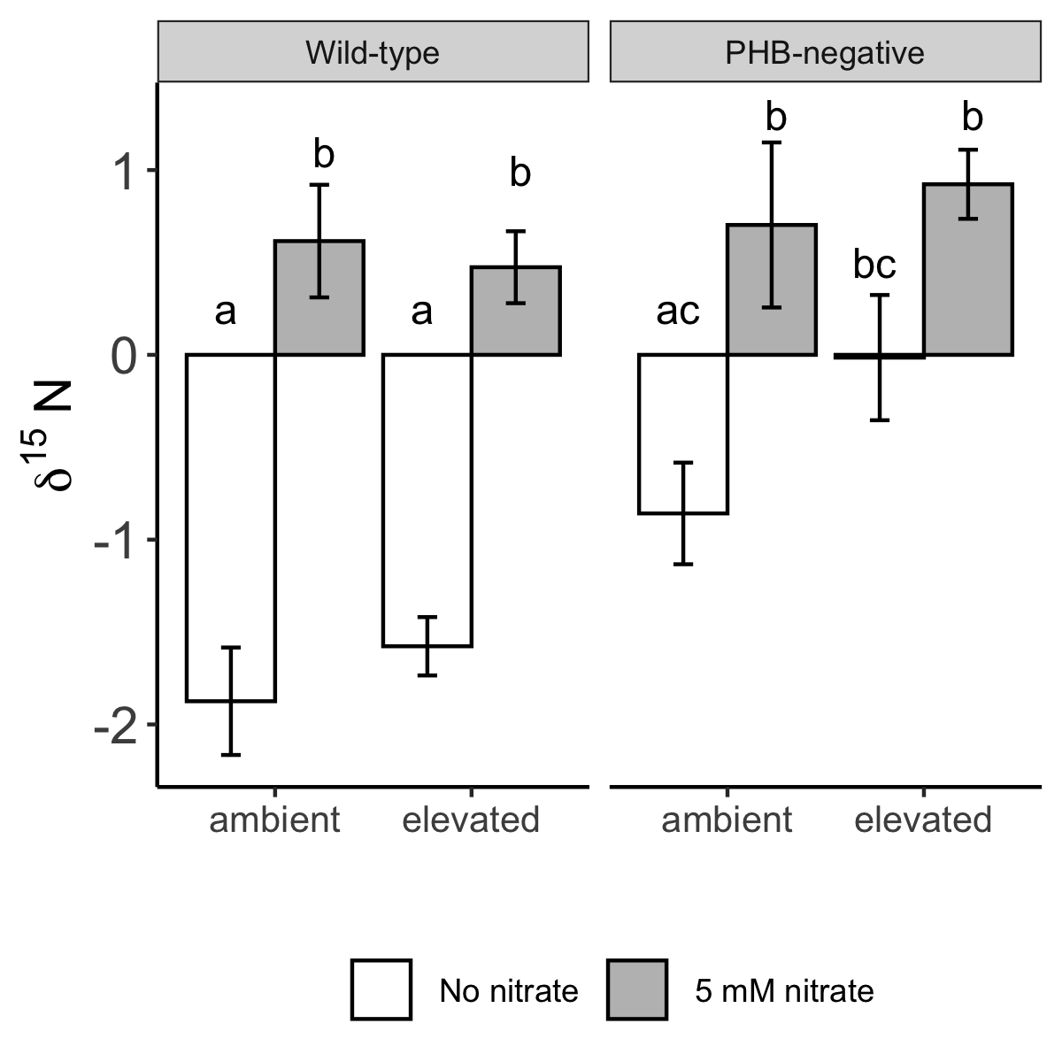
Suppl Fig 4 Effects of CO₂ and nitrate treatments on shoot δ¹⁵N. Effects of rhizobial inoculum (wild type vs. PHB-negative), CO₂ treatment (ambient vs. elevated) and nitrate (0 vs. 5 mM nitrate) treatments on δ¹⁵N of shoot tissues. Bars are standard errors (7-12 plants per group, sample numbers are lower because not all samples were analyzed by the mass spectrometer). Letters indicate results from post-hoc Tukey’s HSD tests after overall significances for nitrate and inoculum treatments were confirmed with linear models with interaction terms (Suppl Table 2).

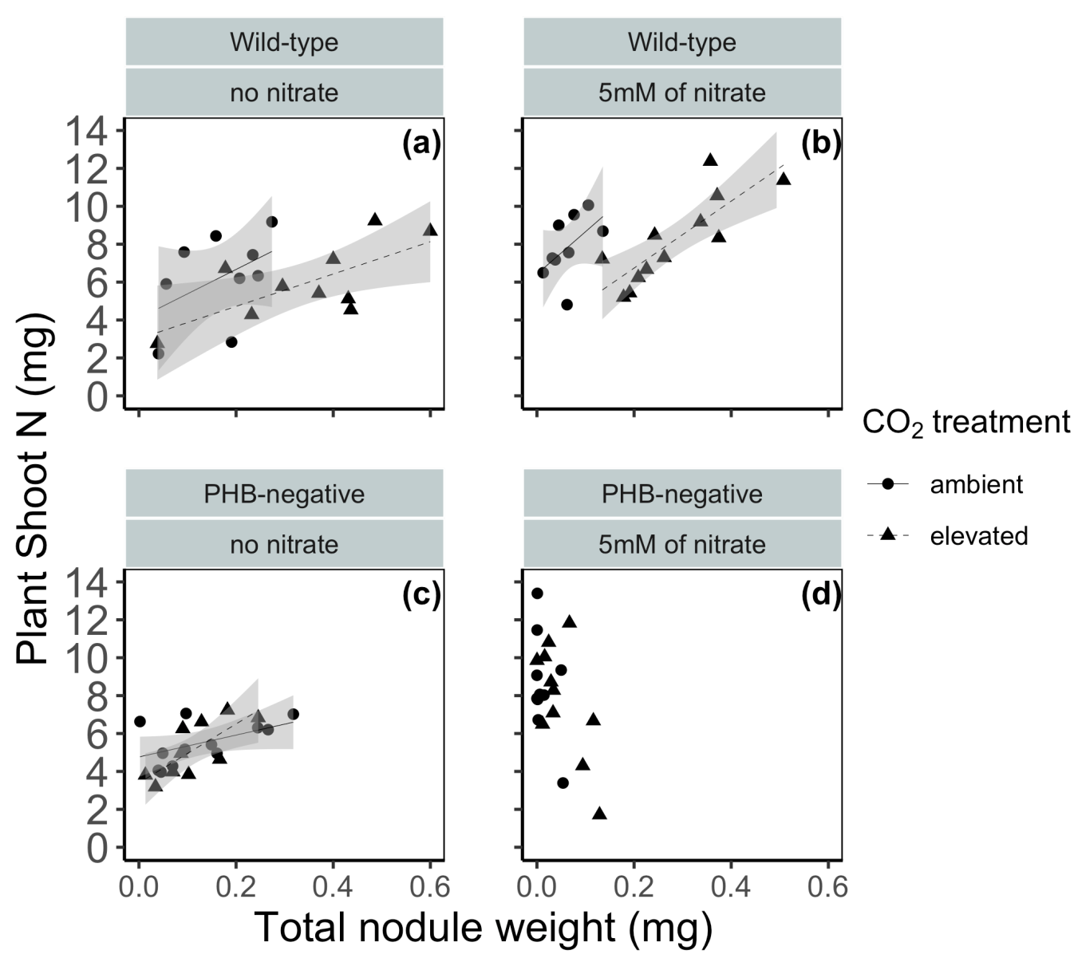

Suppl Fig 5 Effects of elevated CO₂ treatments and nitrate on the relationship between plant nitrogen and total nodule wet biomass. Shaded area of regression line represent 95% confidence interval. Only plant samples whose nitrogen contents were analyzed are included in analysis.

SUPPLEMENTARY TABLES

 | Root biomass
 | Estimate | Std. Error | t-value | p
Nitrate (N) | 0.002 | 0.019 | 0.124 | 0.901
CO₂ | 0.003 | 0.019 | 0.156 | 0.876
Strain | 0.014 | 0.019 | 0.741 | 0.46
N * CO₂ | 0.071 | 0.027 | 2.66 | 0.009
N * Strain | -0.025 | 0.029 | -0.876 | 0.383
CO₂ * Strain | 0 | 0.026 | 0.008 | 0.993
CO₂ * Strain * N | 0.022 | 0.039 | 0.583 | 0.561

Supplementary Table 1 Linear model summary testing effect of nitrate, CO₂, and their interaction on root biomass (residual df = 65). Estimates are based on plants growing in no nitrate under ambient CO₂ conditions with the wild-type (CE3) as the reference group.

 | Shoot δ¹⁵N
 | Estimate | Std. Error | t-value | p
Nitrate (N) | 2.49 | 0.399 | 6.238 | <0.001
CO₂ | 0.297 | 0.389 | 0.765 | 0.447
Strain | 1.016 | 0.381 | 2.67 | 0.009
N * CO₂ | -0.439 | 0.539 | -0.814 | 0.419
N * Strain | -0.929 | 0.572 | -1.625 | 0.109
CO₂ * Strain | 0.546 | 0.537 | 1.016 | 0.313
CO₂ * Strain * N | -0.184 | 0.776 | -0.237 | 0.813

Supplementary Table 2 Linear model summary testing effect of nitrate, CO₂, inoculum and their interactions on stable nitrogen isotope signature in bean shoots (residual df = 70). Estimates are based on plants growing in no nitrate under ambient CO₂ conditions with the wild-type strain as the reference group.

