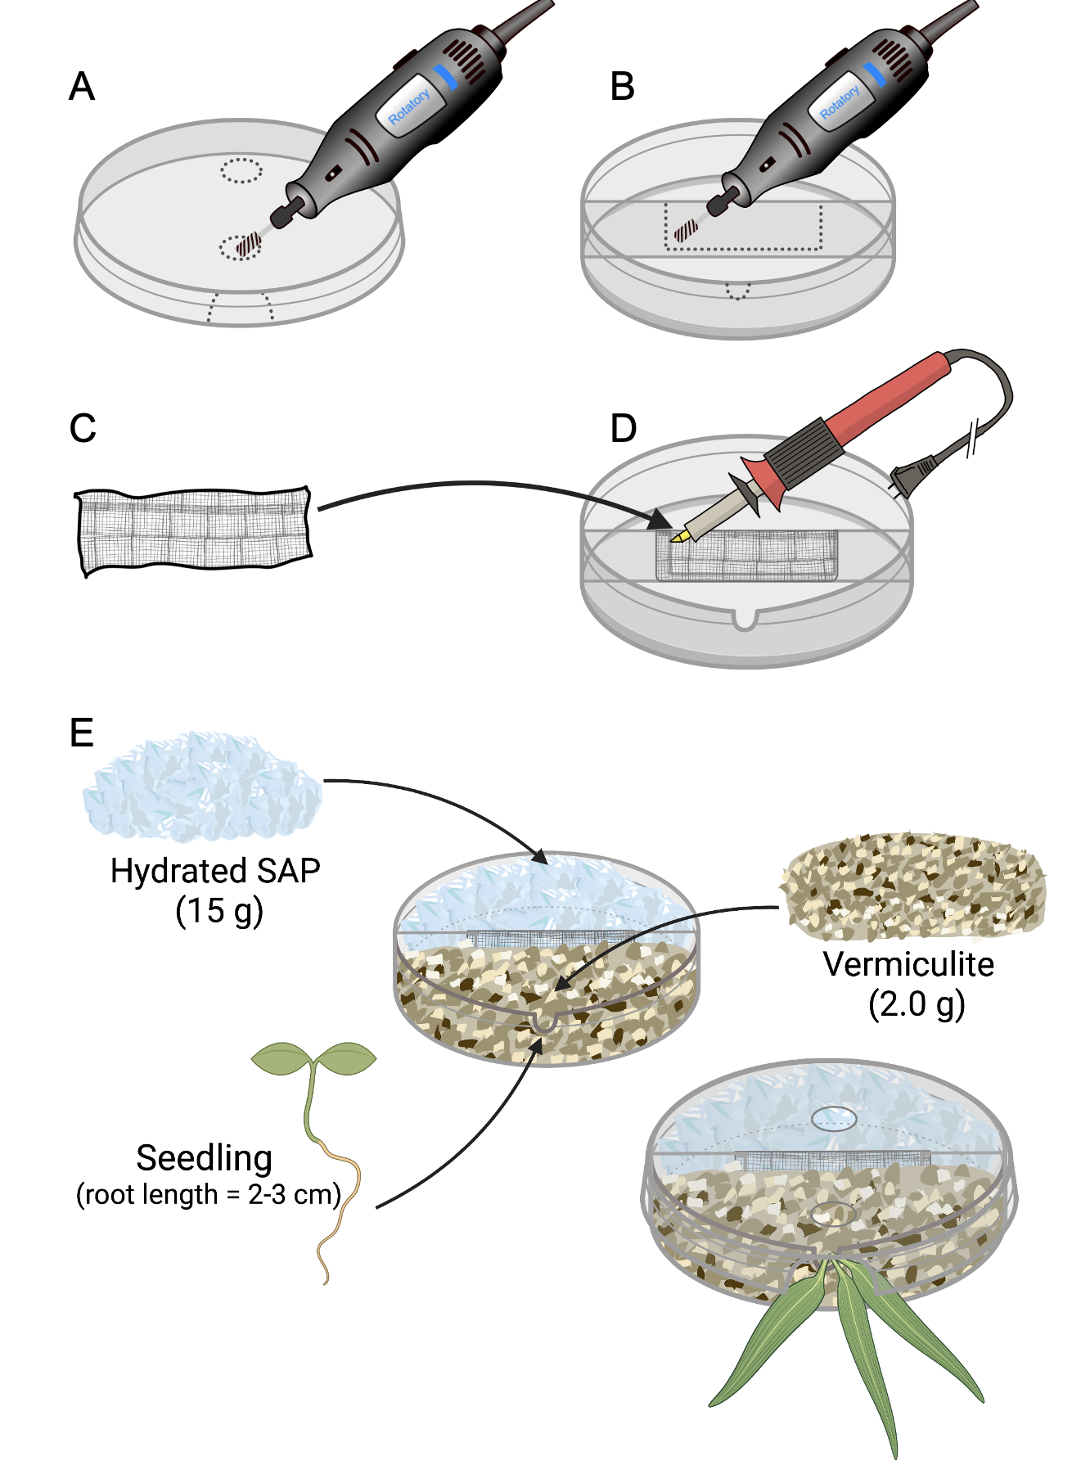
Figure S1. Set-up of a two-compartment Petri dish. A) Using a rotary tool, two holes are perforated through the lid to allow watering of each compartment. A notch is cut into the side to leave space for the plantlet stem. B) A rectangular notch is cut to receive the nitex membrane, and another notch is cut into the side to leave space for the plantlet stem. C and D) Using a pyrography tool, fuse the nitex membrane with the plastic barrier. E) Fill one compartment with 15 g of SAP and the other with 2 g of vermiculite. Add a plantlet with a root length of ~2-3 cm on the vermiculite side. Align the notches and close the Petri dish. Wrap the Petri dish in parafilm.

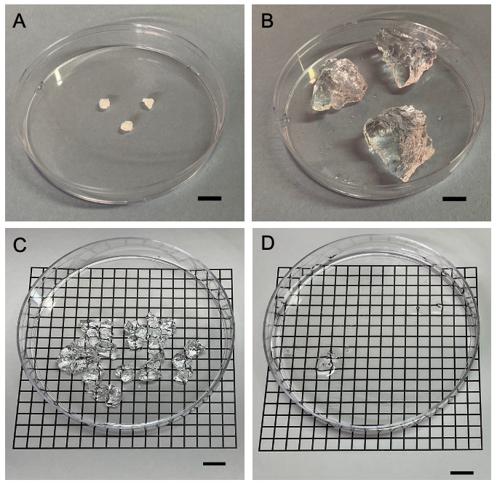
Figure S2. A) Large size dry particles of SAP, B) the same particles of SAP after 12 hours of hydration in the modified M medium, C) Medium size particles of SAP hydrated with the modified M solution and deposited in a dry Petri dish, D) the same Petri dish filled with the modified M solution to show the transparency of the hydrated particles of SAP. The scale bars are 1 cm long.

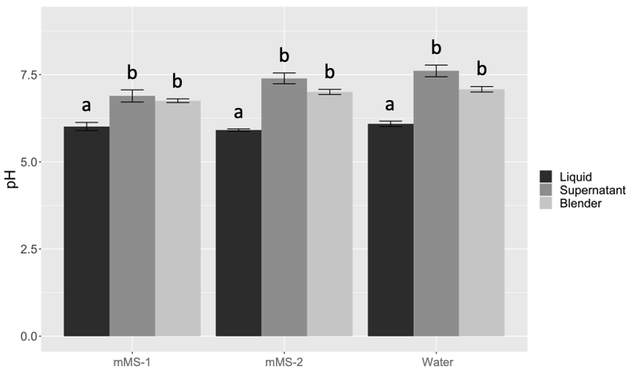
Figure S3. Analyses of the pH recorded in the SAP hydrated with mMS-1, mMS-2 and reverse osmosis-purified water. The pH was measured directly in each solution (Liquid), in the supernatant in hydrated grains of SAP after 12 h (Supernatant), and in hydrated and blended SAP after 12 h (Blender). For each category, five readings were taken. Error bars represent the standard deviation. Different letters indicate significant differences at p = 0.05 (Tukey HSD test).

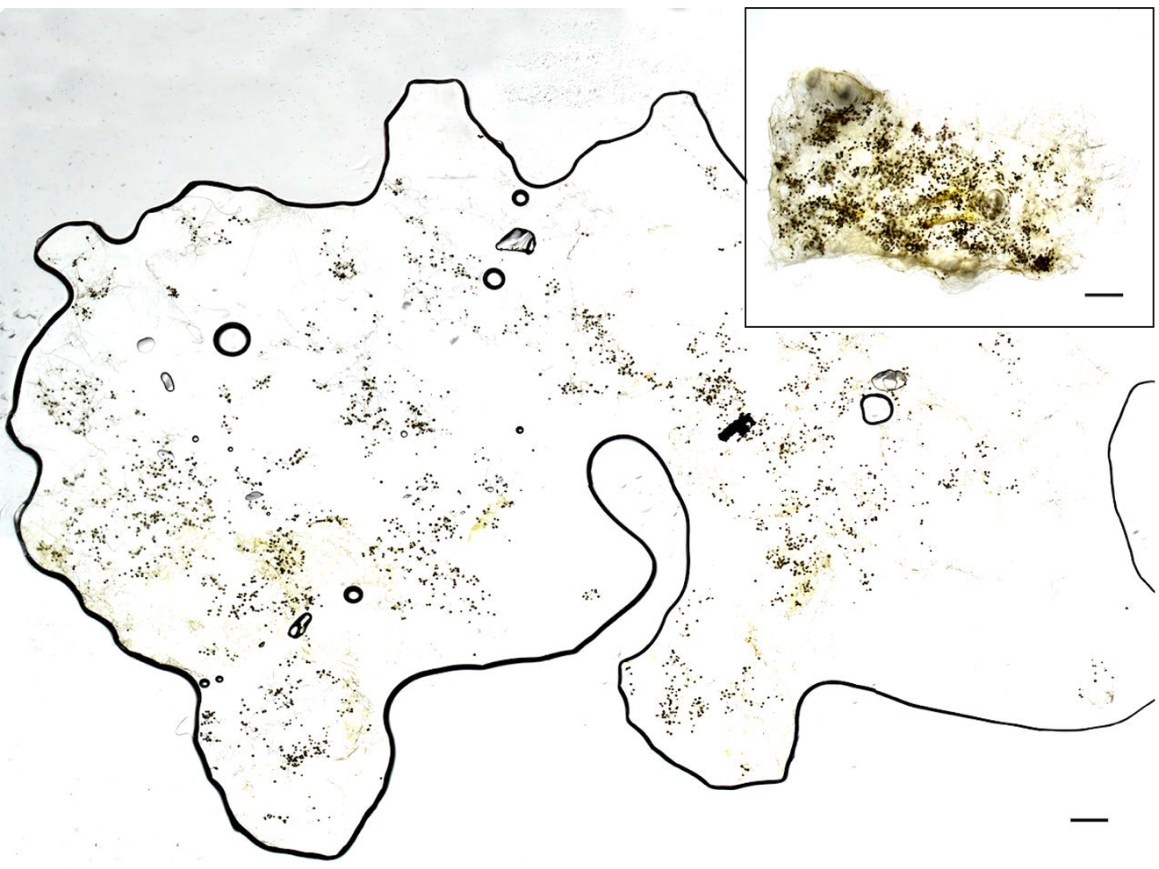
Figure S4. Grain of SAP colonized with spores of R. irregularis. The inset represents the grain extracted from the SAP compartment, and the main picture is the grain squeezed in between two glass slides to spread the spores on a horizontal plan. High-resolution pictures are then taken and assembled. Fiji software enumerated 1,965 spores in this grain of SAP. The horizontal scale bars are 1 mm long.

