Symbiosis
Nitrogen fixation capacity and metabolite responses to phosphorus in soybean nodules
Yubo Yao^{1,2}, Hongmei Yuan², Guangwen Wu², Jun Yan³, Dongsheng Zhao², Si Chen², Qinghua Kang², Chunmei Ma⁴, Zhenping Gong⁴*
Corresponding Author: College of Agriculture, Northeast Agricultural University, Harbin 150030, China gzpyx2004@163.com
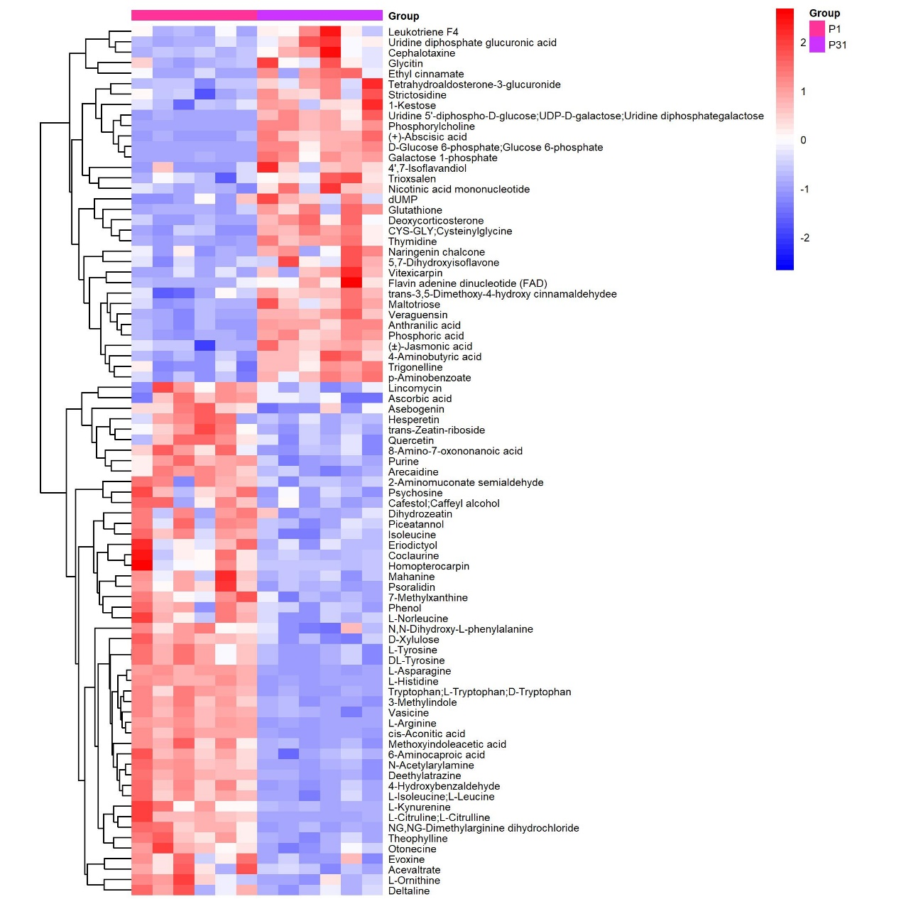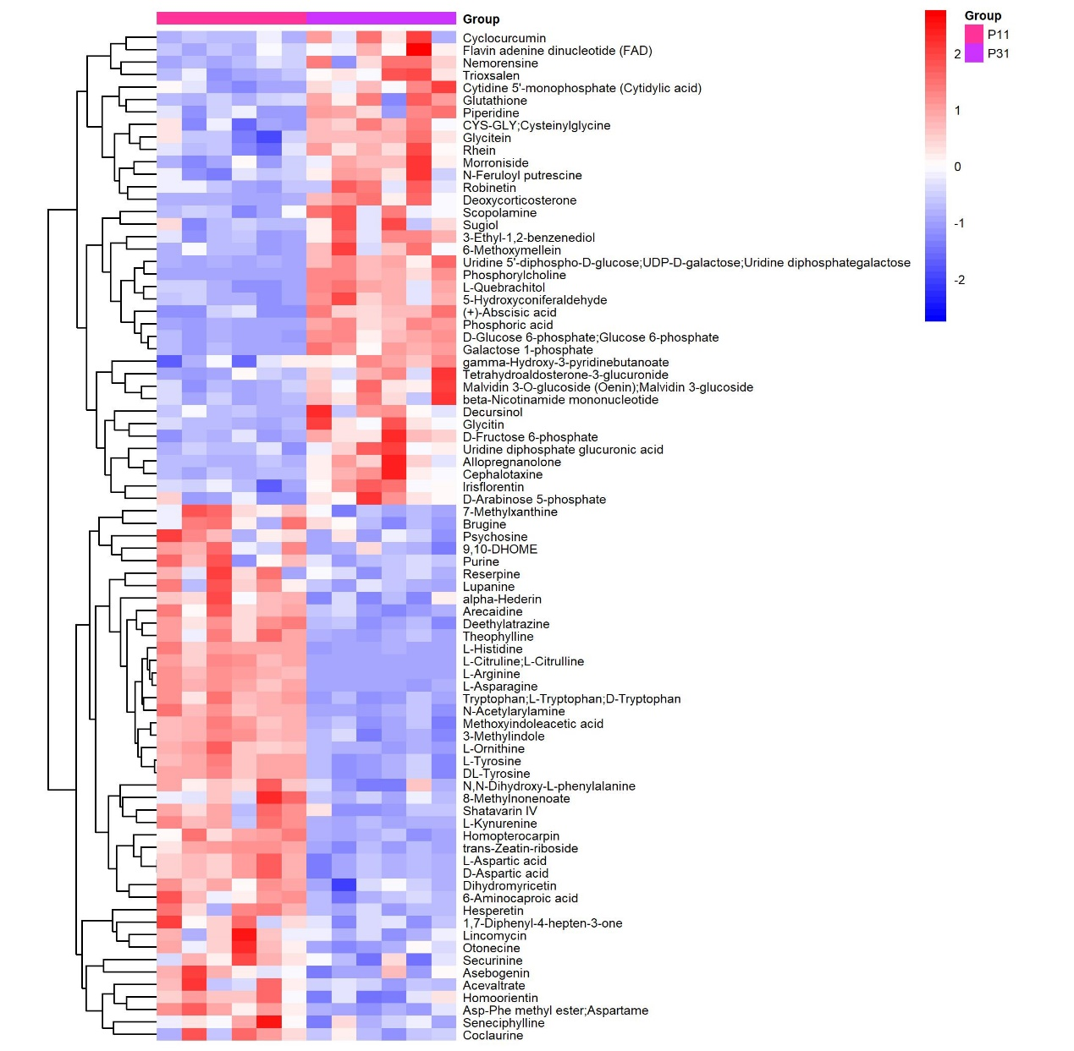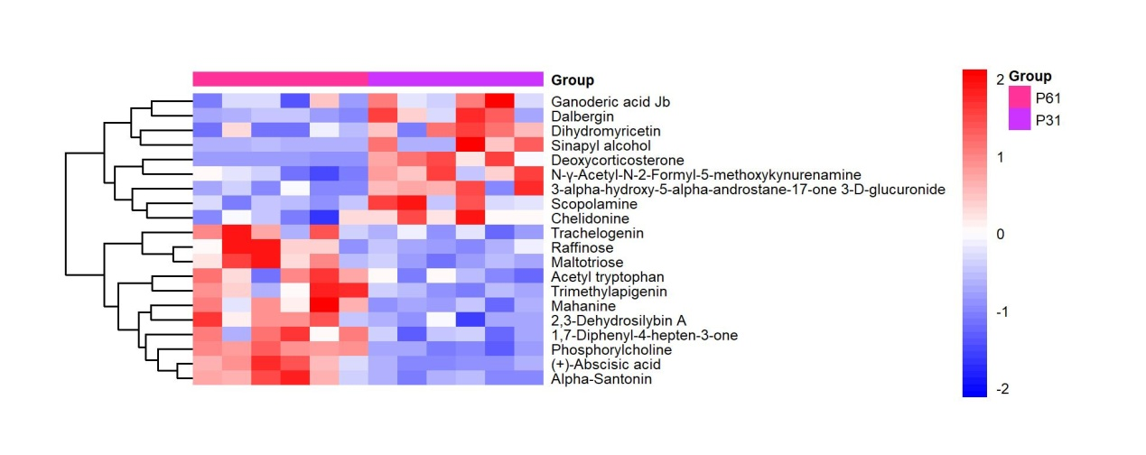
Heatmap of hierarchical clustering analysis

