Symbiosis
Nitrogen fixation capacity and metabolite responses to phosphorus in soybean nodules
Yubo Yao^{1,2}, Hongmei Yuan², Guangwen Wu², Jun Yan³, Dongsheng Zhao², Si Chen², Qinghua Kang², Chunmei Ma⁴, Zhenping Gong⁴*
Corresponding Author: College of Agriculture, Northeast Agricultural University, Harbin 150030, China gzpyx2004@163.com
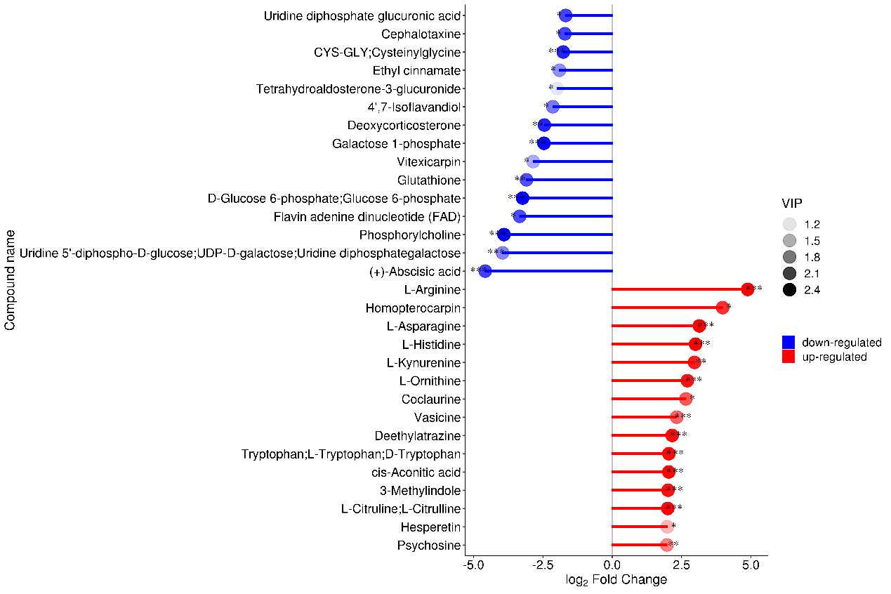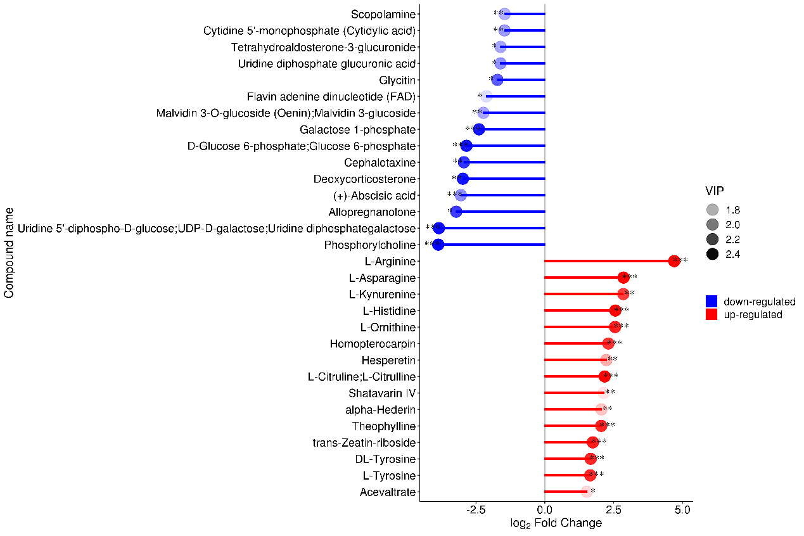
P1 VS P31
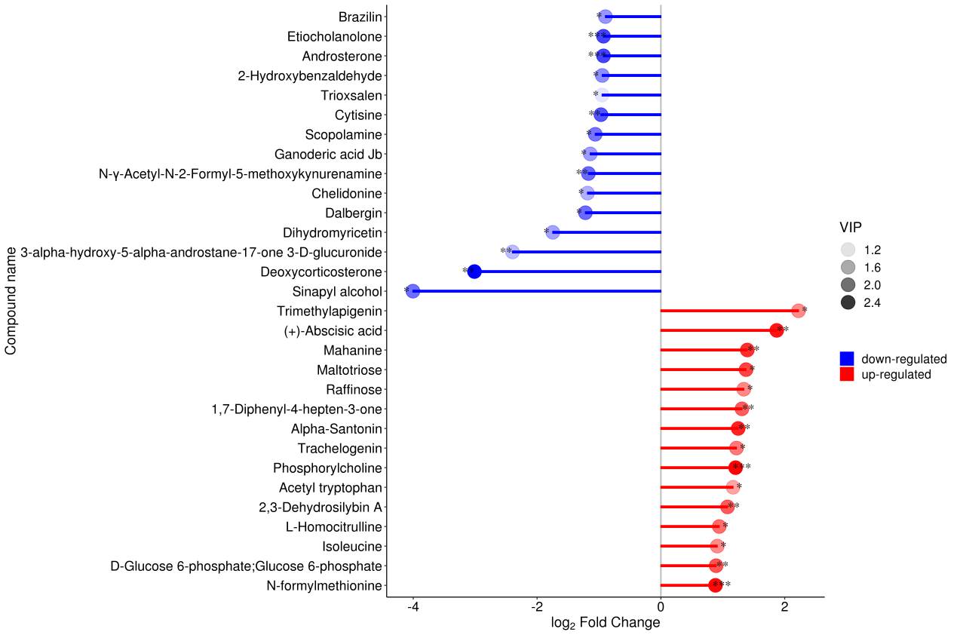
P61 VS P31
P11 VS P31
The abscissa shows the change multiple after logarithmic transformation, the shade of the dot represents the VIP value, and * represents the significance. (Note: * 0.01<p<0.05, ** 0.001<p<0.01, *** p<0.001)

