Symbiosis
Nitrogen fixation capacity and metabolite responses to phosphorus in soybean nodules
Yubo Yao^{1,2}, Hongmei Yuan², Guangwen Wu², Jun Yan³, Dongsheng Zhao², Si Chen², Qinghua Kang², Chunmei Ma⁴, Zhenping Gong⁴*
Corresponding Author: College of Agriculture, Northeast Agricultural University, Harbin 150030, China gzpyx2004@163.com
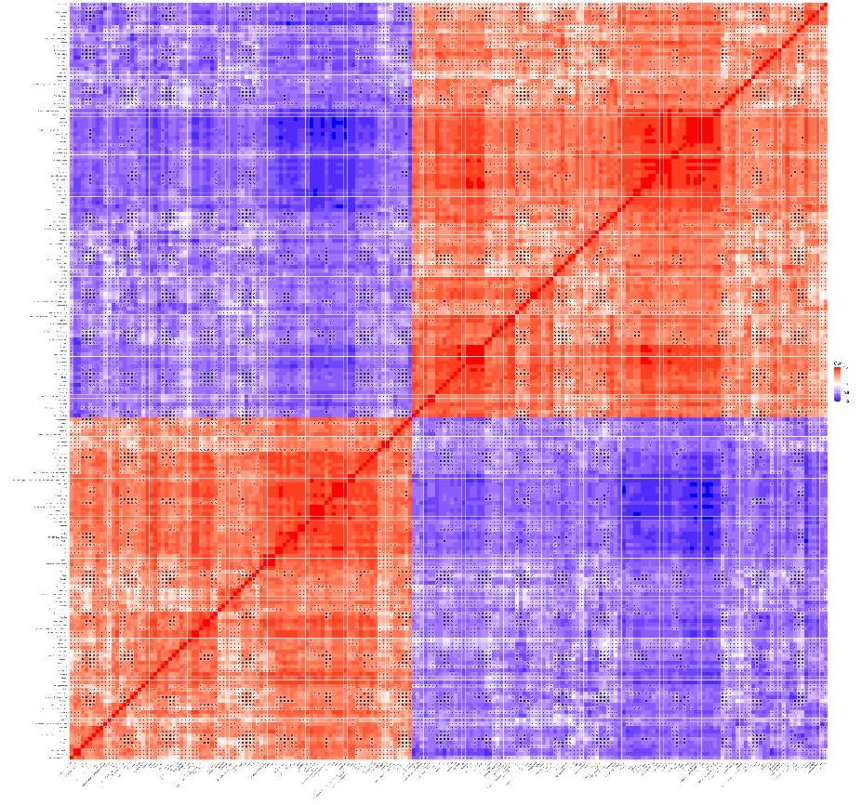
P1 VS P31
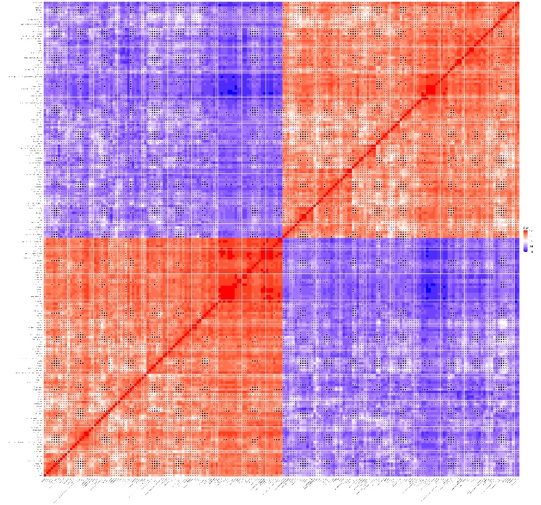
P11 VS P31
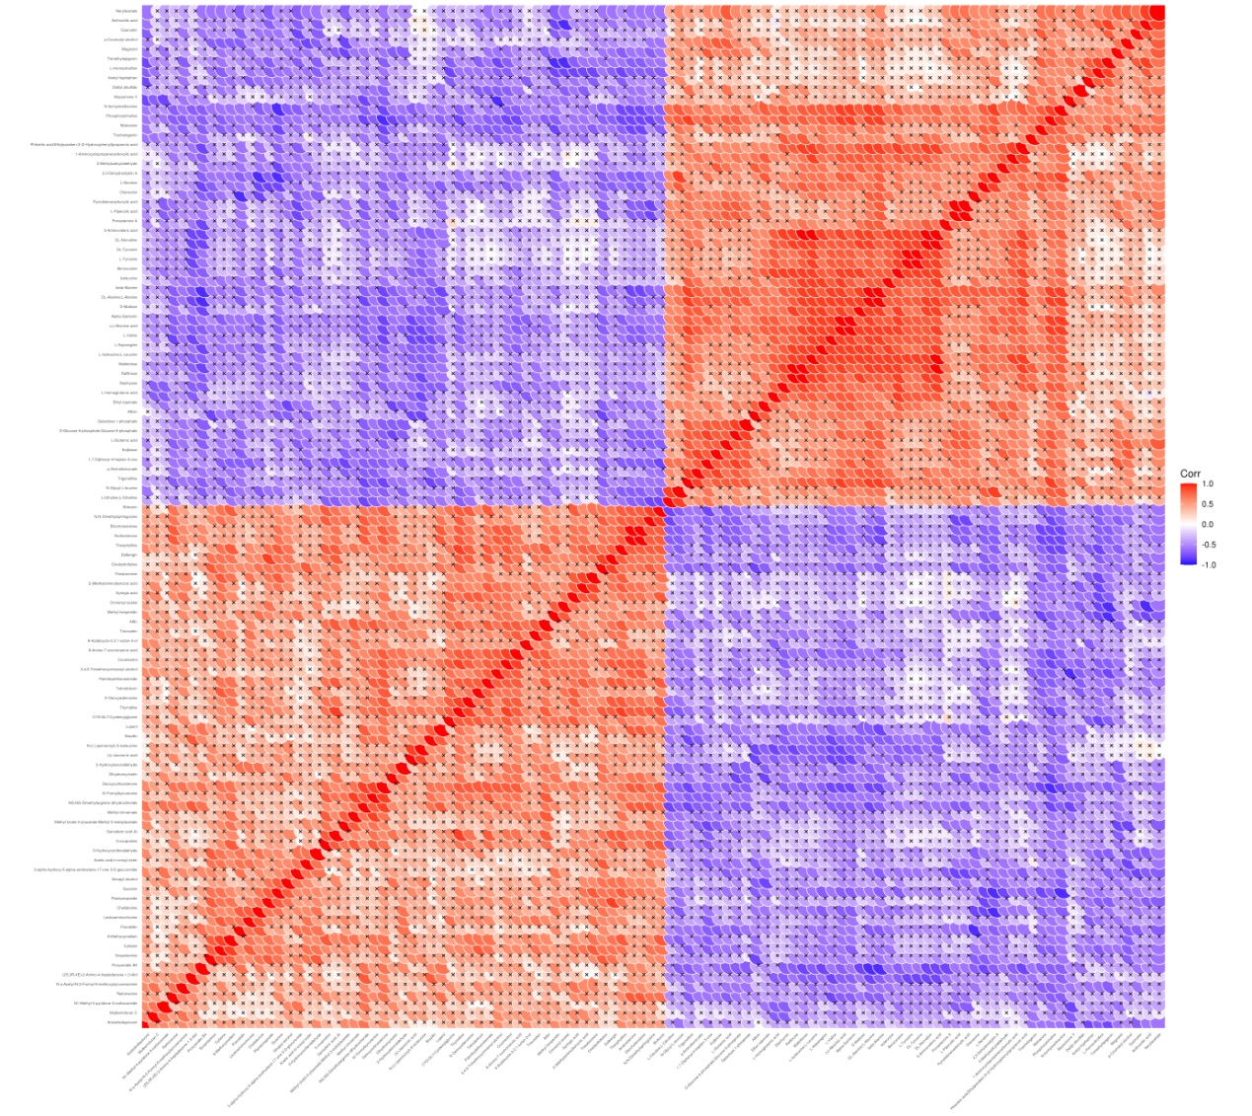
P61 VS P31
The horizontal and vertical coordinates represent the different metabolites of the comparison. The color patches at different locations represent the correlation coefficients between metabolites at the corresponding locations. Red represents positive correlation, blue represents negative correlation, and the darker the color, the stronger the correlation. Non-significant correlations are marked with a cross.

