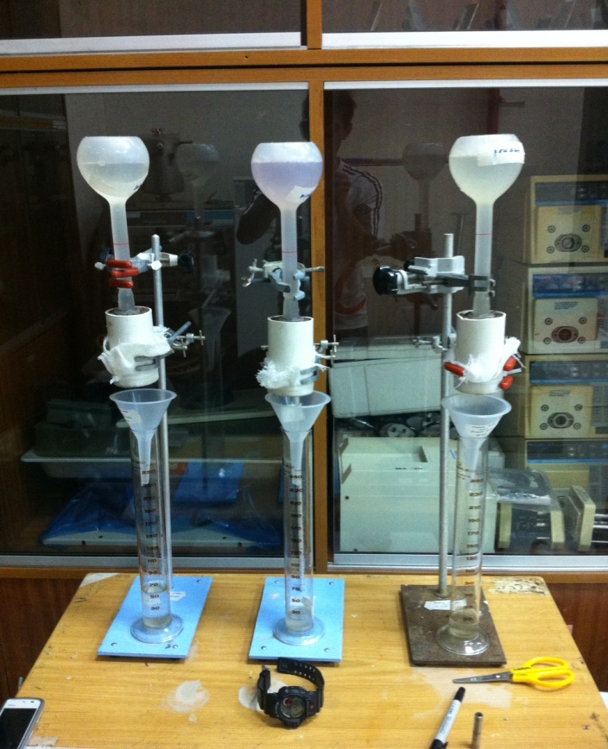

Appendix B: Hydraulic conductivity set up during the experiment

