Supplementary Material
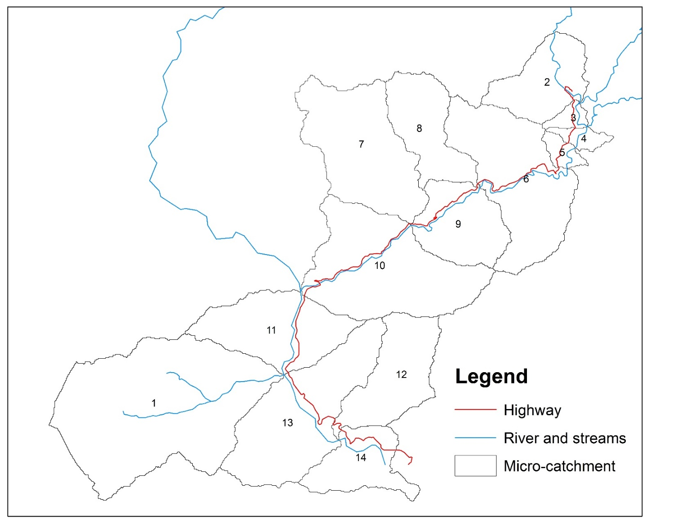
Figure S1. Micro-catchments with their code.

Table S1. Empirical model outputs for pre-project scenario (2004)
Micro-catchment | COD | pH | TSS | TDS | Zn
Code | In mg/l
Catch_1 | 26.859 | 7.203 | 65.334 | 27.057 | 0.073
Catch_2 | 26.859 | 7.045 | 52.257 | 27.057 | 0.062
Catch_3 | 26.859 | 6.825 | 38.305 | 27.057 | 0.049
Catch_4 | 26.859 | 6.841 | 39.152 | 27.057 | 0.050
Catch_5 | 26.859 | 6.842 | 39.203 | 27.057 | 0.050
Catch_6 | 26.859 | 7.134 | 59.248 | 27.057 | 0.068
Catch_7 | 26.859 | 7.125 | 58.542 | 27.057 | 0.067
Catch_8 | 26.859 | 7.052 | 52.809 | 27.057 | 0.062
Catch_9 | 26.859 | 7.058 | 53.191 | 27.057 | 0.063
Catch_10 | 26.859 | 7.148 | 60.434 | 27.057 | 0.069
Catch_11 | 26.859 | 7.092 | 55.867 | 27.057 | 0.065
Catch_12 | 26.859 | 7.070 | 54.105 | 27.057 | 0.063
Catch_13 | 26.859 | 7.134 | 59.285 | 27.057 | 0.068
Catch_14 | 26.859 | 7.029 | 51.047 | 27.057 | 0.061

Table S2. Empirical model outputs for project-implementation scenario (2014)
Micro-catchment | COD | pH | TSS | TDS | Zn
Code | In mg/l
Catch_1 | 26.859 | 7.209 | 65.927 | 27.302 | 0.074
Catch_2 | 26.859 | 7.052 | 52.732 | 27.302 | 0.063
Catch_3 | 26.859 | 6.832 | 38.653 | 27.302 | 0.050
Catch_4 | 26.859 | 6.847 | 39.508 | 27.302 | 0.051
Catch_5 | 26.859 | 6.848 | 39.559 | 27.302 | 0.051
Catch_6 | 26.859 | 7.140 | 59.786 | 27.302 | 0.069
Catch_7 | 26.859 | 7.132 | 59.074 | 27.302 | 0.068
Catch_8 | 26.859 | 7.059 | 53.289 | 27.302 | 0.064
Catch_9 | 26.859 | 7.064 | 53.675 | 27.302 | 0.064
Catch_10 | 26.859 | 7.154 | 60.984 | 27.302 | 0.070
Catch_11 | 26.859 | 7.099 | 56.375 | 27.302 | 0.066
Catch_12 | 26.859 | 7.076 | 54.597 | 27.302 | 0.065
Catch_13 | 26.859 | 7.141 | 59.824 | 27.302 | 0.069
Catch_14 | 26.859 | 7.035 | 51.511 | 27.302 | 0.062

Table S3. Empirical model outputs for post-project scenario (2039)
For all micro-catchments | COD | pH | TSS | TDS | Zn
For all micro-catchments | In mg/l
For all micro-catchments | 215.800 | 7.200 | 360.000 | 338.200 | 0.015

Table S4. Input of water pollutant profile and discharge rate at the two river sites. These inputs along with runoff derived from micro-watersheds were included in the Mass Balance Model.
Location of discharge input | Discharge (l/sec) | COD | pH | TSS | TDS | Zn
Location of discharge input | Discharge (l/sec) | In mg/l
Ranipool | 14500 | 10.667 | 6.1 | 15.185 | 45.56 | 0
Singtam | 76800 | 40 | 6.93 | 39.96 | 42.55 | 0.127

Table S5. Cumulative discharge rates (derived from SCS-CN method) and concentration of water pollutants in the project impact area under various micro-catchments (derived from Empirical method) for pre-project scenario (2004).
Micro-catchment | cumulative discharge | Concentration (mg/l)- 2004
Code | l/sec | COD | pH | TSS | TDS | Zn
Catch_2 | 18385.2375 | 14.0885 | 6.2997 | 23.0189 | 41.6498 | 0.0131
Catch_3 | 32022.5070 | 8.6684 | 3.7642 | 14.0427 | 24.4966 | 0.0086
Catch_4 | 32713.6523 | 9.1805 | 3.8617 | 14.7595 | 24.6794 | 0.0097
Catch_5 | 33560.4350 | 9.6022 | 3.9307 | 15.3406 | 24.7148 | 0.0107
Catch_6 | 39564.9083 | 11.6670 | 4.2697 | 20.7817 | 24.5119 | 0.0179
Catch_7 | 47750.5381 | 14.2712 | 4.7592 | 27.2548 | 24.9481 | 0.0263
Catch_8 | 51228.2735 | 15.1258 | 4.9149 | 28.9896 | 25.0913 | 0.0288
Catch_9 | 53622.7135 | 15.6497 | 5.0106 | 30.0703 | 25.1790 | 0.0303
Catch_10 | 63410.7514 | 17.3800 | 5.3405 | 34.7573 | 25.4688 | 0.0362
Catch_11 | 140210.7514 | 30.7566 | 6.4716 | 39.6591 | 35.8188 | 0.0883
Catch_1 | 153848.0209 | 30.4111 | 6.5365 | 41.9349 | 35.0421 | 0.0869
Catch_12 | 164810.8661 | 29.3355 | 6.3510 | 41.0537 | 33.6655 | 0.0834
Catch_13 | 172570.1266 | 29.2242 | 6.3862 | 41.8735 | 33.3683 | 0.0827
Catch_14 | 175471.7460 | 29.1851 | 6.3969 | 42.0252 | 33.2639 | 0.0823

Table S6. Cumulative discharge rates (derived from SCS-CN method) and concentration of water pollutants in the project impact area under various micro- catchments (derived from Empirical method) for project implementation scenario (2014).
Micro-catchment | cumulative discharge | Concentration (mg/l)- 2014
Code | l/sec | COD | pH | TSS | TDS | Zn
Catch_2 | 18348.32953 | 14.06281 | 6.299578 | 23.05975 | 41.73071744 | 0.544813
Catch_3 | 31723.23291 | 8.712449 | 3.790798 | 14.17027 | 24.72478379 | 0.3162
Catch_4 | 32406.72821 | 9.200212 | 3.882043 | 14.85917 | 24.88591615 | 0.310812
Catch_5 | 33216.94922 | 9.602386 | 3.947115 | 15.4196 | 24.91583279 | 0.304428
Catch_6 | 39170.63473 | 11.69394 | 4.291209 | 20.98031 | 24.73846877 | 0.267287
Catch_7 | 47242.64722 | 14.28509 | 4.776572 | 27.48918 | 25.17656367 | 0.233316
Catch_8 | 57262.10625 | 16.48522 | 5.17594 | 32.0035 | 25.54854738 | 0.203615
Catch_9 | 59673.34504 | 16.90439 | 5.252236 | 32.87918 | 25.61941923 | 0.19797
Catch_10 | 69607.00341 | 18.32502 | 5.523689 | 36.89 | 25.85961043 | 0.179715
Catch_11 | 140210.7514 | 31.99388 | 6.79886 | 42.27268 | 37.14743436 | 0.161214
Catch_1 | 153585.6548 | 31.54671 | 6.834618 | 44.33263 | 36.29009348 | 0.153628
Catch_12 | 164570.0085 | 30.39324 | 6.629281 | 43.30905 | 34.83574115 | 0.145667
Catch_13 | 172201.8238 | 30.23661 | 6.65195 | 44.04097 | 34.50187461 | 0.142273
Catch_14 | 175101.7794 | 30.18067 | 6.658294 | 44.16468 | 34.3826416 | 0.140944

Table S7. Cumulative discharge rates (derived from SCS-CN method) and concentration of water pollutants in the project impact area under various micro- catchments (derived from Empirical method) for post-project scenario (2039). Discharge rates for the micro- catchments are same as that of project implementation scenario.
Micro-catchment | cumulative discharge | Concentration (mg/l)- 2039
Code | l/sec | COD | pH | TSS | TDS | Zn
Catch_2 | 18348.32953 | 53.69078 | 6.330711 | 87.50542 | 106.9375304 | 0.01659
Catch_3 | 31723.23291 | 35.70363 | 3.816734 | 58.36847 | 69.13807198 | 0.0113
Catch_4 | 32406.72821 | 40.34595 | 3.916246 | 66.138 | 76.13542126 | 0.013039
Catch_5 | 33216.94922 | 44.39615 | 3.988688 | 72.92307 | 82.16807516 | 0.014566
Catch_6 | 39170.63473 | 66.17931 | 4.334351 | 109.4351 | 114.3927428 | 0.02281
Catch_7 | 47242.64722 | 91.74392 | 4.823984 | 152.2473 | 152.6330846 | 0.032428
Catch_8 | 57262.10625 | 113.4507 | 5.239728 | 188.5989 | 185.1027268 | 0.040595
Catch_9 | 59673.34504 | 117.5863 | 5.318937 | 195.5248 | 191.2889744 | 0.04215
Catch_10 | 69607.00341 | 131.6025 | 5.587385 | 218.9972 | 212.2547374 | 0.047424
Catch_11 | 140210.7514 | 95.17043 | 6.8342 | 143.8322 | 141.1028287 | 0.096013
Catch_1 | 153585.6548 | 105.6754 | 6.866055 | 162.657 | 158.2669032 | 0.09454
Catch_12 | 164570.0085 | 106.272 | 6.663011 | 164.5622 | 159.6922625 | 0.091034
Catch_13 | 172201.8238 | 111.1262 | 6.68681 | 173.2238 | 167.6035497 | 0.090505
Catch_14 | 175101.7794 | 112.8597 | 6.695309 | 176.3171 | 170.42889 | 0.090316

$$percent contribution of the road runoff to the pollution load in the impact area=\frac{road runoff concentration}{road runoff concentration + river water concentration}×100$$
Table S8. Percent contribution of traffic induced water pollution w.r.t. total water pollution in the rivers (pre-project scenario, 2004)
Micro-catchment | COD | pH | TSS | TDS | Zn
code | In precent
Catch_2 | 40.288 | 23.633 | 47.974 | 13.728 | NA
Catch_3 | 10.716 | 5.063 | 10.733 | 2.753 | NA
Catch_4 | 12.820 | 6.147 | 13.087 | 3.352 | NA
Catch_5 | 12.416 | 5.939 | 12.690 | 3.235 | NA
Catch_6 | 47.395 | 29.500 | 58.265 | 17.525 | NA
Catch_7 | 58.703 | 39.738 | 68.518 | 25.108 | NA
Catch_8 | 37.653 | 21.710 | 45.478 | 12.468 | NA
Catch_9 | 29.369 | 16.041 | 36.647 | 8.931 | NA
Catch_10 | 62.960 | 44.165 | 72.875 | 28.616 | NA
Catch_11 | 4.111 | 5.558 | 8.044 | 3.426 | 3.312
Catch_1 | 10.195 | 13.664 | 21.315 | 8.586 | 9.215
Catch_12 | 4.615 | 6.210 | 8.727 | 3.849 | 3.640
Catch_13 | 6.067 | 8.188 | 12.270 | 5.073 | 5.110
Catch_14 | 2.358 | 3.181 | 4.309 | 1.959 | 1.776
NA is not available
Table S9. Percent contribution of traffic induced water pollution w.r.t. total water pollution in the rivers (project implementation scenario, 2014)
Micro-catchment | COD | pH | TSS | TDS | Zn
code | In precent
Catch_2 | 40.058 | 23.477 | 47.961 | 13.722 | NA
Catch_3 | 10.610 | 5.015 | 10.713 | 2.747 | NA
Catch_4 | 12.335 | 5.902 | 12.693 | 3.240 | NA
Catch_5 | 11.861 | 5.660 | 12.221 | 3.103 | NA
Catch_6 | 47.350 | 29.482 | 58.441 | 17.630 | NA
Catch_7 | 58.364 | 39.425 | 68.412 | 25.015 | NA
Catch_8 | 63.503 | 44.433 | 70.803 | 29.283 | NA
Catch_9 | 29.514 | 16.148 | 37.020 | 9.062 | NA
Catch_10 | 63.303 | 44.552 | 73.343 | 29.105 | NA
Catch_11 | 4.111 | 5.563 | 8.112 | 3.456 | 3.378
Catch_1 | 10.018 | 13.447 | 21.141 | 8.505 | 9.223
Catch_12 | 4.631 | 6.236 | 8.829 | 3.897 | 3.725
Catch_13 | 5.973 | 8.072 | 12.189 | 5.037 | 5.129
Catch_14 | 2.357 | 3.182 | 4.344 | 1.976 | 1.811

Table S10. Percent contribution of traffic induced water pollution w.r.t. total water pollution in the rivers (post-project scenario, 2039)
Micro-catchment | COD | pH | TSS | TDS | Zn
code | In precent
Catch_2 | 84.300 | 23.854 | 86.287 | 66.331 | NA
Catch_3 | 48.814 | 5.271 | 52.775 | 25.921 | NA
Catch_4 | 53.062 | 6.187 | 56.984 | 29.318 | NA
Catch_5 | 51.951 | 5.934 | 55.889 | 28.403 | NA
Catch_6 | 87.843 | 29.655 | 89.437 | 72.612 | NA
Catch_7 | 91.845 | 39.653 | 92.957 | 80.516 | NA
Catch_8 | 93.324 | 44.922 | 94.247 | 83.685 | NA
Catch_9 | 77.087 | 16.407 | 79.767 | 55.246 | NA
Catch_10 | 93.271 | 44.709 | 94.200 | 83.567 | NA
Catch_11 | 25.621 | 5.638 | 36.050 | 30.719 | 4.009
Catch_1 | 47.216 | 13.431 | 59.414 | 53.520 | 9.785
Catch_12 | 28.067 | 6.339 | 38.970 | 33.433 | 4.517
Catch_13 | 33.793 | 8.133 | 45.514 | 39.651 | 5.829
Catch_14 | 16.244 | 3.255 | 24.093 | 19.978 | 2.298

Table S11. Predicted verses observed water pollutant concentration at Rangpo site.
 | COD | pH | TSS | TDS | Zn
Predicted | 30.181 | 6.658 | 44.165 | 34.383 | 0.141
Observed | 33.333 | 6.46 | 35.964 | 40 | 0.135

