SUPPLEMENTAL DATA

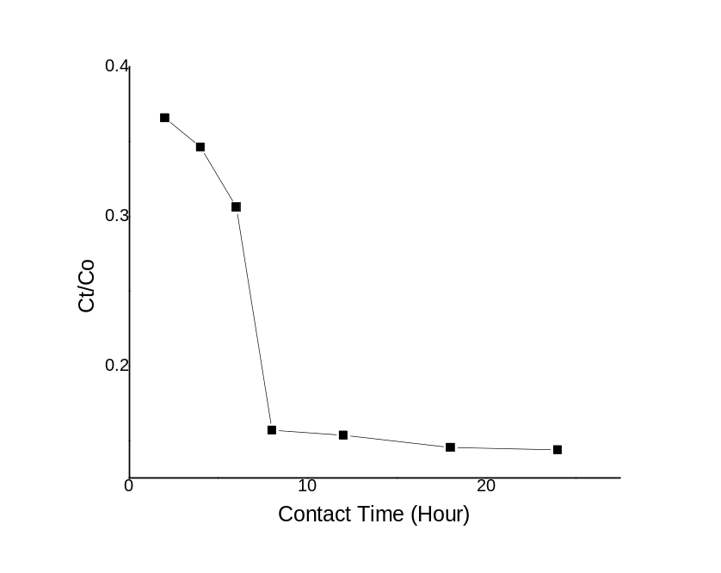
Fig. 1: Plot of Ct/Co versus contact time of CuO-kaolinite composite used for the calculation of mass transfer rates

Table 1: Mass transfer rates for CuO-kaolinite composite derived from Fig. 1
Slope I(hr⁻¹) | SlopeII(hr⁻¹) | Exposed Surface  Area (cm⁻¹) | K_{fI} (cmhr⁻¹) | K_{fII} (cmhr⁻¹)
0.0345 | 0.0184 | 4700 | 7.34^⁻⁶ | 3.91^⁻⁶

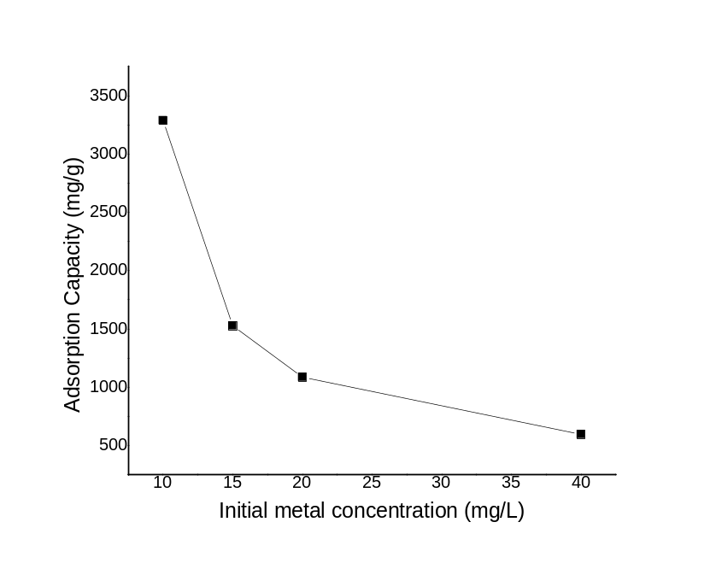

Fig. 2: Adsorption capacity versus initial metal concentration of CuO-kaolinite composite [pH=4, 2g/L solid concentration, 10 mg/L Pb²⁺ concentration]

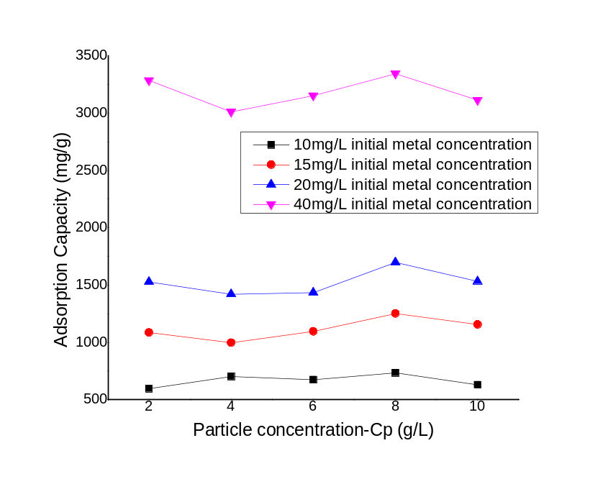
Fig. 3: Plot of adsorption capacity versus particle concentration (Cp) [pH=4]

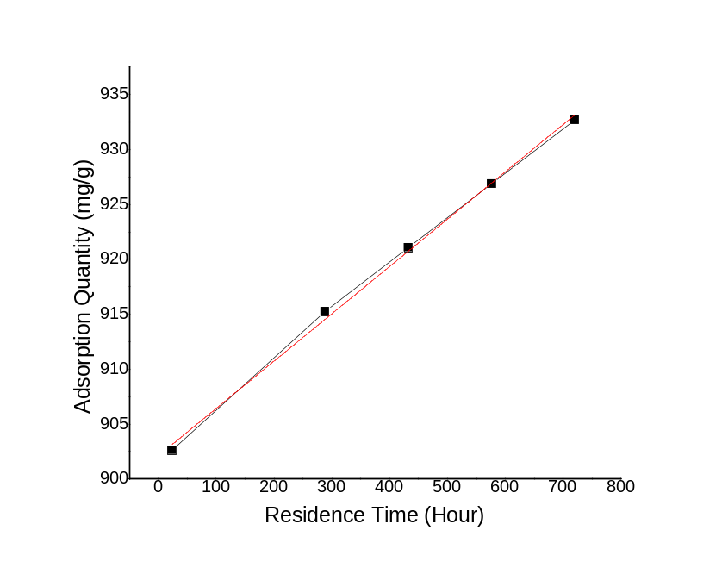
Fig. 4: Adsorption capacity versus residence time for CuO-kaolinite composite [pH=4,2 g/L solid concentration, 10mgL⁻¹ Pb²⁺ concentration]

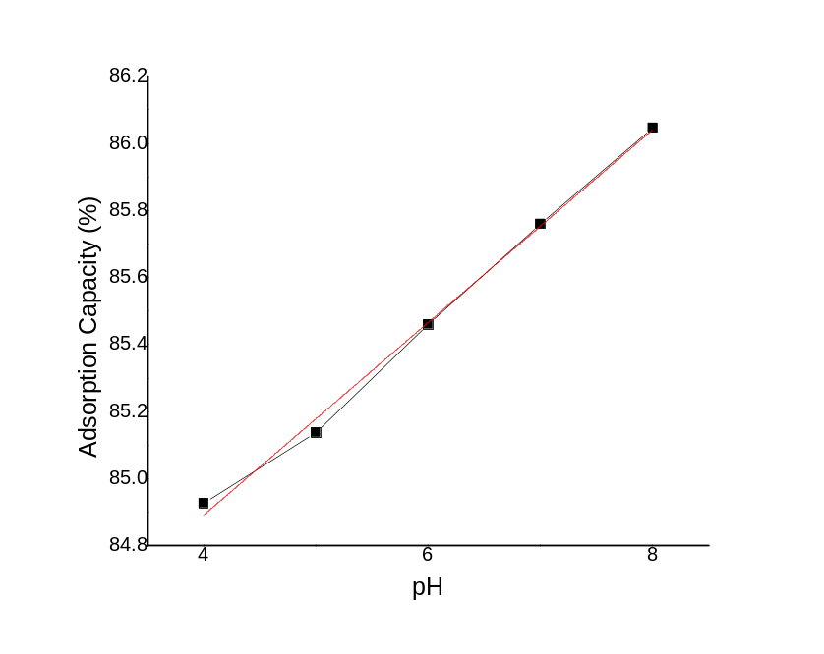
Fig. 5: Plot of adsorption capacity versus initial pH for CuO-kaolinite composite [2 g/L solid concentration, 10mgL⁻¹ Pb²⁺ concentration]

