Supplementary Table 1. Operating condition of GC-MS/MS and LC-MS/MS
Parameter | Condition for GC-MS/MS | Parameter | Condition for LC-MS/MS
Injection volume | 1 µL | Injection volume | 20 µL
Injection mode | Splitless | Flow rate | 0.3 mL/ min
Inlet temperature |  | Mobile phase A | Water with 0.1% acetic acid and 10 mM ammonium acetate
  Ramp (°C) | Temp. (°C) | Hold (min)
  - | 70 | 0.1
  200 | 285°C | Oven time
Inlet temperature |  | Mobile phase B | Methanol with 0.1% acetic acid and 10 mM ammonium acetate
Column | HP - 5MS; 30 m ×0.25 mm ×0.25µm | Column | Symmetry® C₁₈ (100mm × 2.1mm × 5µm)
Carrier gas flow | He at 1 mL/min
Oven temperature programme |  | Gradient
  Ramp (°C) | Temp. (°C) | Hold (min)
  - | 70 | 2.5
  20 | 180 | 0
  5 | 200 | 3
  5 | 220 | 0
  7 | 240 | 0
  10 | 290 | 10
  Time (min) | A (%) | B (%) | Hold (min)
  0 | 95 | 5 | 0.6
  2 | 5 | 95 | 4
  12 | 95 | 5 | 3
Oven temperature programme |  | Capillary voltage | 0.50 kV
Oven temperature programme |  | Cone voltage | 22 V
Ion source | EI mode (+ve) | Ionisation mode | ESI (+ve)
Source temp. | 230°C | Source temp. | 120°C
MS1 temp. | 150 °C | Desolvation temp. | 350°C
MS2 temp. | 150 °C | Desolvation gas flow | N₂ at 650.0 L/hr
Collision gas | N₂ at 1.5 mL/min | Cone flow | N₂ at 50.0 L/hr
Scan mode | Multiple Reaction Monitoring, MRM | Collision gas | Ar
Solvent delay | 6 min. | Scan type | MRM
Run time | 29.875 min | Run time | 15 min

Supplementary Table 2. Chromatographic and mass spectrometric data for identification of pesticides
Instrument | Name | Time segment | Retention time (min) | Quantifier mass transition | Qualifier mass transition
GC-MS/MS | Carbaryl | 1 | 9.29 | 144.0->115.2 | 144.5->116.1
GC-MS/MS | Monocrotophos | 1 | 10.63 | 127.1->95.0 | 127.1->109.0
GC-MS/MS | Alpha-HCH | 2 | 11.06 | 216.9->181.0 | 218.9->183.0
GC-MS/MS | Atrazine | 2 | 11.47 | 214.9->58.1 | 214.9->200.2
GC-MS/MS | Beta-HCH | 2 | 11.66 | 216.9->181.1 | 181.0->145.0
GC-MS/MS | Lindane | 2 | 11.75 | 216.9->181.0 | 181.0->145.0
GC-MS/MS | Delta-HCH | 2 | 12.33 | 217.0->181.1 | 181.1->145.1
GC-MS/MS | Methyl Parathion | 3 | 13.36 | 124.7->79.0 | 108.7->79.0
GC-MS/MS | Alachlor | 3 | 13.56 | 188.1->160.2 | 160.0->132.1
GC-MS/MS | Metalaxyl | 3 | 13.71 | 205.7->132.1 | 205.7->162.2
GC-MS/MS | Malathion | 4 | 14.59 | 126.7->99.1 | 172.7->99.1
GC-MS/MS | Aldrin | 4 | 14.77 | 262.7->193.1 | 262.7->227.8
GC-MS/MS | Chlorpyrifos | 4 | 15.01 | 196.9->169.0 | 198.9->171.0
GC-MS/MS | Parathion | 4 | 15.01 | 96.7->47.1 | 108.7->81.0
GC-MS/MS | Dicofol | 4 | 15.18 | 139.0->111.1 | 249.6->139.0
GC-MS/MS | op-DDE | 5 | 17.50 | 246.0->176.2 | 248.0->176.2
GC-MS/MS | Alpha-Endosulphan | 5 | 17.74 | 240.5->206.0 | 194.6->159.0
GC-MS/MS | Butachlor | 5 | 17.95 | 175.7->147.2 | 159.7->132.1
GC-MS/MS | pp-DDE | 5 | 18.78 | 246.1->176.2 | 315.0->246.0
GC-MS/MS | op-DDD | 6 | 19.10 | 235.0->165.2 | 237.0->165.2
GC-MS/MS | Beta-Endosulphan | 6 | 19.96 | 194.6->159.0 | 194.6->125.1
GC-MS/MS | Dieldrin | 6 | 19.97 | 262.5->193.0 | 78.8->51.1
GC-MS/MS | op-DDT | 7 | 20.40 | 235.0->165.2 | 237.0->165.2
GC-MS/MS | Ethion | 7 | 20.62 | 152.9->96.9 | 124.9->96.9
GC-MS/MS | Endosulphan Sulfate | 7 | 21.52 | 271.9->237.0 | 273.8->238.9
GC-MS/MS | pp-DDD | 7 | 21.70 | 234.9->165.1 | 236.9->165.2
GC-MS/MS | pp-DDT | 8 | 23.50 | 235.0->166.2 | 237.0->165.2
GC-MS/MS | Bifenthrin | 8 | 24.96 | 180.8->166.1 | 180.8->165.1
GC-MS/MS | Permethrin | 9 | 26.02 | 182.7->168.2 | 182.7->153.1
GC-MS/MS | Alpha-Cypermethrin | 9 | 27.17 | 162.7->91.2 | 180.6->152.2
LC- MS/MS | Thiamethoxam | - | 5.10 | 291.9->211.0 | 291.9->131.8
LC- MS/MS | Imidacloprid | - | 5.31 | 255.9->175.0 | 255.9->209.1
LC- MS/MS | Acetamiprid | - | 5.41 | 222.8->125.7 | 222.8->55.4
LC- MS/MS | Dimethoate | - | 5.46 | 229.8->124.8 | 229.8->46.9
LC- MS/MS | Thiacloprid | - | 5.51 | 252.8->125.8 | 252.8->89.7
LC- MS/MS | Carbendazim | - | 5.59 | 191.9->159.9 | 191.9->131.8
LC- MS/MS | Tricyclazole | - | 5.71 | 189.8->135.9 | 189.8->162.8
LC- MS/MS | Carbofuran | - | 5.84 | 221.8->122.8 | 221.8->164.9
LC- MS/MS | Isoproturon | - | 6.26 | 206.8->71.5 | 206.8->133.9
LC- MS/MS | Isoprothiolane | - | 6.45 | 290.1->188.9 | 290.1->230.9
LC- MS/MS | Tetraconazole | - | 6.60 | 371.7->158.8 | 371.7->69.4
LC- MS/MS | Hexaconazole | - | 7.07 | 313.8->158.8 | 313.8->69.5
LC- MS/MS | Difenoconazole | - | 7.10 | 405.9->251.6 | 405.9->188.2

Supplementary Table 3. Results of method validation of pesticide analysis in de-ionized water by GC-MS/MS and /LC-MS/MS
Pesticide class | r²  value | Average recovery (%)# with RSD (%)
Pesticide class | r²  value | 20 µg/L |  | 50 µg /L |  | 100 µg /L
Pesticide class | r²  value | Recovery | RSD | Recovery | RSD | Recovery | RSD
Organochlorine | 0.997-0.999 | 70.71-97.07 | 5.79-16.67 | 80.85- 106.39 | 5.56-11.64 | 83.32-106.80 | 5.38-14.89
Organophos-phorus | 0.979-0.999 | 74.77-107.09 | 5.76-14.34 | 91.23-109.67 | 4.78-10.67 | 91.38-110.89 | 4.95-14.89
Neonicotinoid | 0.989-0.999 | 71.24-100.76 | 6.37-10.02 | 72.98- 91.94 | 8.22-16.49 | 85.72-99.56 | 4.99-10.06
Pyrethroid | 0.978-0.989 | 70.76-96.13 | 7.65-12.20 | 71.52-100.64 | 7.54- 8.95 | 78.55-99.73 | 7.49- 8.27
Carbamate | 0.977- 0.998 | 80.82-85.51 | 8.12-10.12 | 97.87-100.00 | 6.13- 6.28 | 95.50-99.24 | 6.84- 7.49
Triazole | 0.979-0.999 | 72.24-81.30 | 11.46-14.22 | 77.35-101.09 | 7.62-12.09 | 76.88-90.84 | 4.80-17.55
Bezimidazole | 0.999 | 98.45 | 7.48 | 91.28 | 5.09 | 87.54 | 6.03
Thiaazole | 0.988 | 89.04 | 8.57 | 90.23 | 10.54 | 100.00 | 5.55
Phosphoro-thiolate | 0.999 | 92.90 | 11.20 | 92.50 | 8.78 | 95.49 | 6.98
Phenyl amide | 0.997 | 78.76 | 7.65 | 98.90 | 8.95 | 97.84 | 7.95
Chloro-acetamide | 0.988-0.989 | 79.20-80.31 | 6.80-12.43 | 93.64- 98.65 | 6.53- 7.43 | 92.32-101.66 | 6.21-  6.78
Triazine | 0.989 | 105.49 | 7.52 | 101.58 | 9.80 | 104.32 | 5.82
Urea | 0.998 | 95.07 | 13.01 | 91.45 | 10.39 | 94.82 | 8.39
#Average of three replications; r² = correlation coefficient of calibration curve; RSD = Relative standard deviation

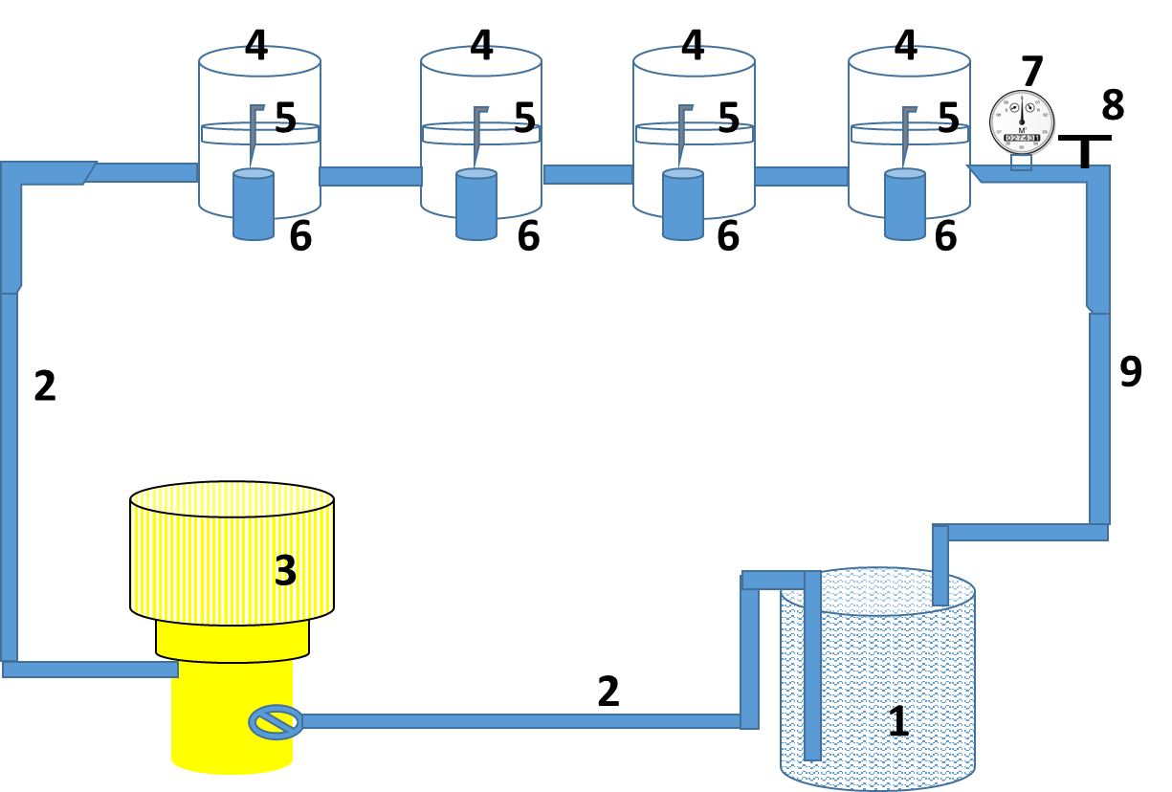

Supplementary Fig. 1 Schematic Diagram of cross flow filtration kit. 1. Feed Tank, 2. Feed tube, 3. Feed pressure Pump, 4. Stainless steel cell for membrane fixing, 5.Porous disk, 6. Permeate collector, 7. Pressure gauge, 8.Pressure valve, and 9.Tube for rejected stream.

