Small Hydro Power Dam site suitability modelling in Upper Benue River Watershed, Nigeria
Caleb Odiji, Matthew Adepoju, Idris Ibrahim, Oluwatola Adedeji, Ihenacho Nnaemeka, Olaide Aderoju
Department of Strategic Space Application, National Space Research and Development Agency, Airport Road, P.M.B. 437, Abuja, Nigeria

Supplementary Material
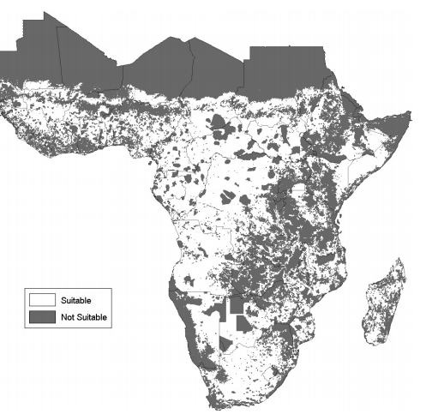

Supplementary Figure 1. small hydro land suitability map of Sub-Saharan Africa. The map represents the historical data of surveyed potential dam site. The Upper Benue Watershed was clipped off the map and used to validate result of the prediction (Sources; Korkovelos et al., 2018)

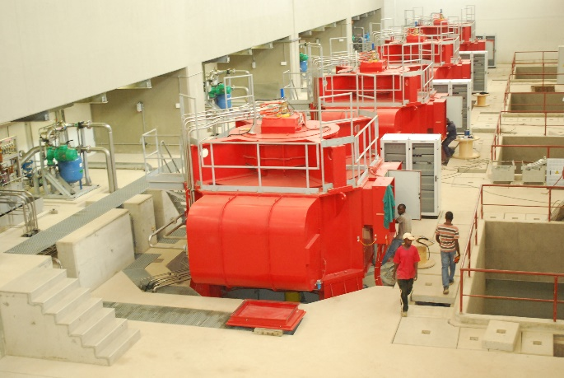

Supplementary Figure S2: inside the kashimbila multi-purpose dam turbines
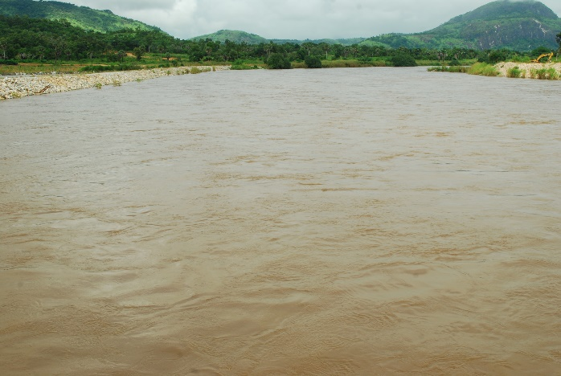

Supplementary Figure S3: one section of the sampled rivers in the watershed

References

