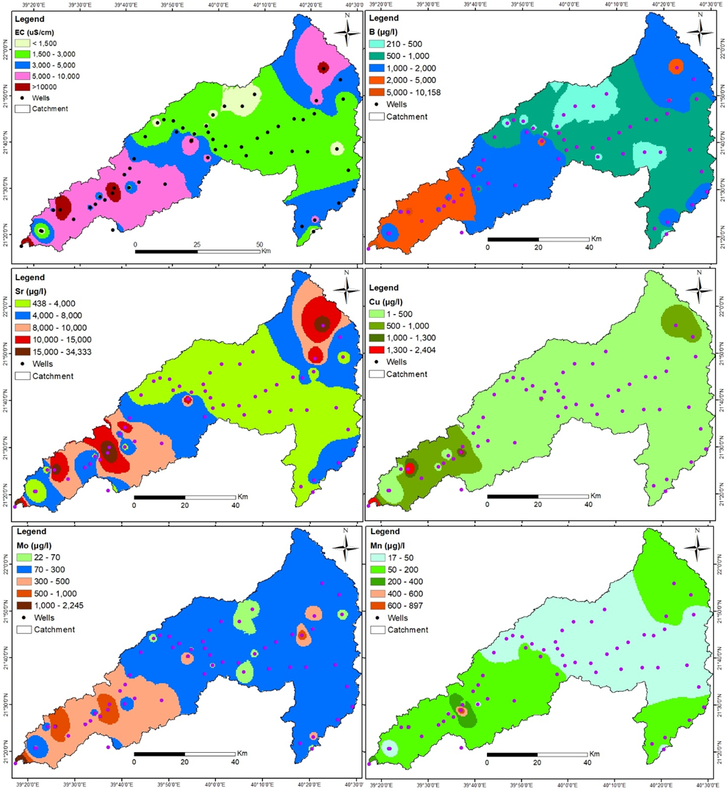
Supplementary Figures

Figure SF1. Spatial distribution of EC, B, Sr, Cu, Mo and Mn in this aquifer.

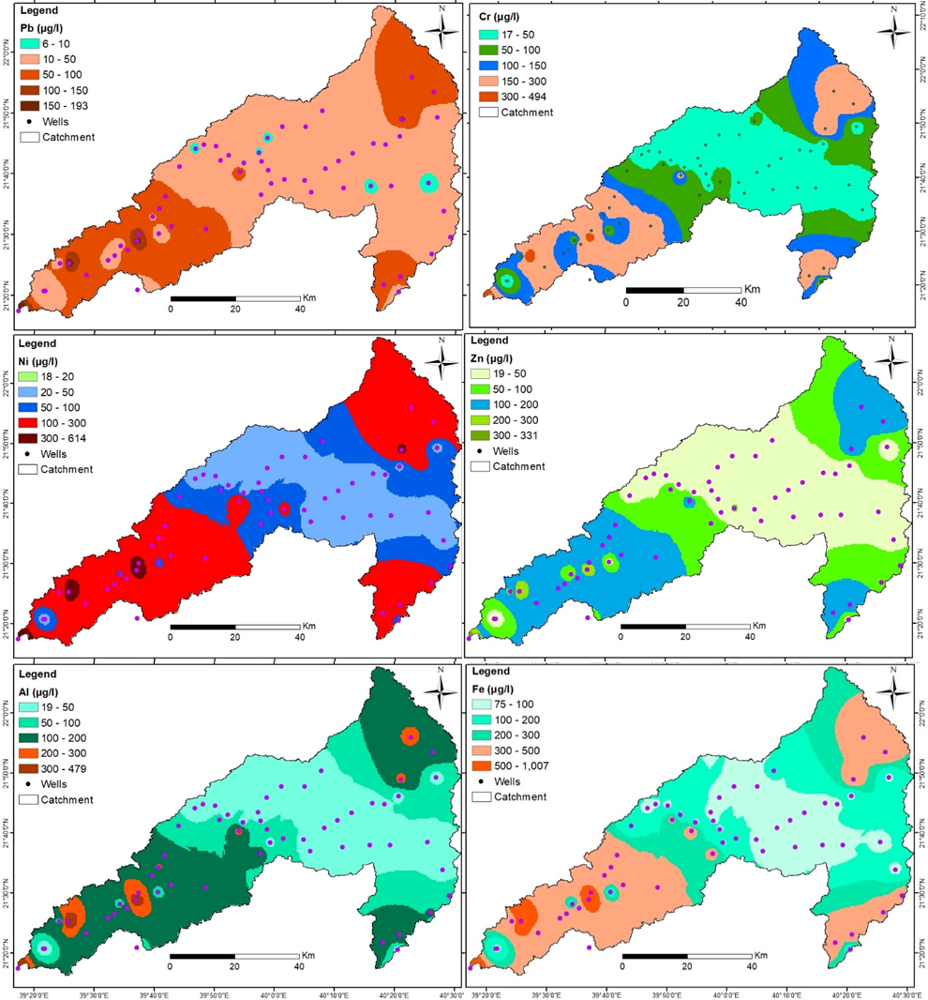

Figure SF2. Spatial distribution of Pb, Cr, Ni, Zn, Al and Fe in the aquifer.

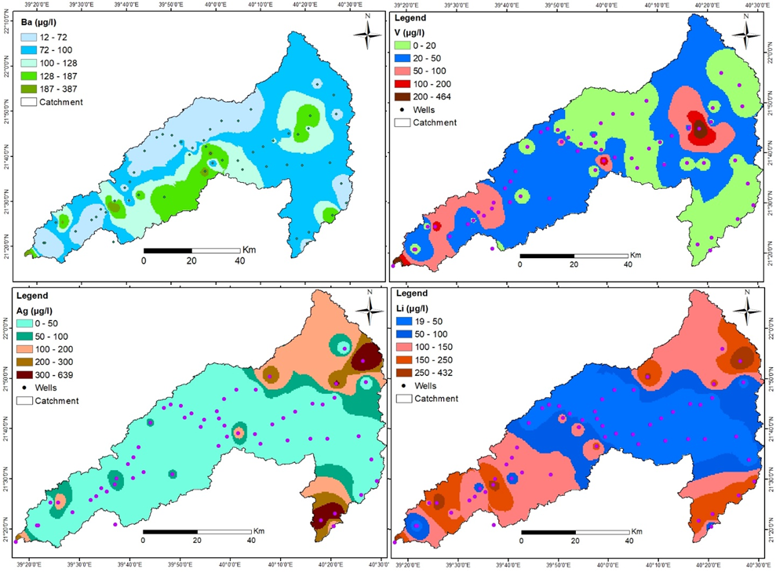

Figure SF3. Spatial distribution of Ba, V, Ag and Li in this aquifer.

