Water disinfection using durable ceramic filter coated with silver nanoparticles synthesized using actinomycetes

Supplementary data

Table S1. Comparison between the antibacterial efficiency of pristine and AgNPs-decorated ceramic filter
Testing water | E. coli MTCC 739 |  | P. aeruginosa MTCC 2453 |  | S. aureus MTCC 96 |  | B. subtilis MTCC 736
Testing water | CFU/100ml | Efficiency (%) | CFU/100ml | Efficiency (%) | CFU/100ml | Efficiency (%) | CFU/100ml | Efficiency (%)
Spiked water before filtration | 1.1 x 10⁶ | - | 1.3 x 10⁶ | - | 5 x 10⁵ | - | 3.8 x 10⁵ | -
Filtered by a modified filter | 0 | 100 | 0 | 100 | 0 | 100 | 0 | 100
Filtered by pristine filter | 5 x 10³ | 99.5 | 7 x 10³ | 99.4 | 4 x 10³ | 99.2 | 3 x 10³ | 99.2

Table S2. The concentrations of the dissolved Ag every day in the outlet
Day | Concentration of the Ag | Day | Concentration of the Ag
1 | 31.2 | 31 | 28.2
2 | 32.8 | 32 | 35.1
3 | 30.1 | 33 | 32.5
4 | 32.4 | 34 | 27.6
5 | 38.6 | 35 | 24.8
6 | 35.3 | 36 | 30.2
7 | 32.9 | 37 | 29.5
8 | 35.4 | 38 | 32.7
9 | 38.4 | 39 | 35.7
10 | 37.6 | 40 | 34.5
11 | 40.6 | 41 | 30.2
12 | 37.8 | 42 | 37.6
13 | 32.3 | 43 | 32.8
14 | 30.7 | 44 | 30.9
15 | 35.6 | 45 | 36.3
16 | 33.5 | 46 | 25.6
17 | 34.6 | 47 | 29.2
18 | 35.7 | 48 | 38.4
19 | 29.8 | 49 | 33.2
20 | 32.1 | 50 | 30.8
21 | 33.3 | 51 | 29.3
22 | 39.4 | 52 | 33.3
23 | 36.5 | 53 | 35.6
24 | 30.2 | 54 | 34.9
25 | 42.8 | 55 | 28.5
26 | 29.6 | 56 | 37.5
27 | 35.4 | 57 | 30.8
28 | 34.1 | 58 | 30.1
29 | 32.3 | 59 | 39.6
30 | 41.2 | 60 | 33.2
Day | Concentration of the Ag | Day | Concentration of the Ag
61 | 35.2 | 76 | 33.2
62 | 30.4 | 77 | 30.5
63 | 35.6 | 78 | 39.5
64 | 35.2 | 79 | 37.5
65 | 30.2 | 80 | 38.1
66 | 28.9 | 81 | 39.5
67 | 33.5 | 82 | 38.5
68 | 35.6 | 83 | 35.6
69 | 36.4 | 84 | 31.2
70 | 25.6 | 85 | 36.5
71 | 30.2 | 86 | 37.1
72 | 36.4 | 87 | 40.5
73 | 29.8 | 88 | 33.9
74 | 39.5 | 89 | 30.8
75 | 32.4 | 90 | 36.5

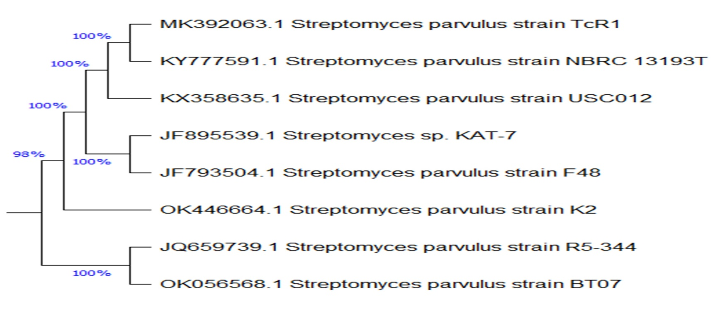
Fig S1. Phylogenetic dendrogram based on 16S rRNA gene sequence analysis showing the phylogenetic position of Streptomyces parvulus strain k2 OK446664.1

Fig. S2. UV-Vis spectrum of biosynthesized AgNPs. The inset indicates the color difference of AgNO₃ (a), cell free supernatant (b), and AgNPs (c).

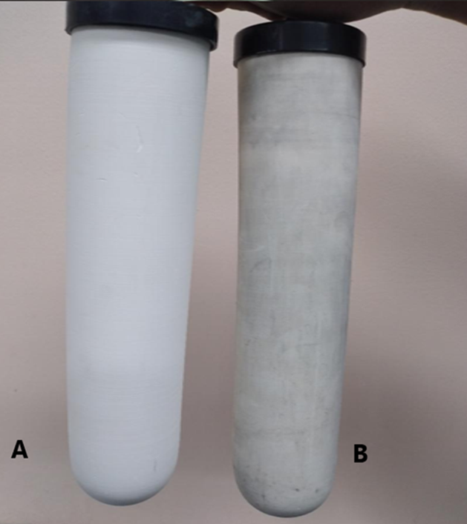
Fig. S3. Digital photo of blank (a) and modified ceramic filter (b).

