Elimination of Cd²⁺ from Synthetic and Real Polluted Water by Optimized Acacia nilotica Biographene
Nourhan El-Maghrabi^{1,2*}, Manal Fawzy^{1,2,3} , and Alaa El Din Mahmoud^{1,2}
¹ Environmental Sciences Department, Faculty of Science, Alexandria University, 21511 Alexandria, Egypt.
² Green Technology Group, Faculty of Science, Alexandria University, 21511 Alexandria, Egypt
³ National Biotechnology Network of Expertise (NBNE), Academy of Scientific Research and Technology (ASRT), Egypt
*Corresponding author: nourhan.elmaghrabi@alexu.edu.eg orcid: 0000-0001-6097-3208

Supplemental Information
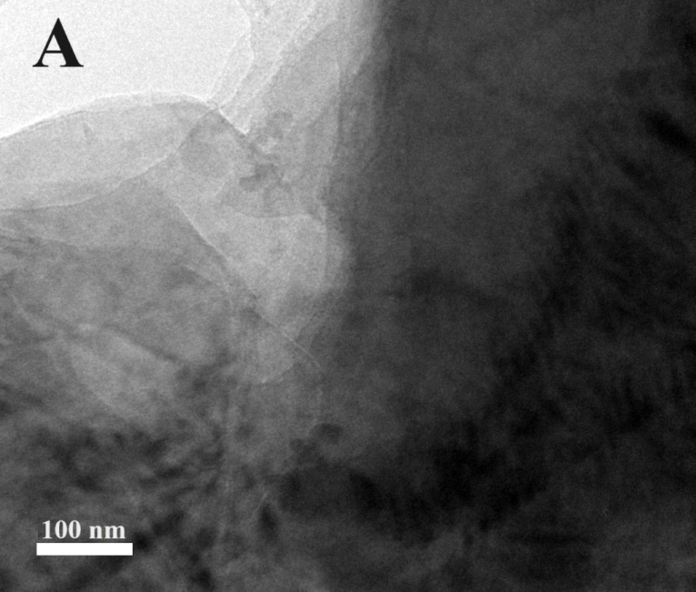
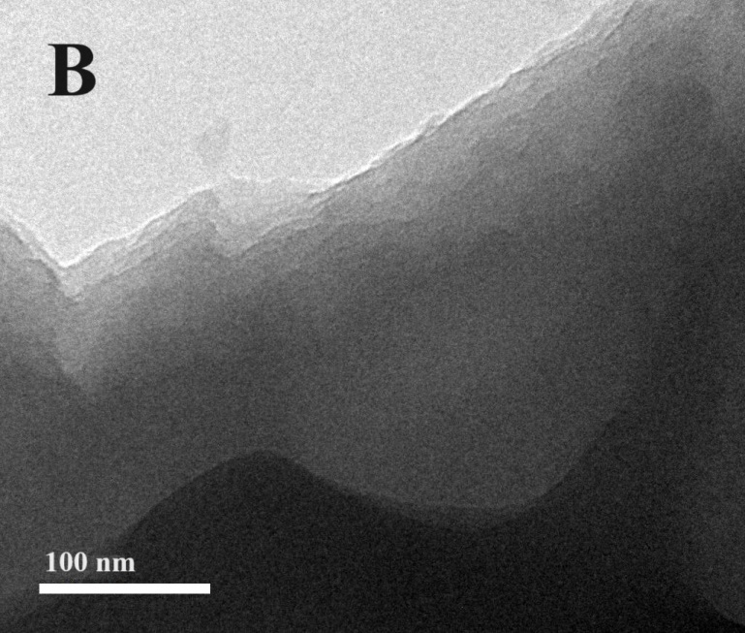
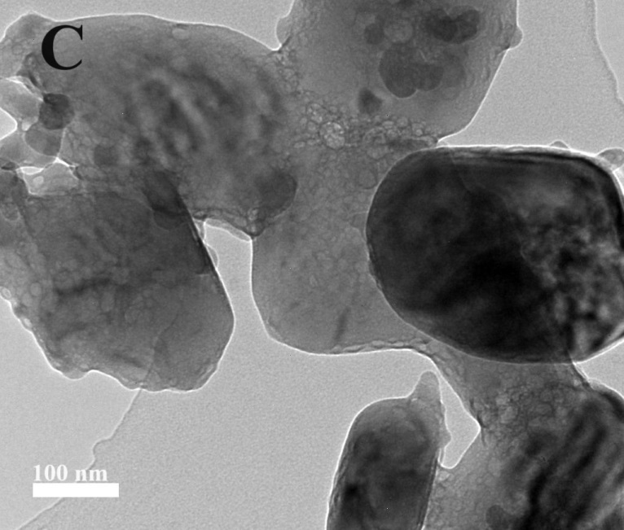
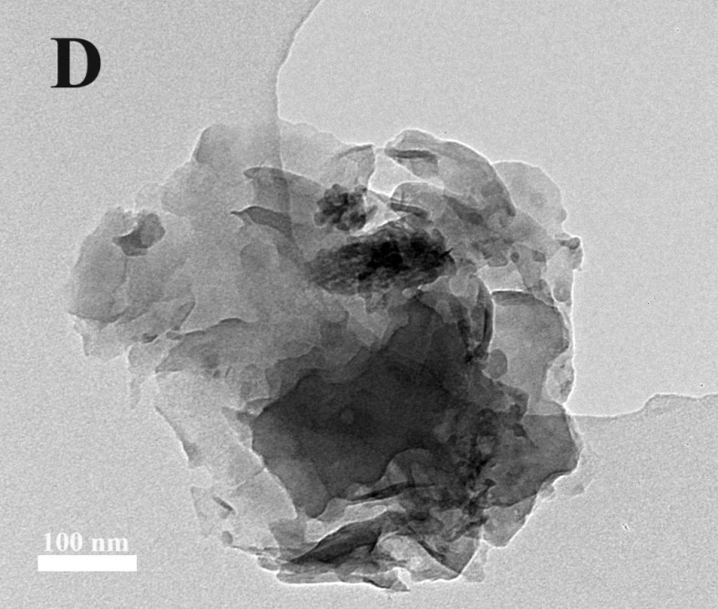
Fig. S1 TEM images of graphene synthesized at 250$℃$ for 1h (A), at 250$℃$ for 3h (B), at 450$℃$ for 1h (C), and at 450$℃$ for 3h (D).

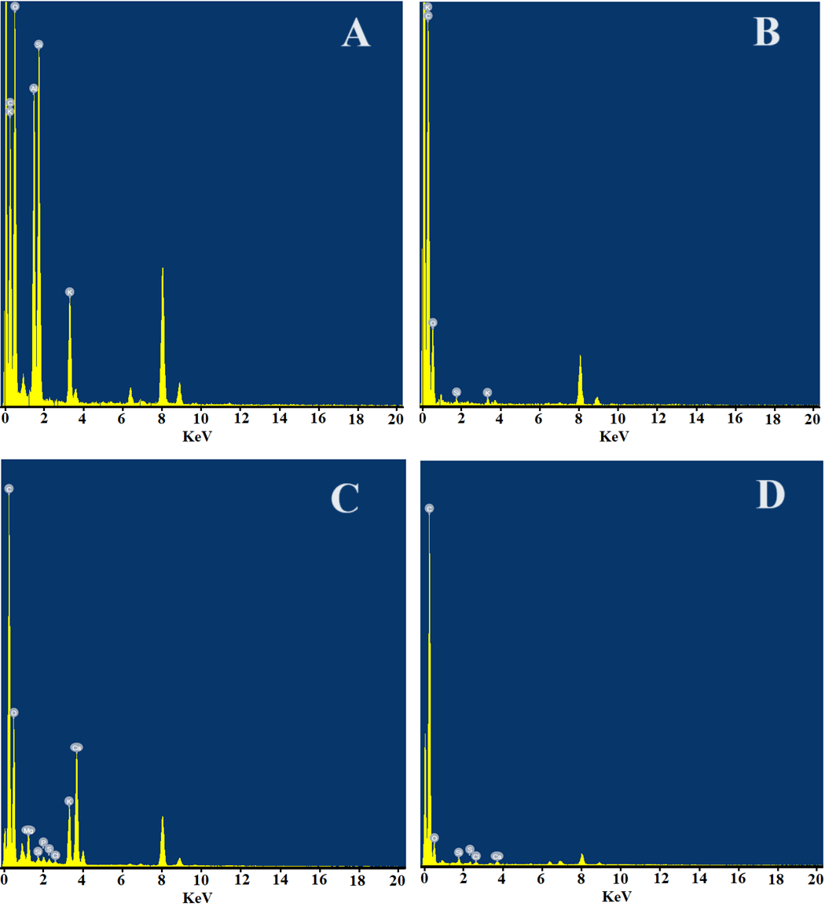
Fig. S2. Elemental analysis of the fabricated graphene at 250$℃$ for 1h (A), at 250$℃$ for 3h (B), at 450$℃$ for 1h (C), and at 450$℃$ for 3h (D).

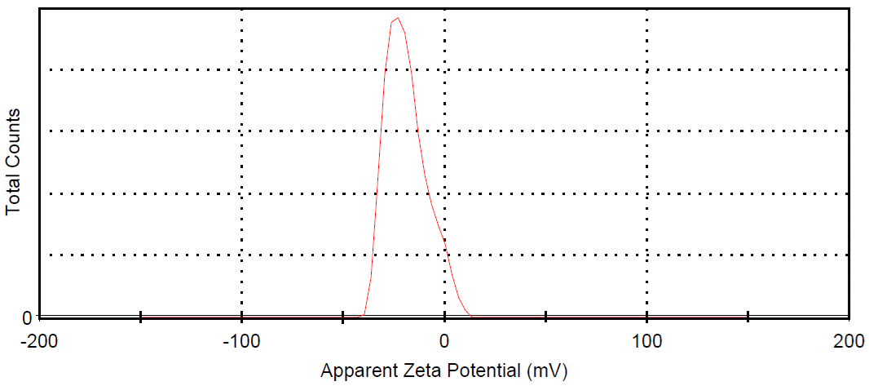
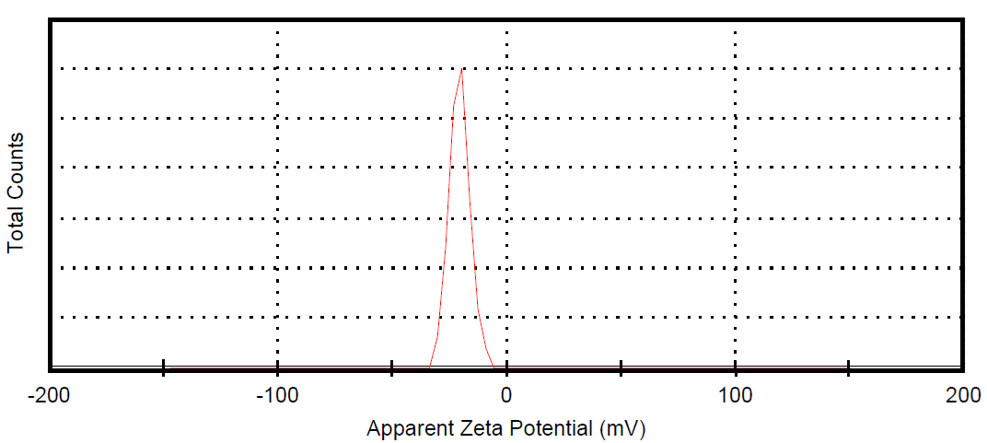
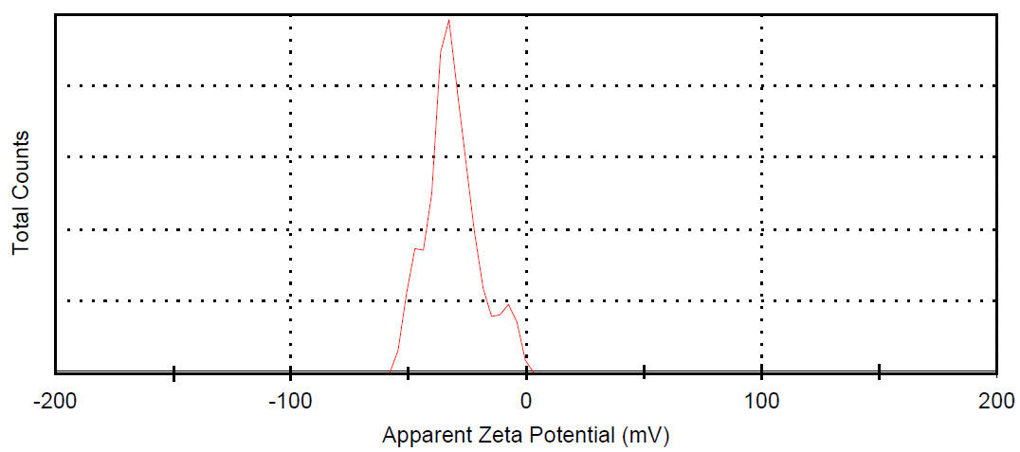
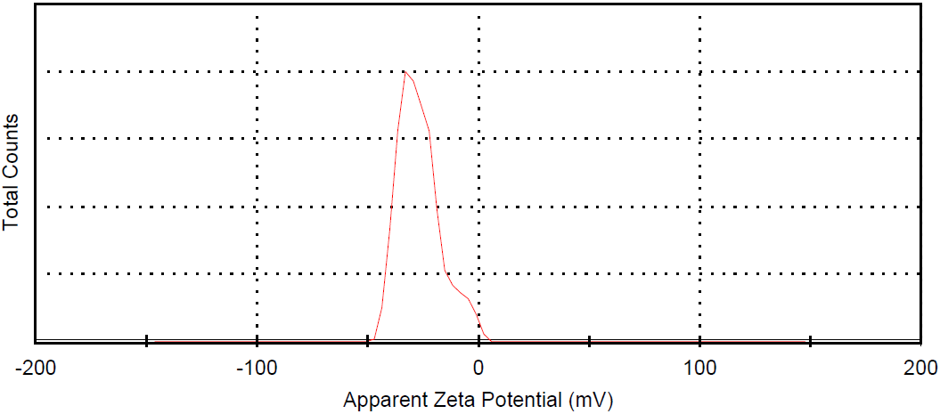
D
C
B
A
Fig. S3. Zeta potential of the prepared graphene at 250$℃$ for 1h (A), at 250$℃$ for 3h (B), at 450$℃$ for 1h (C), and at 450$℃$ for 3h (D).
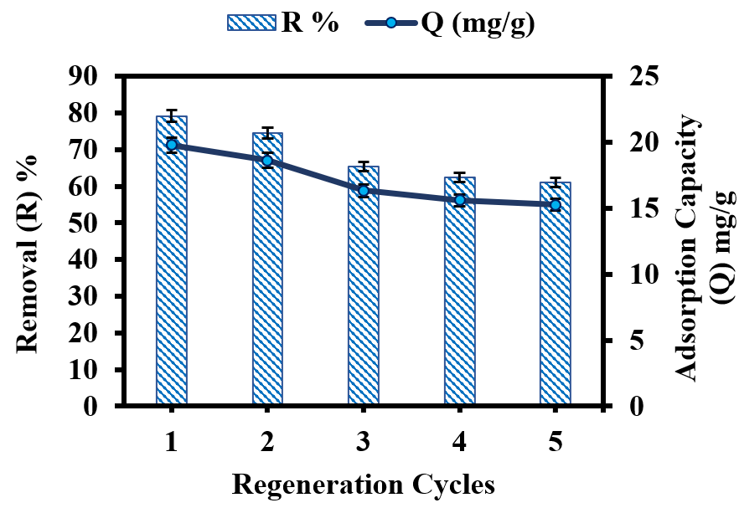
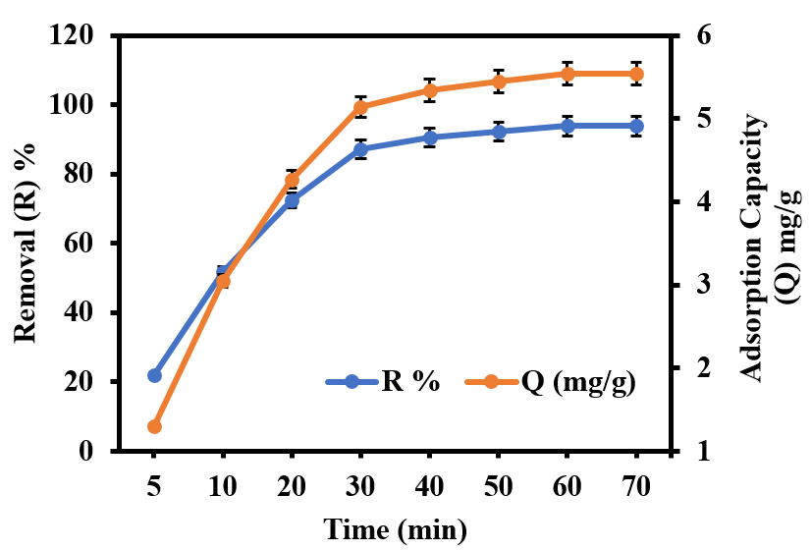
B
A
B

Fig. S4. The reusability of biographene (A), the removal of cadmium from real wastewater (B).

Table S1
The elemental analysis of the synthesized graphene at 250$℃$ for 1 hour (G250-1h), 250$℃$ for 3 hours (G250-3h), 450$℃$ for 1 hour (G450-1h), and 450$℃$ for 3 hours (G450-3h) in atomic%
The element | G250-1h | G250-3h | G450-1h | G450-3h
C | 53.64 | 93.87 | 81.76 | 95.38
O | 27.57 | 5.91 | 12.32 | 4.00
Al | 7.83 | - | - | -
Si | 8.69 | 0.10 | 0.15 | 0.31
K | 2.26 | 0.12 | 1.53 | -
Mg | - | - | 0.97 | -
P | - | - | 0.17 | -
S | - | - | 0.13 | 0.10
Cl | - | - | 0.06 | 0.11
Ca | - | - | 2.90 | 0.10

Table S2
Kinetic and isotherm parameters of G450-3h
Kinetic Parameters
 | Pseudo-first-order |  |  |  | Pseudo-second-order |  |  |  | Elovich
q_{e, exp}ª  (mg g⁻¹) | K₁  (min⁻¹) | q_{e, cal} (mg g⁻¹) | R² |  | K₂  (g mg⁻¹ min⁻¹) | q_{e, cal}  (mg g⁻¹) | R² |  | β  (g mg⁻¹) | α  (g mg⁻¹ min⁻¹) | R²
21.3 | 0.1 | 0.9 | 0.95 |  | 0.003 | 24.33 | 0.99 |  | 0.2 | 1.2 | 0.96
a = experimental data at initial Cd(II)concentration of 15 mg L⁻¹
Isotherm Parameters
 | Langmuir |  |  |  |  | Freundlich |  |  |  | Temkin
q_{m}*  (mg g⁻¹) | K_{L}  (L mg⁻¹) | R_{L} | R² |  | K_{F}  (L mg⁻¹) |  | 1/n | R² |  | B_{T}  (J mol⁻¹) | K_{T}  (L mg⁻¹) | R²
122.3 | 9.6 | 0.02 | 0.99 |  | 3.34 |  | 0.5 | 0.96 |  | 16.3 | 1.18 | 0.95
* q_{m} is the calculated maximum adsorption capacity by Langmuir model.
Table S3
Physicochemical parameters of the real wastewater sample
Parameter | Concentration
pH | 6
Cadmium (mg/L) | 1.18
TDS (ppm) | 345
BOD (mg/L) | 127
COD (mg/L) | 54
EC (µS cm⁻¹) | 677

