Supplementary Figure

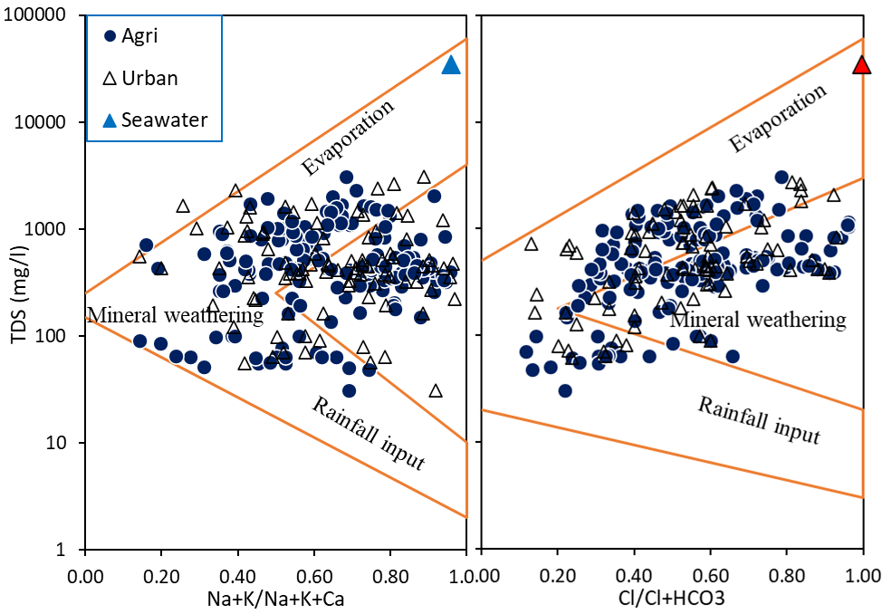

Figure SF1. Gibbs plots explain major geochemical processes in this aquifer.

