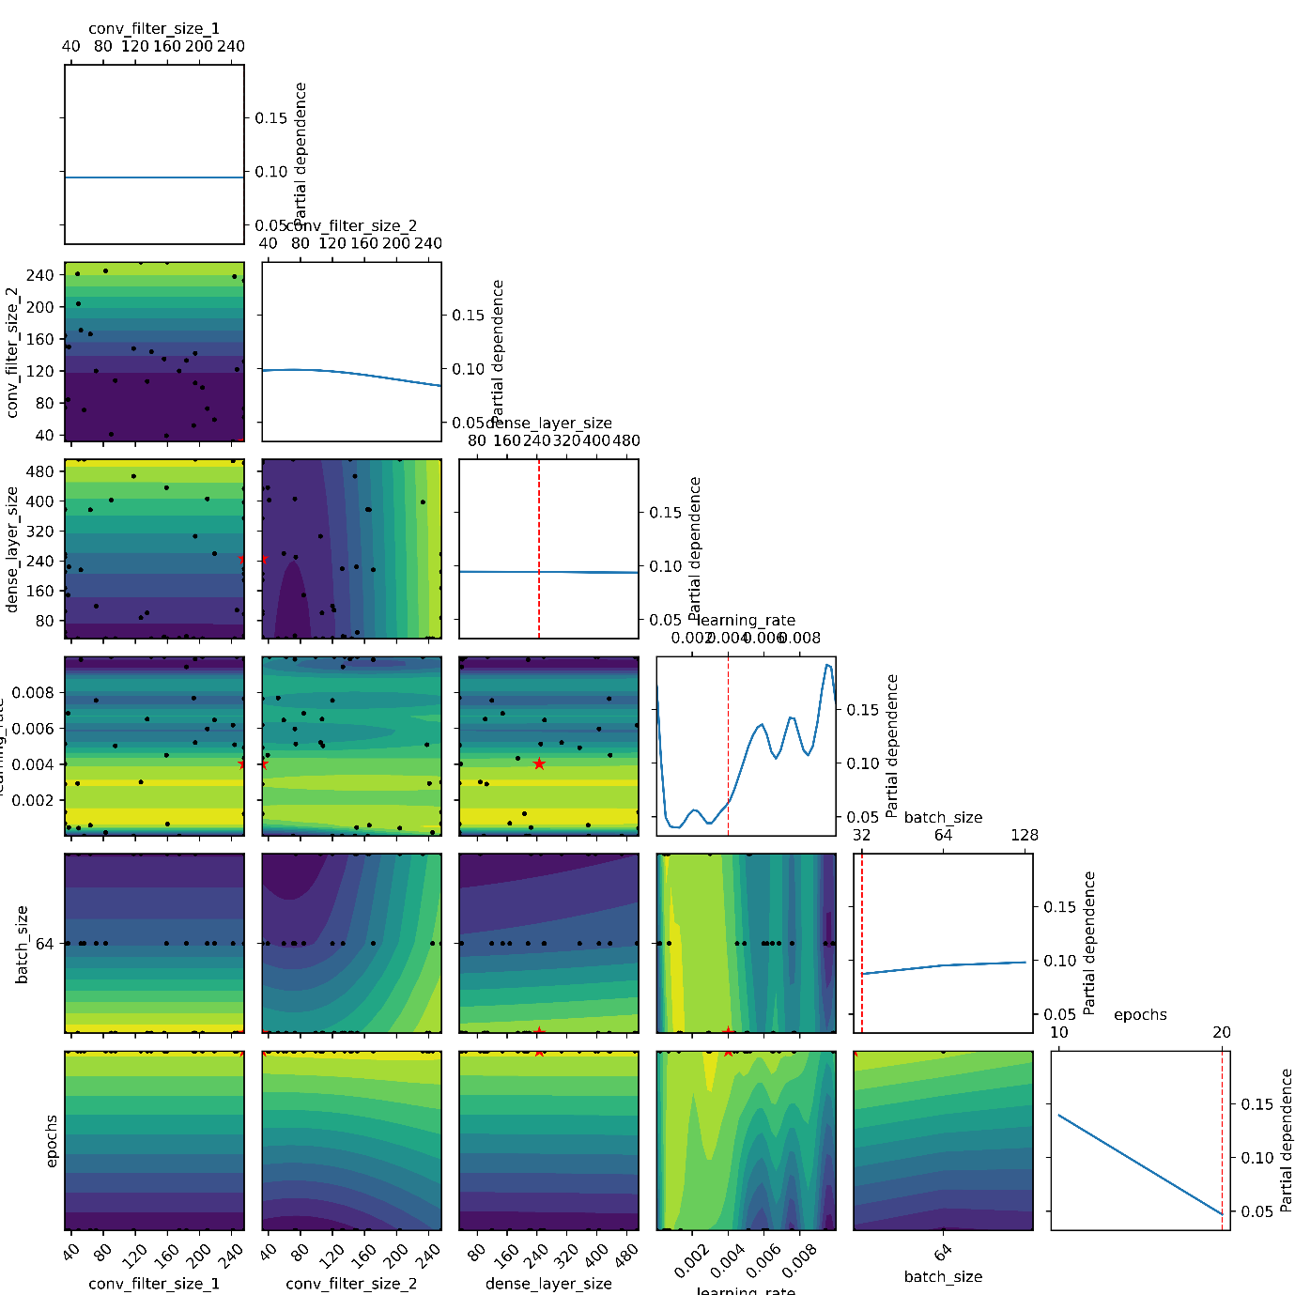
Supplementary Figure 1 Contour and marginal distribution plots from Bayesian optimization showing the relationship between hyper-parameter values and model performance for the SAR
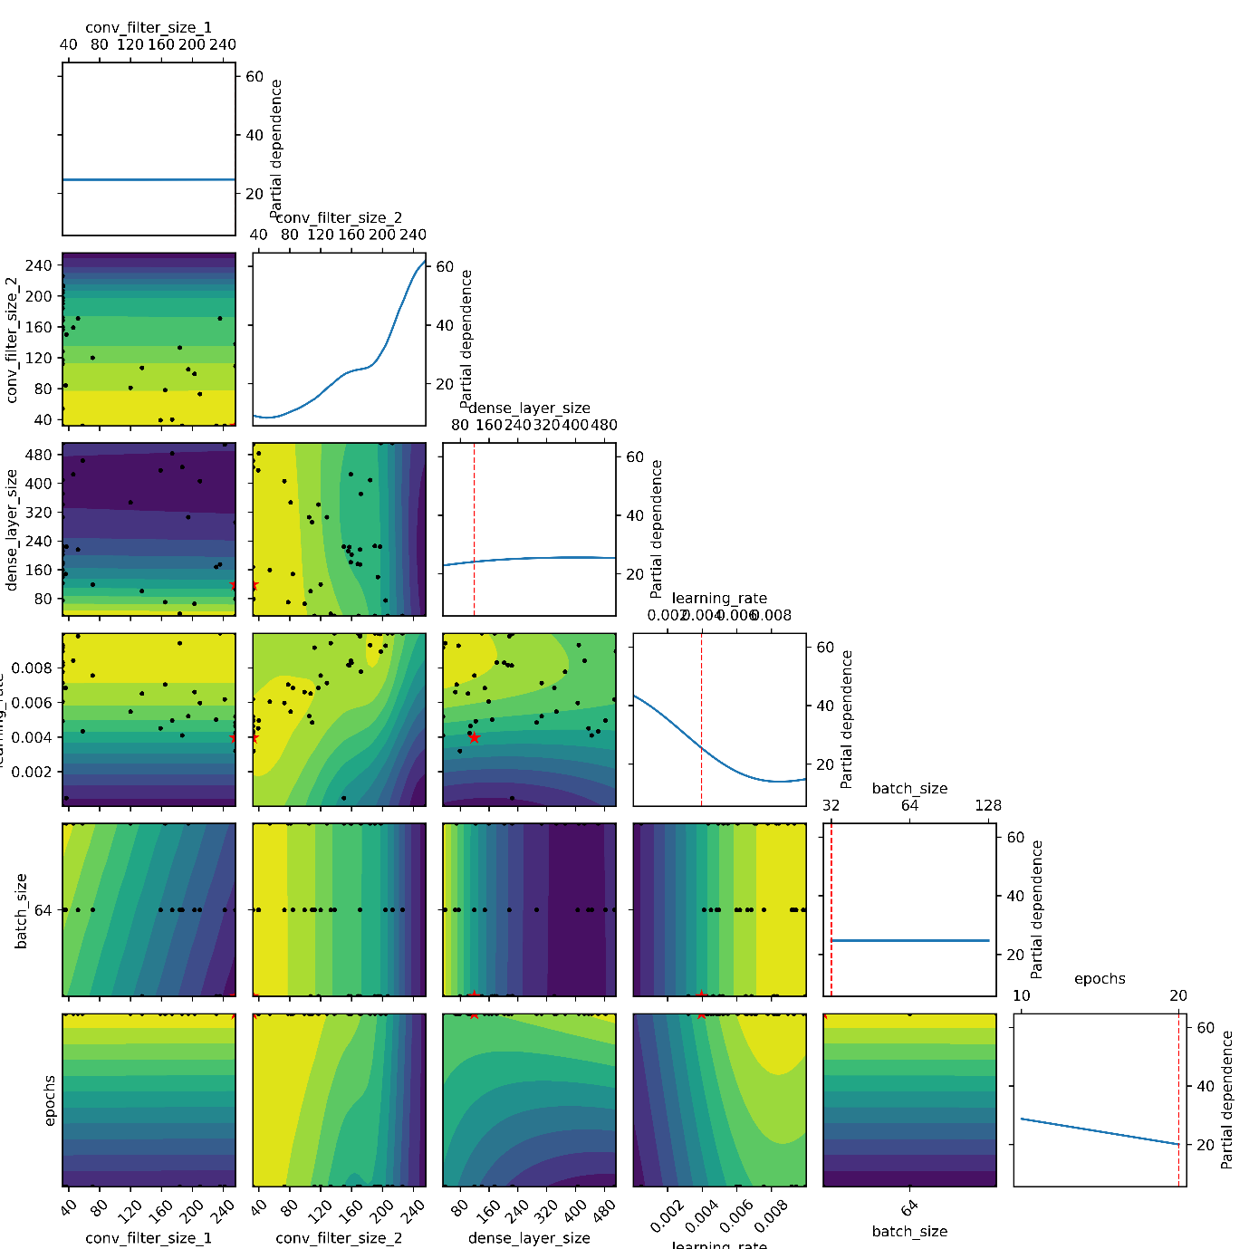
Supplementary Figure 2 Contour and marginal distribution plots from Bayesian optimization showing the relationship between hyper-parameter values and model performance for the NA%
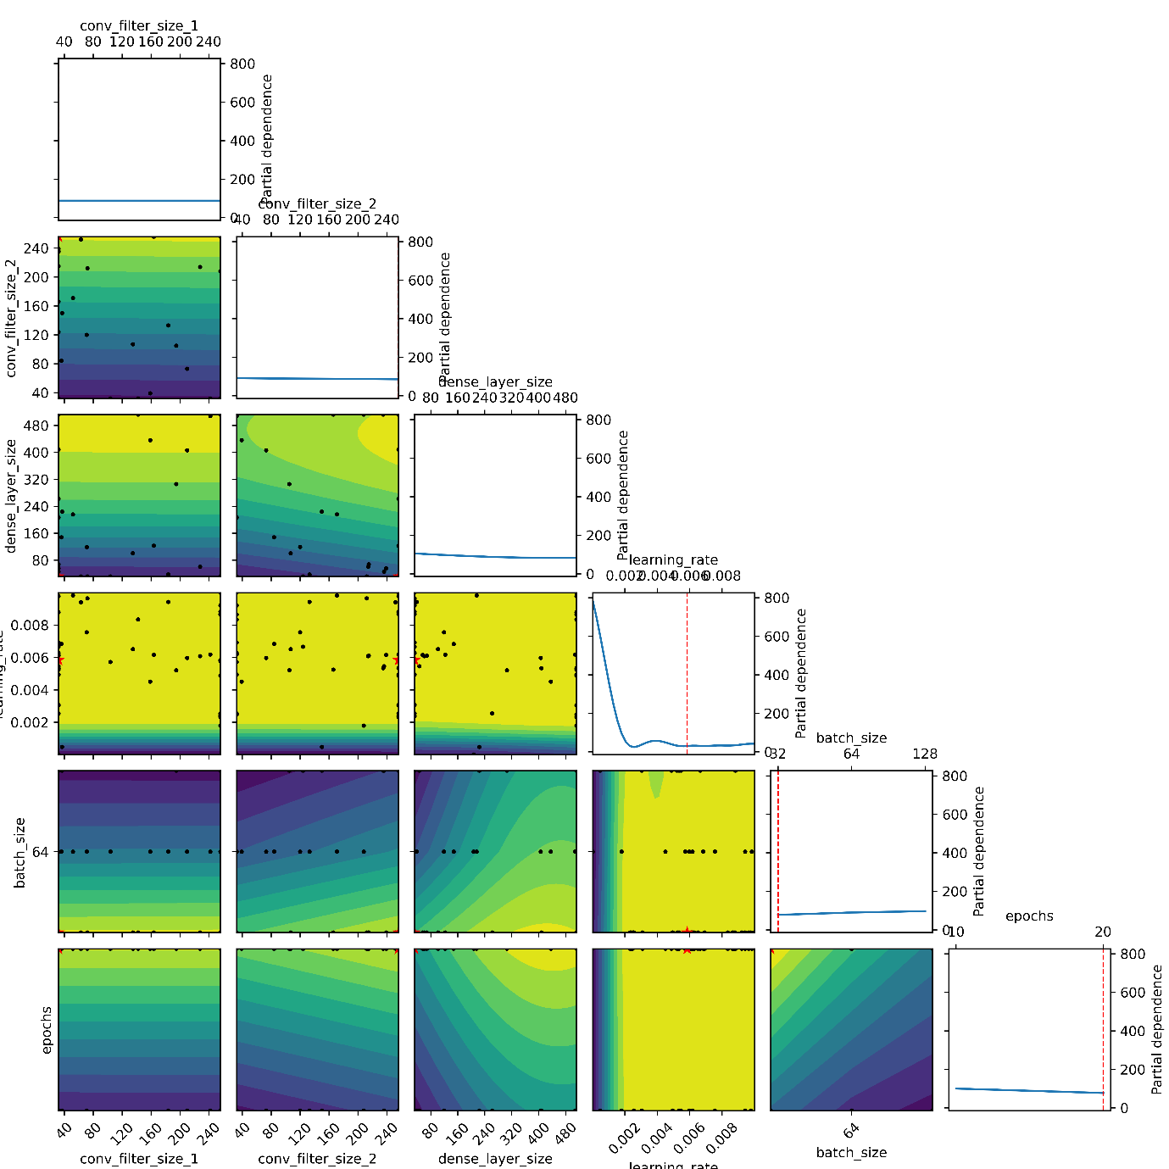
Supplementary Figure 3 Contour and marginal distribution plots from Bayesian optimization showing the relationship between hyper-parameter values and model performance for the PI
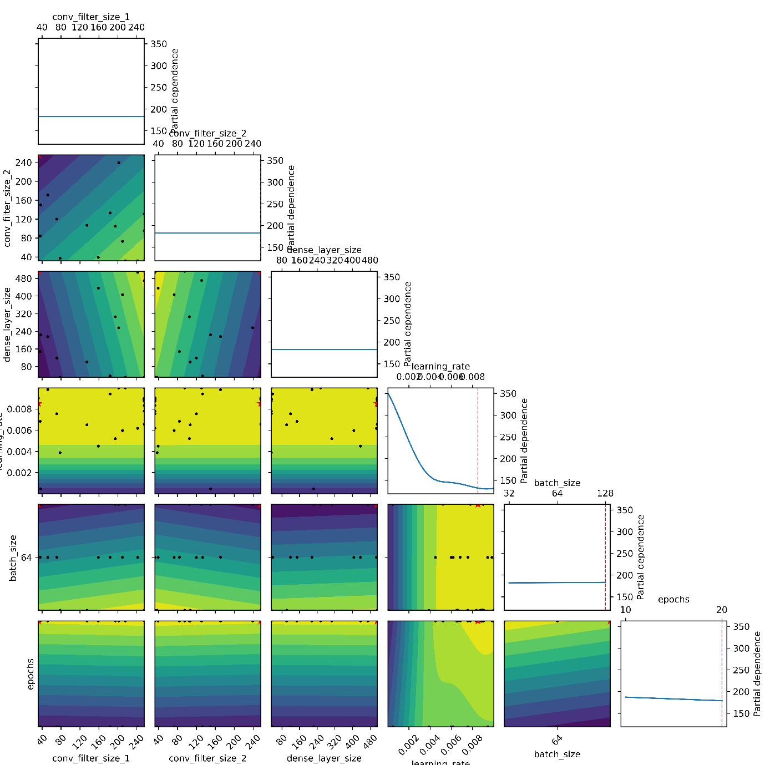
Supplementary Figure 4 Contour and marginal distribution plots from Bayesian optimization showing the relationship between hyper-parameter values and model performance for the MH
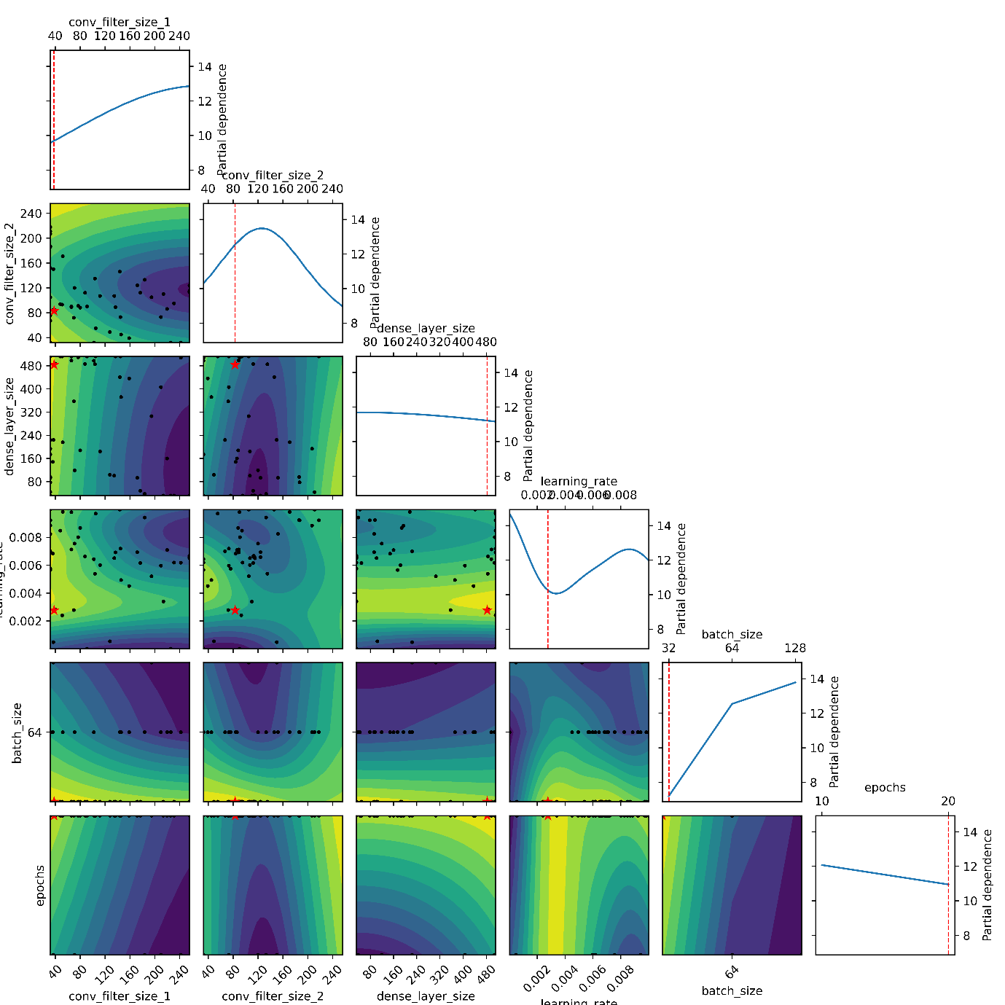
Supplementary Figure 5 Contour and marginal distribution plots from Bayesian optimization showing the relationship between hyper-parameter values and model performance for the RSB
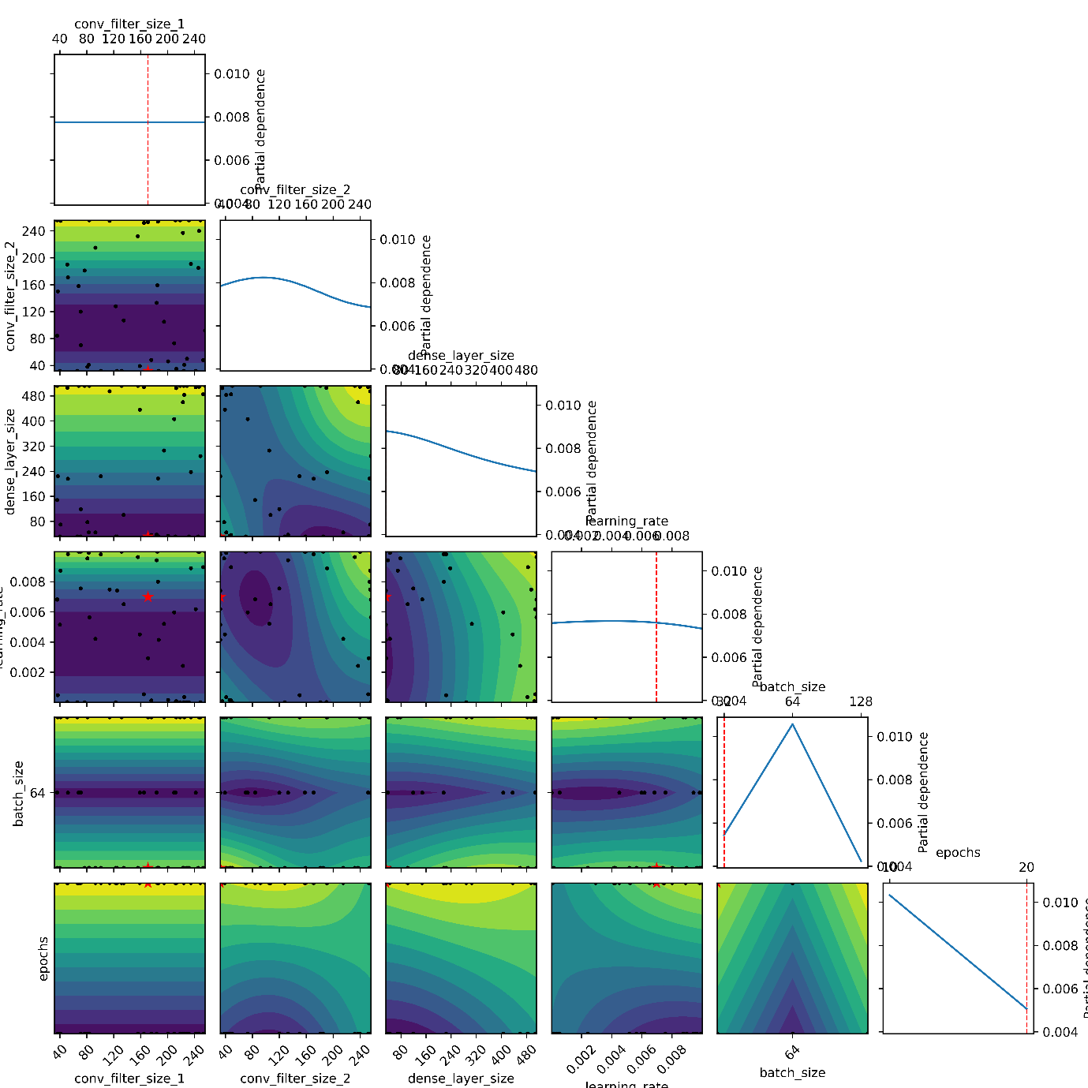
Supplementary Figure 6 Contour and marginal distribution plots from Bayesian optimization showing the relationship between hyper-parameter values and model performance for the KR
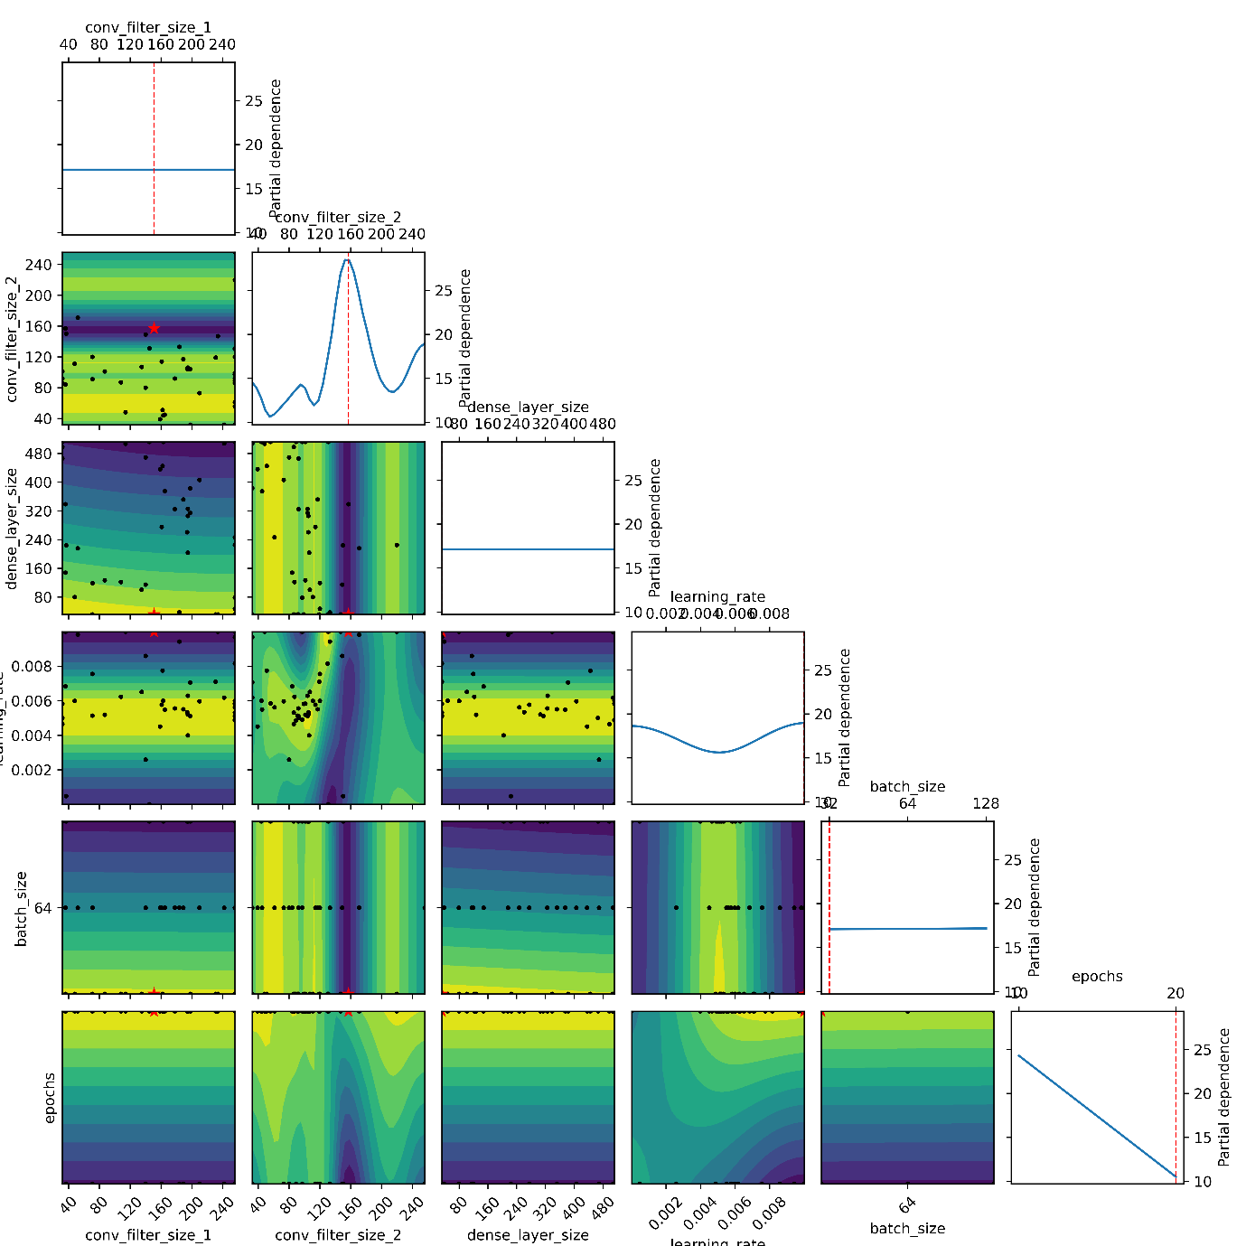
Supplementary Figure 7 Contour and marginal distribution plots from Bayesian optimization showing the relationship between hyper-parameter values and model performance for the RSC

