Supplementary information

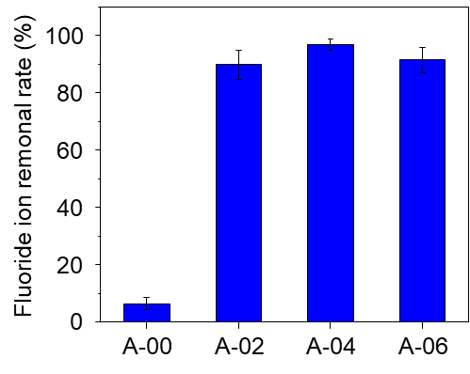
Fig. S1 Fluoride ion removal rate of A-00, A-02, A-04, and A-06 (initial concentration (C_{init}) = 20 ppm, adsorbent dose = 3 mg/ml, adsorption time = overnight).

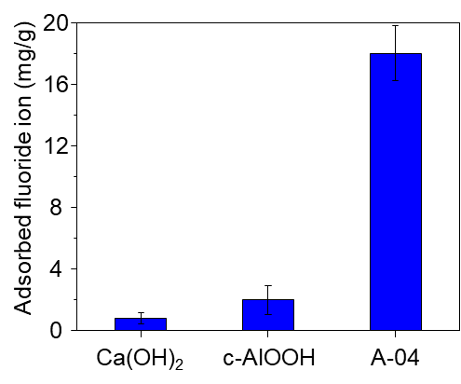
Fig. S2 Comparison of fluoride ion removal capacity between Ca(OH)₂, commercial AlOOH (c-AlOOH) and A-04 (C_{init} = 20 ppm, adsorbent dose = 0.4 mg/ml, adsorption time = 120 min).

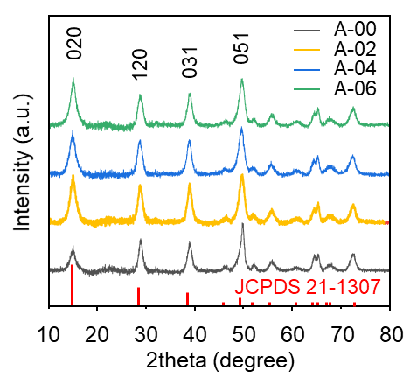
Fig. S3 Powder X-ray diffraction patterns of A-00, A-02, A-04, and A-06.

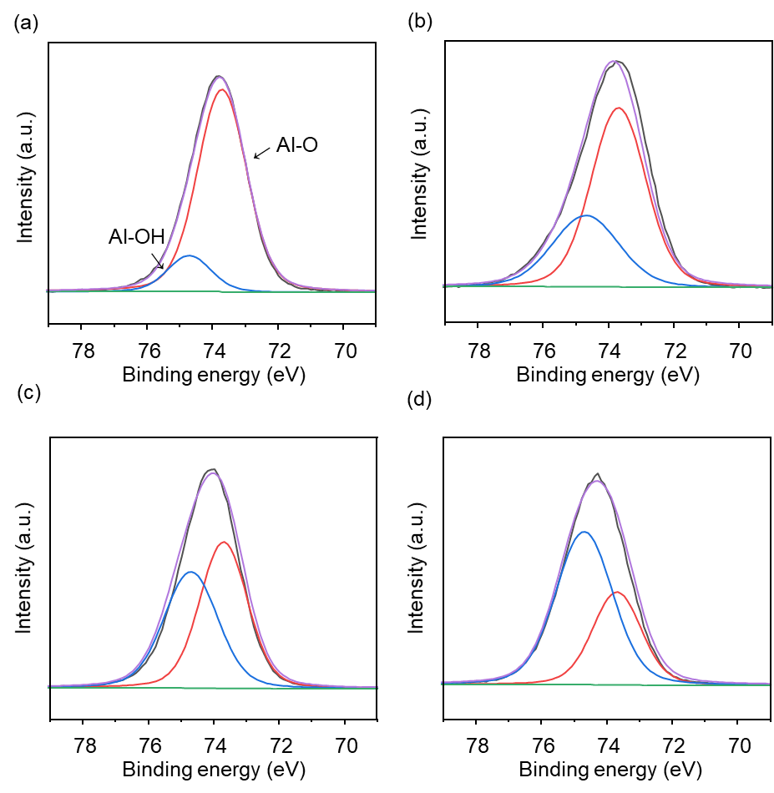
Fig. S4 Al 2p X-ray photoelectron spectroscopy (XPS) spectra of (a) A-00, (b) A-02, (c) A-04, and (d) A-06 (grey: experimental data, purple: fitted curve, green: background, blue: Al-OH, and red: Al-O).
Table S1 Al 2p XPS peak parameters for A-00, A-02, A-04, and A-06 adsorbents.
 | Binding energy (eV) | A-00 | A-02 | A-04 | A-06
Al-OH | 74.6 | 13.71 % | 32.67 % | 47.23 % | 66.00 %
Al-O | 74.1 | 86.29 % | 67.34 % | 52.77 % | 34.00 %
Area ratio of Al-OH to Al-O | - | 0.16 | 0.49 | 0.89 | 1.94

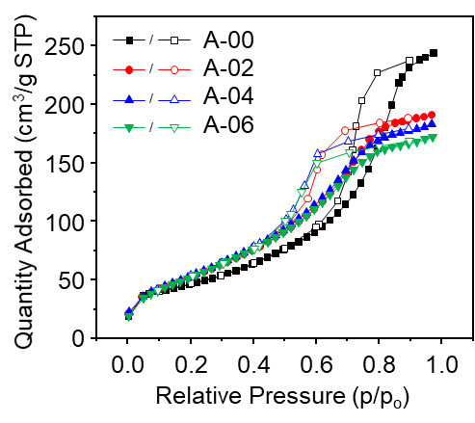
Fig. S5 N₂ isotherm of A-00, A-02, A-04, and A-06 at 77 K.

Table S2 Brunauer-Emmett-Teller (BET) surface area of A-00, A-02, A-04, and A-06 (calculated from N₂ isotherm measurement at 77 K).
AlOOH powders | BET surface area (m²/g)
A-00 | 166
A-02 | 203
A-04 | 207
A-06 | 204

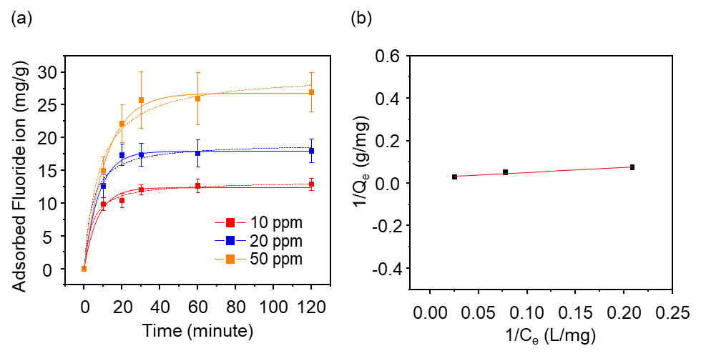

Fig. S6 (a) The fluoride ion removal adsorption capacity of A-04 as a function of initial fluoride ion concentrations (solid line = pseudo-first order fitting, dashed line = pseudo-second order fitting, adsorbent dose = 0.4 mg/ml) and (b) its Langmuir fit (red solid line).

Table S3 Pseudo-first order, pseudo-second order kinetics and Langmuir isotherm model parameters for fluoride ion adsorption on A-04 with different initial fluoride ion concentrations.
Experimental values
parameters | values
C_{init} | 10 ppm | 20 ppm | 50 ppm
q_{e} (mg/g) | 13.00 | 17.75 | 27.00
Pseudo-first order
parameters | values
C_{init} | 10 ppm | 20 ppm | 50 ppm
q_{e} (mg/g) | 12.40 | 17.94 | 26.84
k₁ (min⁻¹) | 0.14 | 0.13 | 0.09
R² | 0.98 | 0.99 | 0.99
Pseudo-second order
parameters | values
C_{init} | 10 ppm | 20 ppm | 50 ppm
q_{e} (mg/g) | 13.33 | 19.17 | 29.82
k₂ (g/mg*min) | 0.02 | 0.13 | 0.01
R² | 0.99 | 0.98 | 0.98
Langmuir isotherm
q_{max} (mg/ml) |  | 34.17
K_{L} (L/mg) |  | 0.13
R² |  | 0.94

Table S4 Comparison of maximum adsorption capacities (q_{max}) of various Al-based powder-type adsorbents and paper-type adsorbents for fluoride ions.

Adsorbent type | Name | q_{max} (mg/g) | References
Powder | Activated alumina | 16.34 | (Ku and Chiou 2002)
Powder | Amorphous AlOOH | 41.9 | (Gai et al. 2021)
Powder | Bayerite/boehmite | 56.8 | (Jia et al. 2015)
Powder | Al₂O₃ nanoparticles | 9.73 | (Tangsir et al. 2016)
Powder | Nano-AlOOH | 3.259 | (Wang et al. 2009)
Powder | Hydrous-manganese oxide-coated alumina | 7.09 | (Maliyekkal et al. 2006)
Powder | A-04 | 34.17 | This study
Paper | CBM/UF/MMM | 5.00 | (Chatterjee et al. 2020)
Paper | ABN/TPU-NFM | 1.90 | (Suriyaraj et al. 2015)
Paper | MFS-AA-PVDF | 5.30 | (Meng et al. 2020)
Paper | PA-1.25 | 6.26 | This study

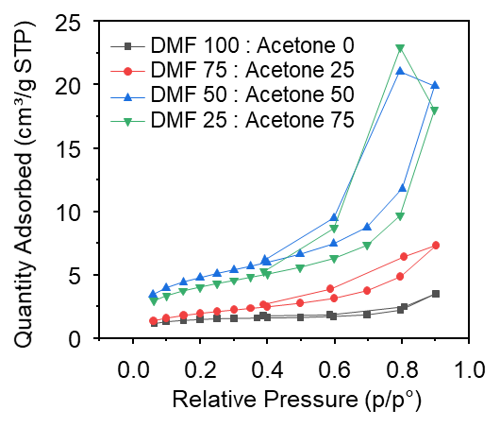
Fig. S7 N₂ isotherm of polyvinylidene fluoride (PVDF) film with the different volumetric ratio of N,N-dimethylformamide (DMF) and acetone at 77 K.

Table S5 BET surface area of PVDF film with the different volumetric ratio of DMF and acetone.
The composition of the PVDF solution | BET surface area (m²/g)
DMF 100 : Acetone 0 | 5
DMF 75 : Acetone 25 | 7
DMF 50 : Acetone 50 | 17
DMF 25 : Acetone 75 | 14

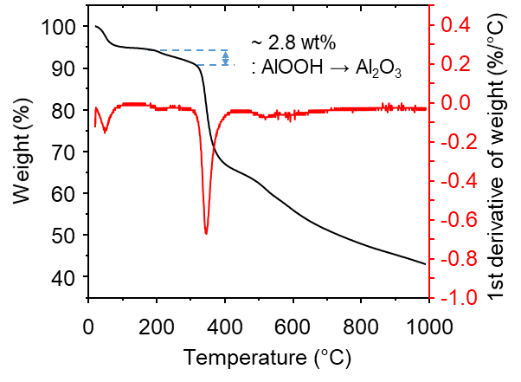
Fig. S8 Thermogravimetric analysis of PA-1.25 (a mass loss of approximately 2.8 wt% occurs as AlOOH changes to Al₂O₃ between 200 °C and 320 °C).

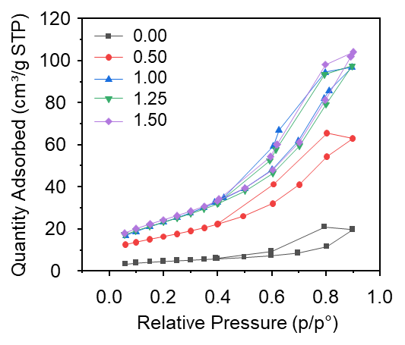
Fig. S9 N₂ isotherm of A-04-incorporated paper-type adsorbent with different mass ratio of A-04 to PVDF at 77 K.

Table S6 BET surface area of A-04-incorporated PVDF paper-type adsorbent with different mass ratio of A-04 to PVDF.
Mass ratio of A-04 to PVDF | BET surface area (m²/g)
0.00 | 17
0.50 | 60
1.00 | 86
1.25 | 88
1.50 | 90

Table S7 Pseudo-first order, pseudo-second order kinetics and Langmuir isotherm model parameters for fluoride ion adsorption on PA-1.25 with different initial fluoride ion concentrations.
Experimental values
parameters | values
C_{init} | 10 ppm |  | 20 ppm |  |  | 30 ppm |  | 40 ppm |  | 50 ppm
q_{e} (mg/g) | 2.17 |  | 3.80 |  |  | 4.90 |  | 4.67 |  | 5.42
Pseudo-first order
parameters | values
C_{init} | 10 ppm | 20 ppm |  |  | 30 ppm |  | 40 ppm |  | 50 ppm
q_{e} (mg/g) | 2.11 | 4.03 |  |  | 4.41 |  | 5.03 |  | 5.49
k₁ (min⁻¹) | 0.03 | 0.03 |  |  | 0.04 |  | 0.04 |  | 0.04
R² | 0.98 | 0.99 |  |  | 0.99 |  | 0.98 |  | 0.99
Pseudo-second order
parameters | values
C_{init} | 10 ppm | 20 ppm |  |  | 30 ppm |  | 40 ppm |  | 50 ppm
q_{e} (mg/g) | 2.37 | 4.55 |  |  | 4.90 |  | 5.51 |  | 6.04
k₂ (g/mg*min) | 0.01 | 0.01 |  |  | 0.01 |  | 0.01 |  | 0.01
R² | 0.98 | 0.97 |  |  | 0.99 |  | 0.99 |  | 0.99
Langmuir isotherm
q_{max} (mg/ml) |  |  |  | 6.26
K_{L} (L/mg) |  |  |  | 0.16
R² |  |  |  | 0.98

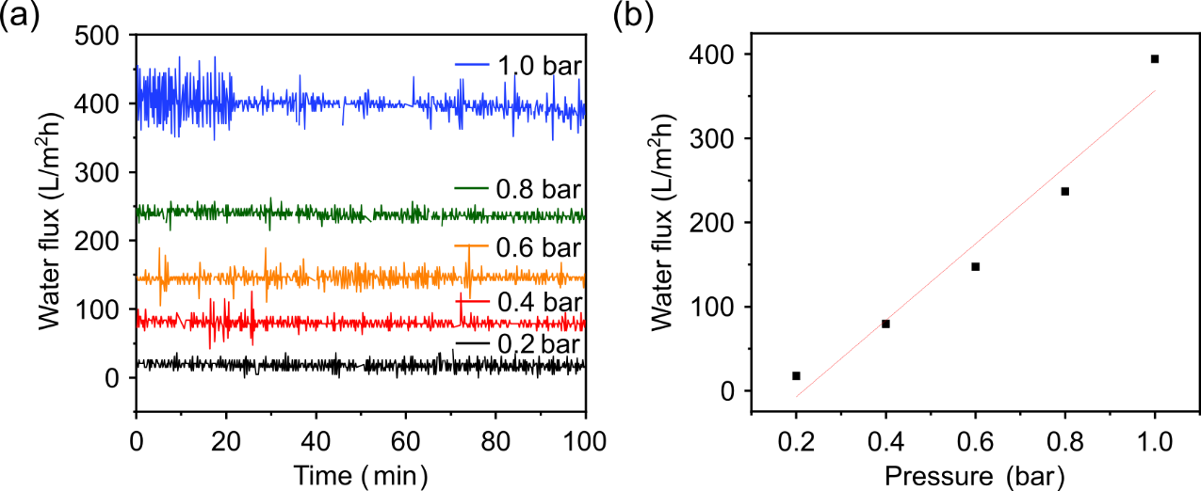
Fig. S10 (a) Water flux of PA-1.25 at 0.2, 0.4, 0.6, 0.8, and 1.0 bar and (b) linear fit of water flux as a function of pressure.

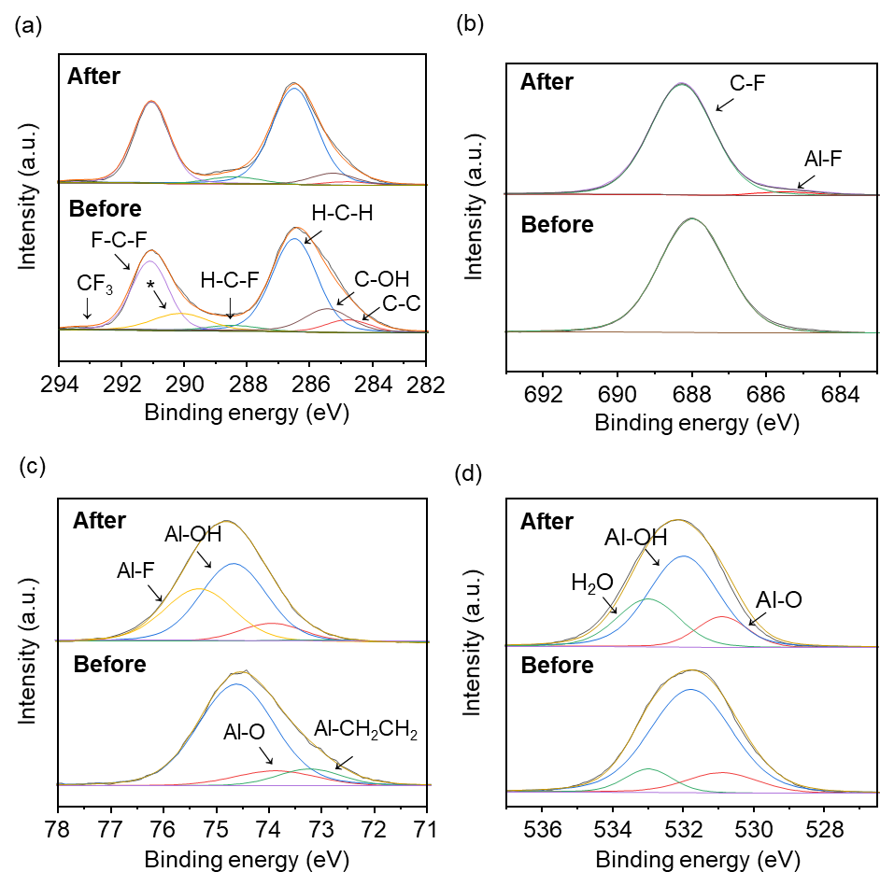
Fig. S11 XPS (a) C 1s, (b) F 1s (c) Al 2p, and (d) O 1s spectra of PA-1.25 before and after fluoride ion adsorption (C_{init} = 50 ppm, adsorbent dose = 3 mg/ml, t = 120 min).

Table S8 XPS peak parameters of PA-1.25 before and after fluoride ion adsorption.
Electrons | Peak | Binding energy  (eV) | Before adsorption | After adsorption
Electrons | Peak | Binding energy  (eV) | Concentration  (Atomic %)
Al 2p | Al-CH₂CH₂ | 73.2 | 11.10 | 1.61
Al 2p | Al-O | 73.8 | 12.00 | 11.79
Al 2p | Al-OH | 74.6 | 76.90 | 50.98
Al 2p | Al-F | 75.3 | 0.00 | 35.62
O 1s | Al-O | 530.9 | 13.28 | 14.39
O 1s | Al-OH | 532.0 | 76.58 | 58.37
O 1s | H₂O | 533.0 | 10.14 | 27.24

References
Ku, Y. & Chiou, H.-M. (2002) The adsorption of fluoride ion from aqueous solution by activated alumina Water Air Soil Pollut 133: 349-361 doi:https://doi.org/10.1023/A:1012929900113
Gai, W.-Z., Zhang, S.-H., Yang, Y., Zhang, X. & Deng, Z.-Y. (2021) Separation of excess fluoride from water using amorphous and crystalline AlOOH adsorbents ACS omega 6: 16488-16497 doi:https://doi.org/10.1021/acsomega.1c01620
Jia, Y. et al. (2015) Fluoride removal mechanism of bayerite/boehmite nanocomposites: roles of the surface hydroxyl groups and the nitrate anions J Colloid Interface Sci 440: 60-67 doi:https://doi.org/10.1016/j.jcis.2014.10.069
Tangsir, S. et al. (2016) Water defluoridation using Al2O3 nanoparticles synthesized by flame spray pyrolysis (FSP) method Chem Eng J 288: 198-206 doi:https://doi.org/10.1016/j.cej.2015.11.097
Wang, S. G., Ma, Y., Shi, Y. J. & Gong, W. X. (2009) Defluoridation performance and mechanism of nano‐scale aluminum oxide hydroxide in aqueous solution J Chem Technol Biotechnol 84: 1043-1050 doi:https://doi.org/10.1002/jctb.2131
Maliyekkal, S. M., Sharma, A. K. & Philip, L. (2006) Manganese-oxide-coated alumina: a promising sorbent for defluoridation of water Water Res 40: 3497-3506 doi:https://doi.org/10.1016/j.watres.2006.08.007
Chatterjee, S., Mukherjee, M. & De, S. (2020) Groundwater defluoridation and disinfection using carbonized bone meal impregnated polysulfone mixed matrix hollow-fiber membranes J Water Process Eng 33: 101002 doi:https://doi.org/10.1016/j.jwpe.2019.101002
Suriyaraj, S., Bhattacharyya, A. & Selvakumar, R. (2015) Hybrid Al 2 O 3/bio-TiO 2 nanocomposite impregnated thermoplastic polyurethane (TPU) nanofibrous membrane for fluoride removal from aqueous solutions RSC Adv 5: 26905-26912 doi:https://doi.org/10.1039/C5RA02523K
Meng, C., Zheng, X., Hou, J. & Wang, C. (2020) Preparation and defluoridation effectiveness of composite membrane sorbent MFS-AA-PVDF Water Air Soil Pollut 231: 1-10 doi:https://doi.org/10.1007/s11270-019-4351-2

