Table S1. EDX elemental analysis of CMC and MOF: Fe (Ⅱ)-CMC sorbent.
Element | CMC (wt %) | MOF (wt %)
C | 28.78 | 28. 25
N | 22.91 | 32.50
O | 48.16 | 36.25
S | 0.02 | 0.1
Fe | _ | 2.90

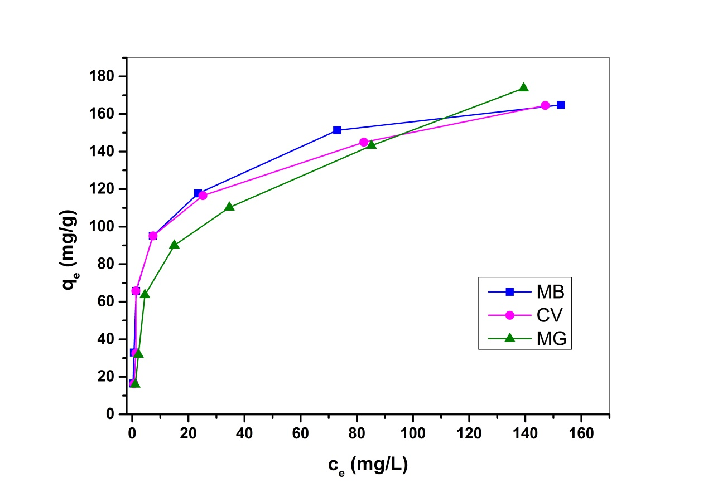

Fig.S1. Equilibrium isotherms for the adsorptive uptake of MB, CV and MG onto (MOF: Fe (Ⅱ)-CMC) sorbent.

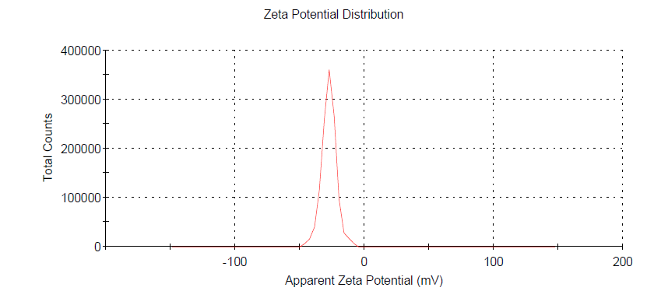
Fig. S2. Zeta Potential distribution of MOF: Fe (Ⅱ)-CMC nanocomposite structure.

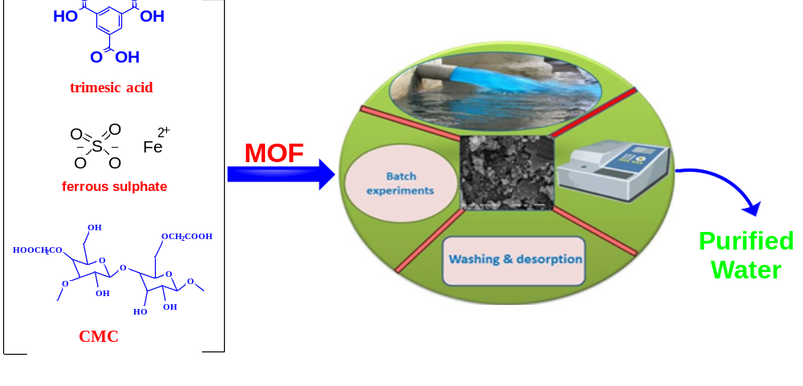

Fig. S3. Diagrammatic representation of the synthesis of MOF:Fe(Ⅱ)-CMC nanocomposite and the dye adsorption process

