SUPPLEMENTARY MATERIAL

Effective elimination of indigo carmine in wastewater using green nanostructured modified biochar: Optimization, sorption equilibrium, kinetics, thermodynamics and mechanisms

Mai El-Kammah¹, Elsayed Elkhatib²*, Maneea Moubarak³

- Determination of Indigo Carmine (IC)
The concentration of indigo carmine solutions neither before or after adsorption were determined using colorimetric method by using using UV-Vis spectrophotometer (GENESYS 10S, Fisher Scientific). Maximum wavelength corresponding to IC color was measured and specified at 610 nm based on the greatest absorbance value. The calibration curve of IC was performed by measuring the absorbance of a series of IC solutions with specific concentrations ranging from 5 to 100 mgL⁻¹ at 610nm. The calibration curve was generated by plotting the value of different concentrations verse the absorbance values with high correlation coefficient (R = 0.995). Unknown samples concentrations were quantified according to the absorbance value.
- IC chemical characteristics
Indigo Carmine is an organic, anionic dye with a chemical formula C16H8N2O8S2Na2. Molecular weight = 466.35 m·mol⁻¹, solubility: 1 g·L⁻¹, density 0.71 g·cm³ at 29 °C. The molecular structure of indigo carmine consists of a central indigotin nucleus with two sulfate groups attached to the molecule, along with two sodium ions for charge balance.

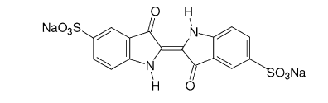
Figure S1. Chemical structure of Indigo Carmine

Adsorption Experiments
The batch adsorption experiments of IC on bMOS and nMOSAB were carried out and both IC removal percentage (%) and IC adsorbed quantity (mg/g) were computed according to the following equations:
IC removal (%) = $\frac{C_{i}- C_{e} }{C_{i}} ×100$ [eq. 1]
q_{e} (mg·g⁻¹) = $\frac{C_{i}- C_{e}}{M} ×V$ [eq. 2]
Where.
Ci refers to the starting concentration of dye in the water solution (mg L⁻¹). Ce is the concentration of the solution at equilibrium (mg L⁻¹) when a solid sorbent is present, qe represents the amount of dye adsorbed onto the solid sorbent at equilibrium (mgg⁻¹) and m is the mass in grams of the adsorbent used, and V is the volume in liters of the solution.

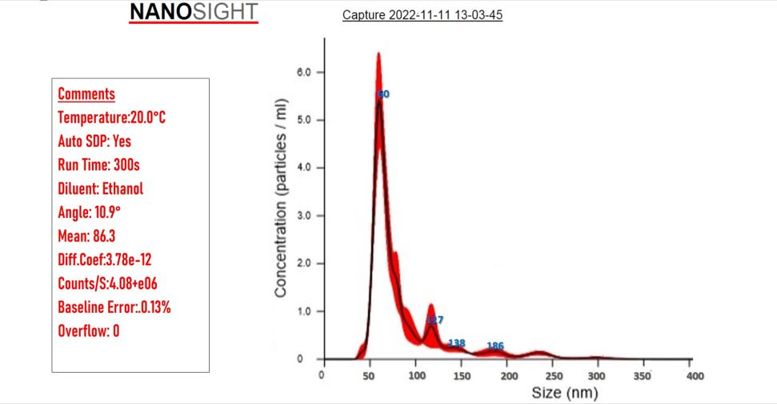
Figure.S2. Particle size distribution of nMOSAB

Sorption thermodynamics
The adsorption process's thermodynamic characteristics were examined by the application of Van't Hoff and Gibb's equations (eq.1&2)
∆G= - RT ln K_{c} [eq. 1]
ln Kc = ∆S°/R - ∆H°/RT [eq. 2]
Where Kc is equilibrium value, as determined by Langmuir equation (Kc = qe/Ce at 298 –318 K), T is the temperature of the system expressed in Kelvin and R is the universal gas constant (8.314 J/mol⁻¹K⁻¹). The values of ΔS◦ and ΔH◦ were calculated using the value of intercept (ΔS◦/R) and slope (ΔH◦/ R) from the plot of ln K_{c} versus 1/T (Supplementary material, Fig. S3).

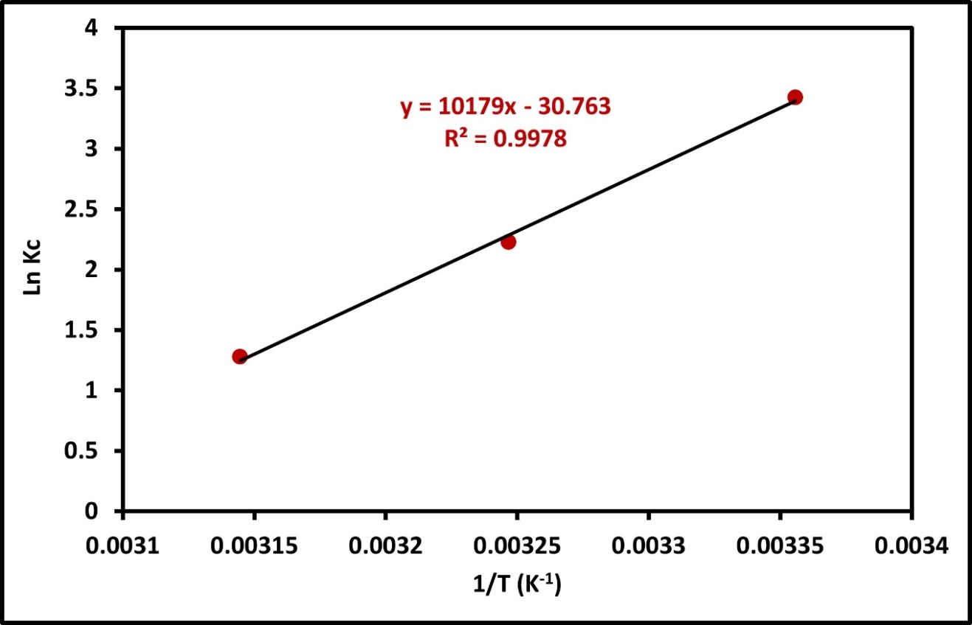
Figure.S3. Arrhenius plot for IC adsorption onto nMOSAB at different temperatures (298 - 318) K

