Supporting Information:

In Silico Design and Simulation of Graphene Oxide-based Metal-Organic Framework Nanomaterial for Water Purification

Section S1: MD simulation details on the components of the designed Cu-BTC/GO composite
The graphene oxide layers are built based on the model proposed by Lerf-Klinowski (Lerf et al. 1998) which both sides of a pristine graphene with a dimension of 3.4 nm×3.5 nm are randomly decorated with hydroxyl and epoxy functional groups and carboxyl groups are distributed on the edges of graphene. The molecular structure of GO can be expressed as C₁₀O₁(OH)₁(COOH)_{0.5} (Shahabi and Raissi 2018), which means that the ratio of the number of carbon atoms, epoxy groups, hydroxyl groups and carboxyl groups on the layer is 10:1:1:0.5. Therefore, the resulting chemical formula for GO layers is C₅₃₅H₉₁O₇₉, which corresponds to a carbon-to-oxygen ratio of approximately 6:1. Regarding MOF, the crystallographic structure for a single primitive unit cell of Cu-BTC with dimension of 2.63 nm×2.63 nm reported by Chui et al. (1999) has been used. For GO layers, all sp² carbon atoms are treated as uncharged and partial atomic charges of the functional groups and their anchoring carbons are taken from Tang et al. (2015). The force field parameters for GO layers are extracted from the general CHARMM36 force field (CGenFF) (Vanommeslaeghe et al. 2010). The Lenard-Jones parameters and the partial atomic charges of the Cu-BTC atom species are obtained from the works of Zhao et al. (2022). The topology and parameter files for PA66 and PU monomers are also determined based on CGenFF in CHARMM-GUI webserver (Jo et al. 2008; Kim et al. 2017).

Section S2: DFT calculations
The interaction of MP molecules with GO, pristine MOF and Cu-BTC/GO composite is evaluated using DFT calculations (Shahabi and Raissi 2020). All DFT calculations are performed with the non-local dispersion modified version of the B3LYP method (i.e., B3LYP-D3) (Grimme et al. 2011) using the GAMESS program (Schmidt et al. 1993) in aqueous media. The 6-31G** split-valence basis set is applied to O, C, N and H atoms while the Los Alamos relativistic effective core potential plus the DZ (LanL2DZ) (Hay et al. 1985) basis set is used for Cu atoms.

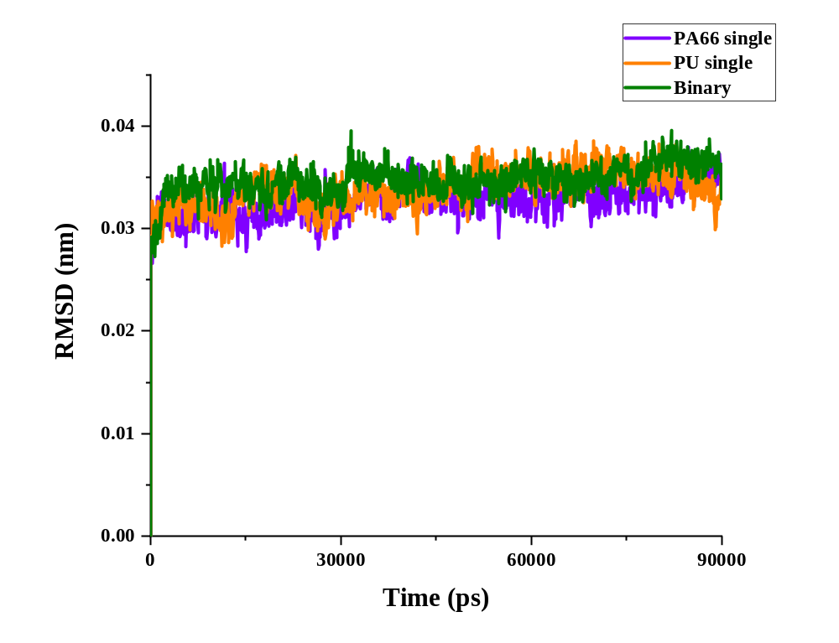
Fig. S1 Representation of RMSD plots for Cu-BTC/GO composite as a function of time in the simulation systems.

(a) t= 2 ns
(b) t= 9 ns
(c) t= 25 ns
(d) t= 90 ns

(e) t= 2 ns
(h) t= 90 ns
(g) t= 25 ns
(f) t= 9 ns

Fig. S2 Representative snapshots of the trajectory for the MPs removal process in PA66-single GO (a-d) and PU-single GO (e-h) systems.

(d) t=90 ns
(c) t= 40 ns
(b) t=24 ns
(a) t= 2 ns

(e) t= 2 ns
(g) t= 40 ns
(h) t= 90 ns
(f) t= 24 ns

Fig. S3 Representative snapshots of the trajectory for the MPs removal process in PA66-sinle Cu-BTC (a-d) and PU-single Cu-BTC (e-h) systems.

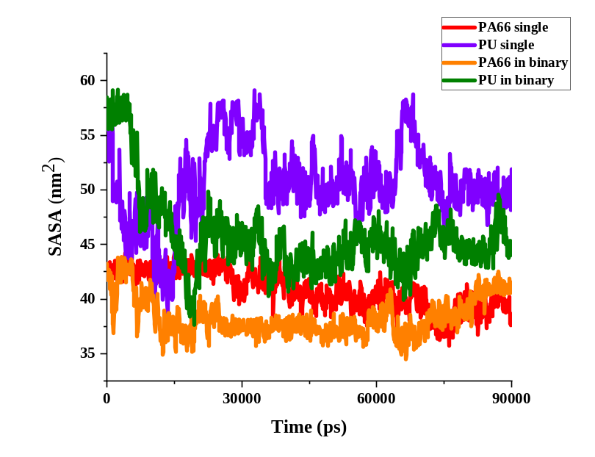
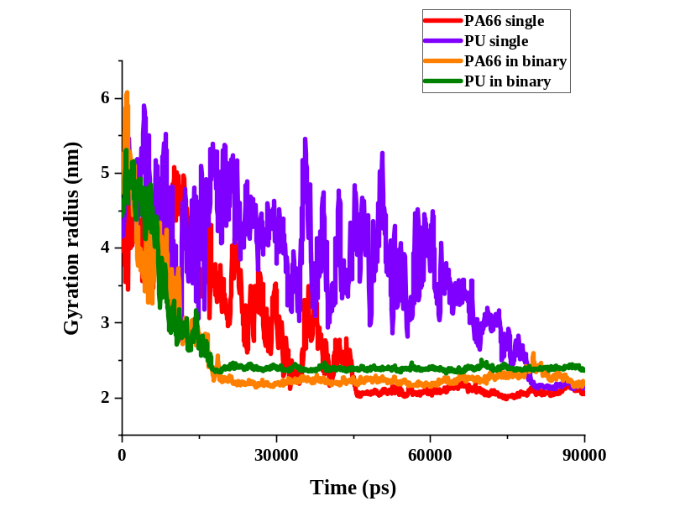

(b)
(a)

Fig. S4 (a) Time evolution of the Gyration radius of MPs during the interaction with Cu-BTC/GO composite; (b) The solvent-accessible surface area (SASA) for MPs during the adsorption on Cu-BTC/GO composite in single-component and binary systems, respectively.

PA66-single RGO
PA66-single Cu-BTC
PA66-single GO

PU-single Cu-BTC
PU-single RGO
PU-single GO

Fig. S5 Representative snapshots for the final configuration of MPs on single GO, single RGO and single Cu-BTC systems.

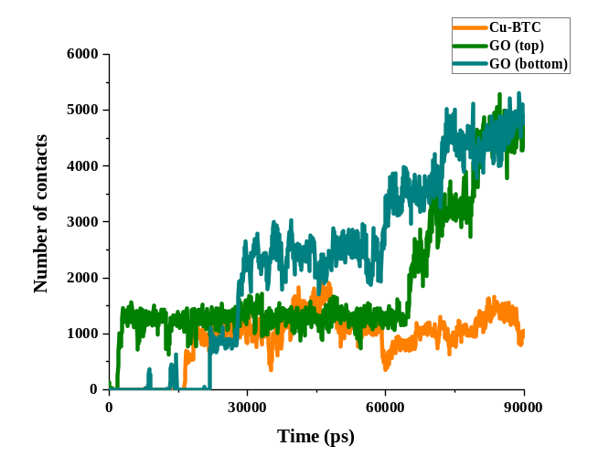
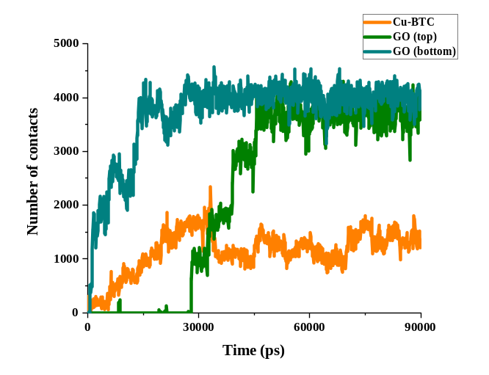
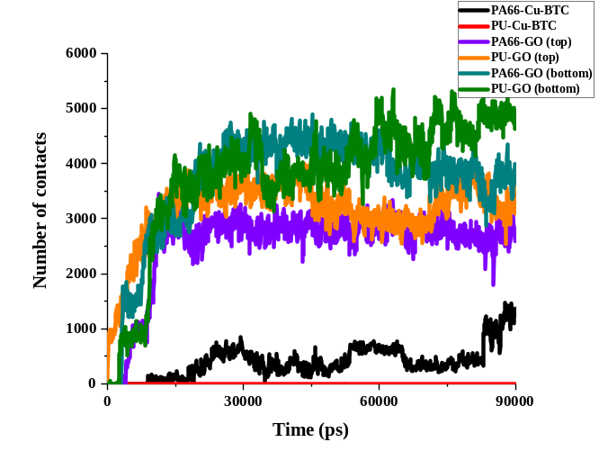

(c)
(b)
(a)

Fig. S6 The number of contacts between MPs and the components of the designed Cu-BTC/GO composite in (a) PA66 single, (b) PU single, (c) binary systems, respectively.

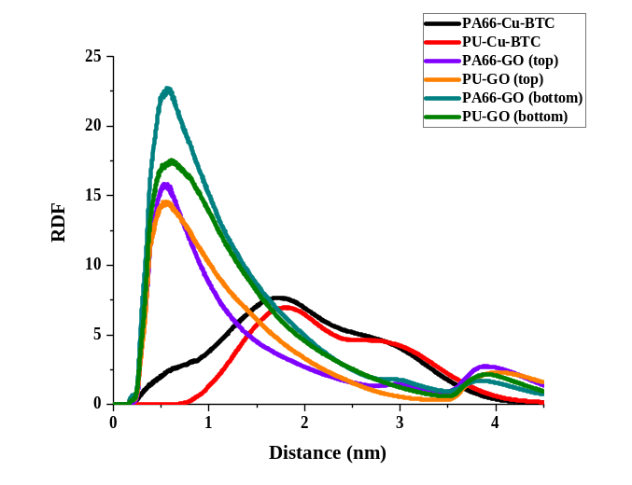
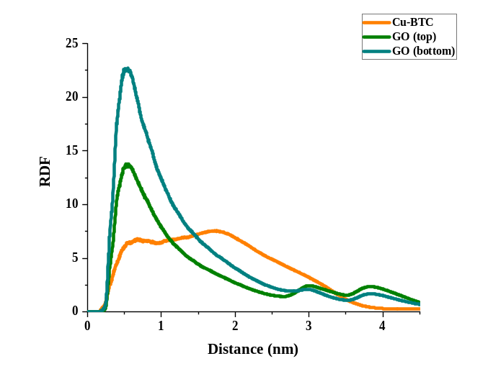
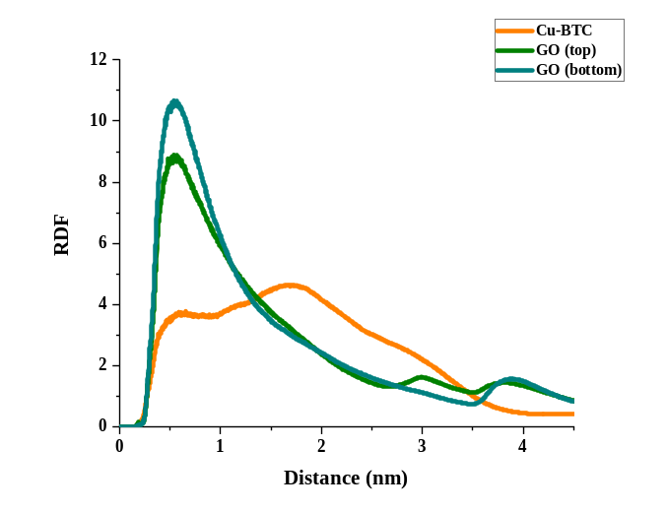
(b)
(a)

(c)

Fig. S7 Radial distribution functions (RDF) of MPs around the components of Cu-BTC/GO composite in (a) PA66 single, (b) PU single, (c) binary systems, respectively.

Composite
PA66@Composite
PU@Composite

PU@GO
GO
PA66@GO

PA66@MOF
PU@MOF
Pristine MOF

Fig. S8 Optimized structures for Cu-BTC/GO composite, GO, pristine MOF, and the studied complexes.
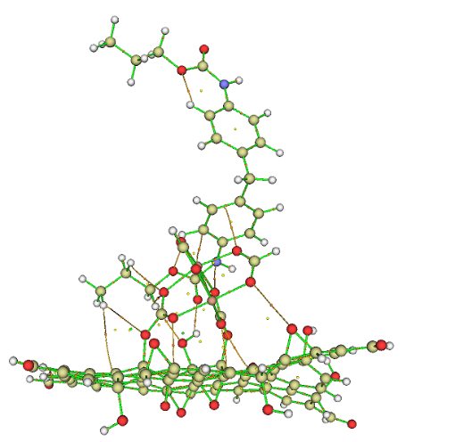
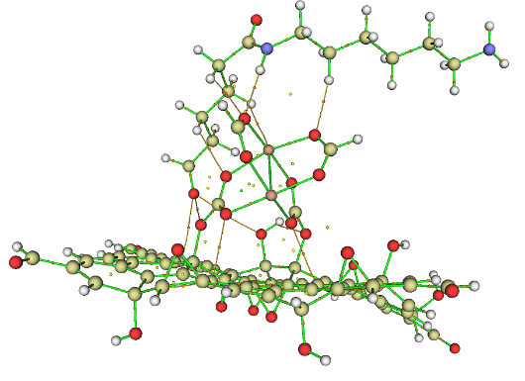

PU@Composite
PA66@Composite

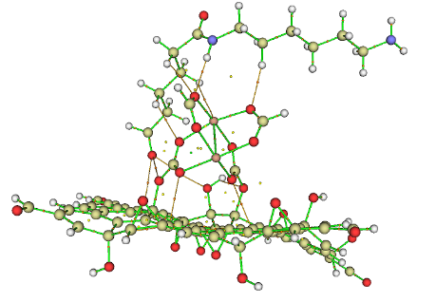
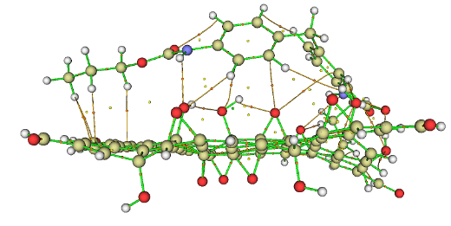

PA66@GO
PU@GO
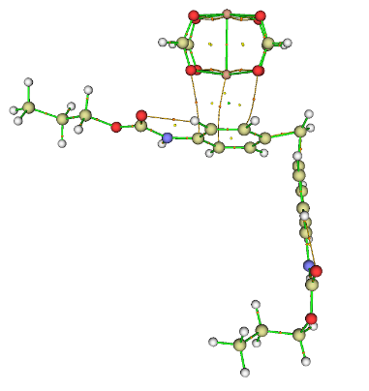

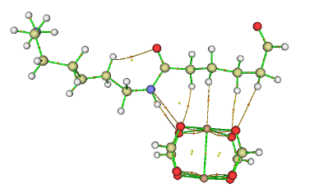

PA66@MOF
PU@MOF
Fig. S9 Molecular graphs of the studied complexes derived from QAIM analysis.
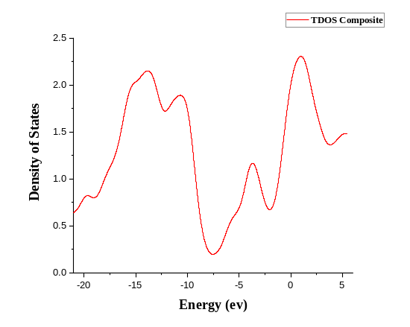
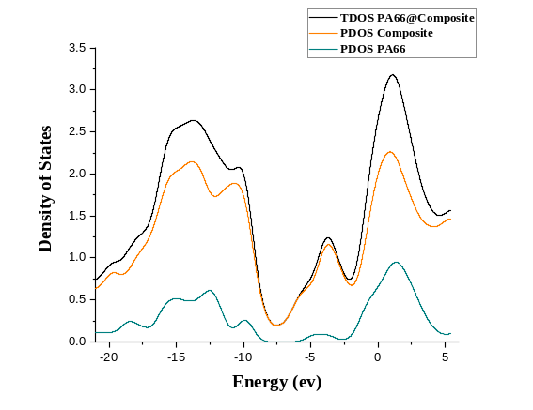
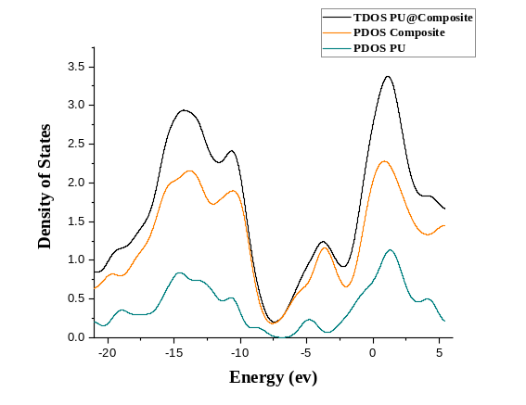
(c)
(b)
(a)

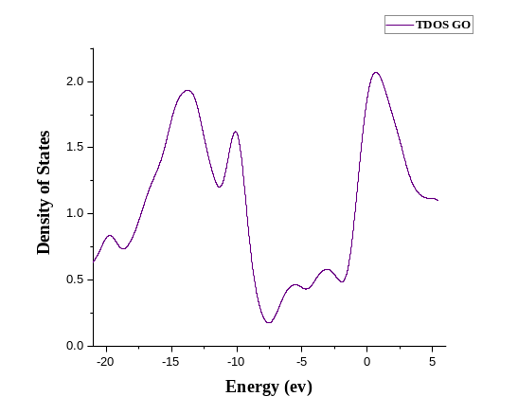
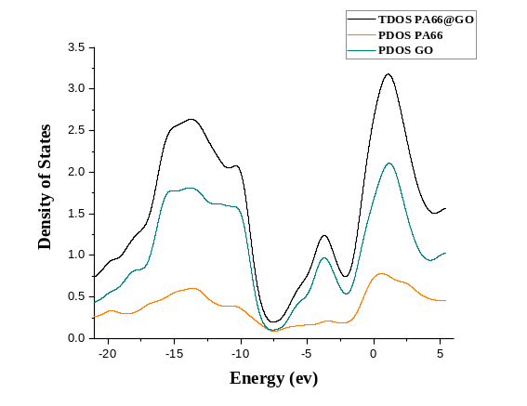
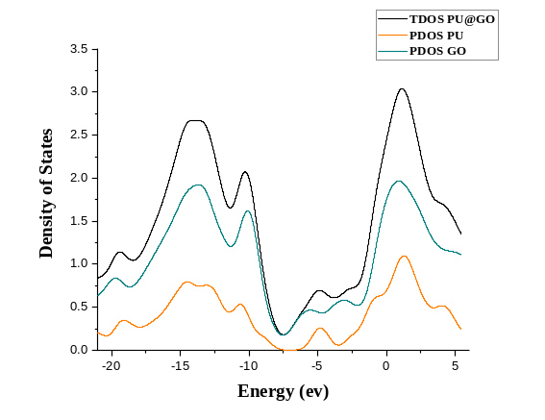
(d)
(e)
(f)

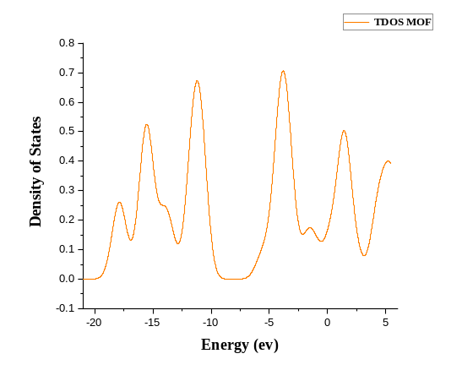
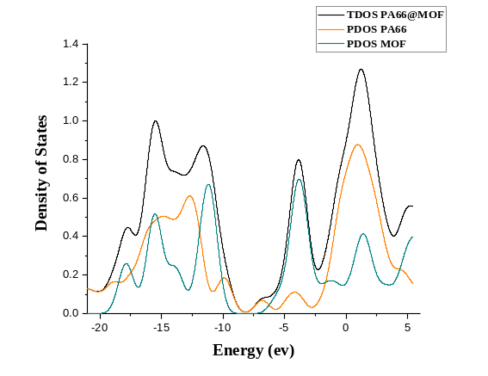
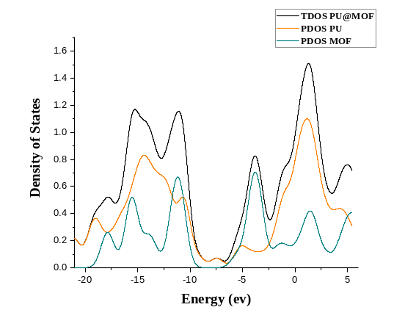
(g)
(h)
(I)

Fig. S10 Calculated total and projected electronic density of states (TDOS and PDOS) before and after adsorption of MPs on (a) Composite, (b) PA66@Composite, (c) PU@Composite, (d) GO, (e) PA66@GO, (f) PU@GO, (g) pristine MOF, (h) PA66@MOF and (I) PU@MOF complexes, respectively.

Table S1 Calculated average number of HBs between the considered fragments in the simulation systems.
Microplastic | Interaction | Average Number of HBs
Microplastic | Interaction | Single- component | Binary
PA66 | PA66-Cu-BTC | 1.22 | 1.47
PA66 | PA66-GO (top) | 0.66 | 0.72
PA66 | PA66-GO (bottom) | 1.03 | 2.94
PU | PU-Cu-BTC | 2.12 | 0
PU | PU-GO (top) | 0.78 | 3.41
PU | PU-GO (bottom) | 0.45 | 3.35

Table S2 Values of the electron density (ρ) and its Laplacian (∇²ρ) as well as the total electron energy density (H) (all in a.u.) for intermolecular interactions in the considered complexes (values in brackets refer to the calculation of the adsorption energy (E_{Ads} in kJ/mol)).

 |  | ρ | ∇²ρ | H |  |  |  | ρ | ∇²ρ |  | H |  |  |  |  | ρ |  | ∇²ρ |  | h
 | H₅₀-C₃₃ | 0.01016 | 0.03818 | -0.00925 |  |  | H₂₉-O₁₄₂ | 0.01253 | 0.05349 |  | -0.01734 |  |  | C₁₃₄-O₁₁₈ |  | 0.01439 |  | 0.05978 |  | -0.02126
pu@mof | Cu₅₄-C₁₉ | 0.00556 | 0.01865 | -0.00221 | PU@GO |  | H₂₃-O₁₄₂ | 0.00768 | 0.02909 |  | -0.00548 | PU@Composite |  | Cu₁₁₅-C₁₃₅ |  | 0.01491 |  | 0.02917 |  | -0.00550
[0.34] | O₅₆-C₁₅ | 0.01084 | 0.03836 | -0.00933 | [-319.61] |  | H₈-O₁₄₀ | 0.01131 | 0.03403 |  | -0.00743 | [-395.09] |  | H₁₄₀-O₁₇₃ |  | 0.01594 |  | 0.06195 |  | -0.02268
 |  |  |  |  |  |  | H₇-O₁₄₄ | 0.00786 | 0.03045 |  | -0.00599
 |  | ρ | ∇²ρ | H |  |  |  | ρ | ∇²ρ |  | H |  |  |  |  | ρ |  | ∇²ρ |  | H
 | H₃₂-O₄₅ | 0.00778 | 0.02800 | -0.00508 |  |  | H₁₄₄-O₁₁₈ | 0.01054 | 0.03380 |  | -0.00733 |  |  | H₁₄₄-O₁₁₈ |  | 0.01054 |  | 0.03380 |  | -0.00733
pa66@mof | H₃₀-O₄₆ | 0.00718 | 0.02398 | -0.00373 | PA66@GO |  | H₁₅₆-O₁₁₇ | 0.01806 | 0.05442 |  | -0.01791 | PA66@Composite |  | H₁₅₆-O₁₁₇ |  | 0.01806 |  | 0.05442 |  | -0.01791
[0.33] | H₂₃-Cu₄₁ | 0.01042 | 0.03339 | -0.00716 | [-307.96] |  | H₁₅₃-O₁₁₈ | 0.00584 | 0.02295 |  | -0.00341 | [-329.08] |  | H₁₅₁-O₁₁₇ |  | 0.00246 |  | 0.00799 |  | -0.00025
 | H₂₁-O₄₃ | 0.00646 | 0.02188 | -0.00309 |  |  | H₁₆₀-O₁₁₉ | 0.00661 | 0.02521 |  | -0.00412
 | H₂₆-O₄₃ | 0.01999 | 0.06099 | -0.02205

References
Chui SSY et al (1999) A chemically functionalizable nanoporous material [Cu₃(TMA)₂(H₂O)₃]_{n}, Science 283(5405):1148-1150.
Grimme S, Ehrlich S, Goerigk L (2011) Effect of the damping function in dispersion corrected density functional theory. J Comput Chem 32(7):1456-1465.
Hay PJ, Wadt WR (1985) Ab initio effective core potentials for molecular calculations. Potentials for the transition metal atoms Sc to Hg. J Chem Phys 82(1):270-283.
Jo S at el (2008) CHARMM‐GUI: a web‐based graphical user interface for CHARMM. J Comput Chem 29(11):1859-1865.
Kim S et al (2017) CHARMM-GUI Ligand Reader and Modeler for CHARMM Force Field Generation of Small Molecules. J Comput Chem 38:1879-1886.
Lerf A et al (1998) Structure of graphite oxide revisited. J Phys Chem B 102(23):4477-4482.
Schmidt MW et al (1993) General at structure system. J Comput Chem 14(11):1347–1363.
Shahabi M, Raissi H (2018) Comprehensive theoretical prediction of the dynamics and stability properties of Tegafur pharmaceutical agent on the Graphene based nanostructures in aqueous environment. Appl Surf Sci 455:32-36.
Shahabi M, Raissi H (2020) Two dimensional porous frameworks of graphyne family as therapeutic delivery vehicles for Idarubicin biomolecule in silico: Density functional theory and molecular dynamics simulation. J Mol Liq 319:114334.
Tang H et al (2015) Molecular dynamics study of the aggregation process of graphene oxide in water. J Phys Chem C 119(47):26712-26718.
Vanommeslaeghe K et al (2010) CHARMM general force field: A force field for drug‐like molecules compatible with the CHARMM all‐atom additive biological force fields. J Comput Chem 31(4):671-690.
Zhao H et al (2022) Insights into the performance of hybrid graphene oxide/MOFs for CO₂ capture at process conditions by molecular simulations. J Chem Eng 449:137884.

