Hydrogeochemical sources and enrichment mechanisms of trace elements in river water of a typical endorheic headwater region on Tibetan Plateau
Jie Wang ¹, Yong Xiao ^{1,}*, Yuqing Zhang ¹, Wenxu Hu ¹, Zexue Qi ^{2,}*, Xiangzhi You ^{3,4}, Xiaofan Gu ^{3,4}, Huizhu Chen ⁵, Jibin Han ⁶, Yongxing Zhang ², Liwei Wang ^{1,7,8}
¹ Faculty of Geosciences and Environmental Engineering, Southwest Jiaotong University, Chengdu 611756, China
² Xining Natural Resources Comprehensive Survey Center, China Geological Survey, Xining 810000, China
³ Xi’an Center of Geological Survey, China Geological Survey, Xi’an, 710054, China
⁴ Key Laboratory for Groundwater and Ecology in Arid and Semi-arid Areas, China Geological Survey, Xi’an, 710054, China
⁵ School of International Studies, Chengdu College of Arts and Sciences, Chengdu 610401, China
⁶ Qinghai Institute of Salt Lakes, Chinese Academy of Sciences, Xining 810008, China
⁷ MOE Key Laboratory of Groundwater Circulation and Environmental Evolution, China University of Geosciences (Beijing), Beijing 100083, P. R. China
⁸ Sichuan Province Engineering Technology Research Center of Ecological Mitigation of Geohazards in Tibet Plateau Transportation Corridors, Chengdu 611756, China
Corresponding author: Dr. Yong Xiao
ORCID: 0000-0002-6414-8384
E-mail: xiaoyong@swjtu.edu.cn
Co-Corresponding author: Zexue Qi
E-mail: geoqzx@163.com
Supplementary material
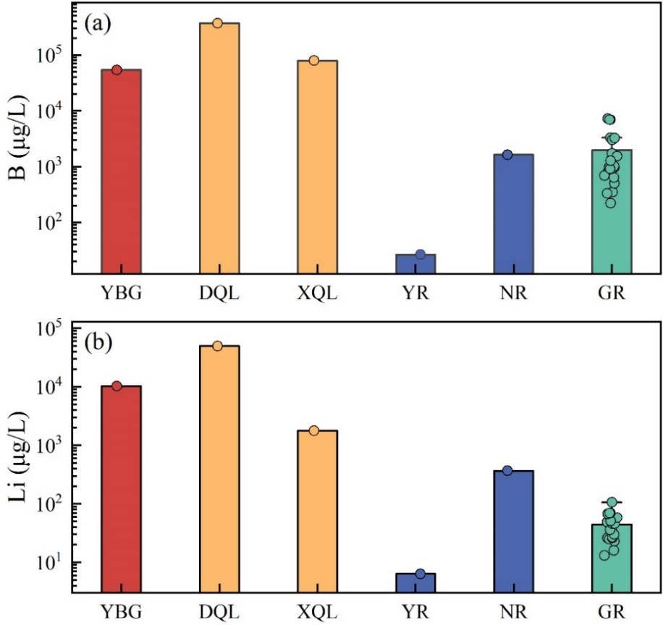
Fig. S1 B and Li abundances in Yangbajing geothermal field (YBG), Da Qaidam Lake (DQL), Xiao Qaidam Lake (XQL), Yangtse River (YR), Nalinggele River (NR) and Golmud River (GR)
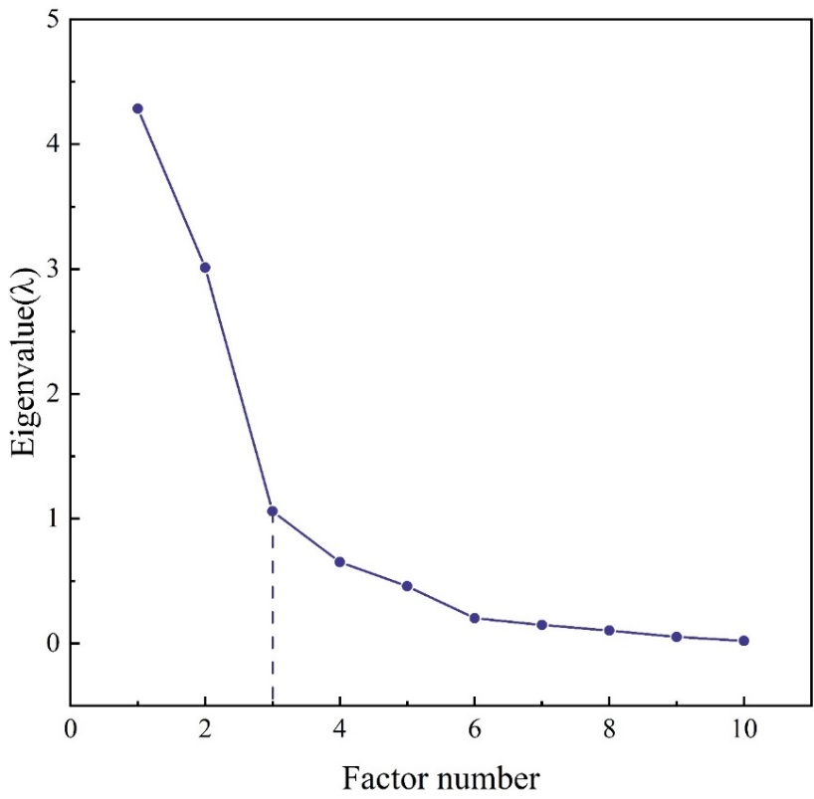
Fig. S2 The principal component eigenvalue curve.

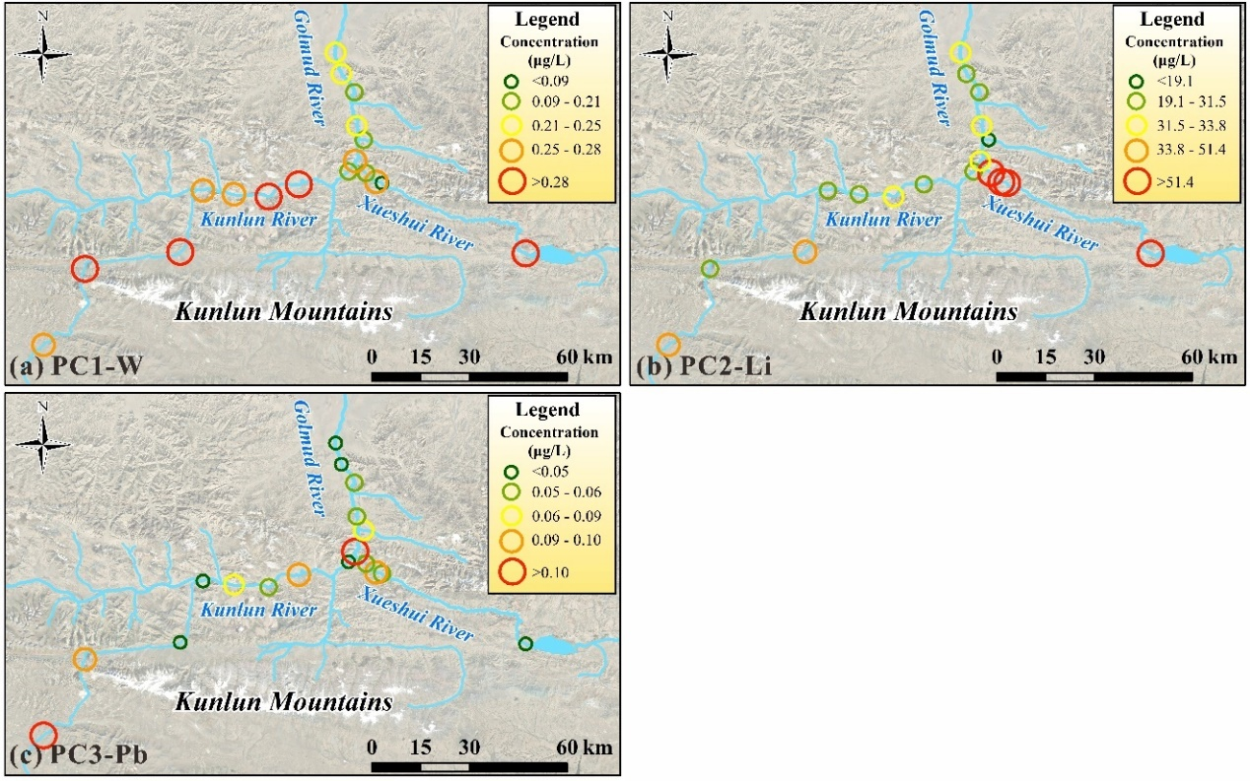
Fig. S3 Spatial distribution of representative elements of (a) PC1, (b) PC2 and (c) PC3

