ELECTRONIC SUPORTING INFORMATION

Effective removal of thiabendazole pesticide from polluted water using metal-organic frameworks

Contents
S1. Samples degasification conditions 2
S2. MOF synthesis 3
S3. MOF physicochemical properties 5
S4. Pelletizing process 6
S5. LC-MS conditions 7
S6. HPLC conditions 8
S7. Ionic chromatography results 10
S8. Computational studies 11
S9. TBZ removal performances 20
S10. Particle size and ζ-potential of powder materials 21
S11. MOFs characterization after TBZ encapsulation (screening) 22
S12. Pellets characterization after shaping process (PXRD and N₂ sorption) 23
S13. Continuous flow experimental set-up 24
S14. Continuous flow tests 25
14.1. SEM images of SU-101 before and after continuous flow 25
14.2. Pellets characterization (XRD and N₂ sorption) 26
S15. SU-101 cyclability 27

S1. Samples degasification conditions
Table S1. Degasification conditions (time and temperature) for N₂ sorption analysis of selected materials
MOF | Temperature (°C) | Time (h)
UiO-66 | 200 | 12
UiO-66-COOH | 50 | 4
MIL-125-NH₂ | 150 | 12
MIL-100(Fe) | 130 | 3
MIL-101(Cr) | 150 | 12
PCN-224 | 150 | 12
PCN-222 | 150 | 12
SU-101 | 150 | 10

S2. MOF synthesis
UiO-66 or [Zr₆O₄(OH)₄(C₈H₃O₄H₆]·nH₂O was synthesized under a solvothermal method previously reported.(Cunha et al., 2013) Briefly, 10 mmol (2.3 g) of zirconium(IV) chloride (ZrCl₄) and 10 mmol (1.7 g) of terephthalic acid (H₂BDC) were dispersed in 387 mmol (30 mL) of N,N-dimethylformamide (DMF). The mixture was transferred into a Teflon-lined stainless autoclave (125 mL) and heated 12 h at 220 °C. The resulting powder was recovered by vacuum filtration and washed with distilled water (100 mL) and acetone (100 mL) twice.
jj
The washing and activation process to remove the remaining free organic ligand and/or solvent of both solids was carried out suspending 200 mg of as-synthetized solid in 100 mL of DMF for 12 h under magnetic stirring. Then, the solids were filtered and resuspended in 100 mL of methanol (MeOH) under magnetic stirring for 12 h. The materials were recovered by vacuum filtration. Finally, the obtained white solid was dried overnight at 200 °C.
UiO-66-COOH or [Zr₆O₄(OH)₄(C₉H₄O₆)₆]·nH₂O material was synthesized under reflux conditions following a modified procedure previously reported.(Ragon et al., 2015) Firstly, 10.46 mmol (2.2 g) of trimesic acid (H₃BTC) were dissolved in 25 mL of distilled H₂O, kept 2 min under magnetic stirring and then, 5.1 mmol (1.2 g) of ZrCl₄ were added. The resulting mixture was kept under reflux, in a previously preheated silicon bath (at 100 °C) during 13 h and under magnetic stirring.

The resulting white powder was recovered by centrifugation (11,000 rpm, 10 min) and further washed with 80 mL of distilled water under reflux for 16 h. The final solid was recovered by centrifugation (11,000 rpm, 10 min).
MIL-125-NH₂ or [Ti₈O₈(OH)₄(C₈H₃NO₄)₆]·nH₂O was synthesized following the previously described method including a slight modification.(Moreira et al., 2012) First, 7.6 mmol (1.4 g) of aminoterephthalic acid (H₂BDC-NH₂) were dissolved in 259.4 mmol (20 mL) of DMF and 123.4 mmol (5 mL) of MeOH at room temperature (RT), under magnetic stirring. Then, the mixture was placed in a 50 mL round bottom flask equipped with a condenser and heated at 100°C under air. When the temperature (Tª) reached 100 °C, 5.1 mmol (1.5 mL) of titanium(IV) isopropoxide (Ti(OiPr)₄) was incorporated, maintaining the mixture at 100 °C for 72 h under air and magnetic stirring. The obtained yellow solid was recovered by filtration and was washed with 200 mL DMF.

The activation was carried out in two steps: i) the yellow powder was dispersed in DMF (100 mL of DMF per 1 g of obtained solid) under magnetic stirring overnight at RT to remove the free ligand. Then, the solid was recovered by filtration, being resuspended in MeOH using the same proportion as previously. This step was repeated twice to eliminate the DMF excess. Finally, the yellow solid was recovered by filtration and introduced in an oven at 200 °C for 12 h for the total disposal of the remaining MeOH.
MIL-100(Fe) or [Fe₃O(H₂O)₂OH(C₉H₃O₆)₂]·nH₂O was synthetized following the reported procedure.(Canioni et al., 2011) 6.6 mmol (1.9 g) of triethyl-1,3,5-benzenecarboxylate (Et₃BTC) and 10 mmol (2.7 g) of iron(III) chloride hexahydrate (FeCl₃⋅6H₂O) were introduced in a 125mL-Teflon-lined autoclave with 50 mL of distilled H₂O. The autoclave was heated to 130 °C in 1 h, maintaining the temperature for 72 h. After cooling down to RT, the orange solid was recovered by filtration.

The activation process was carried out under reflux in Milli-Q H₂O for 3 h, adding 150 mL of H₂O for each 1 g product. Solid was recovered by filtration and washed under reflux conditions with absolute ethanol in the same proportions as previously. Afterwards, the solid was dispersed under stirring for 2 h and 40 min with a 0.1 M potassium fluoride (KF) solution (1 g product : 50 mL solution) at RT. The last wash step was performed in Milli-Q H₂O (1 g product : 150 mL) under magnetic stirring during 1 h. The solid was finally recovered by filtration and dried.
MIL-101(Cr) or Cr₃F(H₂O)₂F[(C₆H₄)-(CO₂)₂]₃·nH₂O was synthesized following the protocol previously described(Férey et al., 2005) 0.5 g (3 mmol) of H₂BDC, 1.2 g (3 mmol) of chromium(III) nitrate nonahydrate (Cr(NO₃)₃·9H₂O), 14 mL of water and 0.035 mL (0.75 mmol) of hydrofluoric acid (HF) were added in that order into 100 mL autoclave and hydrothermally treat it for 8 h at 220 °C. The obtained green solid was recovered by filtration.

Each batch of MIL-101(Cr) was firstly washed with 1.5 L of water at 70 °C for 5 h, then 1.5 L of ethanol at 60 °C for 3 h and finally with 600 mL of 30 mM NH₄F at 60 °C for 10 h. The final product was filtered when still hot and rinsed with hot water.
PCN-224 or [Zr₆O₄(OH)₄(OH)₆(H₂O)₆(TCPP)₆] was synthesized following previously described monomodal microwave protocol.(Carrasco et al., 2023) For this purpose 1.2 mmol (400 mg) of zirconium(IV) chloride oxyhydrate (ZrOCl₂∙8H₂O), 0.2 mmol (194 mg) of tetrakis(4-carboxyphenyl)porphyrin (TCPP), 128 mmol (10 mL) of DMF and 87 mmol (5 mL) of acetic acid were introduced into a 30 mL microwave glass reactor. A magnet was added and the mixture was sonicated for 15 s in ultrasound until the solid reagents were well dispersed. The reactors were microwaved for 30 min at 150 °C (0-15 W). The garnet solid obtained was recovered by centrifugation in absolute ethanol.

Material activation was carried out by performing 3 washes in absolute ethanol (30 mL), introducing the wet solid at the end in a glass vial for subsequent drying in an oven (100 °C, overnight).
PCN-222 or [Zr₆O₄(OH)₄(H₂O)₄(TCPP)₂] was synthesized following a previously described monomodal microwave protocol.(Carrasco, Sanz-Marco and Martín-Matute, 2019) In the case of PCN-222, 0.6 mmol (200 mg) of ZrOCl₂∙8H₂O, 0.3 mmol (98 mg) TCPP, 192 mmol (15 mL) of DMF along with 15.7 mmol (1. 2 mL) of trifluoroacetic acid (TFA) were introduced into a 30 mL microwave glass reactor. A magnetic mixture was performed, sonicating for 15 s in ultrasound until the solid reagents were well dispersed. The reactors were microwaved for 30 min at 150 °C (35 W). The resulting garnet solid was recovered by centrifugation in absolute ethanol.

Material activation was carried out by performing 3 washes with 30 mL of absolute EtOH, introducing the wet solid after the last wash in a glass vial for subsequent drying in an oven (100 °C, overnight).
SU-101 or Bi₂O(H₂O)₂(C₁₄H₂O₈)·nH₂O was synthesized following the reported procedure.(Grape et al., 2020) Briefly, 10.9 mmol (3.3 g) of ellagic acid (EA) and 19.7 mmol (7.6 g) of bismuth acetate (Bi(C₂H₃O₂)₃) were added to a beaker containing 600 mL of a 6 vol.% acetic acid solution in water. The solution was kept under stirring (500 rpm) at RT for 48 h. The resulting yellow powder was recovered under vacuum filtration and washed on the filter with 200 mL of milliQ H₂O followed by 50 mL of EtOH 96 %. Final product was dry out overnight in an oven at 90 °C.

S3. MOF physicochemical properties
Table S3. Physicochemical properties of the selected MOFs, including their composition (cation and organic ligand) and porosity (volume, specific surface area and pore size).
MOF | Metal | Organic ligand |  | S_{BET}  (m²/g) | Pore Volume  (cm³/g) | Pore size (Å)  (window size, Å) | Ref.
UiO-66 | Zr⁴⁺ | X = H |  | 970 | 0.41 | 8 & 11  (5-7) | (Cavka et al., 2008)
UiO-66-COOH | Zr⁴⁺ | X = COOH |  | 150 | 0.06 | 8 & 11  (5-7) | (Ragon et al., 2015)
MIL-125-NH₂ | Ti⁴⁺ | X = NH₂ |  | 1500 | 0.49 | 6 & 12  (5-7) | (Moreira et al., 2012)
MIL-100(Fe) | Fe³⁺ | X = COOH |  | 1770 | 0.79 | 25 & 29  (5.5 & 8.6) | (Canioni et al., 2011)
MIL-101(Cr) | Cr³⁺ | X = H |  | 1900 | 0.88 | 29 & 34  (8.5 & 12) | (Férey et al., 2005)
PCN-224 | Zr⁴⁺ | 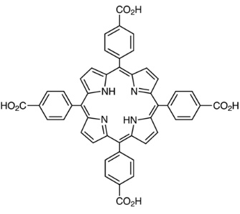 |  | 2840 | 1.08 | 19 | (Carrasco et al., 2023)
PCN-222 | Zr⁴⁺ |  |  | 2300 | 1.42 | 12 & 31 | (Carrasco, Sanz-Marco and Martín-Matute, 2019)
SU-101 | Bi³⁺ | 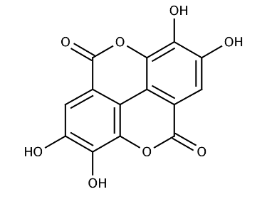 |  | 300 | 0.10 | 6 & 7 | (Grape et al., 2020)

S4. Pelletizing process

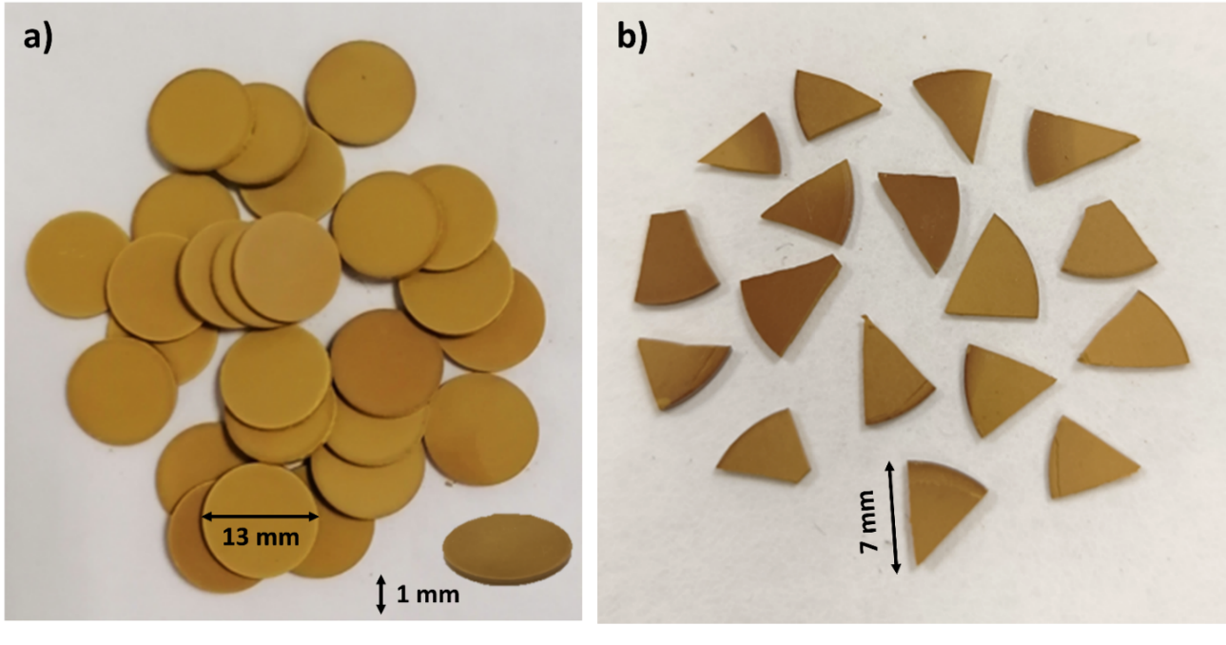
Figure S4. a) SU-101 prepared pellets and b) pellet triangular pieces.

S5. LC-MS conditions

Figure S5. a) LC-MS chromatogram of TBZ obtained in positive ionization mode; b) MS spectrum corresponding to TBZ integrated chromatogram peak and c) TBZ calibration curve in tap water.

S6. HPLC conditions
- H₂BDC-NH₂:
Figure S6.1. Chromatographic data for MIL-125-NH₂ degradation quantification: a) HPLC chromatogram for H₂BDC-NH₂ ligand; b) H₂BDC-NH₂ calibration curve in tap H₂O and c) H₂BDC-NH₂ UV-Vis adsorption spectrum in H₂O.

- Ellagic Acid:
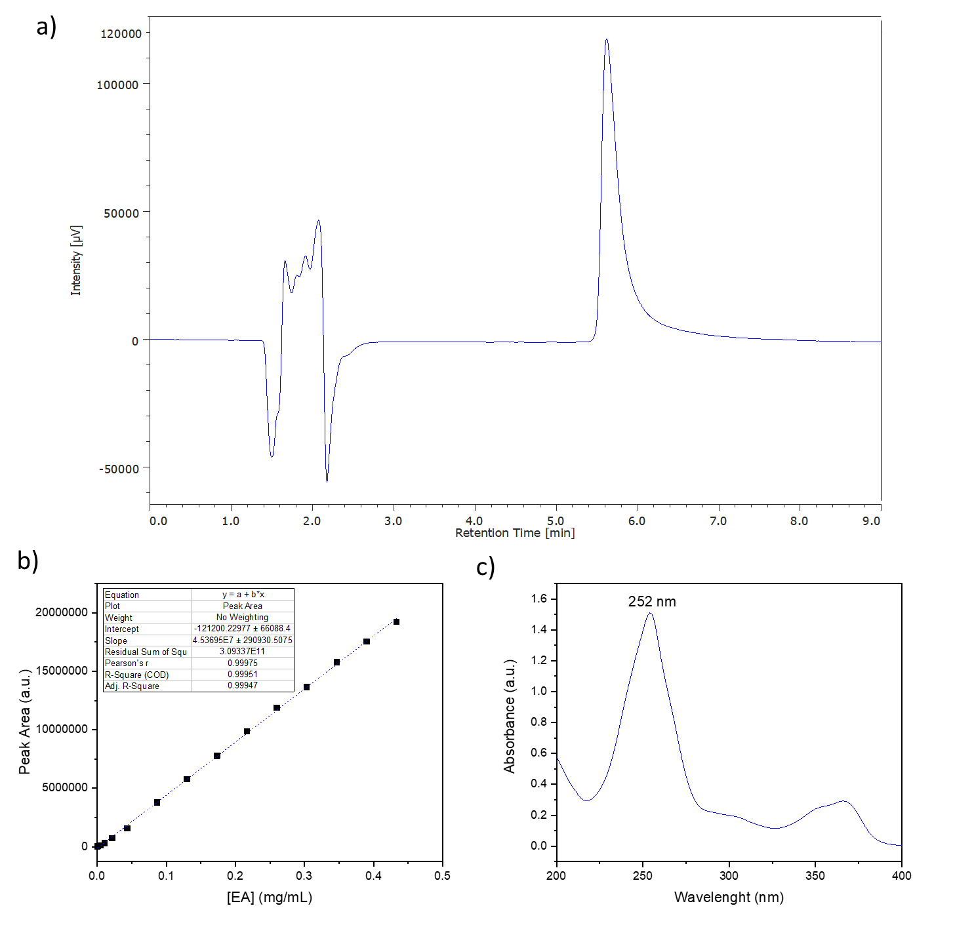
Figure S6.2. Chromatographic information for SU-101 degradation quantification: a) HPLC chromatogram for EA ligand; b) EA calibration curve in MeOH and c) EA UV-Vis adsorption spectrum in MeOH.

S7. Ionic chromatography results
Table S7. Detected anions in tap water, retention time and concentration
Anion | Retention time (min) | [mg·mL⁻¹]
Fluoride (F⁻) | 7.16 | 0.03 ± 0.01
Chlorite (ClO₂⁻) | - | n.d.
Chloride (Cl⁻) | 10.42 | 13.04 ± 0.01
Nitrite (NO₂⁻) | 13.97 | 0.45 ± 0.01
Bromide (Br⁻) | 17.62 | 0.01 ± 0.00
Chlorate (ClO₃⁻) | 18.54 | 0.12 ± 0.01
Nitrate (NO₃⁻) | 20.36 | 0.67 ± 0.01
Phosphate (PO₄³⁻) | - | n.d.
Sulphate (SO₄²⁻) | 31.63 | 9.47 ± 0.02
*n.d.: non-detected, under detection limits of the chromatograph.

S8. Computational studies
The partial charges extracted from the qEq method available in Materials Studio, based on the equalization of the electronegativity are reported in the following figures (Figure S8.1). Also, the DFT calculations, saturation loading and density in presence of TBZ given by Monte Carlo have been plotted (Table S8 and Figures S8.2-S8.6).
Importantly, the evaluation of the adsorption mechanisms occurring in MOF materials during TBZ capture have been depicted below as: i) values in blue correspond to the distance between TBZ and MOF; ii) values in green are representative of distances between TBZ molecules for pi-stacking effect; and values in purple correspond to the distances between TBZ and ethanol molecules. In essence, the final color code is the following: C: grey, H: white; O: red; S: yellow; N: blue; Zr: pale green; Ti: pale grey; Bi: purple; Cl: green):

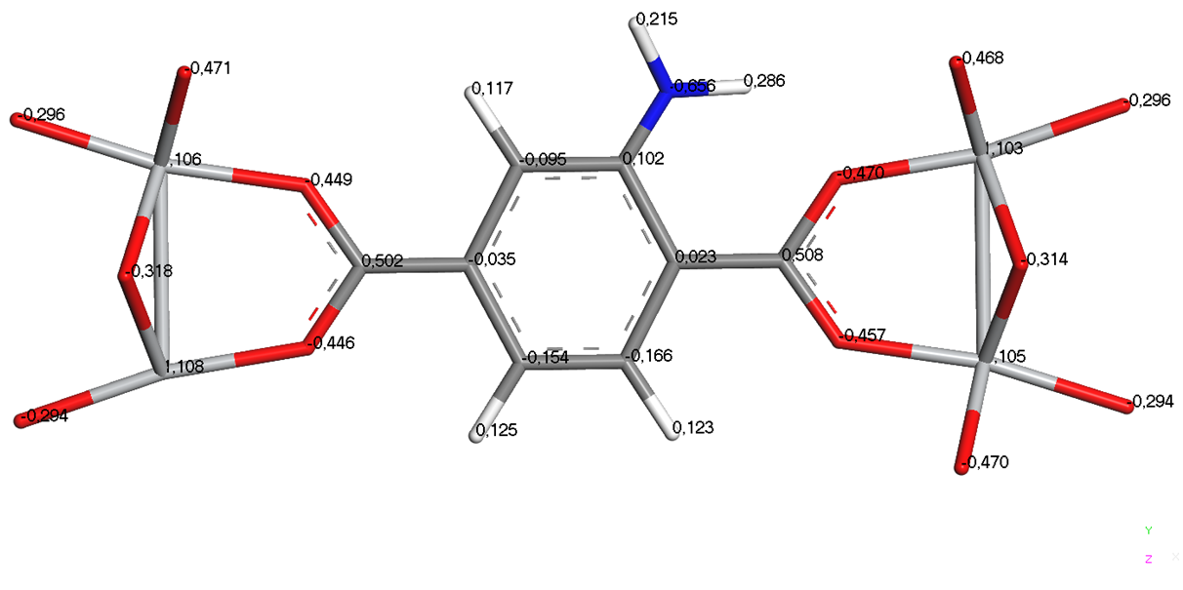
- MIL-125-NH₂
Figure S8.1.a. Partial charges obtained from molecular simulations for MIL-125-NH₂.

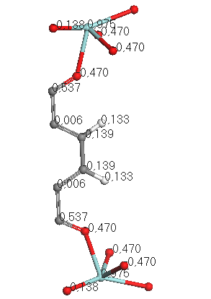
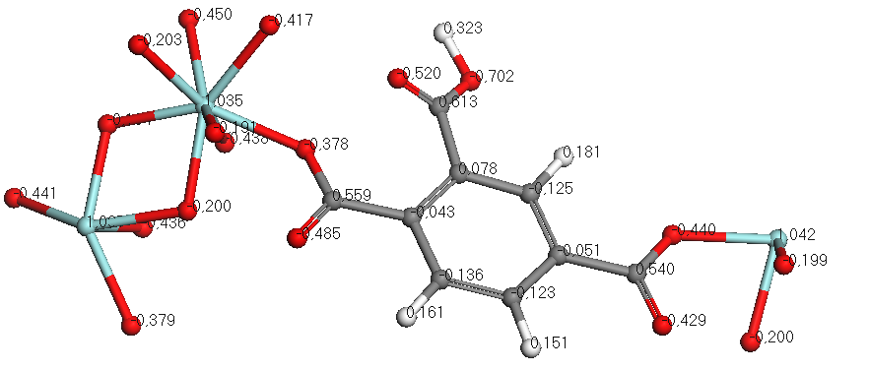
- UiO-66 C) UiO-66-COOH

Figure S8.1.b,c. Partial charges obtained from molecular simulations for: b) UiO-66 and c) UiO-66-COOH.

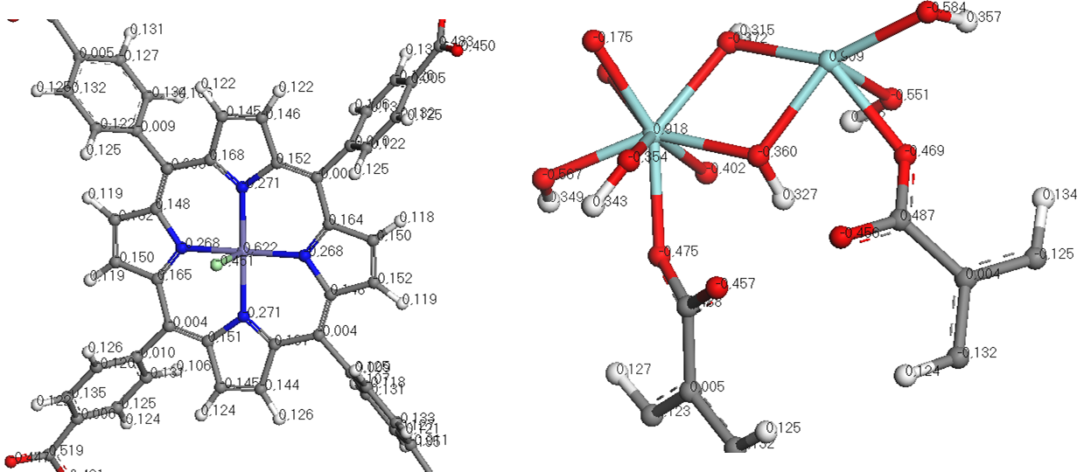
- PCN-222

Figure S8.1.d. Partial charges obtained from molecular simulations for PCN-222.

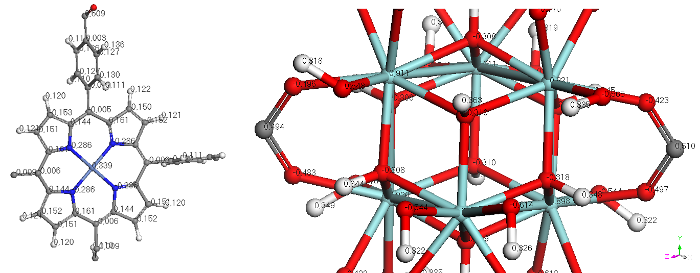
- PCN-224

Figure S8.1.e. Partial charges obtained from molecular simulations for PCN-224.

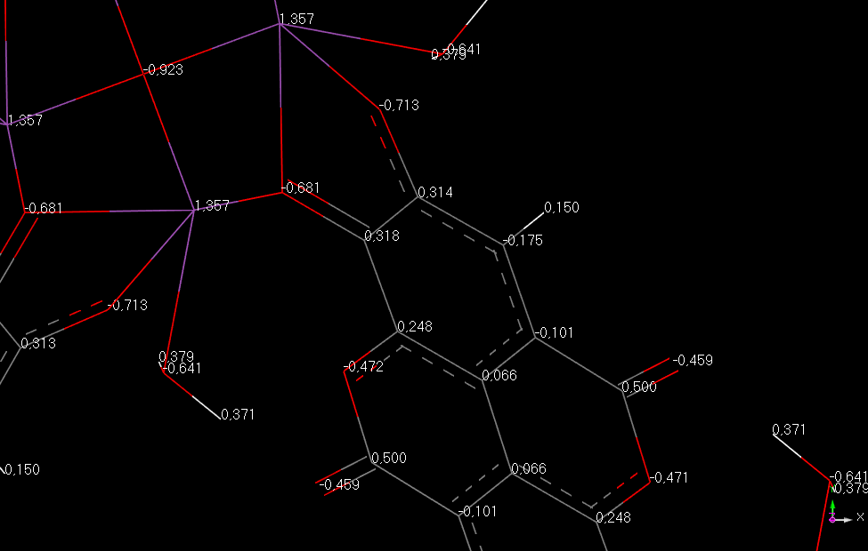
- SU-101

Figure S8.1.f. Partial charges obtained from DFT molecular simulations for SU-101.
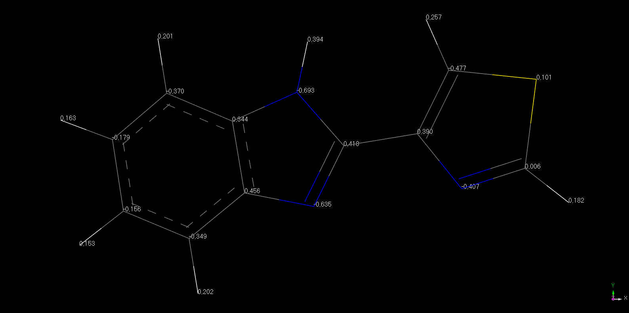
- TBZ

Figure S8.1.g. DFT calculations for partial charges extraction of TBZ molecule.

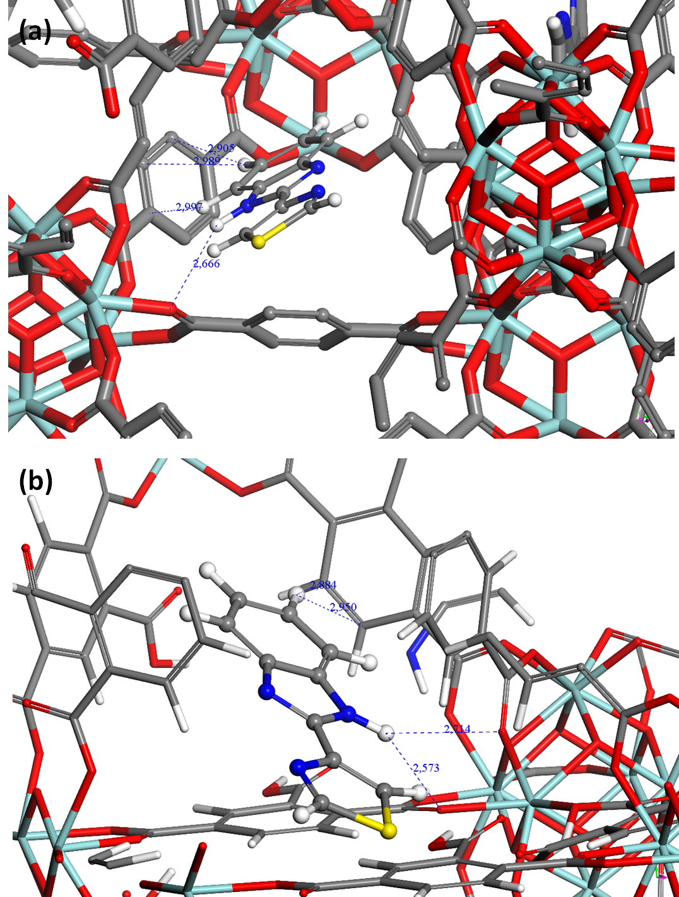
Figure S8.2. Snapshots extracted for: a) UiO-66 and b) UiO-66-COOH from Monte Carlo simulations.

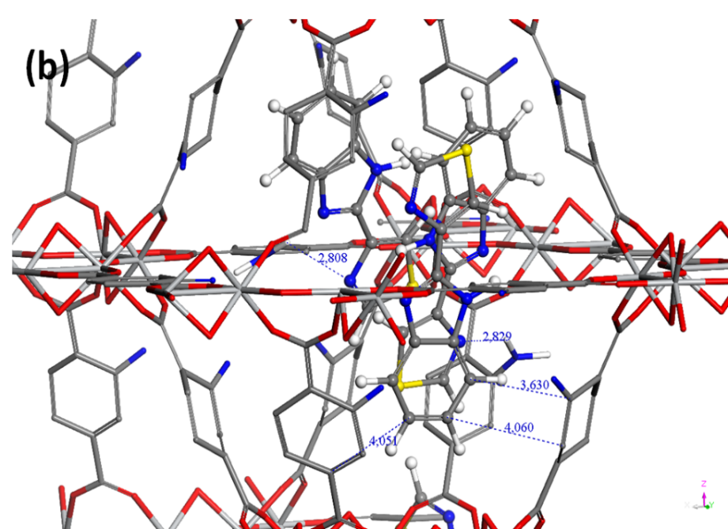
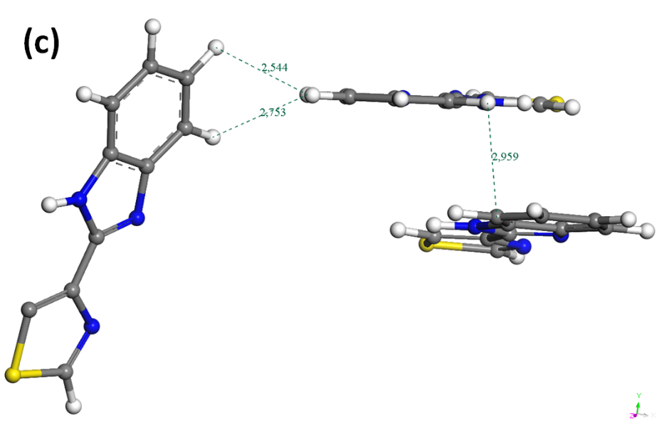
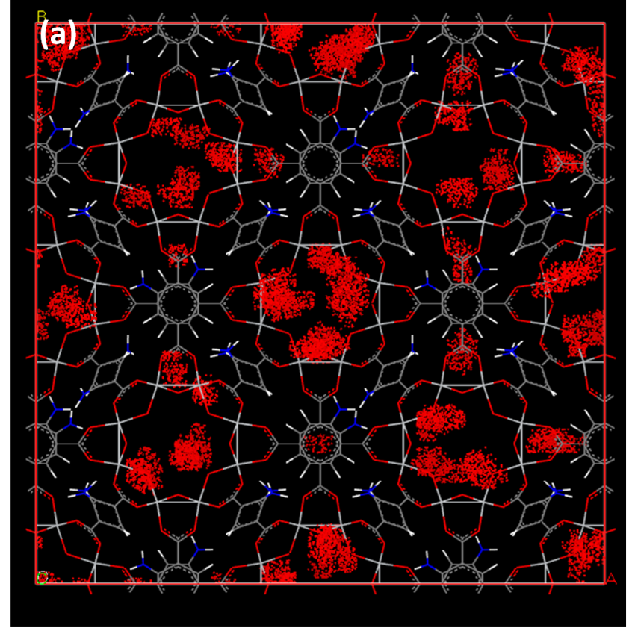
Figure S8.3. a) Density of Presence for TBZ in MIL-125-NH₂ and snapshots reporting the interaction distances between: b) TBZ and framework atoms and c) pi-stacking in the pores between TBZ.
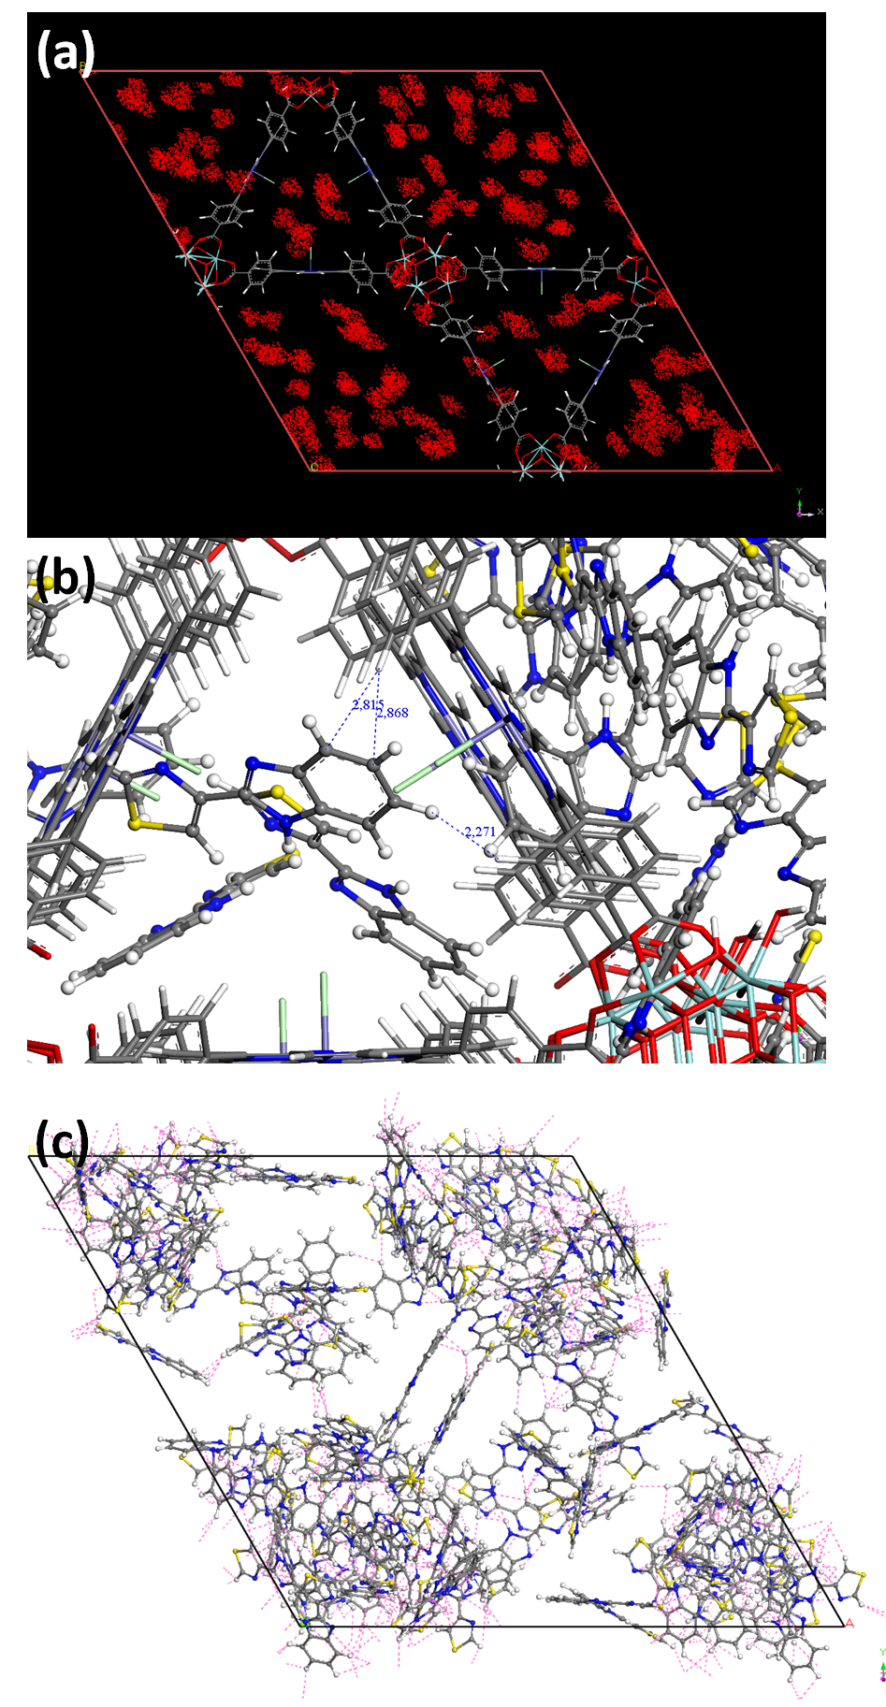
Figure S8.4. a) Density of Presence for TBZ in PCN-222 and snapshots reporting the interaction distances between: b) TBZ and framework atoms and c) pi-stacking in the pores between TBZ.
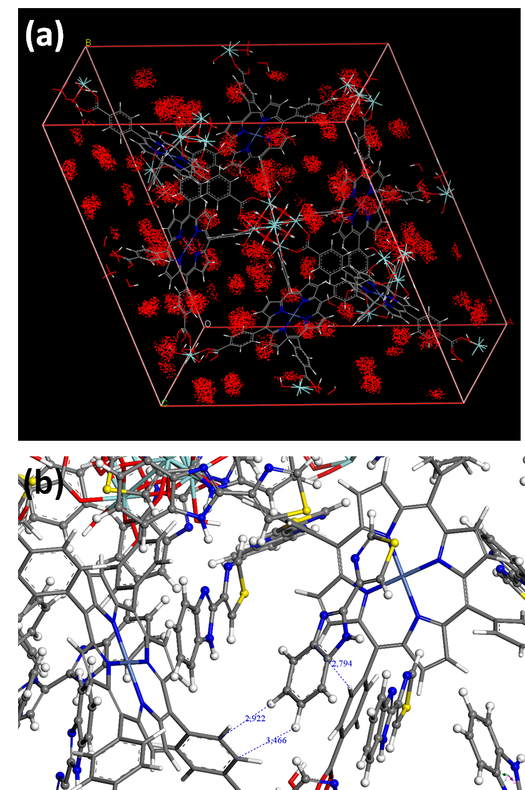

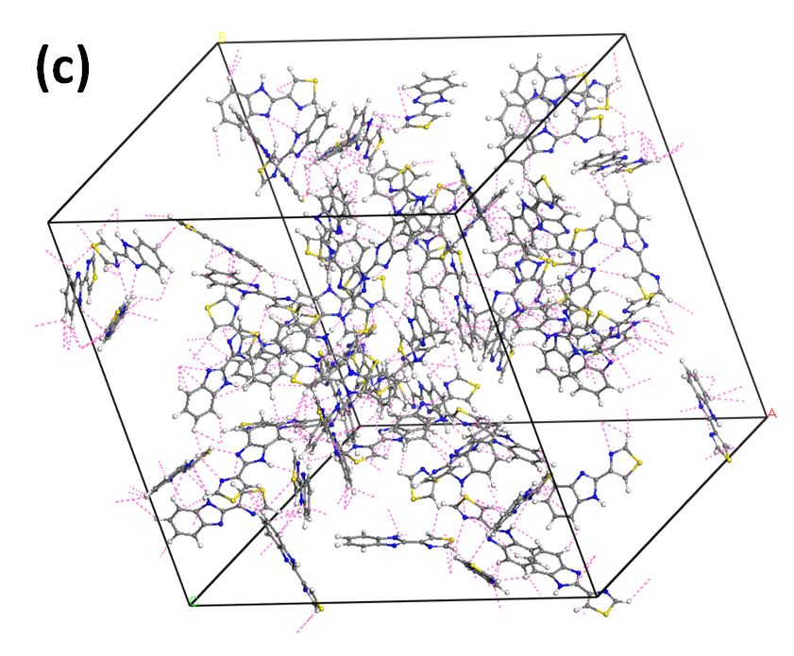

Figure S8.5. a) Density of Presence for TBZ in PCN-224 and snapshots reporting the interaction distances between: b) TBZ and framework atoms and c) pi-stacking in the pores between TBZ.
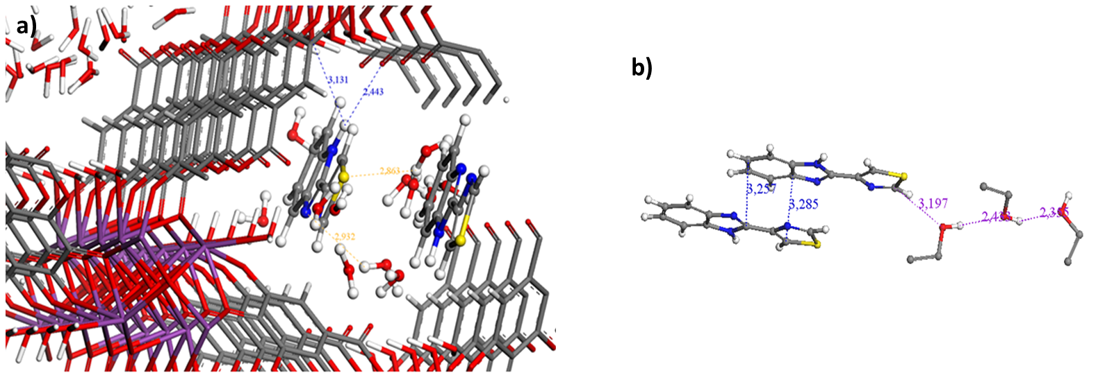
Figure S8.6. Snapshots reporting the interaction distances between TBZ and SU-101 framework atoms: a) in presence of water and b) ethanol.

Table S8. Adsorption enthalpy and saturation values (without taking into account the presence of solvent) extracted from Monte Carlo simulations for TBZ in the investigated MOFs.
MOF sample | Thiabendazole saturation (g.g⁻¹) | Adsorption enthalpy (kJ.mol⁻¹)
UiO-66 | 0.147 | 88
UiO-66-COOH | 0.059 | 110
MIL-125-NH₂ | 0.43 | 151
MIL-100 | 0.6 | 162
MIL-101 | 1.24 | 153
PCN-222 | 1.6 | 193
PCN-224 | 1.6 | 198
SU-101 | 0.06 | 145

S9. TBZ removal performances
Table S9. TBZ removal performances for tested materials in shorter (5 min) and longer times (60 min).
Material | % TBZ removed |  | µg TBZ · mg⁻¹ MOF |  | mmol TBZ · mol⁻¹ MOF
Material | 5 min | 60 min | 5 min | 60 min | 5 min | 60 min
UiO-66 | 8 ± 1 | 10 ± 1 | 0.77 ± 0.02 | 1.01 ± 0.04 | 6 ± 1 | 8 ± 1
UiO-66-COOH | 17 ± 1 | 26 ± 2 | 1.03 ± 0.03 | 1.63 ± 0.06 | 9 ± 1 | 15 ± 1
MIL-125-NH₂ | 95 ± 2 | 96 ± 2 | 6.09 ± 0.11 | 6.14 ± 0.08 | 50 ± 1 | 51 ± 1
MIL-100(Fe) | 23 ± 5 | 22 ± 8 | 3.33 ± 2.12 | 3.22 ± 2.36 | 11 ± 7 | 10 ± 7
MIL-101(Cr) | 18 ± 1 | 20 ± 2 | 1.16 ± 0.03 | 1.31 ± 0.05 | 4 ± 1 | 5 ± 1
PCN-222 | 94 ± 3 | 93 ± 3 | 5.49 ± 0.19 | 5.47 ± 0.22 | 33 ± 1 | 33 ± 1
PCN-224 | 88 ± 2 | 89 ± 2 | 5.69 ± 0.15 | 5.71 ± 0.16 | 116 ± 3 | 116 ± 3
SU-101 | 89 ± 5 | 96 ± 1 | 6.56 ± 0.27 | 6.97 ± 0.21 | 29 ± 1 | 31 ± 1

S10. Particle size and ζ-potential of powder materials
Table S10. ζ-potential and particle size of the screened materials in tap water.
MOFs | ζ-potential (mV)
UiO-66 | -15 ± 3
UiO-66-COOH | -14 ± 4
MIL-125-NH₂ | -28 ± 5
MIL-100(Fe) | -28 ± 4
MIL-101(Cr) | -23 ± 6
PCN-224 | -30 ± 4
PCN-222 | -29 ± 5
SU-101 | -22 ± 4

S11. MOFs characterization after TBZ encapsulation (screening)
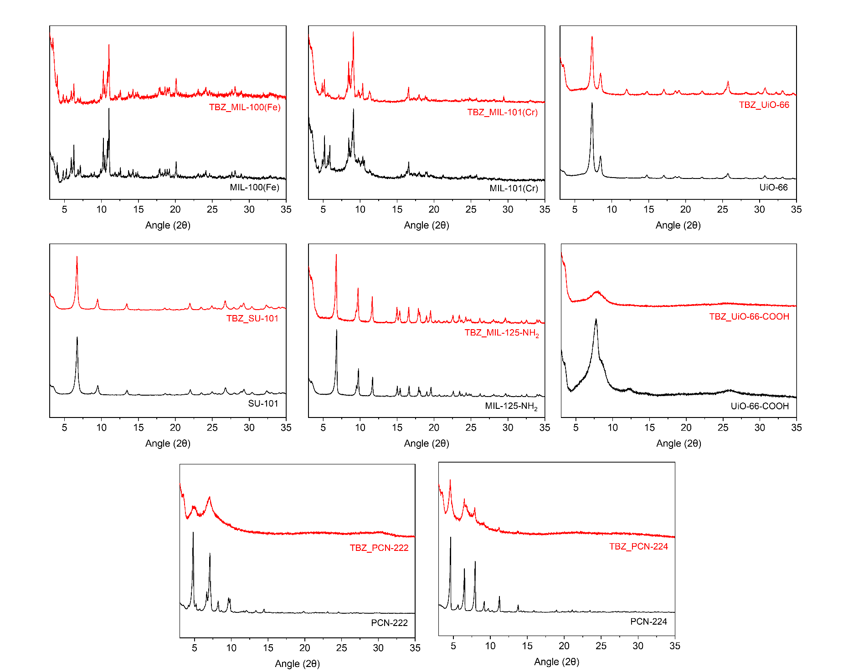
Figure S11. PXRD patterns of tested MOFs before (black) and after (red) TBZ adsorption process (1h) under batch conditions.
S12. Pellets characterization after shaping process (PXRD and N₂ sorption)
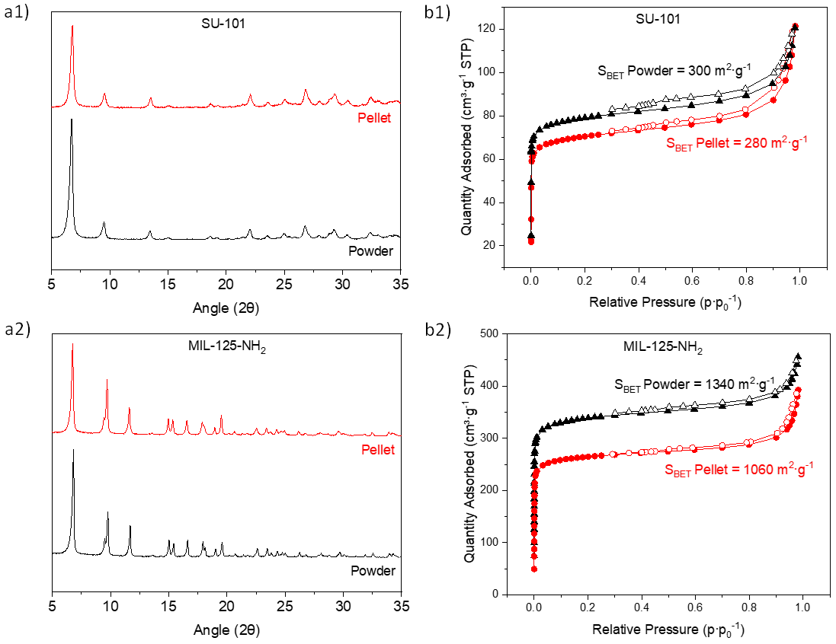
Figure S12. a) XRD patterns and b) N₂ sorption isotherms before and after the MOF shaping. Empty and solid symbols correspond to the adsorption and desorption branches of the isotherm, respectively.

S13. Continuous flow experimental set-up
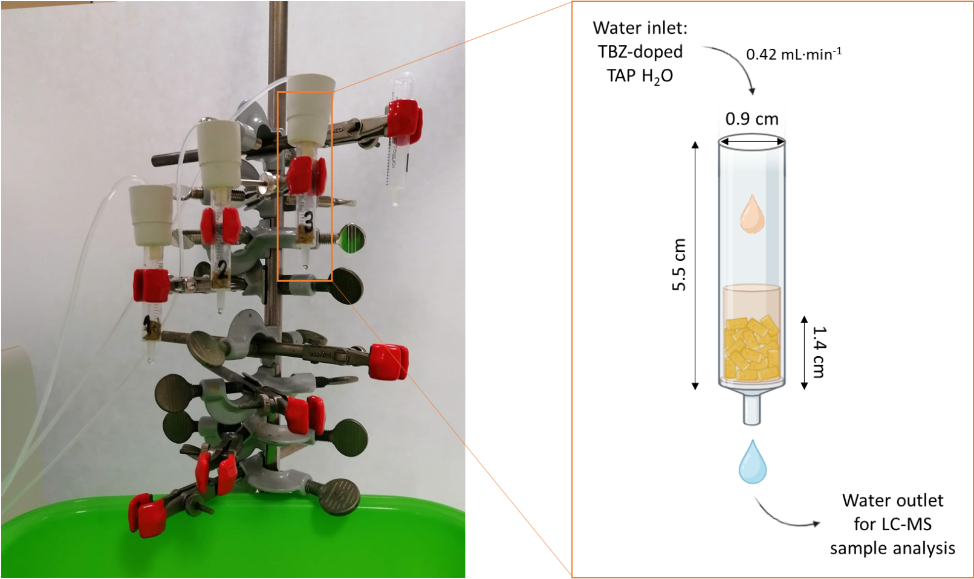
Figure S13. Continuous flow experimental set-up and column dimensions.

S14. Continuous flow tests

14.1. SEM images of SU-101 before and after continuous flow
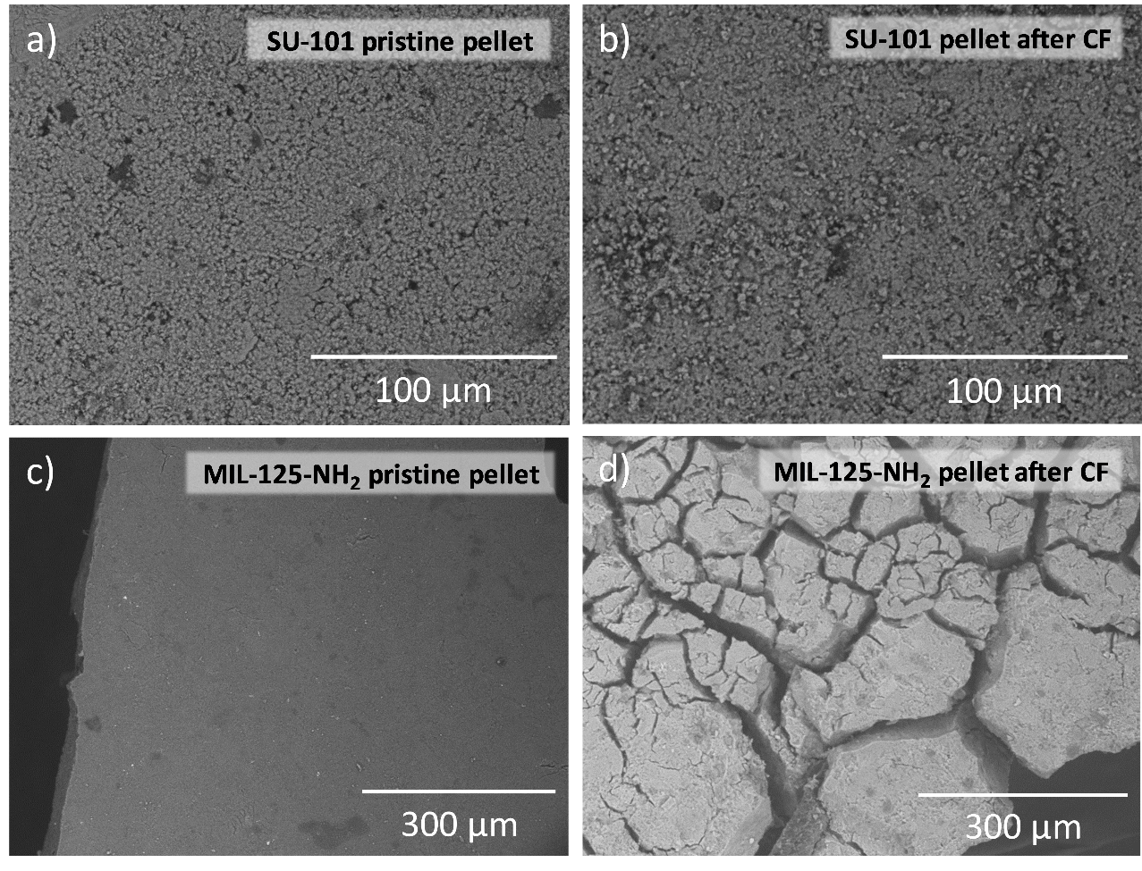
Figure S14.1. SEM images of pelletized SU-101 at 100 µm scale, objective: 300x, a) pristine pellet and b) after continuous flow; MIL-125-NH2 at 300 µm scale, objective: x 1000, c) pristine pellet and d) after continuous flow (CF).

14.2. Pellets characterization (XRD and N₂ sorption)
Figure S14.2. a) XRD pattern and b) N₂ adsorption isotherms of MOF pellets before and after continuous flow experiments

S15. SU-101 cyclability
Figure S15. PXRD patterns of SU-101 before (black) and after (red) 3 cycles of continuous flow (a); N₂ adsorption isotherms of SU-101 pellets after cycle 3 (b); SU-101 pellets after cycle 3.

References
Canioni, R. et al. (2011) ‘Stable polyoxometalate insertion within the mesoporous metal organic framework MIL-100(Fe)’, Journal of Materials Chemistry, 21(4), pp. 1226–1233. Available at: https://doi.org/10.1039/c0jm02381g.
Carrasco, S. et al. (2023) ‘Hf/porphyrin-based metal-organic framework PCN-224 for CO₂ cycloaddition with epoxides’, Materials Today Advances, 19, p. 100390. Available at: https://doi.org/10.1016/j.mtadv.2023.100390.
Carrasco, S., Sanz-Marco, A. and Martín-Matute, B. (2019) ‘Fast and Robust Synthesis of Metalated PCN-222 and Their Catalytic Performance in Cycloaddition Reactions with CO₂’, Organometallics, 38(18), pp. 3429–3435. Available at: https://doi.org/10.1021/acs.organomet.9b00273.
Cavka, J.H. et al. (2008) ‘A new zirconium inorganic building brick forming metal organic frameworks with exceptional stability’, Journal of the American Chemical Society, 130(42), pp. 13850–13851. Available at: https://doi.org/10.1021/ja8057953.
Cunha, D. et al. (2013) ‘Rationalization of the entrapping of bioactive molecules into a series of functionalized porous zirconium terephthalate MOFs’, Journal of Materials Chemistry B, 1(8), pp. 1101–1108. Available at: https://doi.org/10.1039/c2tb00366j.
Férey, G. et al. (2005) ‘A Chromium Terephthalate-Based Solid with Unusually Large Pore Volumes and Surface Area’, Science, 309(5743), pp. 2040–2042. Available at: https://doi.org/10.1126/science.1116275.
Grape, E.S. et al. (2020) ‘A robust and biocompatible bismuth ellagate MOF synthesized under green ambient conditions’, Journal of the American Chemical Society, 142(39), pp. 16795–16804. Available at: https://doi.org/10.1021/jacs.0c07525.
Moreira, M.A. et al. (2012) ‘Effect of ethylbenzene in p-xylene selectivity of the porous titanium amino terephthalate MIL-125(Ti)-NH₂’, Microporous and Mesoporous Materials, 158, pp. 229–234. Available at: https://doi.org/10.1016/j.micromeso.2012.03.039.
Ragon, F. et al. (2015) ‘Acid-functionalized UiO-66(Zr) MOFs and their evolution after intra-framework cross-linking: Structural features and sorption properties’, Journal of Materials Chemistry A, 3(7), pp. 3294–3309. Available at: https://doi.org/10.1039/c4ta03992k.

