China’s Water Security under SSP–RCP Scenarios: A System-Dynamics Evaluation of Trends, Drivers and Spatial Patterns
Supplement information
Table of contents
Metric weight calculation 2
Water security and subsystem score calculations 3
System dynamics model test 6
Formulas for specific functions of system dynamics 7

Metric weight calculation
Table 1. The entropy weight method calculates the objective weight of each index
Objective weight of each index (entropy weight method)
Groundwater resources | 2.01% | Degree of surface water development | 3.32% | River water quality compliance rate | 2.72% | Industrial wastewater discharge | 3.14%
Surface water resources | 1.76% | Water for agriculture | 2.84% | Occupancy rate of water quality above category III | 3.89% | Total wastewater discharge | 3.12%
Quantity of rain | 2.04% | Industrial water | 4.39% | Water pollution accident | 2.79% | Number of sewage treatment plants | 3.06%
Water supply | 1.51% | Dynamics of water storage | 1.93% | Industrial wastewater discharge compliance rate | 1.17% | Investment in industrial wastewater treatment | 2.94%
Water consumption | 2.27% | Domestic water | 2.69% | Water quality compliance rate of urban centralized drinking water sources | 1.95% | COD emissions from industrial wastewater | 5.47%
Water resources per capita | 1.79% | Ecosystem recharge | 7.51% | Domestic sewage discharge | 3.17% | Number of heavy rainfalls | 2.89%
Water penetration rate | 1.41% | Urban sewage treatment rate | 1.52% | COD discharge from domestic sewage | 5.47% | Numbered Floods | 1.35%
Degree of groundwater development | 2.42% | Lake water quality compliance rate | 2.67% | Total COD discharge from wastewater | 5.47% | Flood deaths and missing persons | 0.85%
Direct economic losses from floods | 2.37% | Investment in drainage infrastructure development | 3.29% | Rivers in excess of warning floods | 1.45% | Forest cover | 1.35%

Table 2. Expert scores to calculate the weight of supervisors in the four subsystems, considering that there is a large difference in subjective weight scoring for each indicator, the subjective weight scoring is directly conducted for the four subsystems for calculation.
Subjective weights of subsystems (analytic hierarchy process)
Water quantity | Water quality | Water pollution | Flood disasters
37.9% | 16.7% | 31.9% | 13.6%

Water security and subsystem score calculations
Table 3. The specific score calculation methods of the four subsystems, the indicators involved in the equation calculation are determined based on the comprehensive weights of the indicators. Mainly, the indicators with a relatively large proportion of weights are selected for score calculation to ensure the objective accuracy of the calculation results.
The formula for calculating the score of each subsystem
Water quantity score | IF(Water supply<0,(Water consumption- Water supply)/ Water supply *100,(Water supply - Water consumption)/ Water supply *100)
Water quality score | （Class III. or above water quality occupancy*0.1+ River water quality compliance rate  *0.1+ Lake water quality compliance rate*0.1+ The water quality compliance rate of drinking water sources*0.7）*100
Water pollution score | 100- Waste water COD/Total population*20000
Flood disasters score | 100- Flood economic losses/ Total population*10⁸
Water security score | Water quantity score *0.45+ Water quality score *0.223+ Water pollution score *0.23+ Flood disasters score *0.097

Table 4. Division of Grade Thresholds for Rating Indicators
Index |  | Level
 |  | Poor | Average | Good | Excellent
Water quantity | X1 Groundwater resources | ＜7210 | 7210-8010 | 8010-8810 | ＞8810
Water quantity | X2 Surface water resources | ＜2220 | 2220-2720 | 2720-3120 | ＞3120
Water quantity | X3 Quantity of rain | ＜590 | 590-660 | 660-730 | ＞730
Water quantity | X4 Water supply | ＜5910 | 5910-6020 | 6020-6120 | ＞6120
Water quantity | X5 Water consumption | ＜5850 | 5850-5950 | 5950-6050 | ＞6050
Water quantity | X6 Water resources per capita | ＜420 | 420-440 | 440-460 | ＞460
Water quantity | X7 Water penetration rate | ＜96 | 96-98 | 98-99 | ＞99
Water quantity | X8 Degree of groundwater development | ＜0.132 | 0.132-0.145 | 0.145-0.158 | ＞0.158
Water quantity | X9 Degree of surface water development | ＜0.153 | 0.153-0.173 | 0.173-193 | ＞0.193
Water quantity | X10 Water for agriculture | ＜3620 | 3620-3750 | 3750-3880 | ＞3880
Water quantity | X11 Industrial water | ＜1080 | 1080-1280 | 1280-1480 | ＞1480
Water quantity | X12 Dynamics of water storage | ＜3070 | 3070-3770 | 3770-4470 | ＞4470
Water quantity | X13 Domestic water | ＜730 | 730-810 | 810-900 | ＞900
Water quantity | X14 Ecosystem recharge | ＜110 | 100-170 | 170-340 | ＞340
Water quality | X15 Urban sewage treatment rate | ＜60 | 60-80 | 80-90 | ＞90
Water quality | X16 Lake water quality compliance rate | ＜40 | 40-60 | 60-80 | ＞80
Water quality | X17 River water quality compliance rate | ＜50 | 50-70 | 70-90 | ＞90
Water quality | X18 Occupancy rate of water quality above category III | ＜50 | 50-70 | 70-90 | ＞90
Water quality | X19 Water pollution accident | ＞80 | 70-80 | 60-70 | ＜60
Water quality | X20 Industrial wastewater discharge compliance rate | ＜92 | 92-96 | 96-98 | ＞98
Water quality | X21 Water quality compliance rate of urban centralized drinking water sources | ＜75 | 75-89 | 89-95 | ＞95
Water pollution | X22 Domestic sewage discharge | ＞460 | 416-460 | 374-416 | ＜374
Water pollution | X23 COD discharge from domestic sewage | ＞1500 | 1230-1500 | 680-1230 | ＜680
Water pollution | X24 Industrial wastewater discharge | ＞310 | 280-310 | 240-280 | ＜240
Water pollution | X25 COD emissions from industrial wastewater | ＞880 | 660-880 | 440-660 | ＜440
Water pollution | X26 Total COD discharge from wastewater | ＞2380 | 1890-2380 | 1120-1890 | ＜1120
Water pollution | X27 Number of sewage treatment plants | ＜2000 | 2000-6800 | 6800-12000 | 12000
Water pollution | X28 Investment in industrial wastewater treatment | ＞150 | 105-150 | 35-105 | ＜35
Water pollution | X29 Total wastewater discharge | ＞770 | 690-770 | 610-690 | ＜610
Flood disasters | X30 Number of heavy rainfalls | ＞50 | 40-50 | 30-40 | ＜30
Flood disasters | X31 Numbered Floods | ＞15 | 10-15 | 5-10 | ＜5
Flood disasters | X32 Rivers in excess of warning floods | ＞630 | 430-630 | 230-430 | ＜230
Flood disasters | X33 Direct economic losses from floods | ＞3110 | 2110-3110 | 1110-2110 | ＜1110
Flood disasters | X34 Forest coverage rate | ＜20 | 20-21.5 | 21.5-23 | ＞23
Flood disasters | X35 Drainage pipe length | ＜31.5 | 51.5-71.3 | 71.3-91.3 | ＞91.3
Flood disasters | X36 Flood deaths and missing persons | ＞890 | 830-890 | 170-830 | ＜170
Flood disasters | X37 Investment in drainage infrastructure construction | ＜930 | 930-1560 | 1560-2710 | ＞2710
Table 5. Score Thresholds Corresponding to the Levels of Water Security and Its Sub - systems
 | Evaluation grade threshold
 | Poor | Average | Good | Excellent
Water quantity | 0-91.236 | 91.237-93.808 | 93.809-96.324 | 96.325-100
Water quality | 0-89.533 | 89.534-92.833 | 92.834-94.933 | 94.934-100
Water pollution | 0-75.736 | 75.737-84.507 | 84.508-90.907 | 90.908-100
Flood disasters | 0-74.6 | 74.601-89.366 | 89.367-94.583 | 94.584-100
Water security | 0-90.34 | 90.341-92.12 | 92.121-94.73 | 94.731-100

System dynamics model test
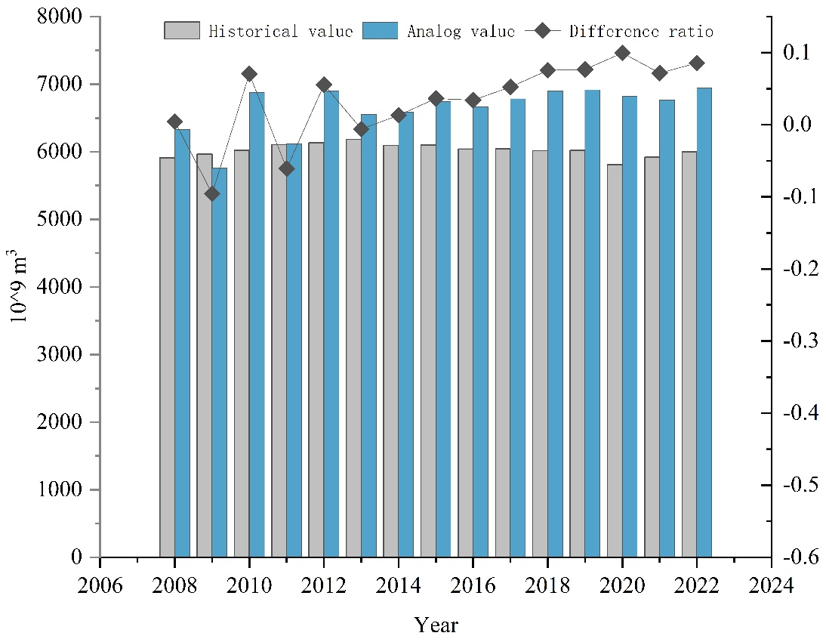
Fig. 1 The historical test of the model, through the comparison of the historical value of water supply with the simulated value, the error is within 10%, indicating that the model is real and effective.
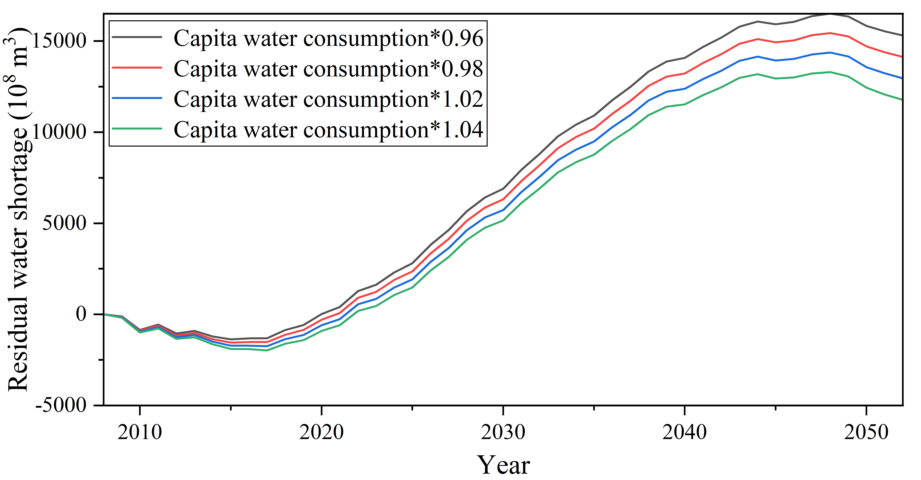
Fig. 2 Adjusting the per capita water consumption index by -2%, -4%, +2%, and +4%, and then observing the change of residual water shortage, it can be found that the change does not change significantly, indicating that the sensitivity of the model is qualified.

Formulas for specific functions of system dynamics
Specific parameters, equations and functions of the SSP2 - RCP4.5 scenario：
(01) Residual water deficit(t) = Residual water deficit(t - dt) + (Water supply – Water consumption) * dt
INIT Residual water deficit = 0
INFLOWS:
Water supply = Surface water supply + Underground water supply
OUTFLOWS:
Water consumption = Domestic water + Ecosystem recharge + Water for agriculture + Water for industry

(02) Direct economic losses from floods(t) = Direct economic losses from floods(t - dt) + (Incremental economic loss) * dt
INIT Direct economic losses from floods = 0
INFLOWS:
Incremental economic loss = Rivers in excess of warning floods missing and dead persons/7+Numbered floods*190

(03) Total COD(t) = Total COD(t - dt) + (Incremental COD) * dt
INIT Total COD = 0
INFLOWS:
Incremental COD = Domestic wastewater COD^0.99+Industrial wastewater COD^0.99

(04) Total population(t) = Total population(t - dt) + (Population increase – Population decrease) * dt
INIT Total population = 13.28*10^9
INFLOWS:
Population increase = Total population*(Population growth rate/10^4-Missing and dead persons/10^6+0.00081)
OUTFLOWS:
Population decrease = Total population*(Population decrease rate/10^4+Missing and dead persons/10^6)

(05) Capita water consumption = 439.533

(06) Degree of groundwater development = 0.149-Incremental economic loss/10^6

(07) Degree of surface water development = 0.15

(08) Domestic sewage discharge = 4891*Domestic water

0(9) Domestic sewage treatment rate = (LN(Number of sewage treatment plants)*14.719-51.59)/100

(10) Domestic wastewater COD = 0.000329*Domestic sewage discharge^1.01

(11) Domestic water = ((Total population/10^9)*Capita water consumption*Water penetration rate*Drinking water source water quality compliance rate)/5.3

(12) Drinking water source water quality compliance rate = (3.3647*(Lake water quality compliance rate*0.239+River water quality compliance rate*0.383+Occupancy rate of water quality above category III*0.375)-0.0205*(Lake water quality compliance rate*0.239+River water quality compliance rate*0.383+Occupancy rate of water quality above category III*0.375)^2-40.035)/100

(13) Dynamics of water storage = GRAPH(TIME)
(2008, 3083), (2009, 2816), (2010, 3405), (2011, 3197), (2012, 3656), (2013, 3401), (2014, 3749), (2015, 4037), (2016, 3954), (2017, 4080), (2018, 4104), (2019, 4118), (2020, 4359), (2021, 4449), (2022, 3928), (2023, 3928), (2024, 4006), (2025, 4368), (2026, 4287), (2027, 4420), (2028, 4303), (2029, 4384), (2030, 4747), (2031, 4667), (2032, 4803), (2033, 4691), (2034, 4773), (2035, 5138), (2036, 5059), (2037, 5195), (2038, 5088), (2039, 5171), (2040, 5536), (2041, 5458), (2042, 5595), (2043, 5490), (2044, 5574), (2045, 5940), (2046, 5862), (2047, 6000), (2048, 5897), (2049, 5981), (2050, 6347), (2051, 6270), (2052, 6408)

(14) Ecosystem recharge = GRAPH(TIME)
(2008, 118), (2009, 101), (2010, 120), (2011, 116), (2012, 110), (2013, 105), (2014, 104), (2015, 122), (2016, 145), (2017, 163), (2018, 199), (2019, 247), (2020, 308), (2021, 320), (2022, 342), (2023, 345), (2024, 367), (2025, 371), (2026, 393), (2027, 396), (2028, 418), (2029, 421), (2030, 444), (2031, 447), (2032, 469), (2033, 472), (2034, 494), (2035, 498), (2036, 520), (2037, 523), (2038, 545), (2039, 548), (2040, 571), (2041, 574), (2042, 596), (2043, 599), (2044, 621), (2045, 625), (2046, 647), (2047, 650), (2048, 672), (2049, 675), (2050, 698), (2051, 701), (2052, 723)

(15) Forest cover = 0.215

(16) Groundwater resources = GRAPH(TIME)
(2008, 8122), (2009, 7267), (2010, 8417), (2011, 7215), (2012, 8296), (2013, 8081), (2014, 7745), (2015, 7797), (2016, 8455), (2017, 8310), (2018, 8247), (2019, 8192), (2020, 8554), (2021, 8196), (2022, 7924), (2023, 7973), (2024, 8437), (2025, 8396), (2026, 8252), (2027, 8043), (2028, 8744), (2029, 8189), (2030, 8653), (2031, 8612), (2032, 8468), (2033, 8259), (2034, 8960), (2035, 8405), (2036, 8869), (2037, 8828), (2038, 8684), (2039, 8475), (2040, 9176), (2041, 8621), (2042, 9084), (2043, 9044), (2044, 8900), (2045, 8691), (2046, 9392), (2047, 8836), (2048, 9300), (2049, 9260), (2050, 9116), (2051, 8907), (2052, 9608)

(17) Industrial wastewater COD = Industrial wastewater discharge^1.01*0.000237

(18) Industrial wastewater discharge = (99734.26401365828+5930.194114748761*Water for industry-2.942634875292459*Water for industry^2)

(19) Industrial wastewater discharge compliance rate = 99.43429930599667-3.129901606856568/10^6*Investment in industrial wastewater treatment+2.685061972795606/10^12*Investment in industrial wastewater treatment^2-1.363505191381588/10^18*Investment in industrial wastewater treatment^3

(20) Investment in drainage facilities = GRAPH(TIME + Investment in industrial wastewater treatment/10^5)
(2008, 637), (2009, 1036), (2010, 1173), (2011, 972), (2012, 934), (2013, 1055), (2014, 1196), (2015, 1249), (2016, 1486), (2017, 1728), (2018, 1829), (2019, 1930), (2020, 2676), (2021, 2715), (2022, 2821), (2023, 2904), (2024, 2973), (2025, 3082), (2026, 3165), (2027, 3234), (2028, 3343), (2029, 3426), (2030, 3495), (2031, 3604), (2032, 3687), (2033, 3756), (2034, 3866), (2035, 3949), (2036, 4017), (2037, 4127), (2038, 4210), (2039, 4278), (2040, 4388), (2041, 4471), (2042, 4540), (2043, 4649), (2044, 4732), (2045, 4801), (2046, 4910), (2047, 4993), (2048, 5062), (2049, 5171), (2050, 5254), (2051, 5323), (2052, 5432)

(21) Investment in industrial wastewater treatment = 2514288.12699338*EXP(-0.000145398479634693 *Number of sewage treatment plants)+Total COD/10

(22) Lake water quality compliance rate = 100-(water pollution accident/0.96)^1.02+20

(23) Missing and dead persons = 700

(24) Modulus of water yield = 0.0039

(25) Numbered floods = 25.38038054972242-1.667249401460666*Number of heavy rainfalls+0.03148331832166361*Number of heavy rainfalls^2-INT((Investment in drainage facilities)/1000)

(26) Number of heavy rainfalls = GRAPH(TIME)
(2008, 43.0), (2009, 39.0), (2010, 47.0), (2011, 34.0), (2012, 46.0), (2013, 42.0), (2014, 30.0), (2015, 32.0), (2016, 38.0), (2017, 40.0), (2018, 39.0), (2019, 44.0), (2020, 48.0), (2021, 42.0), (2022, 38.0), (2023, 35.0), (2024, 41.0), (2025, 42.0), (2026, 43.0), (2027, 42.0), (2028, 50.0), (2029, 45.0), (2030, 37.0), (2031, 36.0), (2032, 42.0), (2033, 43.0), (2034, 44.0), (2035, 43.0), (2036, 50.0), (2037, 46.0), (2038, 38.0), (2039, 37.0), (2040, 43.0), (2041, 44.0), (2042, 45.0), (2043, 44.0), (2044, 51.0), (2045, 46.0), (2046, 39.0), (2047, 38.0), (2048, 44.0), (2049, 45.0), (2050, 46.0), (2051, 44.0), (2052, 52.0)

(28) Number of sewage treatment plants = GRAPH(TIME)
(2008, 1692), (2009, 2192), (2010, 2881), (2011, 3974), (2012, 4628), (2013, 5364), (2014, 6031), (2015, 6910), (2016, 7103), (2017, 7536), (2018, 8200), (2019, 9322), (2020, 11055), (2021, 12586), (2022, 12702), (2023, 12726), (2024, 13356), (2025, 13801), (2026, 14766), (2027, 15421), (2028, 15885), (2029, 16865), (2030, 17534), (2031, 18008), (2032, 18998), (2033, 19675), (2034, 20157), (2035, 21154), (2036, 21837), (2037, 22324), (2038, 23325), (2039, 24012), (2040, 24504), (2041, 25509), (2042, 26199), (2043, 26694), (2044, 27702), (2045, 28396), (2046, 28893), (2047, 29904), (2048, 30599), (2049, 31099), (2050, 32111), (2051, 32809), (2052, 33310)

(29) Occupancy rate of water quality above category III = 100-(Water pollution accident/14)^2
Population decrease rate = GRAPH(TIME+ Water consumption/10^4)
(2008, 0.00), (2009, 0.00), (2010, 0.00), (2011, 0.00), (2012, 0.00), (2013, 0.00), (2014, 0.00), (2015, 0.00), (2016, 0.00), (2017, 0.00), (2018, 0.00), (2019, 0.00), (2020, 0.00), (2021, 0.00), (2022, 6.00), (2023, 0.00), (2024, 0.00), (2025, 0.00), (2026, 7.00), (2027, 4.00), (2028, 3.00), (2029, 0.00), (2030, 0.00), (2031, 1.00), (2032, 4.00), (2033, 3.00), (2034, 2.00), (2035, 1.00), (2036, 0.00), (2037, 0.00), (2038, 0.00), (2039, 0.00), (2040, 0.00), (2041, 0.00), (2042, 0.00), (2043, 0.00), (2044, 0.00), (2045, 0.00), (2046, 0.00), (2047, 0.00), (2048, 0.00), (2049, 0.00), (2050, 0.00), (2051, 0.00), (2052, 0.00)

(30) Population growth rate = GRAPH(TIME+ Water supply/10^4)
(2008, 51.0), (2009, 59.0), (2010, 58.0), (2011, 61.0), (2012, 74.0), (2013, 59.0), (2014, 67.0), (2015, 59.0), (2016, 65.0), (2017, 66.0), (2018, 48.0), (2019, 33.0), (2020, 24.0), (2021, 13.0), (2022, 0.00), (2023, 4.00), (2024, 0.00), (2025, 1.00), (2026, 0.00), (2027, 0.00), (2028, 0.00), (2029, 3.00), (2030, 2.00), (2031, 0.00), (2032, 0.00), (2033, 0.00), (2034, 0.00), (2035, 0.00), (2036, 2.00), (2037, 2.00), (2038, 3.00), (2039, 9.00), (2040, 7.00), (2041, 5.00), (2042, 8.00), (2043, 3.00), (2044, 1.00), (2045, 2.00), (2046, 3.00), (2047, 7.00), (2048, 8.00), (2049, 5.00), (2050, 3.00), (2051, 2.00), (2052, 2.00)

(31) Quantity of rainfall = 661+Number of heavy rainfalls

(32) Rivers in excess of warning floods = GRAPH(TIME +Quantity of rainfall/10^2)
(2008, 208), (2009, 212), (2010, 239), (2011, 263), (2012, 425), (2013, 384), (2014, 343), (2015, 336), (2016, 473), (2017, 471), (2018, 454), (2019, 615), (2020, 836), (2021, 571), (2022, 626), (2023, 701), (2024, 771), (2025, 822), (2026, 814), (2027, 776), (2028, 884), (2029, 895), (2030, 965), (2031, 1016), (2032, 1008), (2033, 970), (2034, 1078), (2035, 1089), (2036, 1159), (2037, 1210), (2038, 1202), (2039, 1163), (2040, 1272), (2041, 1283), (2042, 1352), (2043, 1403), (2044, 1395), (2045, 1357), (2046, 1466), (2047, 1476), (2048, 1546), (2049, 1597), (2050, 1589), (2051, 1551), (2052, 1660)

(33) River water quality compliance rate = 100-(Water pollution accident/14.7)^2-Total_COD/10^5

(34) Surface water resources = GRAPH(TIME)
(2008, 26377), (2009, 23125), (2010, 29798), (2011, 26214), (2012, 28373), (2013, 26840), (2014, 26264), (2015, 26901), (2016, 25274), (2017, 27746), (2018, 26323), (2019, 27993), (2020, 24407), (2021, 28311), (2022, 25984), (2023, 28022), (2024, 26755), (2025, 30477), (2026, 28829), (2027, 30882), (2028, 28925), (2029, 27658), (2030, 31381), (2031, 29733), (2032, 31786), (2033, 29829), (2034, 28562), (2035, 32285), (2036, 30636), (2037, 32690), (2038, 30733), (2039, 29466), (2040, 33188), (2041, 31540), (2042, 33593), (2043, 31636), (2044, 30369), (2045, 34092), (2046, 32444), (2047, 34497), (2048, 32540), (2049, 31273), (2050, 34996), (2051, 33347), (2052, 35401)

(35) Surface water supply = Modulus of water yield*Dynamics of water storage + Surface water resources*Degree of surface water development + Industrial wastewater discharge compliance rate*Industrial wastewater discharge*0.15/10^4+Domestic sewage discharge*Domestic sewage treatment rate*0.15/10^4+Quantity of rainfall-4435.66+Water for industry/1.8

(36) Underground water supply = Groundwater resources*Degree of groundwater development*(1+Forest cover/100)

(37) Water for agriculture = GRAPH(TIME)
(2008, 3664), (2009, 3722), (2010, 3692), (2011, 3744), (2012, 3899), (2013, 3933), (2014, 3870), (2015, 3851), (2016, 3768), (2017, 3766), (2018, 3693), (2019, 3682), (2020, 3612), (2021, 3644), (2022, 3781), (2023, 3783), (2024, 3830), (2025, 3816), (2026, 3768), (2027, 3771), (2028, 3817), (2029, 3803), (2030, 3756), (2031, 3758), (2032, 3804), (2033, 3790), (2034, 3743), (2035, 3745), (2036, 3792), (2037, 3778), (2038, 3730), (2039, 3732), (2040, 3779), (2041, 3765), (2042, 3717), (2043, 3720), (2044, 3766), (2045, 3752), (2046, 3705), (2047, 3707), (2048, 3753), (2049, 3739), (2050, 3692), (2051, 3694), (2052, 3741)

(38) Water for industry = GRAPH(TIME)
(2008, 1401), (2009, 1390), (2010, 1445), (2011, 1460), (2012, 1380), (2013, 1410), (2014, 1353), (2015, 1337), (2016, 1308), (2017, 1277), (2018, 1262), (2019, 1218), (2020, 1030), (2021, 1050), (2022, 968), (2023, 963), (2024, 927), (2025, 872), (2026, 933), (2027, 852), (2028, 846), (2029, 811), (2030, 755), (2031, 816), (2032, 735), (2033, 730), (2034, 694), (2035, 639), (2036, 700), (2037, 618), (2038, 613), (2039, 577), (2040, 522), (2041, 583), (2042, 502), (2043, 496), (2044, 461), (2045, 405), (2046, 466), (2047, 385), (2048, 380), (2049, 344), (2050, 289), (2051, 350), (2052, 269)

(39) Water penetration rate = 0.9781

(40) Water pollution accident = GRAPH(TIME)
(2008, 84.0), (2009, 79.0), (2010, 82.0), (2011, 80.0), (2012, 80.0), (2013, 68.0), (2014, 68.0), (2015, 77.0), (2016, 72.0), (2017, 71.0), (2018, 69.0), (2019, 67.0), (2020, 65.0), (2021, 63.0), (2022, 60.0), (2023, 68.0), (2024, 68.0), (2025, 66.0), (2026, 66.0), (2027, 59.0), (2028, 56.0), (2029, 65.0), (2030, 60.0), (2031, 60.0), (2032, 58.0), (2033, 57.0), (2034, 50.0), (2035, 47.0), (2036, 56.0), (2037, 51.0), (2038, 51.0), (2039, 50.0), (2040, 49.0), (2041, 42.0), (2042, 39.0), (2043, 48.0), (2044, 43.0), (2045, 43.0), (2046, 41.0), (2047, 40.0), (2048, 33.0), (2049, 30.0), (2050, 39.0), (2051, 35.0), (2052, 34.0)

