Synergistic adsorption–photocatalysis in TiO₂/activated carbon composites: optimization of p-nitrophenol degradation and application to real textile wastewater treatment
Lalit Kumarª, Pushpendra Kumar^{a*}, Anand Gupta Chakinala^{b*}
ª Department of Physics, Manipal University Jaipur, Jaipur-303007, Rajasthan, India
^{b}Department of Biotechnology & Chemical Engineering, Manipal University Jaipur, Jaipur-303007, Rajasthan
*E-Mail: pushpendra.kumar@jaipur.manipal.edu ,anandgupta.chakinala@jaipur.manipal.edu

Supplementary Section
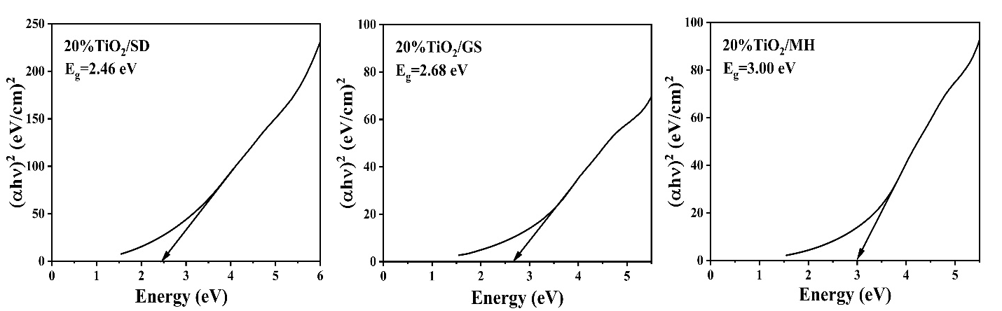
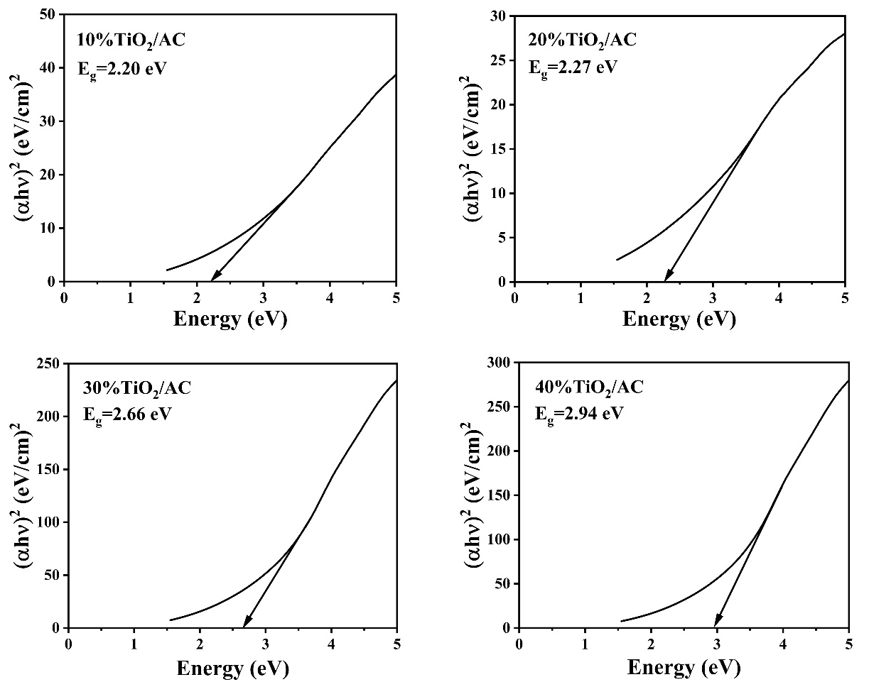

Fig. S1: Band gap energy of all the samples with their respective Tauc Plots.

