Supplemental material
Experimental investigation of the effect of smart water and a novel synthetic nanocomposite on wettability alteration, interfacial tension reduction, and EOR
Mohsen mansouri*, Ehsan Jafarbeigi^{1,2}, Yaser Ahmadi¹, Seyyed Hossein Hosseini¹
¹ Department of Chemical and Petroleum Engineering, Ilam University, P.O. Box 69315/516, Ilam, Iran
² Department of Chemical and Petroleum Engineering, Sharif University of Technology, Azadi St., P.O Box: 11365-11155, Tehran, Iran

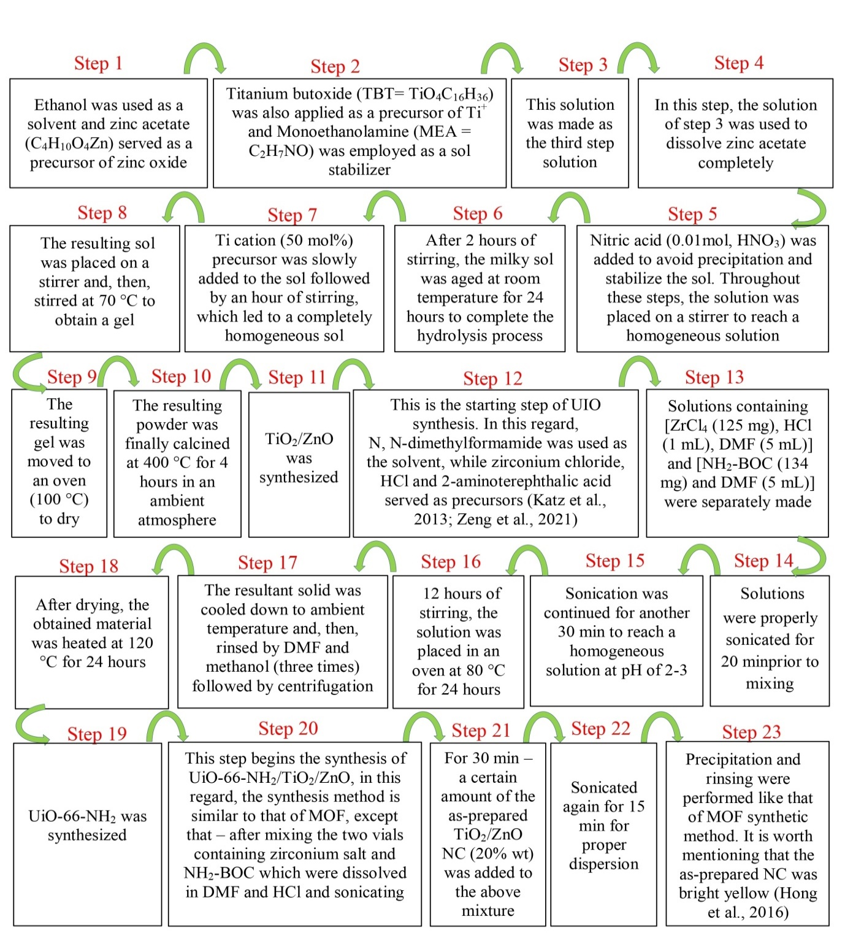
Fig .S1 Step-by-step schematic view of NC synthesis.
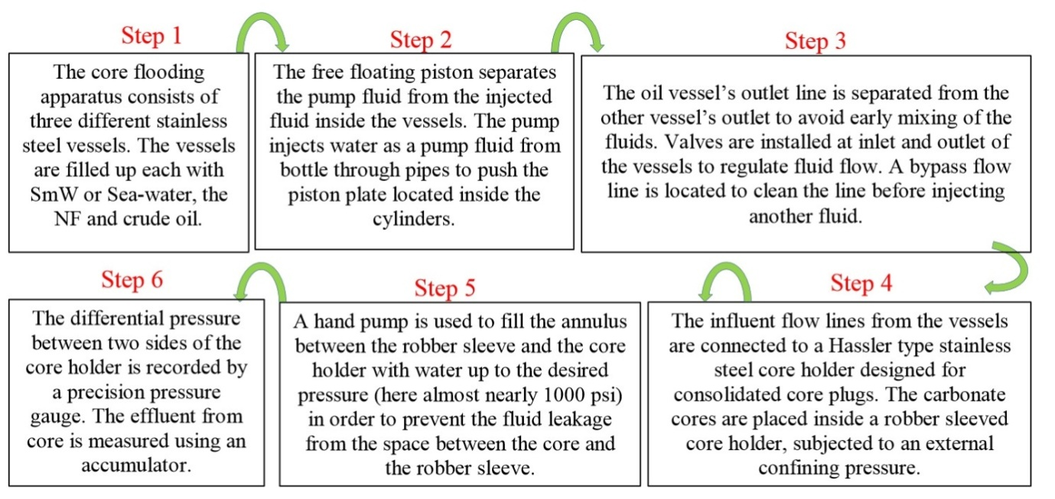
Fig. S2 Schematic view of the step-by-step core flooding test

Corresponding’s author E-mail: m.mansouri@ilam.ac.ir

