Supplementary Information.

Transhydrogenation of C₅H₁₂/C₆H₁₀ over CrO_{x}/Al₂O₃ and Potassium-doped CrO_{x}/Al₂O₃ Catalysts.

Mustapha D. Garba and S. David Jackson*
Centre for Catalysis Research, School of Chemistry, University of Glasgow, Glasgow G12 8QQ, Scotland, UK.
e-mail: david.jackson@glasgow.ac.uk

The yield of each product formed, assuming no interaction between the species, was calculated from the individual run and summed as the theoretical yield:
$$P_{alone }+{ 1HY}_{alone}= 1HY Theory$$
This was then compared to the mixed feed runs termed as transhydrogenation yield, which was used to understand the effect of the transhydrogenation occurring during reaction.

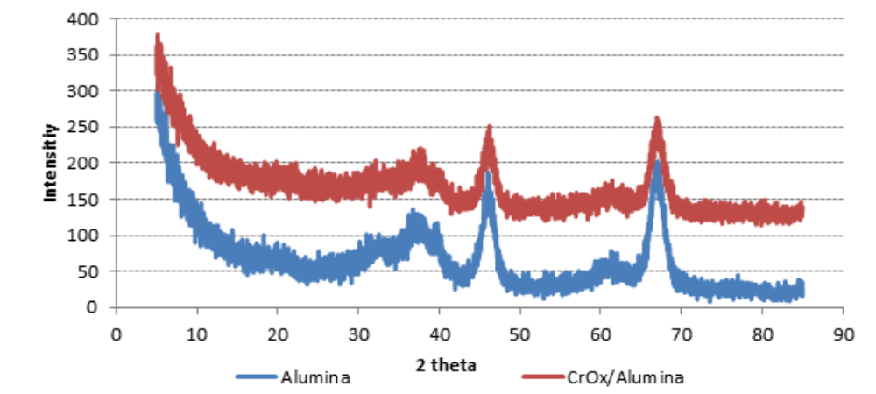
XRD spectra for the alumina support and the catalyst. Only alumina reflections are observed.

Table S1: Products yield of the transhydrogenation over CrO_{x}/Al₂O₃ at 773 K
 | P | 1HY | P+1HY | P+1HY Theory
 | Conversion [%]
Pentane[P] | 11 |  | 19 | 11
Hexyne[1HY] |  | 98 | 96 | 98
 | Yield [%]
Iso-pentane | 1.0 |  | 0.2 | 1.0
Pentene |  |  | 0.9 | 0
Trans-2-pentene | 8.6 |  |  | 8.6
Hexane |  | 1.6 | 2.1 | 1.6
Hexene |  | 1.0 | 0.7 | 1.0
2-Hexene |  | 0.6 | 1.6 | 0.6
3-Hexene |  | 1.6 | 1.9 | 1.6
Methyl-2-pentene |  | 3.2 | 4.2 | 3.2
3-Methylpentyne |  | 5.2 | 3.3 | 5.2
3-methyl-1-hexene |  | 7.5 | 5.1 | 7.5
3-Methylhexane |  | 2.5 | 5.4 | 2.5
2-Methyl-1,3-pentadiene |  | 1.4 | 9.2 | 1.4
1,4-Hexadiene |  | 13.5 | 16.9 | 13.5
2-methyl-1-hexene |  | 7.4 | 5.1 | 7.4
methylcyclohexane | 0.6 | 8.8 | 1.6 | 9.4
Ethylcyclopentane | 0.4 |  |  | 0.4

Table S2: Products yield of the transhydrogenation over CrO_{x}/Al₂O₃ at 673 K
 | P | 1HY | P+1HY | P+1HY Theory
 | Conversion [%]
Pentane[P] | 08 |  | 13 | 08
Hexyne[1HY] |  | 97 | 86 | 97
 | Yield [%]
Iso-pentane | 0.46 |  | 0.11 | 0.46
Pentene |  |  | 0.01 | 0
Trans-2-Pentene | 0.53 |  |  | 0.53
hexane |  | 0.38 | 1.95 | 0.38
Hexene |  |  | 0.27 | 0
2-Hexene |  | 0.9 | 6.08 | 0.9
3-Hexene |  |  | 0.42 | 0
Methyl-2-pentene |  | 3.42 | 4.61 | 3.42
3-Methylpentyne |  | 7.49 | 10.28 | 7.49
3-methyl-1-hexene |  | 1.67 | 1.97 | 1.67
3-Methylhexane |  | 6.17 | 1.36 | 6.17
2-Methyl-1,3-pentadiene |  | 7.49 | 0.27 | 7.49
1,4-Hexadiene |  | 31.42 | 25.18 | 31.42
methylcyclohexane | 3.91 | 1.8 |  | 5.17

Table S3: Products yield of the transhydrogenation over CrO_{x}/Al₂O₃ at 623 K
 | P | 1HY | P+1HY | P+1HY Theory
 | Conversion [%]
Pentane[P] | 10 |  | 26 | 10
Hexyne[1HY] |  | 95 | 87 | 95
 | Yield [%]
Pentene |  |  | 0.19 | 0
Trans-2-Pentene | 0.08 |  |  | 0.08
Haxane |  |  | 0.52 | 0
Hexene |  | 0.33 | 1.81 | 0.33
2-Hexene |  | 1.21 | 2.06 | 1.21
3-Hexene |  |  | 1.46 | 0
Methyl-2-pentene |  | 2.17 | 2.22 | 2.17
3-Methylpentyne |  | 11.6 | 19.24 | 11.6
3-methyl-1-hexene |  | 1.29 | 1.70 | 1.29
3-Methylhexane |  | 0.55 | 1.38 | 0.55
2-Methyl-1,3-pentadiene |  |  | 2.14 | 0
1,4-Hexadiene |  | 20.95 | 19.38 | 20.95
methylcyclohexane | 5.23 | 15.19 | 2.42 | 20.42
Ethylcyclopentane | 1.25 | 2.77 | 1.12 | 3.92

Table S4: Products yield of the transhydrogenation over CrO_{x}/Al₂O₃ at 573 K
 | P | 1HY | P+1HY | P+1HY Theory
 | Conversion [%]
Pentane[P] | 04 |  | 20 | 04
Hexyne[1HY] |  | 42 | 48 | 42
 | Yield [%]
Iso-pentane |  |  | 0.05 | 0
Pentene |  |  | 0.10 | 0
Trans-2-Pentene | 0.02 |  |  | 0.02
hexane |  | 0.05 | 0.88 | 0.05
Hexene |  | 1.07 | 3.06 | 1.07
2-Hexene |  | 0.2 | 3.08 | 0.2
3-Hexene |  |  | 3.44 | 0
Methyl-2-pentene |  |  | 0.28 | 0
3-Methylpentyne |  | 6.18 | 7.75 | 6.18
3-methyl-1-hexene |  | 1.13 | 0.65 | 1.03
3-Methylhexane |  | 0.45 | 0.34 | 0.41
2-Methyl-1,3-pentadiene |  | 0.17 | 0.66 | 0.17
1,4-Hexadiene |  | 9.41 | 5.32 | 9.41
methylcyclohexane | 0.22 | 3.87 | 1.24 | 3.99
Ethylcyclopentane | 0.39 | 1.36 | 0.89 | 1.75

Table S5: Products yield of the transhydrogenation over CrO_{x}/Al₂O₃ at 523 K
 | P | H | P+H | P+H Theory
 | Conversion [%]
Pentane[P] | 0.9 |  | 20 | 0.9
Hexyne[1HY] |  | 47 | 46 | 47
 | Yield [%]
Iso-pentane |  |  | 0 | 0
Pentene |  |  |  | 0
Trans-2-Pentene | 0.008 |  |  | 0.008
Hexane |  | 0 | 0 | 0
Hexene |  | 0.12 | 0 | 0.12
2-Hexene |  | 0 | 0 | 0
3-Hexene |  | 0 | 0.09 | 0
Methyl-2-pentene |  | 0.56 | 1.45 | 0.56
3-Methylpentyne |  | 10.55 | 0 | 10.55
3-methyl-1-hexene |  | 1.65 | 1.81 | 1.5
3-Methylhexane |  | 0.46 | 0.31 | 0.42
2-Methyl-1,3-pentadiene |  | 1.64 | 1.58 | 1.64
1,4-Hexadiene |  | 11.51 | 0.56 | 11.51
2-methyl-1-1hexene |  | 1.36 | 2.24 | 1.364
methylcyclohexane |  | 11.18 | 2.41 | 11.187

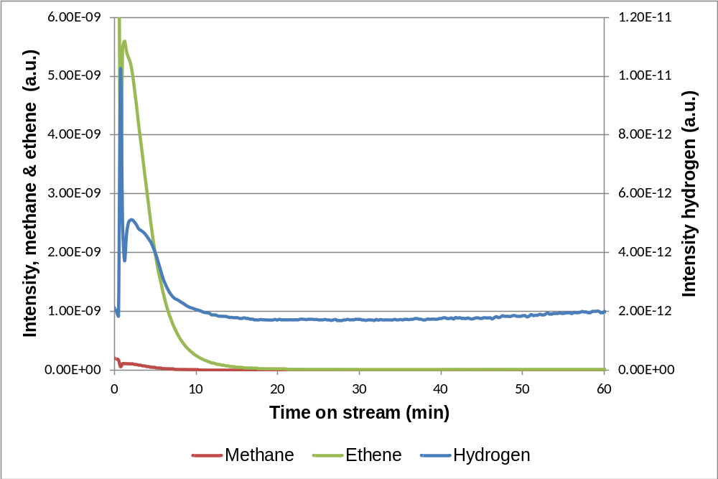
Figure S1. Profile of the evolved gases over CrO_{x}/Al₂O₃ using pentane only at 523 K.

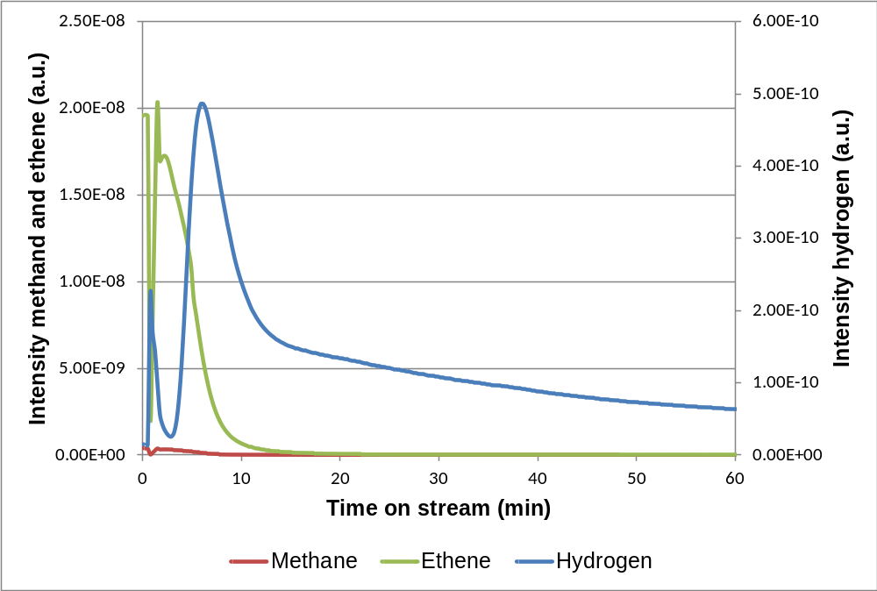
Figure S2. Profile of the evolved gases over CrO_{x}/Al₂O₃ using 1-hexyne only at 523 K.

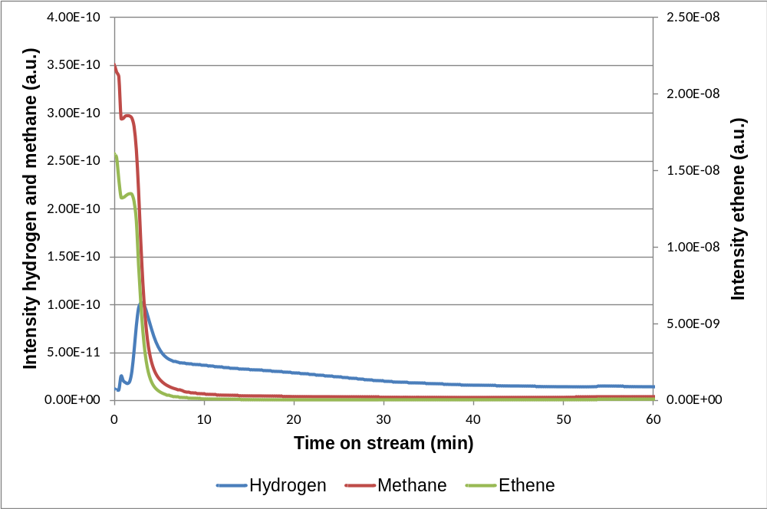
Figure S3. Profile of the evolved gases over CrO_{x}/Al₂O₃ using pentane/1-hexyne at 523 K.

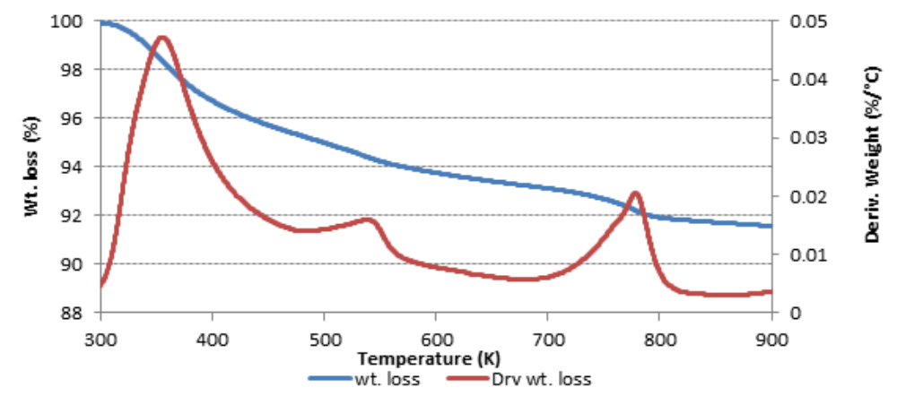
The TPR/TGA for K-CrOx/Al₂O₃. There are hydrogen up-takes at 540 K and 760 K’

Table S6. Product yield of trans-hydrogenation over K-CrOx/Al₂O₃ at 773K
 | P | H | P+H | P+H Theory
 | Conversion (%)
Pentane(P) | 35.7 |  | 91 | 35.7
Hexyne(1HY) |  | 98 | 97 | 98
 | Yield (%)
Iso-pentane | 10.48 |  | 0.21 | 0.48
Pentene |  |  | 1.81 | 0
Trans-2-Pentene | 0.2 |  |  | 0.2
4-Methylpentene |  | 0.03 |  | 0.03
Hexane |  | 0.77 | 0.66 | 0.77
1-Hexene |  | 2.58 | 1.60 | 2.58
2-Hexene |  | 0.9 | 3.56 | 0.9
3-Hexene |  | 3.24 | 4.04 | 3.24
Methyl-2-pentene |  | 10.65 | 8.58 | 10.65
3-Methyl-1-hexene |  | 21.06 | 15.29 | 21.06
Benzene |  | 4.09 | 2.86 | 4.09
3-Methylhexane |  | 6.27 | 4.59 | 6.27
2-Methyl-1,3-pentadiene |  | 23.3 | 17.05 | 23.3
methylcyclohexane | 17.69 | 6.20 | 18.94 | 23.89

Table S7. Product yield of trans-hydrogenation over K-CrOx/Al₂O₃ at 673K
 | P | H | P+H | P+H Theory
 | Conversion (%)
Pentane(P) | 43.58 |  | 87 | 43.58
Hexyne(1HY) |  | 97 | 100 | 97
 | Yield (%)
Iso-pentane |  |  | 0.04 | 0
Pentene | 22.82 |  |  | 22.82
Trans-2-Pentene | 0.22 |  |  | 0.22
Cis-2-pentene | 0.57 |  |  | 0.57
Hexane |  | 0.4 | 10.76 | 0.4
1-Hexene |  | 1.3 | 2.72 | 1.3
2-Hexene |  | 0.22 | 5.29 | 0.22
3-Hexene |  | 1.23 | 12.35 | 1.23
Methyl-2-pentene |  | 9.89 | 1.26 | 9.89
3-Methyl-1-hexene |  | 28.16 | 14.64 | 28.16
Benzene |  | 1.45 | 0.52 | 1.45
3-Methylhexane |  | 6.88 | 1.28 | 6.88
2-Methyl-1,3-pentadiene |  | 27.7 | 4.96 | 27.7
Methylcyclohexane | 11.6 | 2.58 | 14.06 | 14.18

Table S8. Product yield of trans-hydrogenation over K-CrOx/Al₂O₃ at 623K
 | P | H | P+H | P+H Theory
 | Conversion (%)
Pentane(P) | 37.58 |  | 85 | 85
Hexyne(1HY) |  | 97 | 99 | 99
 | Yield (%)
Iso-pentane | 10.38 |  | 0.07 | 10.38
Pentene |  |  | 0.27 | 0
Trans-2-Pentene | 0.46 |  | 0.42 | 0.46
Cis-2-pentene | 0.33 |  | 0.14 | 0.33
Hexane |  | 0.75 | 0.34 | 0.75
1-Hexene |  |  | 0.49 | 0
2-Hexene |  |  | 5.17 | 0
3-Hexene |  |  | 0.72 | 0
Methyl-2-pentene |  | 3.55 | 5.58 | 3.55
3-Methyl-1-hexene |  | 17.32 | 16.17 | 17.32
Benzene |  | 1.45 | 1.03 | 1.45
3-Methylhexane |  | 4.86 | 3.28 | 0
2-Methyl-1,3-pentadiene |  | 6.8 | 15.00 | 6.8
1,4-Hexadiene |  | 31.67 |  | 31.67
Methylcyclohexane | 11.76 | 10.95 | 16.45 | 22.71

Table S9. Product yield of trans-hydrogenation over K-CrO_{x}/Al₂O₃ at 573K
 | P | H | P+H | P+H Theory
 | Conversion (%)
Pentane(P) | 36.59 |  | 77 | 36.59
Hexyne(1HY) |  | 98 | 99 | 98
 | Yield (%)
Iso-pentane | 10.38 |  | 0.18 | 10.38
Pentene |  |  | 0.10 | 0
Trans-2-Pentene | 0.42 |  |  | 0.42
Cis-2-pentene | 0.71 |  |  | 0.71
Hexane |  |  | 0.80 | 0
1-Hexene |  |  | 0.13 | 0
2-Hexene |  |  | 3.17 | 0
3-Hexene |  | 0.4 | 0.63 | 0.4
Methyl-2-pentene |  | 4.47 | 2.35 | 4.47
3-Methyl-1-hexene |  | 18.5 | 17.05 | 18.5
Benzene |  | 5.3 | 0 | 5.3
3-Methylhexane |  |  | 2.03 | 0
2-Methyl-1,3-pentadiene |  | 16.13 | 9.07 | 16.13
2-Methyl-1-1hexene |  |  | 0.89 | 0
1,4-Hexadiene |  | 35.56 | 0 | 35.56
Methylcyclohexane | 13.37 | 12.54 | 14.87 | 15.91

Table S10. Product yield of trans-hydrogenation over K-CrOx/Al₂O₃ at 523K

 | P | H | P+H | P+H Theory
 | Conversion (%)
Pentane(P) | 38.22 |  | 73 | 38.22
Hexyne(1HY) |  | 94 | 98 | 94
 | Yield (%)
Iso-pentane | 26.74 |  |  | 26.74
Pentene | 8.12 |  | 0.06 | 8.12
Trans-2-Pentene |  |  | 0.26 | 0
Cis-2-pentene |  |  | 0.42 | 0
Hexane |  |  | 0.29 | 0
1-Hexene |  |  | 0.20 | 0
2-Hexene |  |  | 0.07 | 0
3-Hexene |  |  | 0.27 | 0
Methyl-2-pentene |  | 6.23 | 6.25 | 6.23
3-Methylpentyne |  | 33.42 |  | 33.42
3-Methyl-1-hexene |  |  | 19.36 | 0
3-Methylhexane |  | 3.91 | 3.16 | 3.91
2-Methyl-1,3-pentadiene |  | 25.89 | 16.43 | 25.89
Methylcyclohexane | 3.72 | 11.86 | 13.19 | 3.7236

