Supporting Information for
Nanoparticle Targeting of Gram Positive and Gram Negative Bacteria for Magnetic-based Separations Bacterial Pathogens
Hoang D. Lu, Shirley S. Yang, Brian K. Wilson, Simon A. McManus, Christopher V.H.-H. Chen, and Robert K. Prud’homme*

Department of Chemical and Biological Engineering, Princeton University, Princeton, New Jersey 08544, United States
*to whom correspondence should be addressed; E-mail: prudhomm@princeton.edu

Supplementary Methods
PS-PEG-NH₂ synthesis
Poly(styrene)-block-poly(ethylene glycol)-OH (PS-PEG-OH, Polymer Source Inc, Montreal, Canada) with block molecular weights of 1600 Da poly(styrene) and 5000 Da poly(ethylene glycol) was converted to a primary amine terminal polymer (PS-PEG-NH₂) using a mesylate intermediate. Solid PS-PEG-OH (600 mg, 0.091 mmoles) was azeotropically distilled in 20 mL dry toluene while purging with argon to remove any residual water in the PEG block. The azeotropically distilled PS-PEG-OH was redissolved in 10 mL dry toluene in a septum-sealed flask. Triethylamine (28 mg, 0.27 mmoles) dissolved in 5 mL dry toluene was injected to the PS-PEG-OH solution while purging the flask with argon. Methanesulfonyl chloride (52 mg, 0.45 mmoles) dissolved in 5 mL dry toluene was injected while purging the flask with argon after stirring the polymer-triethylamine solution for 10 minutes. The flask was covered in aluminum foil and magnetically stirred for 24 hours. After 24 hours, the reaction solution was filtered twice through a 0.22 µm PTFE filter to remove insoluble trimethylamine chloride salts. The filtered toluene solution was concentrated by rotary evaporation at 40 °C to approximately 2 mL and then added dropwise to cold diethyl ether (50 mL, -80 °C) to precipitate the polymer. The precipitated polymer was dissolved in 2 mL dichloromethane and precipitated in diethyl ether again before being dried in vacuo overnight. Mesylated polymer (PS-PEG-Ms) was analyzed by ¹H NMR in deuterated chloroform; the spectrum integration was normalized to the poly(styrene) aromatic protons (6.2 – 7.25 ppm, 77H, complicated pattern). The methane group of the mesylate (3.11 ppm, 3H, s) and the β-methylene unit of the PEG adjacent to the mesylate (4.40 ppm, 2H, t) show quantitative conversion of the PS-PEG-OH to the PS-PEG-Ms. PS-PEG-Ms (500 mg, 0.075 mmoles) was added to a magnetically stirred 24%wt solution of ammonium hydroxide (30 g, 0.21 moles NH₄OH) and allowed to react for 96 hours. After the 96-hour reaction period, the ammonia was evaporated from solution under nitrogen purge for 72 hours. Solid sodium chloride was added to the aqueous polymer dispersion to produce a saturated brine solution and the pH was adjusted to 14 by adding solid sodium hydroxide. PS-PEG-NH₂ was extracted from this brine layer with dichloromethane (5 washes, 50 mL each). The dichloromethane was combined and concentrated down to 2 mL by rotary evaporation prior to precipitating the polymer in diethyl ether (50 mL, -80 °C) and drying in vacuo overnight. Conversion of the mesylate to amine was assessed by ¹H NMR, again with the poly(styrene) protons used for integration normalization (6.2 – 7.25 ppm, 77H, complicated pattern). The α-methylene of the PEG adjacent to the amine (2.87 ppm, 2H, t) shows quantitative conversion of the mesylate to amine.

PS-PEG-DPA synthesis
EDC coupling was used to conjugate the targeting moieties DPA to PS-PEG-NH₂. DPA with a carboxylic acid conjugation handle was formed as previously described.¹ For the conjugation with DPA, PS-PEG-NH₂ was dissolved at 100 mg/mL in DMSO, while 3x molar ratio of DPA and 10x molar ratio of EDC were dissolved in the same volume of DMSO separately. The two solutions were mixed together with 10x molar ratio of DIPEA and reacted overnight at 25 °C. Polymers were micellized by tenfold dilution into deionized water, and purified by extensive dialysis through a 3.5 kDa MWCO Spectrum Spectra/Por standard membrane. Polymers were subsequently lyophilized and stored as a dry powder for use. Polymers were converted to form PS-PEG-DPA with 88% conjugation efficiency, as assessed by ¹H-NMR analysis.

Fluorescence Microscopy
Fluorescence microscopy images were captured using a Leica TCS SP-5 inverted confocal microscope. Bacteria were fixed to glass slides by evaporating a drop of bacterial culture prior to passing the slide over an open flame, heating the backside of the slide. A 0.2 mm thick coverslip was attached by clear nail polish. Fluorescence images of EtTP5-containing nanoparticles were collected with 633 nm excitation by a diode HeNe laser focused by a 40x oil immersion objective, while emission was collected from 660 to 740 nm on a single PMT channel, gain 500 V. A wide confocal pinhole of 200 µm was used to increase the depth of field in the fluorescence channel, effectively making these epifluorescence images once the bacteria are in focus. Brightfield images were simultaneously captured using the same 40x oil immersion objective and the transmission PMT of the microscope, gain 200 V. Fluorescence overlay images are the merge of the fluorescent channel and the transmission brightfield channel.

Iron Colloid Synthesis and Imaging
Magnetic iron oxide (Fe₃O₄) colloids were synthesized following a modified method as previously reported.² All water used to prepare solutions was deoxygenated by sparging with nitrogen for 12 hours immediately prior to use. Solution A was composed of 1.28M FeCl₃-6H₂O, 0.64M FeCl₂-4H₂O and 0.4M HCl and was prepared by dissolving ferrous and ferric chloride hydrate salts and adding stock 12.1N HCl for a total volume of 3 mL. Solution B was composed of 1.5M NaOH prepared by dissolving NaOH pellets in nitrogen-purged water for a total volume of 30 mL. Fe₃O₄ particles are then prepared by adding Solution A dropwise to Solution B with magnetic stirring while purging the flask headspace with nitrogen. The mixed Solution A and B was stirred for a further 30 minutes before the uncoated Fe₃O₄ colloids were isolated magnetically and washed in triplicate with 50 mL of nitrogen-purged water before lyophilizing a dry powder of Fe₃O₄ colloids. Bare Fe₃O₄ colloids (300 mg) were added to nitrogen-purged molten oleic acid (10 mL) heated to 80 °C and magnetically stirred for 24 hours. Fe₃O₄ particles were isolated by precipitation from the oleic acid melt into 100 mL of methanol and magnetically isolating the precipitate. The precipitate was washed three times with 50 mL of methanol to remove residual oleic acid prior to drying under vacuum. The oleic acid coated Fe₃O₄ colloids were readily redispersed in hexane and tetrahydrofuran.
Transmission Electron Microscopy
Particle size was characterized by transmission electron microscopy. TEM grids were prepared by drop-casting and drying 5 µL of a 0.1 mg/mL dispersion of coated Fe₃O₄ colloids in tetrahydrofuran on the carbon film side of a CF300-Cu grid (Electron Microscopy Sciences) and air-drying before imaging on a Philips CM200 TEM operating at 200kV accelerating voltage.

Supplementary Figures
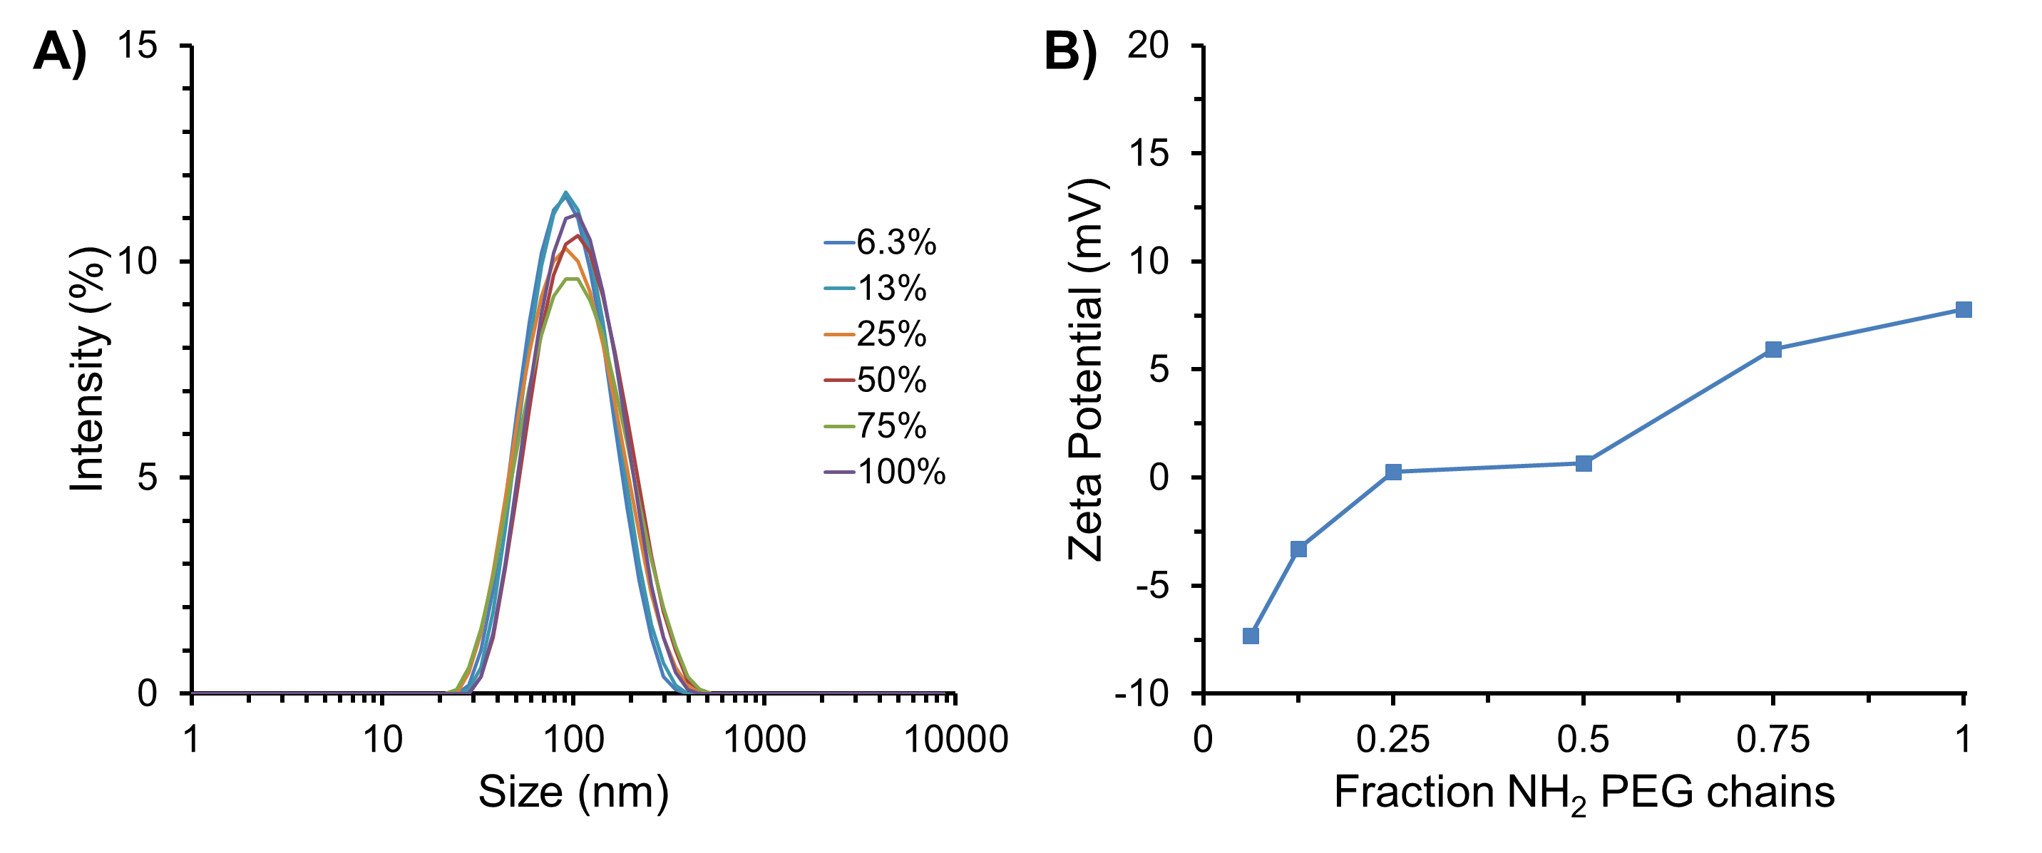
Figure S1. Formation of amine modified nanoparticles. (A) Intensity weighted dynamic light scattering size distributions and (B) zeta potentials of particles made with various amine modifications. Exact compositions of particle are detailed in Table S2.

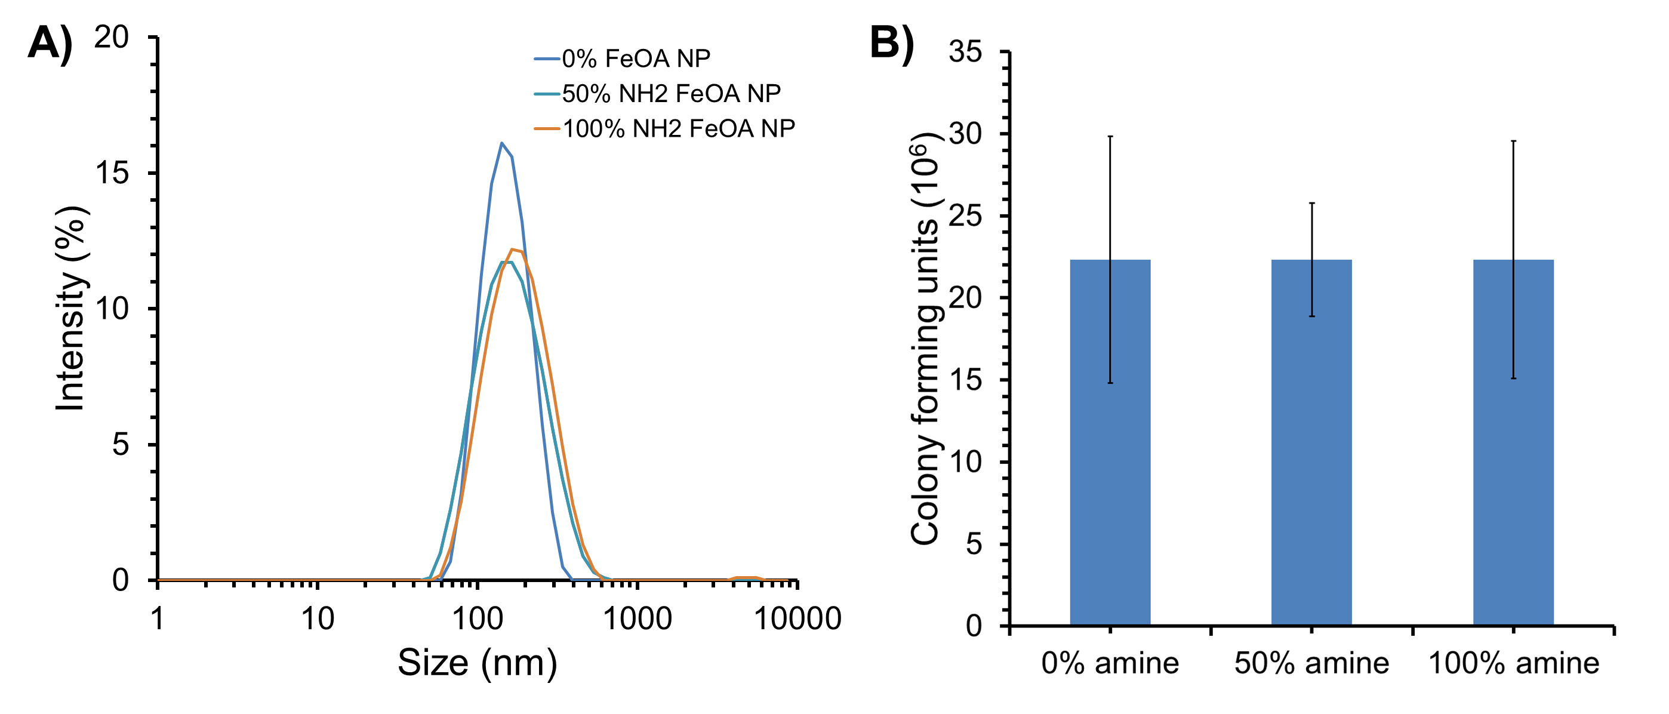
Figure S2. Formation of amine modified iron oxide nanoparticles. (A) Intensity weighted dynamic light scattering size distributions of unmodified and amine modified iron oxide NPs. (B) Number of colony forming units collected when ~2*10⁷ cells are passed through a column containing iron oxide NPs with varying extents of amine modification.

Supplementary Tables

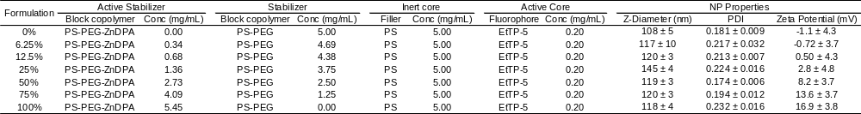
Table S1. Summary of ZnDPA nanoparticles. Particles made with varying levels of ZnDPA modification are formed by dissolving components noted above in tetrahydrofuran and rapid impingement with water. Particle diameters, polydispersity indexes (PDI), and zeta potentials are determined by dynamic light spectroscopy. Values are averages and error bars are standard deviations of three measurements.

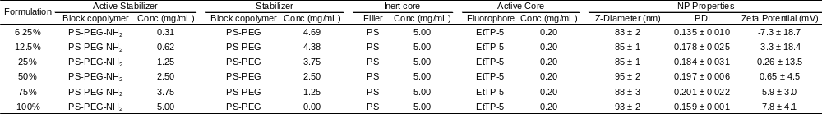
Table S2. Summary of amine-modified nanoparticles. Particles made with varying levels of amine surface modification are formed by dissolving components noted above in tetrahydrofuran and rapid impingement with water. Particle diameters, polydispersity indexes (PDI), and zeta potentials are determined by dynamic light spectroscopy. Values are averages and error bars are standard deviations of three measurements.

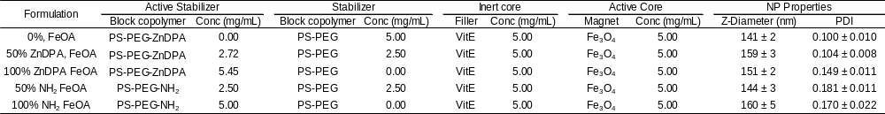Table S3. Summary of iron-oxide containing nanoparticles. Particles made with varying levels of ZnDPA or amine modification and 5 mg/mL iron oxide in their cores are formed by dissolving components noted above in tetrahydrofuran and rapid impingement with water. Particle diameters, polydispersity indexes (PDI), and zeta potentials are determined by dynamic light spectroscopy. Values are averages and error bars are standard deviations of three measurements.

References
1. Lee, J.-J.; Jeong, K. J.; Hashimoto, M.; Kwon, A. H.; Rwei, A.; Shankarappa, S. A.; Tsui, J. H.; Kohane, D. S. Nano Lett. 2014, 14, 1-5.
2. Kim, D. K.; Zhang, Y.; Voit, W.; Rao, K. V.; Muhammed, M. Journal of Magnetism and Magnetic Materials 2001, 225, 30-36.

