Cyclodextrin–PEG conjugate-wrapped magnetic ferrite nanoparticles for enhanced drug loading and release

Israel Vijayaraj Muthu Vijayan Enoch, Sivaraj Ramasamy, Shanid Mohiyuddin, Packirisamy Gopinath, R Manoharan

Supporting Information
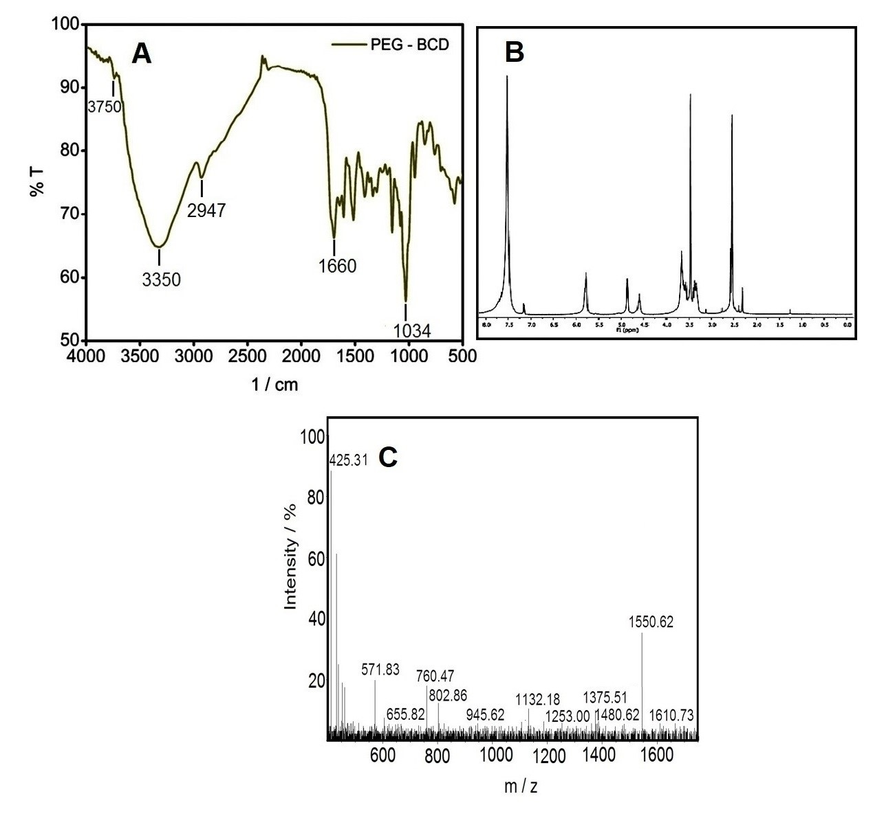
SI 1. A. IR spectrum of CD-PEG. B. ¹H NMR spectrum of CD-PEG. C. Mass spectrum of CD-PEG.

The IR spectrum of CD-PEG (SI. 1A) shows a broad band centered on 3350 cm⁻¹ due to large number of hydroxyl groups in the β-CD moiety. Weak N–H stretchings are seen around 3750 groups. Absence of aromatic stretching frequencies substantiates the complete amination which occurred in the synthesis of the polymer conjugate. The strong C–O–C stretching appears at 1034 cm⁻¹, arising from the PEG moiety. The¹H NMR spectrum (SI. 1B) shows an intense peak at 3.51ppm corresponding to the –CH₂–protons of PEG. This peak is flanked by the 3.74 and 3.42ppm peaks which are due to the H-2, H-6, H-5 and H-3, H-4 protons of β-CD. The 4.65 and 5.04 ppm peaks arise due to the primary hydroxyl and the H-1 protons respectively, of β-CD. The secondary hydroxyl protons signal at 5.18 ppm. The molecule ion peak (m/z = 1546 is observed for the CD-PEG polymer (SI. 1C). The most abundant peak is seen at m/z = 425. This one corresponds to the fragment of H₂N-PEG-NH₂. The spectral studies confirm the formation of the CD-PEG.cm⁻¹. The aliphatic C–H stretching appearing at 2947 cm⁻¹ arises due to the methylene protons.

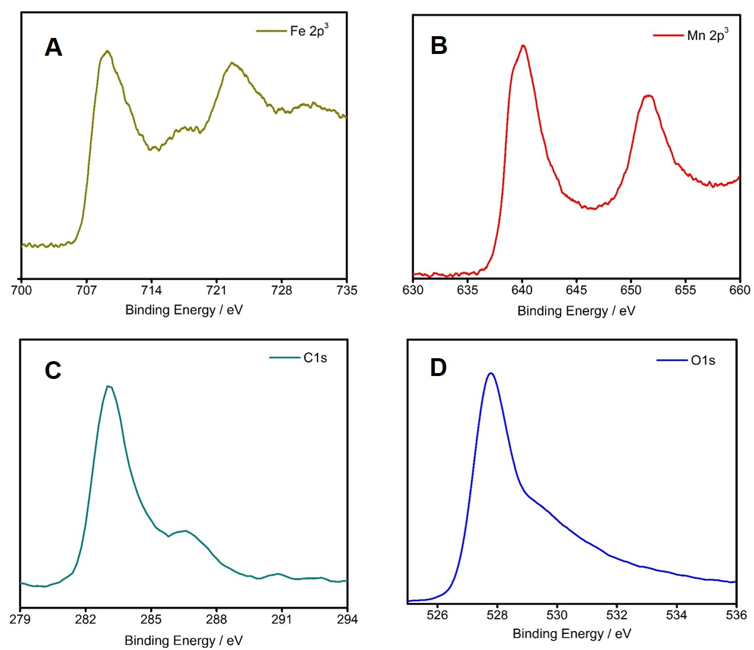
SI 2. X-Ray photoelectron spectra of A. Fe 2p C 1s, B. Mn 2p³, C. C1s, and D. O 1s of MNPs.

SI. 2A shows the peaks corresponding to the Fe2p_{3/ 2} and 2p_{1/ 2} viz., 708.8, 717.5, and 722.8 eV. A greater contribution from Fe³⁺ to the O_{h} site is inferred as the713 and 726 eV peaks are absent. The shoulder appearing at 640.1 eV (2B) is attributed to the Mn²⁺ ions. The formation of ferrite occurs due to the slight reduction of Mn³⁺/ Mn⁴⁺ due to interaction with the CD-PEG polymer.³⁶ The Mn2p_{3/2} feature at 641.1 is attributed to the Mn³⁺ ion.³⁷ A satellite peak at 652.7 eV is also observed.
The C1s spectrum (2C) reveals, nearly four chemical environments, the main peak being 283.2 and 287.4 eV. The C–O binding energy occurs at 290.5 eV, which is lower in intensity. The C–O binding energy is also seen in the O 1s at 527.2 eV.³⁸ The shoulder appearing near 529.5 eV may be attributed to the ferrite oxygen (2D). Hence, it is evident that the Fe and Mn atoms contribute to the ferrite spinal structure with the partial reduction of Mn³⁺ and Mn⁴⁺ centers due to the encapsulating polymer. Also, the possibility of the presence of any other element as impurity is ruled out. The above results show that the formed nanoparticles are not mixed oxides but spinel crystals of manganese ferrite.

