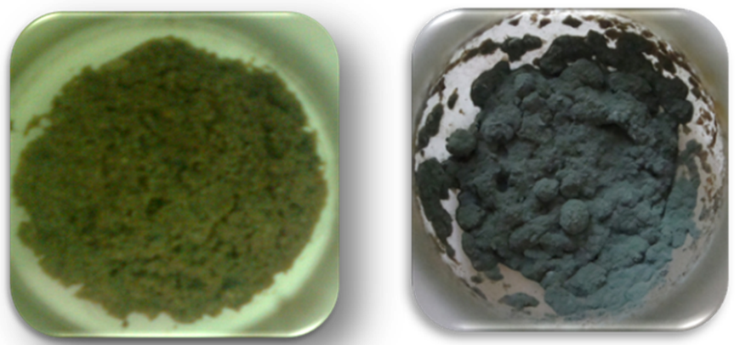

Fig. 4 Fermenting media of lipase before and after fermentation

