Supplementary table
Table 1 Expression of Cry2AX1 protein in T₁ progenies of rice
S. No | Transgenic (T₀) line | T₁  Progeny | Cry2AX1 concentration in fresh leaf tissue ( ng/g )*  Mean ± SD
S. No | Transgenic (T₀) line | T₁  Progeny | Vegetative stage  (25 DAS) | Tillering stage  (55 DAS) | Reproductive stage  (85 DAS)
 |  |  |  |  | Leaves | Seed
1 | UR 11 | UR11-1 | 115.00±0.50 | 84.80±0.00 | 30.40±0.00 | 3.2±0.00
2 | UR 11 | UR11-2 | 103.00±0.00 | 62.40±0.00 | 61.60±0.80 | NT
3 | UR 11 | UR11-3 | 155.00±0.00 | 86.40±0.00 | 72.00±0.00 | 4.8±0.00
4 | UR 11 | UR11-4 | 108.00±0.00 | 46.40±0.00 | 40.00±0.00 | NT
5 | UR 11 | UR11-7 | 96.00±0.00 | 47.20±0.80 | 44.80±0.00 | 4.2±0.00
6 | Control |  | 0 | 0 | 0 | 0
*Mean of two replicates

Supplementary figure
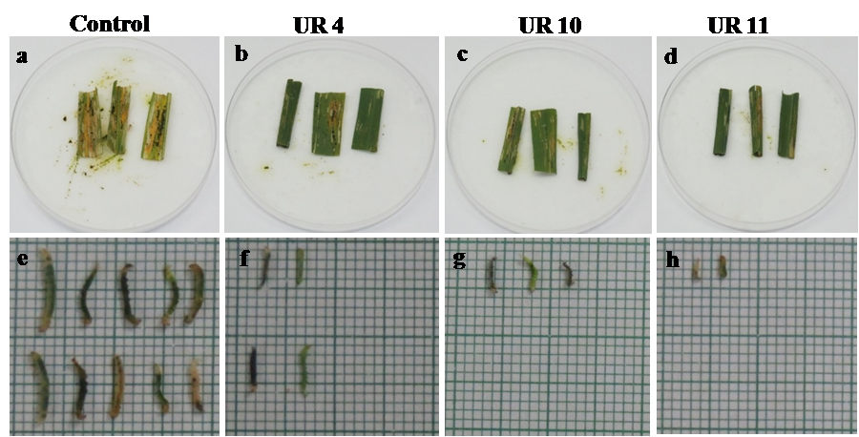

Fig. 1 Detached leaf bit bioassay against rice leaf folder (C. medinalis) in T₀ transgenic rice plants expressing Cry2AX1 protein.
a non transformed control plant (ASD16); b, c and d transformed rice plant (UR4, UR10 and UR11); e, f, g and h size of survivor from non transformed and transformed rice plants.

