Supplementary Information

Purification and Characterization of Endo β-1,4-D-glucanase from Trichoderma harzianum Strain HZN11 and its Application in Production of Bioethanol from Sweet Sorghum Bagasse

Zabin K. Bagewadi, Sikandar I. Mulla and Harichandra Z. Ninnekar*
Department of Biochemistry, Karnatak University, Dharwad 580 003, Karnataka, India

Running title
Purification of endoglucanase from Trichoderma sp.

*Corresponding author’s address: Dr. H Z. Ninnekar,
Professor,
Department of Biochemistry,
Karnatak University,
Dharwad 580 003, Karnataka, India.
Tel.: +91-0836-2215243; fax: +91-0836-2747884.
Email:hzninnekar@yahoo.com

Supporting Information: 15 Pages, 6 Figures and 5 Tables

(A)

(B)

Fig. S1. Purification of endo β-1, 4-D-glucanase by DEAE-sepharose (A) and Sephadex G-100 (B) chromatography. Data values represent average of triplicates and error bars represent standard deviation.

(A)

(B)

(C)

(D)

Fig.S2. Effect of pH (A) pH stability (B) temperature (C) and temperature stability (D) on purified endo β-1, 4-D-glucanase. Data values represent average of triplicates and error bars represent standard deviation.

Fig.S3. Storage stability of crude and purified endo β-1, 4-D-glucanase. Data values represent average of triplicates and error bars represent standard deviation.

(A)
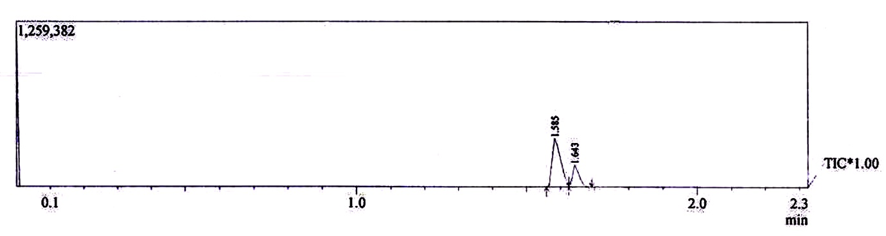
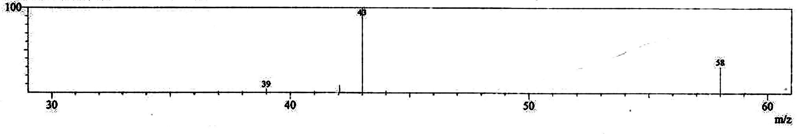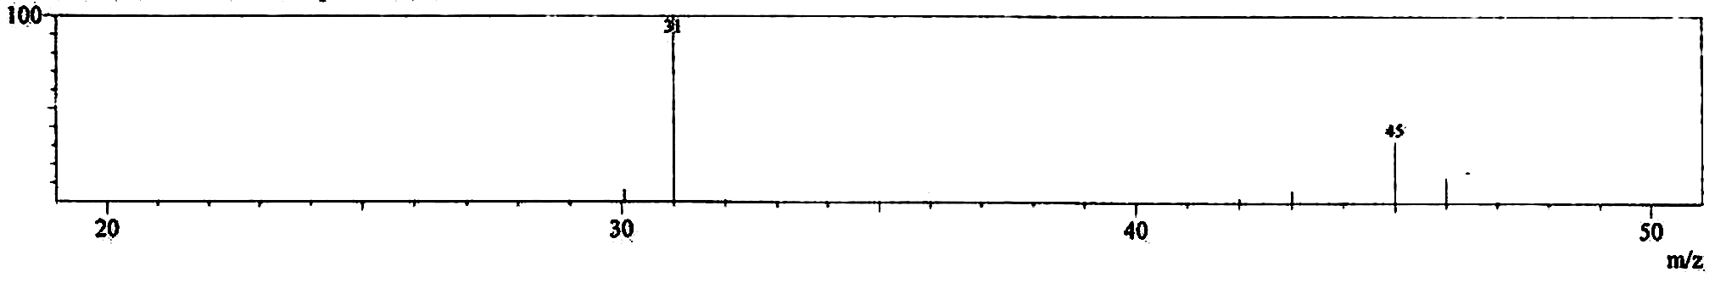
Peak 1
Peak 2
(B)
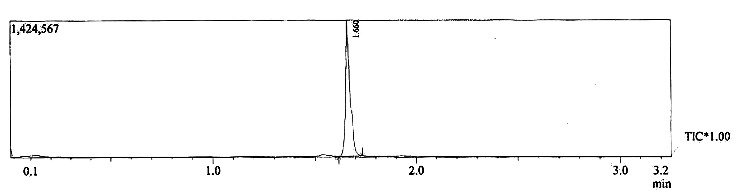
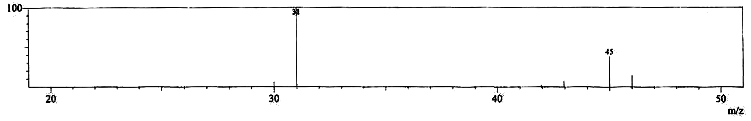
Ethanol
Fig.S4. GC-MS spectra of ethanol produced from sweet sorghum hydrolyzate after 24h of fermentation by Saccharomyces cerevisiae NCIM 3594 in SHF (A) and GC-MS spectra for ethanol standard (B).

(A)
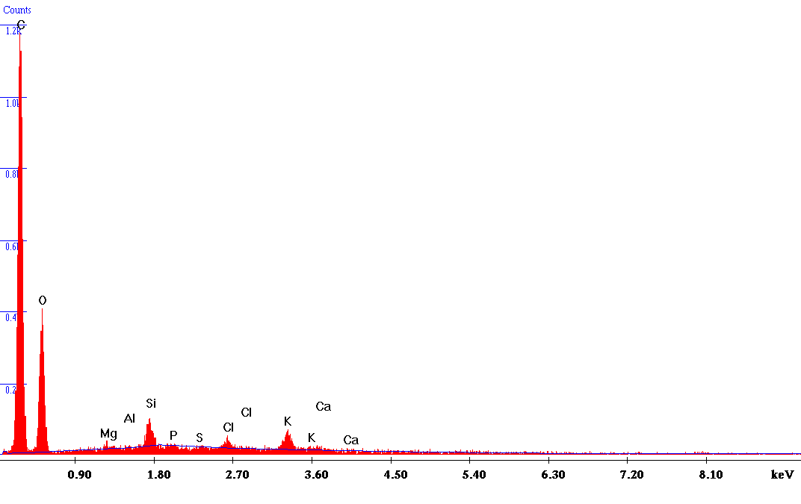
(B)
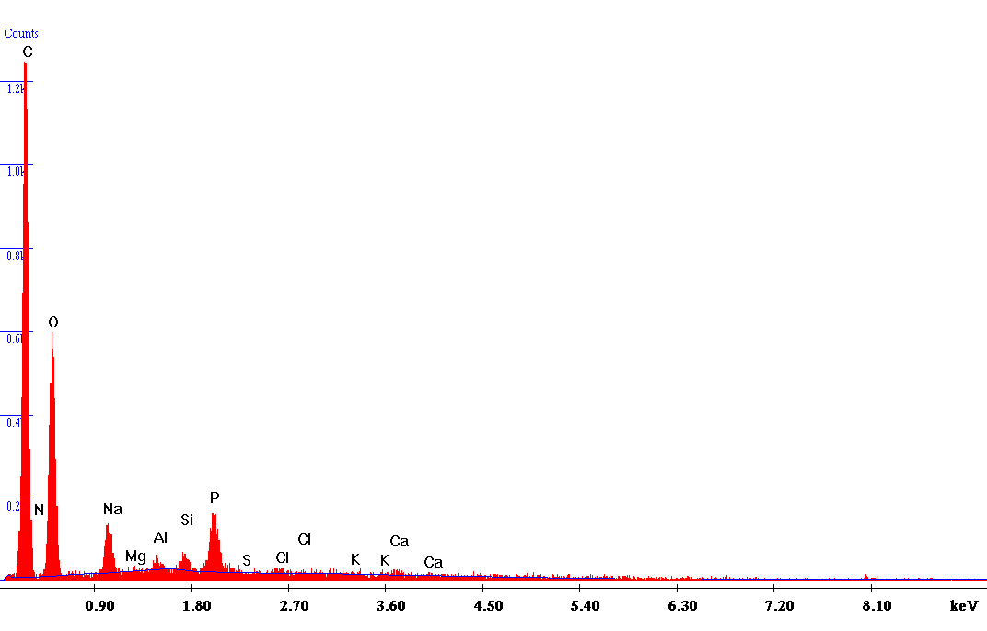

(C)
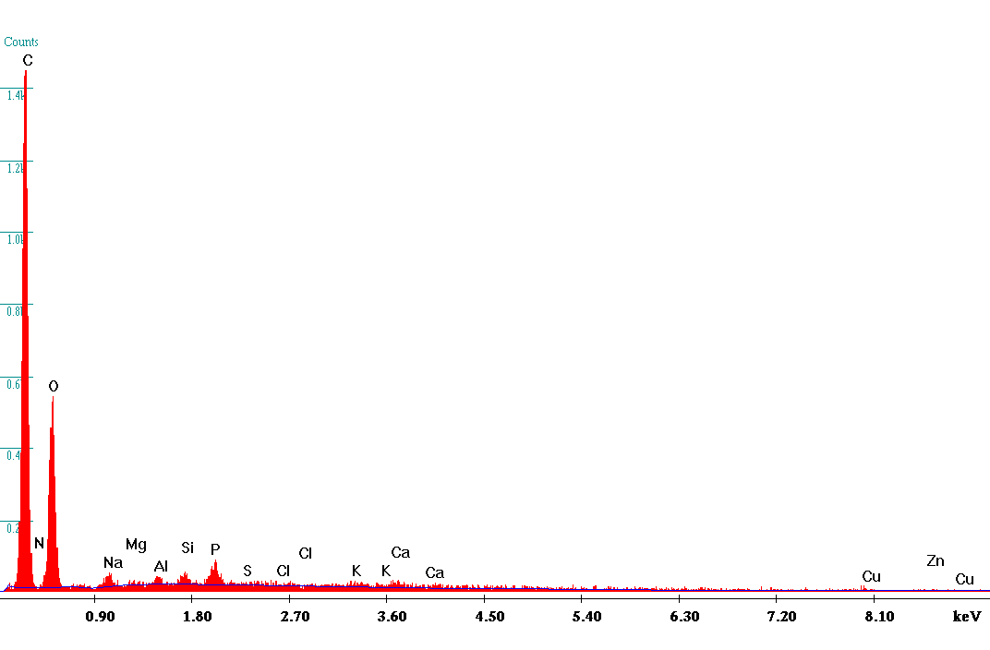
Fig.S5. Elemental analysis (EDX) of untreated sweet sorghum bagasse (A), alkali pretreated sweet sorghum bagasse (B) and pretreated sweet sorghum bagasse hydrolyzed by Trichoderma harzianum strain HZN11(C).

(A)
(B)

(C)

Fig.S6. FTIR analysis of untreated sweet sorghum bagasse (A), alkali pretreated sweet sorghum bagasse (B) and pretreated sweet sorghum bagasse hydrolyzed by Trichoderma harzianum strain HZN11(C).

Table S1 Effect of different concentrations of various metal ions and additives on purified endo β-1, 4-D-glucanase
Metal ions and additives | Relative activity (%)
Metal ions and additives | 1 mM | 2 mM | 5 mM | 10 mM
Controlª  Co²⁺  Zn²⁺  Ca²⁺  Mg²⁺  K⁺  Na⁺  Cu²⁺  Hg²⁺  Fe²⁺  Pb²⁺  Ni²⁺  Mn²⁺  Cd²⁺  DTT  β-mercaptoethanol  EDTA  Urea  PMSF  N-bromosuccinimide  DMSO  Iodoacetamide  p-CMB  1,10-phenathroline | 100  120  60  130  150  105  80  88  30  110  50  108  110  50  120  118  100  125  70  68  75  72  68  77 | 100  97  55  140  166  95  72  80  18  96  41  96  95  38  117  113  105  120  62  55  68  64  61  72 | 100  85  48  120  172  88  60  68  6  87  34  88  80  20  110  105  100  116  55  42  60  55  52  66 | 100  76  41  80  140  70  50  55  0  72  22  71  72  6  100  102  98  112  46  30  50  41  40  60
ªThe activity was assayed in the absence of metal ions or additives was considered as 100%.
Each data value represents average of triplicates.

Table S2 Effect of different concentrations of detergents, surfactants and oxidizing agents on purified endo β-1, 4-D-glucanase
Detergents, surfactants and oxidizing agents | Relative activity (%)
Detergents, surfactants and oxidizing agents | 0.1% | 0.5% | 1%
Controlª  SDS  Sodium tetraborate  Tide  Ariel  Surf Excel  Tween 20  Tween 40  Tween 80  Triton X 100  Sodium perborate  Sodium hypochloride  Hydrogen peroxide | 100  120  98  94  92  93  105  125  115  100  80  90  80 | 100  105  92  80  80  84  90  120  96  92  71  80  65 | 100  90  85  68  71  76  80  105  85  87  64  73  40
ªThe activity was assayed in the absence of chemicals was considered as 100%.
Each data value represents average of triplicates.

Table S3 Effect of different concentrations of various organic solvents on purified endo β-1, 4-D-glucanase
Organic solvents | Relative activity (%)
Organic solvents | 10% | 20% | 30%
Controlª  Glycerol  Ethanol  Methanol  Acetone  Formic acid  Propanol  Petroleum ether  Isopropanol  Benzene  Cylcohexane  Hexane  Butanol  Toluene | 100  126  98  115  95  70  98  97  100  96  96  92  110  115 | 100  115  94  100  90  61  94  92  97  91  90  85  97  98 | 100  110  90  98  88  44  89  90  92  87  83  76  91  90
ªThe activity was assayed in the absence of organic solvents was considered as 100%.
Each data value represents average of triplicates.

Table S4 Substrate specificity of purified endo β-1, 4-D-glucanase
Substrates | Relative activity (%)
CMC  Microcrystalline cellulose  Chitin  Cellobiose  Starch  Filter paper  PNP-α-galactopyranoside  PNP-glucopyranoside  PNP-cellobioside  Brichwoodxylan  Oat spelt xylan | 100  40  0  5  0  40  10  12  15  4  3
Each data values represent average of triplicates.

Table S5 Element compositional analysis of untreated, pretreated and Trichoderma harzianum strain HZN11 hydrolyzed sweet sorghum bagasse by EDX
Elements | Untreated  Wt (%) | Pretreated  Wt (%) | Hydrolyzed  Wt (%)
C  N  O  Na  Mg  Al  Si  P  S  Cl  K  Ca | 65.47  0.00  28.51  0.00  0.30  0.10  1.69  0.11  0.08  0.82  2.43  0.49 | 60.15  1.20  30.00  2.79  0.14  0.42  0.74  3.11  0.00  0.27  0.31  0.52 | 58.32  1.51  36.52  1.25  0.14  0.37  0.41  0.87  0.04  0.06  0.20  0.32

