Supplementary Information

Purification, characterization, gene cloning and expression of GH-10 xylanase (Penicillium citrinum isolate HZN13)

Zabin K. Bagewadi, Sikandar I. Mulla and Harichandra Z. Ninnekar*
Department of Biochemistry, Karnatak University, Dharwad 580 003, Karnataka, India

Running title
Purification of Xylanase from Penicillium sp.

*Corresponding author’s address: Dr. H Z. Ninnekar,
Professor,
Department of Biochemistry,
Karnatak University,
Dharwad 580 003, Karnataka, India.
Tel.: +91-0836-2215243; fax: +91-0836-2747884.
Email:hzninnekar@yahoo.com

Supporting Information: 4 Pages, 2 Figures

(A)

(B)

(C)

Fig.S1. Purification of xylanases from Penicillium citrinum isolate HZN13 by DEAE-Sepharose (A) Sephadex G-100 (B) and Biogel P-60 (C) chromatography. Arrow indicates pooled active fractions. Data values represent average of triplicates and error bars represent standard deviation.

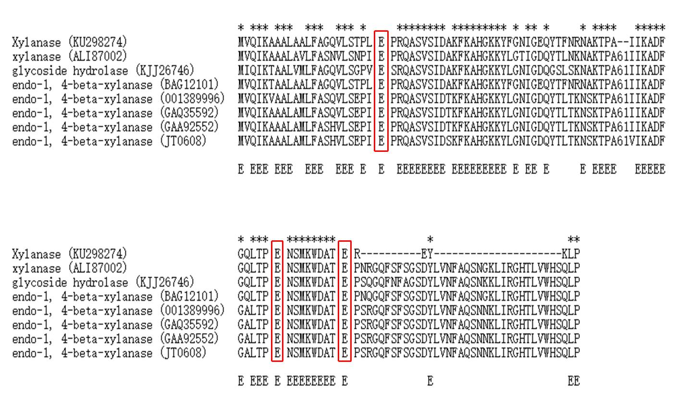
Fig. S2. Alignment of the predicted amino acid sequence of xylanase from Penicillium citrinum isolate HZN13 (GenBank accession Number KU298274) and its closest relatives from the GenBank databases. The closest sequences shown are xylanase from Aspergillus aculeatus (GenBank AN ALI87002); glycoside hydrolase from Penicillium solitum (GenBank AN KJJ26746); endo-1, 4-beta-xylanase from Penicillium citrinum (GenBank AN BAG12101); endo-1, 4-beta-xylanase from Aspergillus niger (GenBank AN 001389996); endo-1, 4-beta-xylanase from Aspergillus niger (GenBank AN GAQ35592); endo-1, 4-beta-xylanasefrom Aspergillus kawachii (GenBank AN GAA92552); and endo-1, 4-beta-xylanase from Aspergillus niger (GenBank AN JT0608). Gaps are showed by dashes. The catalytic residue is boxed, and residues marked E specify beta strands. Asterisks specify identical amino acids.

