3 Biotech
Title: Characterization of methicillin-resistant Staphylococcus aureus through genomics approach
Author names: Romen Singh Naorem¹, Peter Urban^{1,2}, Gunajit Goswami³ and Csaba Fekete¹
Affiliations and address: ¹Department of General and Environmental Microbiology, Institute of Biology, University of Pécs, Pécs 7624, Hungary.
²Microbial Biotechnology Research Group, Szentágothai Research Centre, Pécs 7624, Hungary.
³Department of Life Sciences, Dibrugarh University, Dibrugarh, Assam 786004, India.
Corresponding author: Csaba Fekete
Email: fekete@gamma.ttk.pte.hu
Phone number: +36-72-503600
ORCID: 0000-0001-9430-4643

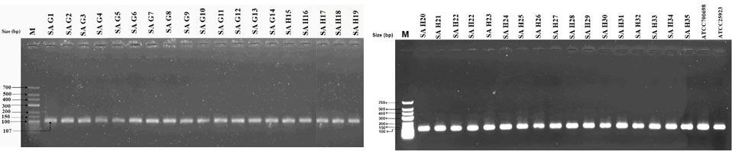
Supplementary Fig. 1 Agarose gel electrophoresis analyses of the PCR amplified products of the species-specific sequence of S. aureus clinical isolates. The amplification of a 107 bp product indicates a positive result. Lane M indicates the low-range DNA ladder (Fermentas, USA) and the rest of the lanes indicate the PCR amplified products of a species-specific sequence of S. aureus isolates.

Supplementary Fig. 2 Agarose gel electrophoresis analyses of the PCR amplified products of mecA gene of S. aureus clinical isolates. Lane M indicates the low-range DNA ladder (Fermentas, USA) and the rest of the lanes indicate the PCR amplified products of mecA gene. A 532 bp amplified product indicates a positive result.
Supplementary Fig. 3 Agarose gel electrophoresis analyses of the PCR amplified product of pvl gene of S. aureus clinical isolates. Lane M indicates the Lambda DNA digested with EcoRI and HindIII Marker 3 (Fermentas, USA). Amplification of 1918 bp indicates a positive result.
B.
A.

C.

D.

Supplementary Fig. 4 Agarose gel electrophoresis of the PCR amplified products of SCCmec gene of S. aureus clinical isolates. The PCR amplified product represents SCCmec type I are shown in panel (A) and (B); SCCmec type II in panel (C); and SCCmec type IV and V in panel (D). Lane M indicates the low-range DNA ladder (Fermentas, USA) and Lane M1 indicates the Lambda DNA digested with EcoRI and HindIII Marker 3 (Fermentas, USA).

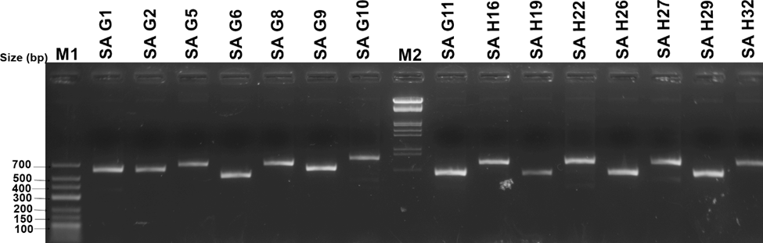
Supplementary Fig. 5 Polymorphism analysis of the S. aureus clinical isolates through Agarose gel electrophoresis of the PCR amplified products of coa gene. Lane M1 indicates the low-range DNA ladder (Fermentas, USA) and Lane M2 indicates the Lambda DNA digested with EcoRI and HindIII Marker 3 (Fermentas, USA).

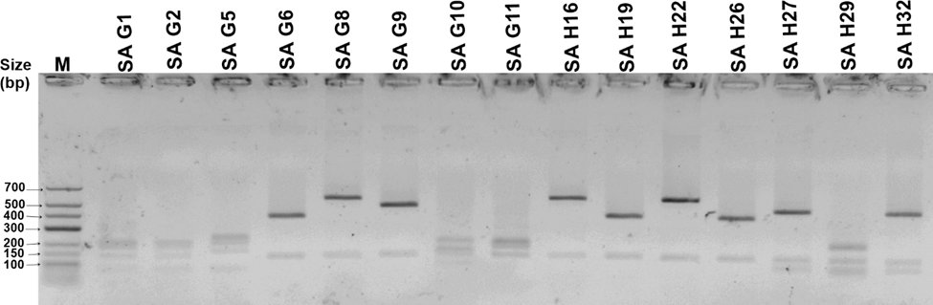
Supplementary Fig. 6 Agarose gel electrophoresis showing the RFLP pattern of S. aureus clinical isolates based on the digestion of coa gene with HaeIII. Lane M indicates the low-range DNA ladder (Fermentas, USA).

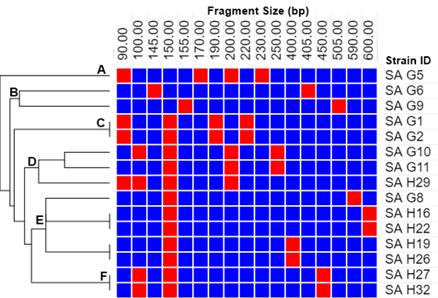
Supplementary Fig. 7. Heat-map showing the similarity and difference of complex coa-HaeIII-RFLP banding pattern. The top labels indicate the fragment sizes (bp), Strain ID listed at the right part of the panel, and clustering hierarchy demonstrated by the dendrogram at left.
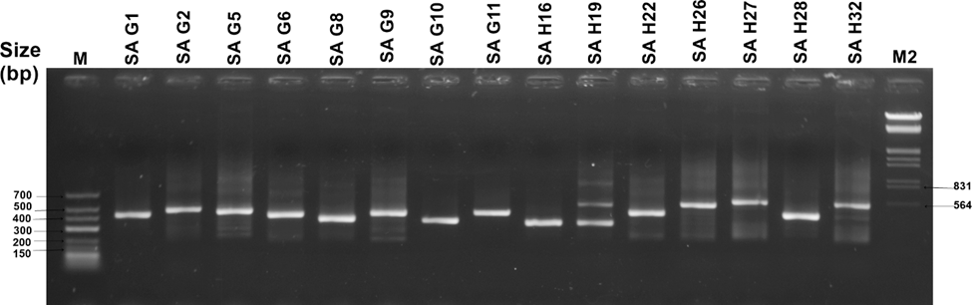
Supplementary Fig. 8 Agarose gel electrophoresis of the PCR amplified products of spa polymorphic gene of S. aureus clinical isolates. Lane M indicates the low-range DNA ladder (Fermentas, USA) and Lane M2 indicates the Lambda DNA digested with EcoRI and HindIII (Fermentas, USA).

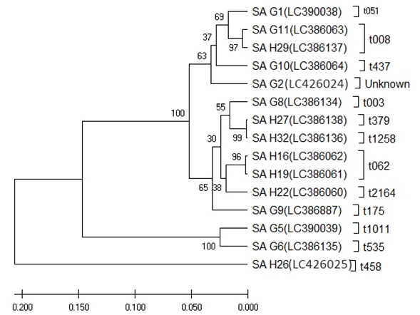

Supplementary Fig. 9 Phylogenetic analysis of S. aureus isolates based on spa gene sequences using UPGMA method. Strain ID and its spa-gene sequence accession number are indicated together with respective spa-type. Clusters are denoted by A, B, C, and D. Evolutionary distance is represented on the scalebar. Bootstrap values are presented based on 1000 replicates.

Supplementary Fig. 10 Agarose gel electrophoresis of the PCR amplified products of icaA gene of S. aureus clinical isolates. Lane M indicates the low-range DNA ladder (Fermentas, USA). A 141 bp amplified product indicates a positive result

Supplementary Fig. 11 Agarose gel electrophoresis of the PCR amplified products of icaB gene of S. aureus clinical isolates. Lane M indicates the low-range DNA ladder (Fermentas, USA). A 137 bp amplified product indicates a positive result.
Supplementary Fig. 12 Agarose gel electrophoresis of the PCR amplified products of icaC gene of S. aureus clinical isolates. Lane M indicates the low-range DNA ladder (Fermentas). A 100 bp amplified product indicates a positive result

Supplementary Fig. 13 Agarose gel electrophoresis of the PCR amplified products of icaD gene of S. aureus clinical isolates. Lane M indicates the low-range DNA ladder (Fermentas, USA). A 78 bp amplified product indicates a positive result

Supplementary Fig. 14 Agarose gel electrophoresis of the PCR amplified products of icaR gene of S. aureus clinical isolates. Lane M indicates the low-range DNA ladder (Fermentas, USA). A 102 bp amplified product indicates a positive result

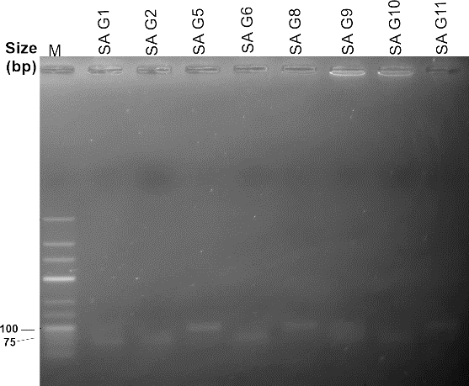

Supplementary Fig. 15 Agarose gel electrophoresis of the PCR amplified products of fnaA gene of S. aureus
clinical isolates. Lane M indicates the low-range DNA ladder (Fermentas, USA).

S. 16. Agarose gel electrophoresis of the PCR amplified products of fnaB gene of S. aureus clinical isolates. Lane M indicates the low-range DNA ladder (Fermentas, USA).
Supplementary Fig. 17 Agarose gel electrophoresis of the PCR amplified products of cna gene of S. aureus clinical isolates. Lane M indicates the low-range DNA ladder (Fermentas, USA). A presence of 91-140 bp amplified product indicates a positive result

Supplementary Fig. 18 Agarose gel electrophoresis of PCR amplified products of clfA gene of S. aureus clinical isolates. Lane M indicates the low-range DNA ladder (Fermentas, USA). A 115 bp amplified product indicates a positive result
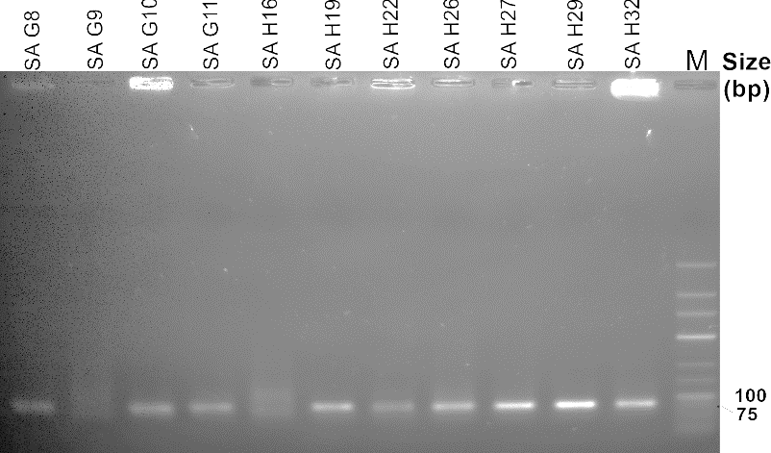

Supplementary Fig. 19 Agarose gel electrophoresis of PCR amplified products of clfB gene of S. aureus clinical isolates. Lane M indicates the low-range DNA ladder (Fermentas, USA). A 77 bp amplified product indicates a positive result
Supplementary Fig. 20 Agarose gel electrophoresis of PCR amplified products of ebps gene of S. aureus clinical isolates. Lane M indicates the low-range DNA ladder (Fermentas, USA). A ~100 bp amplified product indicates a positive result.
Supplementary Table 1. Quantification of S. aureus biofilm-forming ability

Strain ID | Absorbance at 540nm | Category
SA G1 | 0.088±0.012 | Non
SA G2 | 0.092±0.015 | Non
SA G6 | 0.085±0.018 | Non
SA H16 | 0.066±0.016 | Non
SA G8 | 0.128±0.032 | Moderate
SA G9 | 0.160±0.009 | Moderate
SA G10 | 0.157±0.062 | Moderate
SA H19 | 0.142±0.011 | Moderate
SA H26 | 0.122±0.037 | Moderate
SA H32 | 0.133±0.051 | Moderate
SA G5 | 0.604±0.10 | Strong
SA G11 | 0.442±0.013 | Strong
SA H22 | 0.490±0.150 | Strong
SA H27 | 0.690±0.066 | Strong
SA H29 | 0.684±0.075 | Strong
ATCC25923 | 0.272±0.039 | Moderate

Supplementary Table 2. Primers used for the detection of biofilm-associated genes

Gene name | Primer Sequence (5´- 3´) | Amplicon Size (bp)
icaA | TTTCGGGTGTCTTCACTCTATTT | 141
icaA | TGGCAAGCGGTTCATACTT | 141
icaB | ACCGGCAACTGGGTTTATT | 137
icaB | GCAAATCGTGGGTATGTGTTTC | 137
icaC | GCGTTAGCAAATGGAGACTATTG | 100
icaC | GCGTGCAAATACCCAAGATAAC | 100
icaD | AGCCCAGACAGAGGGAATA | 78
icaD | ACGATATAGCGATAAGTGCTGTC | 78
icaR | GCTGTTTCTTGAAAGTTGGTATTTG | 102
icaR | AGTAGCGAATACACTTCATCTTTG | 102
fnbA | AACAATCTTAGGTACGGCATTAGA | 89
fnbA | TCTTGTCCCATCCCAACAAC | 89
fnbB | GTAGAGGAAAGTGGGAGTTCAG | 105
fnbB | TGTCGCGCTGTATGATTGT | 105
ebpS | GTGGCATGGCCAAAGTATTG | 77
ebpS | CATGCCTCCAAATATCGCTAATG | 77
clfA | CACAACAGGAAACGACACAATC | 115
clfA | TGAGTTGTTGCCGGTGTATTA | 115
clfB | CACAAACAGTGCGAATGTAGATAG | 77
clfB | CTGGCTCTGTTGTAGTGGTATT | 77
cna | CAGGTGGGTCAAGCAGTTATTA | 91
cna | CTGCAAATCCCGAAACATCAC | 91

Supplementary Table 3. Typing of coa gene and HaeIII RFLP patterns of S. aureus strains
Strain ID | Detected coa  amplicon size (bp) | RFLP pattern  (approx bp) | Pattern code | DI of coa PCR typing | *DI of coa-PCR-RFLP typing
SA H19 | 550 | 400+150 | C1 | 0.8381 | 0.9619
SA H26 | 550 | 400+150 | C1 | 0.8381 | 0.9619
SA G6 | 550 | 405+145 | C2 | 0.8381 | 0.9619
SA H29 | 550 | 200+150+100+90 | C3 | 0.8381 | 0.9619
SA G11 | 600 | 250+200+150 | D | 0.8381 | 0.9619
SA G1 | 650 | 220+190+150+90 | A | 0.8381 | 0.9619
SA G2 | 650 | 220+190+150+90 | A | 0.8381 | 0.9619
SA G9 | 660 | 505+155 | E | 0.8381 | 0.9619
SA G5 | 700 | 230+200+170+90 | B1 | 0.8381 | 0.9619
SA H16 | 700 | 600+150 | B2 | 0.8381 | 0.9619
SA H22 | 700 | 600+150 | B2 | 0.8381 | 0.9619
SA H27 | 700 | 450+150+100 | B3 | 0.8381 | 0.9619
SA H32 | 700 | 450+150+100 | B3 | 0.8381 | 0.9619
SA G8 | 740 | 590+150 | F | 0.8381 | 0.9619
SA G10 | 800 | 250+200+150+100 | G | 0.8381 | 0.9619
*DI-Discriminatory index
Supplementary Table 4. Typing of spa gene polymorphism and distribution of different repeats and types of S. aureus strains
Strain ID | Detected spa amplicon size (bp) | Repeats Succession | Kreiswirth IDs | spa-type | *DI of spa-PCR typing
SA G1 | 440 | 11-19-21-12-21-17-34-24-34-22-25 | YHFGFMBQBLO | t051 | 0.9429
SA G2 | 500 | 21-17-34-24-34-22-24-34-22-33-25 | FMBQBLQBLPO | UK | 0.9429
SA G5 | 480 | 08-39-34 | XE3B | t1011 | 0.9429
SA G6 | 440 | 26-17-16 | TMK | t535 | 0.9429
SA G8 | 400 | 26-17-20-17-12-17-17-16 | TMDMGMMK | t003 | 0.9429
SA G9 | 460 | 07-23-21-16-16-33-21-16-33-13 | UJFKKPFKPE | t175 | 0.9429
SA G10 | 380 | 04-20-17-20-17-25-34 | ZDMDMOB | t437 | 0.9429
SA G11 | 460 | 11-19-12-21-17-34-24-34-22-25 | YHGFMBQBLO | t008 | 0.9429
SA H16 | 355 | 26-23-17-12-17-16 | TJMGMK | t062 | 0.9429
SA H19 | 355 | 26-23-17-12-17-16 | TJMGMK | t062 | 0.9429
SA H22 | 460 | 26-23-17-34-17-82-17-12-17-16 | TJMBM[r82] MGMK | t2164 | 0.9429
SA H26 | 560 | 26 | T1 | t458 | 0.9429
SA H27 | 550 | 26-23-23-13-23-31-29-17-25-17-25-16-28 | TJJEJNF2MOMOKR | t379 | 0.9429
SA H29 | 430 | 11-19-12-21-17-34-24-34-22-25 | YHGFMBQBLO | t008 | 0.9429
SA H32 | 550 | 26-23-23-13-23 | TJJEJ | t1258 | 0.9429
*DI-Discriminatory index; UK- Unknown

