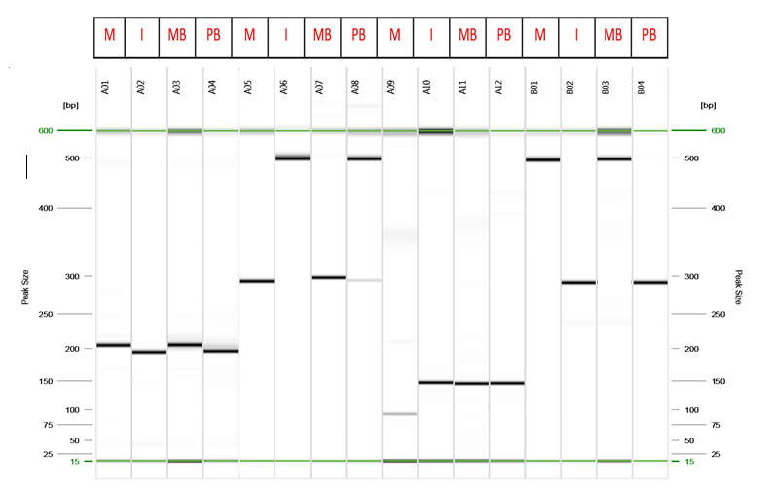
Suppl. Fig 1: Capillary gel electrophoresis representation of bulk segregant analysis of Mutant (M), distant parent (I), mutant bulk (MB) and distant parent bulks (PB) from the F₂ cross TG 89 X ICGV 15007.
Note: Marker order 1-4. Ah1TC3A12, 5-8. AhTE333, 9-12. AhTE810, 12-16 AhTE278.

