Supplementary File for Publication
Table S1. Simufilam drug design structures and their derivatives from A1 to A52.
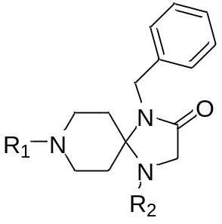

Basic Moieties of Simufilam

S.No. | R₁ | R₂ | S.No. | R₁ | R₂
A1 | -H | -H | A27 | 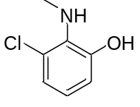 | -C₂H₅O
A2 | -C₂H₅ | -H | A28 | 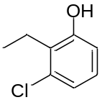 | -C₂H₅O
A3 | -H | -CH₃ | A29 | 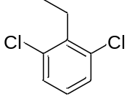 | -C₂H₅O
A4 | -H | -C₂H₅ | A30 |  | -C₂H₅F
A5 | -C₂H₄Cl | -H | A31 |  | -H
A6 | -C₂H₄Cl | -CH₃ | A32 |  | -C₂H₅
A7 | -C₂H₄Cl | -C₂H₅ | A33 | 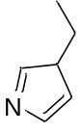 | -C₂H₅
A8 | -C₃H₇Cl | -C₂H₅ | A34 | 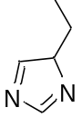 | -C₂H₅
A9 | -C₃H₇Cl | -CH₃ | A35 |  | -H
A10 | -C₃H₇Cl | -C₆H₅ | A36 |  | -CH₃
A11 | -C₂H₅ | -C₆H₅ | A37 |  | -C₂H₅
A12 | -CH₃ | -C₆H₅ | A38 | 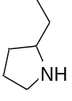 | -C₂H₅
A13 | -CH₂Cl | -C₆H₅ | A39 |  | -CH₃
A14 | 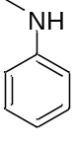 | -C₆H₅ | A40 |  | -H
A15 |  | -H | A41 | 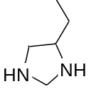 | -H
A16 |  | -CH₃ | A42 |  | -CH₃
A17 |  | -C₂H₅ | A43 |  | -C₂H₅
A18 |  | -C₂H₅ | A44 |  | -C₆H₅
A19 | 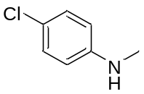 | -C₃H₇ | A45 | 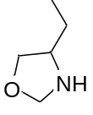 | -C₆H₅
A20 | 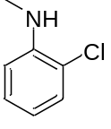 | -H | A46 |  | -C₂H₅
A21 |  | -CH₃ | A47 |  | -CH₃
A22 |  | -C₂H₅ | A48 |  | -H
A23 |  | -C₃H₇ | A49 |  | -H
A24 | 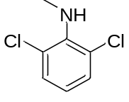 | -H | A50 | 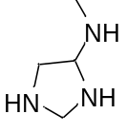 | -H
A25 |  | -H | A51 |  | -CH₃
A26 |  | -C₂H₄Cl | A52 |  | -C₂H₅

Table S2. Binding energy of 52 SD derivatives and PTP1β (PDB ID: 1T49) Co-crystal
CMPD | B.E. (kcal/mol) | CMPD | B.E. (kcal/mol) | CMPD | B.E. (kcal/mol) | CMPD | B.E. (kcal/mol)
1 | -6.7 | 14 | -8 | 27 | -7.6 | 40 | -7.5
2 | -6.6 | 15 | -7.9 | 28 | -6.8 | 41 | -7.5
3 | -6.6 | 16 | -7.4 | 29 | -7.1 | 42 | -7.1
4 | -6.4 | 17 | -7.2 | 30 | -7 | 43 | -6.7
5 | -6.6 | 18 | -7.2 | 31 | -7.5 | 44 | -7.5
6 | -6.2 | 19 | -7.7 | 32 | -7.4 | 45 | -7.8
7 | -6.6 | 20 | -10.8 | 33 | -6.9 | 46 | -6.9
8 | -6.3 | 21 | -7.2 | 34 | -7.1 | 47 | -6.8
9 | -6.2 | 22 | -7.1 | 35 | -7.2 | 48 | -7.7
10 | -7.1 | 23 | -7.4 | 36 | -7.2 | 49 | -7.2
11 | -7.2 | 24 | -7.6 | 37 | -7 | 50 | -7.6
12 | -7.2 | 25 | -8 | 38 | -6.6 | 51 | -7.2
13 | -7.2 | 26 | -9.5 | 39 | -6.9 | 52 | -7
53 | Co-crystal |  | -6.0

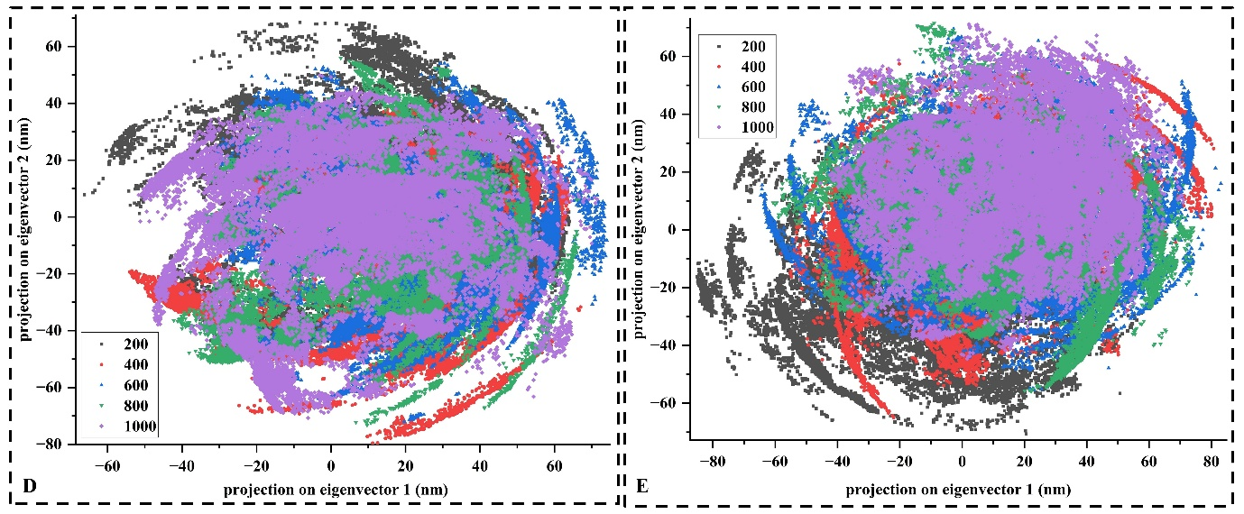
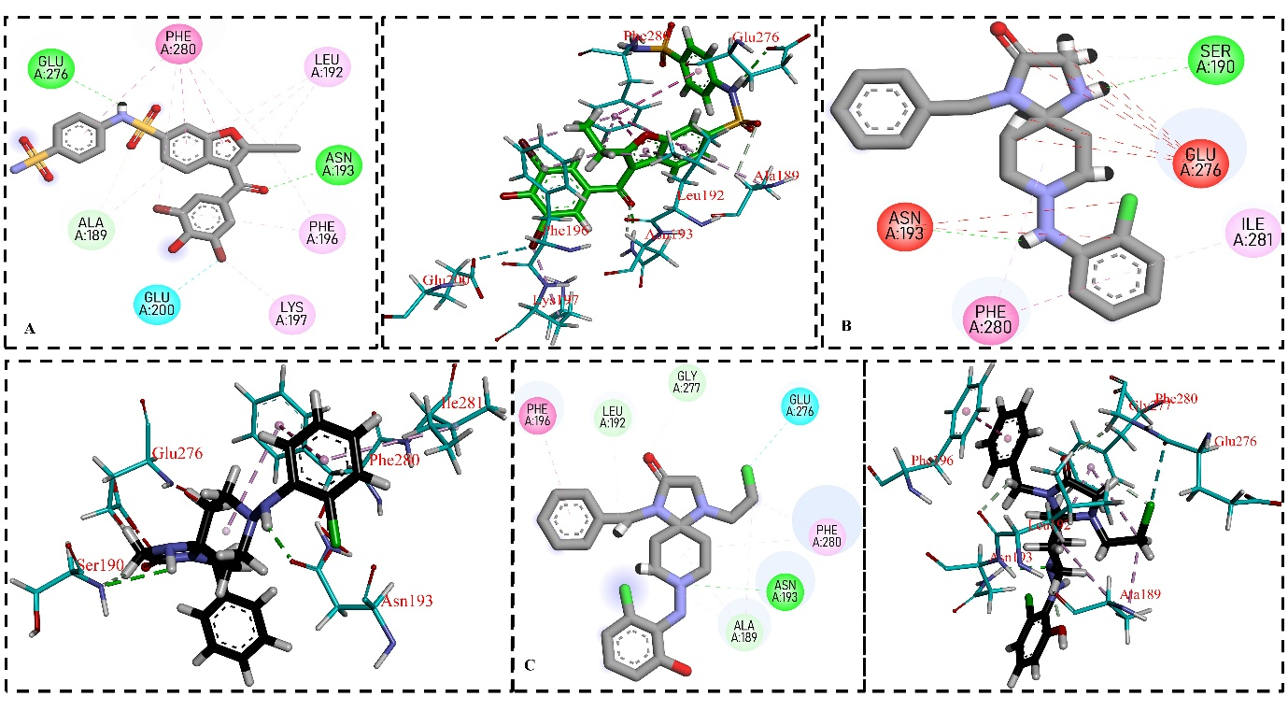
Figure S1. 2D & 3D interactions of protein-ligand complexes. A) Co-crystal, B) A20, and C. A26 protein-ligand complex.
Figure S2. PCA analysis of D) Co-crystal and E) A26 at different time interval like 0, 200 ns, 400, 600, 800, and 1000 ns.

Table S3. Thermodynamic energy parameters of active binding pocket amino acids with A20.
Active amino acids | Optimization energy (Hartree) | Dipole moment (Debye) | E_{HOMO} (Hartree) | E_{LUMO} (Hartree) | E_{HOMO} - E_{LUMO} (Hartree) | ΔE  (EHOMO  ELUMO)  (eV)
Asp193 | -323.75 | 3.41 | -0.25 | -0.03 | -0.21 | -5.83
Glu276 | -398.95 | 3.16 | -0.24 | -0.02 | -0.21 | -5.85
Thr263 | -438.28 | 3.15 | -0.25 | -0.04 | -0.21 | -5.73
Tyr46 | -630.01 | 1.74 | -0.23 | -0.03 | -0.19 | -5.43

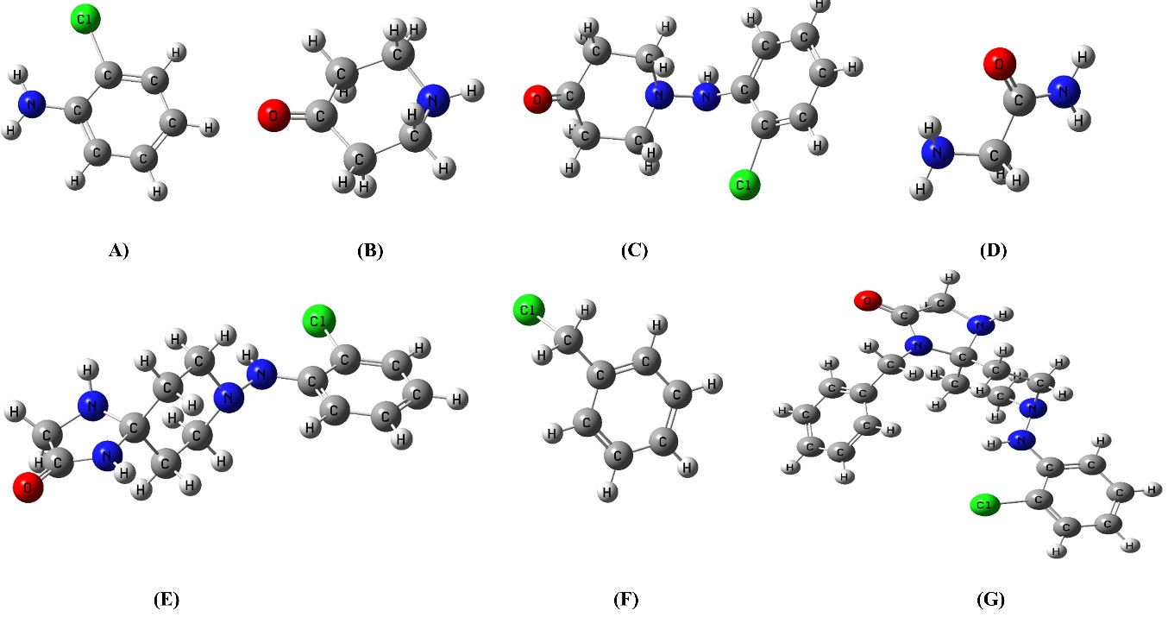
Figure S3. HOMO and LUMO quantum energy of proposed reaction mechanism.

Table S4. Determined HOMO and LUMO energies of proposed reaction mechanism (A20)
Compound | Optimization energy (Hartree) | Dipole moment (Debye) | E_{HOMO} (Hartree) | E_{LUMO} (Hartree) | E_{HOMO}-E_{LUMO} (Hartree) | ΔE  (EHOMO  ELUMO)  (eV)
A | -747.22 | 2.93 | -0.21 | -0.02 | -0.19 | -5.17
B | -325.92 | 4.93 | -0.23 | -0.04 | -0.19 | -5.17
C | -1071.88 | 6.57 | -0.23 | -0.05 | -0.18 | -4.89
D | -264.58 | 5.90 | -0.24 | -0.01 | -0.23 | -6.25
E | -1260.03 | 2.90 | -0.21 | -0.02 | -0.19 | -5.17
F | -731.18 | 4.07 | -0.26 | -0.06 | -0.20 | -5.44
G/ A20 | -1530.38 | 4.09 | -0.21 | -0.02 | -0.19 | -5.17
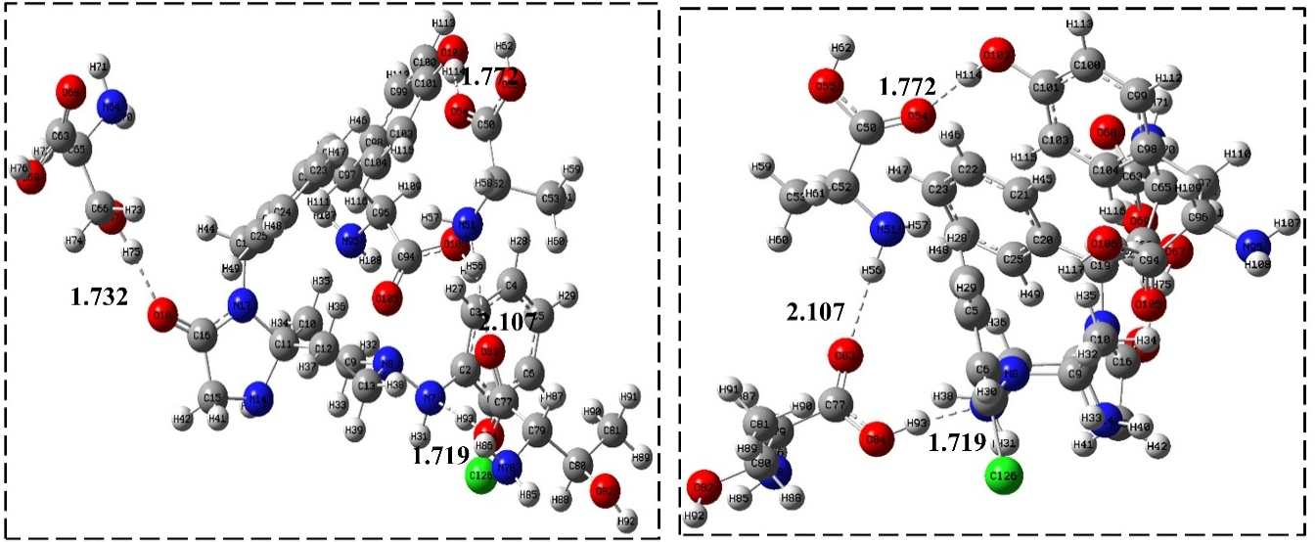
Figure S4. Natural bond orbital energy of compound A20 and their interacting amino acids.

