Supporting Information
On-chip Paper Electrophoresis for Ultrafast Screening of Infectious Diseases
Hamin Na^{1,2}, Byoung-Hoon Kang^{1,2}, Jayoung Ku^{2,3}, Yoosik Kim^{2,3}, and Ki-Hun Jeong^{1,2*}

¹ Department of Bio and Brain Engineering, Korea Advanced Institute of Science and Technology (KAIST), 291 Daehak-ro, Yuseong-gu, Daejeon 34141, Republic of Korea
² KAIST Institute for Health Science and Technology (KIHST), Korea Advanced Institute of Science and Technology (KAIST), 291 Daehak-ro, Yuseong-gu, Daejeon 34141, Republic of Korea
³ Department of Chemical and Biomolecular Engineering, Korea Advanced Institute of Science and Technology (KAIST), 291 Daehak-ro, Yuseong-gu, Daejeon 34141, Republic of Korea

*E-mail: kjeong@kaist.ac.kr
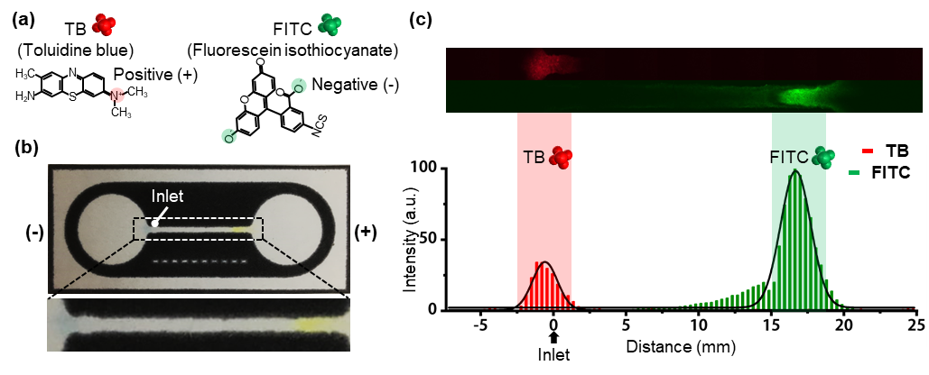
Fig. S1 Electrophoretic separation of toluidine blue (TB) and fluorescein isothiocyanate (FITC). (a) Molecular structures of TB and FITC with opposite charges. (b) Photograph of paper CE chip after electrophoretic separation. (c) Fluorescence detection of separated molecules on the separation channel (top) and the fluorescence intensity profiles of each molecule (bottom).

