Supporting Information

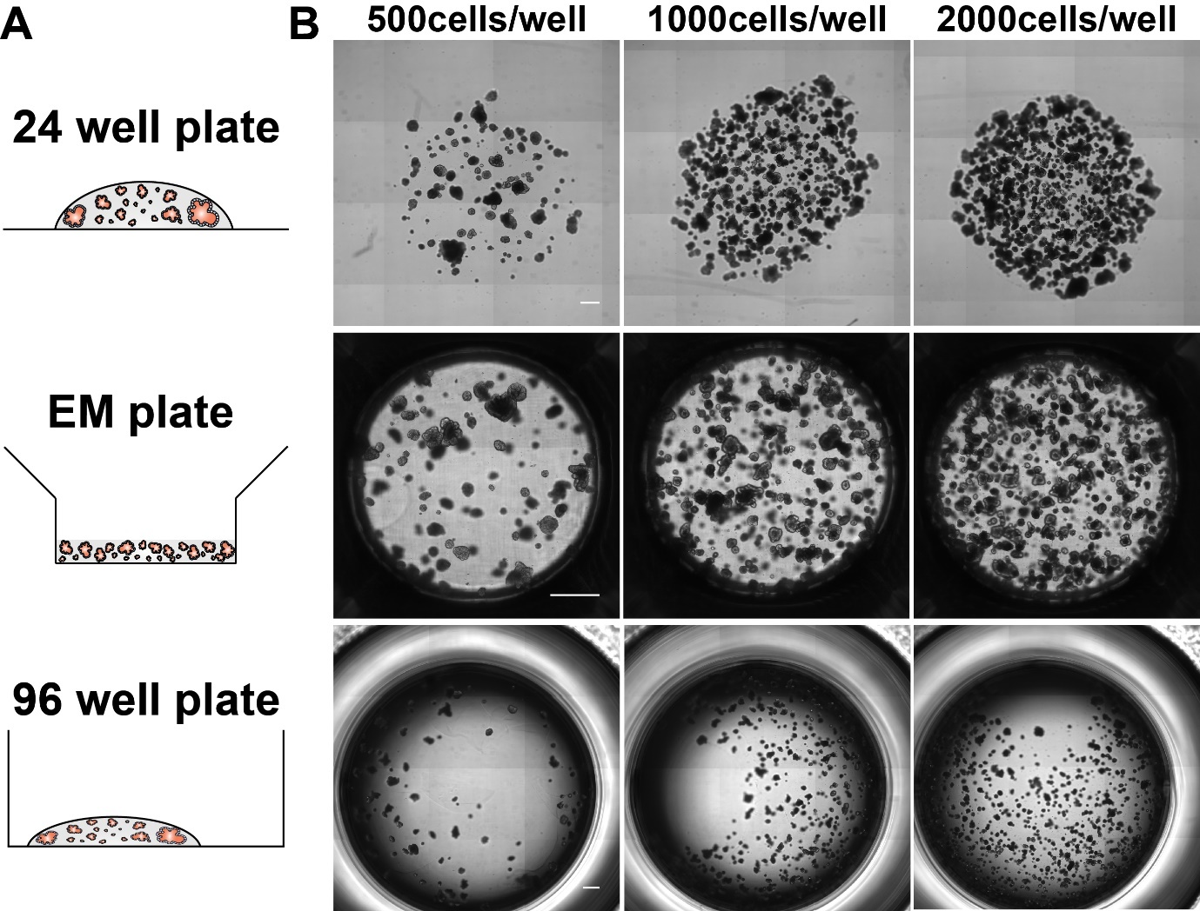
Fig. S1. Comparison between the developed EM plate and conventional 24- and 96- well plate. Whole images of organoids embedded in 10 µl of Matrigel at densities of 500, 100, 2000 cells per well. (A) Schematics of expected position of Matrigel. (B) The bright field images of organoids cultured in conventional 24- and 96-well plate and the EM plate at day 14 after plating. Scale bar: 500 µm

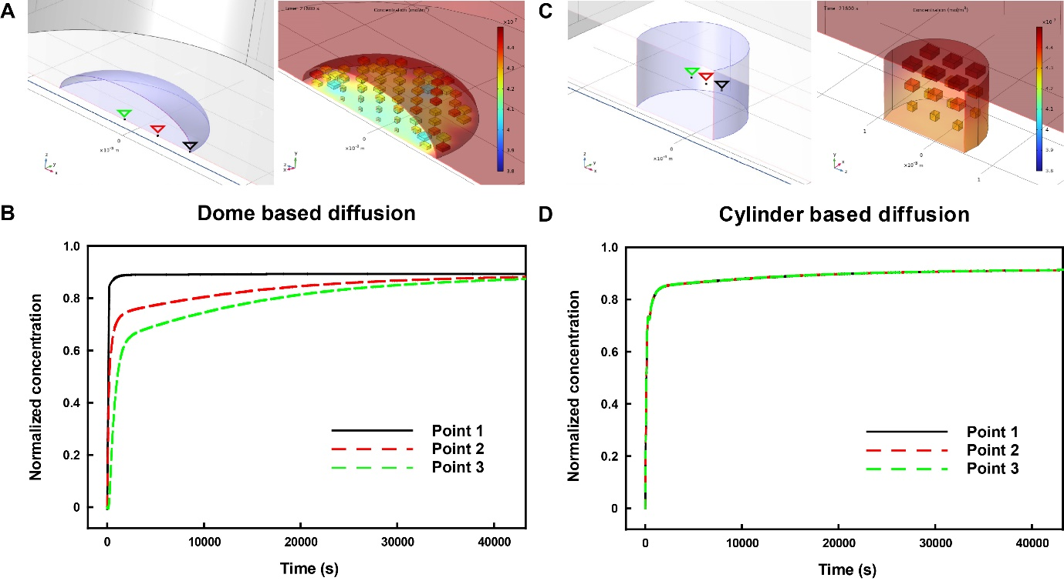
Fig. S2. COMSOL-simulation of dome and cylinder shape. Simulation data of conventional dome shaped Matrigel of 24 well plate and cylinder shaped Matrigel of EM plate. A. Consumption rates were analyzed at three different points in x-axis where edge, middle, and center points showed different consumption in dome shaped Matrigel. B. Computational graph showing different amount of concentration analyzed at edge, middle, and center. C. Consumption rates were not distinct in three different points in cylinder shaped Matrigel. D. Computational graph showing a great resemblance in concentration.

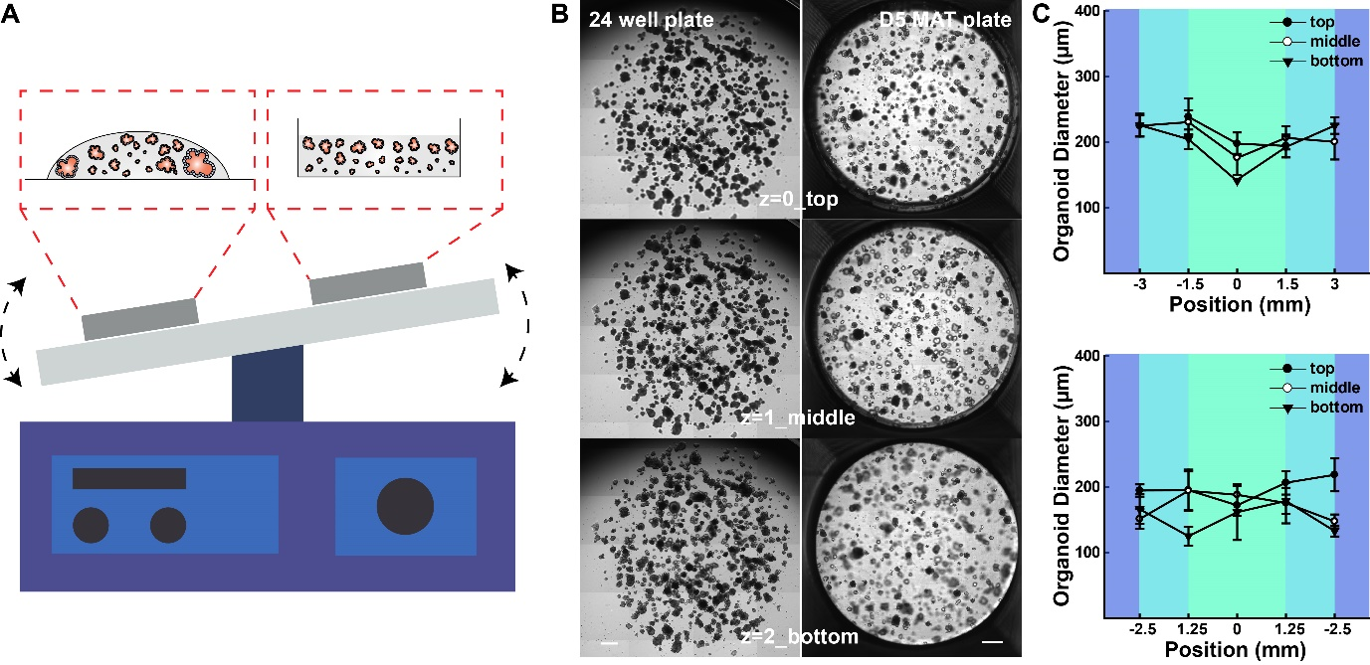
Fig. S3. Organoid culture on a shaker. (A) Schematic images of how plates were placed on a shaker. (B) Bright field images of the 24-well plate and EM plate on a shaker. (C) organoid distribution in the 24-well plate (upper) and EM plate (lower). Scale bar: 500 µm.

