Supplementary Figures

Fig. S1: The pH effect on the potential and peak current of CIN for cyclic voltammetry responses of 1 × 10⁻⁵ M of CIN using Al₂O₃-NPs/MWCNTs/CPE.

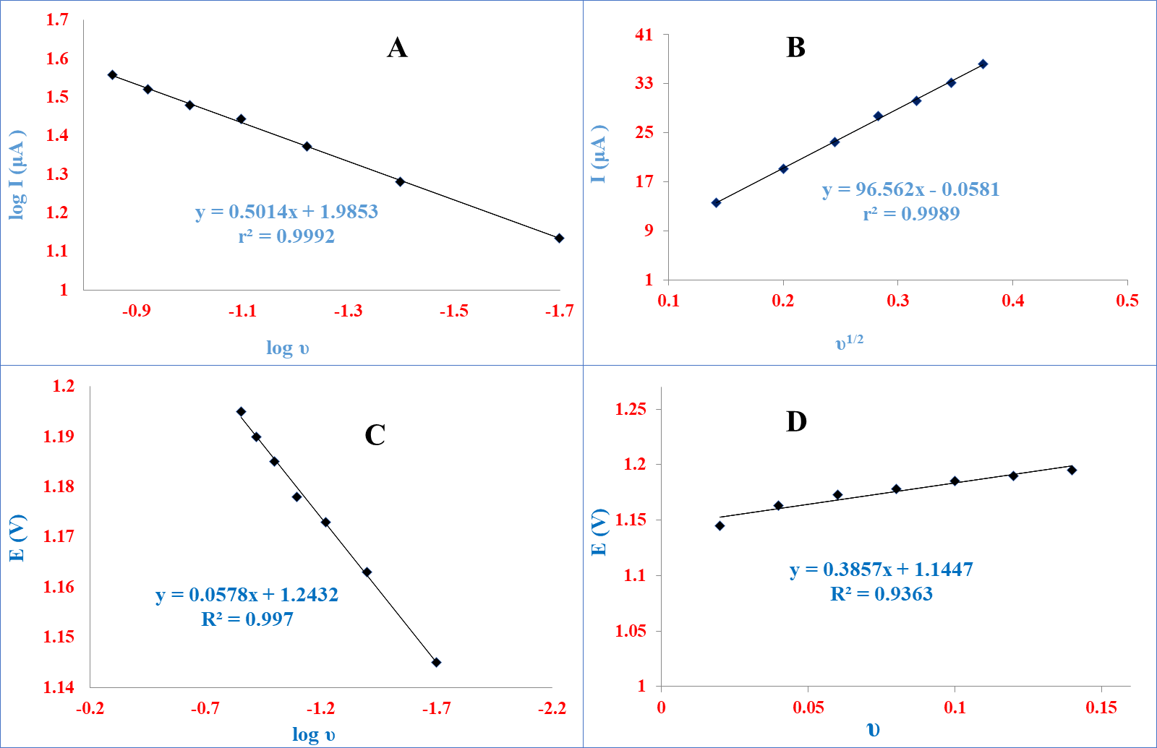
Fig. S2: Different scan rates (0.2 – 1.4 V s⁻¹) for cyclic voltammetry responses of 1× 10⁻⁵ M of CIN using Al₂O₃-NPs/MWCNT/CP sensor with PB (pH=3), inset (A) peak current response logarithm versus scan rate logarithm, inset (B) peak current response against scan rate square root, inset (C) peak potential versus scan rate logarithm, inset (D) peak potential against scan rate.

Fig. S3: (A) Chronoamperograms of CIN at Al₂O₃-NPs/MWCNTs/CPE in PB pH 3, containing: 5, 50, 80, and 100 × 10⁻⁵ M CIN. (B) The plot of I (μA) against t^{−1/2} (S^{-1/2}) for different concentrations of CIN. (C) The plot of the resulting slopes in (B) against the concentrations of CIN.
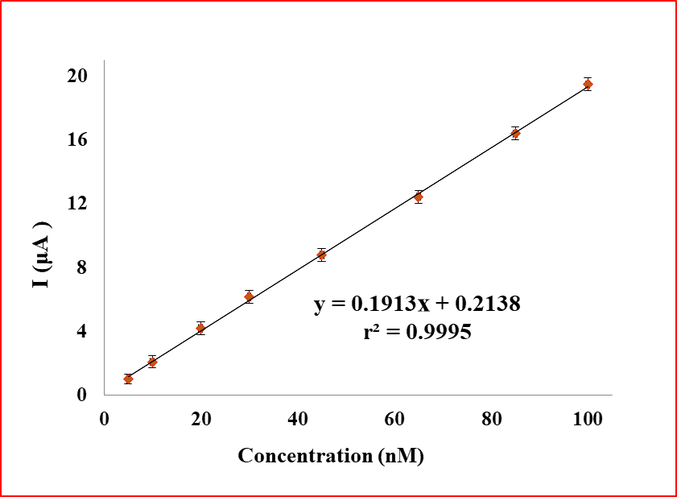

Fig: S4. SWV Calibration graphs for CIN.

Fig. S5: Reproducibility of Al₂O₃-NPs/MWCNT/CP sensor in PB (pH 3), containing 1× 10⁻⁵ M CIN.

Fig. S6: Stability of the Al₂O₃-NPs/MWCNT/CP sensor in PB (pH 3), containing 1× 10⁻⁵ M CIN.

Fig. S7: Characterization of the most popular metrics for the evaluation of the green character of analytical procedures.

Fig. S8: Typical NEMI pictograms.

Fig. S9: The penalty points (PPs) to calculate the analytical Eco-Scale.

Fig. S10: The ComplexGAPI pictogram, with the original GAPI pictogram, greyed out in the background, and particular fields of the added hexagonal glyph are grouped and color-coded for clarity.

Fig. S11: Comparison of the redness, greenness, blueness, and whiteness profiles of the proposed and reported methods, obtained by the RGB 12 algorithm.

Supplementary Tables
Table S1. Determination of CIN at the Al₂O₃-NPs/MWCNTs/CPE in its dosage form and standard addition technique application.

Vial | drug | %Found  ± SD* | Standard addition technique
Vial | drug | %Found  ± SD* | Added  (nM) | Founded  (nM) | % Recovery*
Stugeron® tablets a labelled to contain 25 mg/tablet for CIN | CIN | 99.96 ± 0.33 | 10 | 10.05 | 100.54
Stugeron® tablets a labelled to contain 25 mg/tablet for CIN | CIN | 99.96 ± 0.33 | 20 | 20.14 | 100.69
Stugeron® tablets a labelled to contain 25 mg/tablet for CIN | CIN | 99.96 ± 0.33 | 30 | 30.39 | 101.31
Stugeron® tablets a labelled to contain 25 mg/tablet for CIN | CIN | 99.96 ± 0.33 | 40 | 39.64 | 99.09
Stugeron® tablets a labelled to contain 25 mg/tablet for CIN | CIN | 99.96 ± 0.33 | Mean± %RSD | 100.23 ± 1.9

* n=3

Table S2. Determination of CIN in Stugeron® by the proposed method and statistical comparison with the reported method.

Parameters | Proposed method | Reported method [22]
Drugs | CIN | CIN
n* | 5 | 5
%R | 99.96 | 100.40
SD | 0.33 | 0.48
Variance | 0.11 | 0.23
Student's t-test**  (2.306) | 1.68 | ——
F-value**  (6.388) | 2.07 | ——
*Number of experiments.
** The values in parenthesis are tabulated values of “t“and “F” at (P = 0.05).

Table S3. Determination of CIN in bovina food samples by the proposed method.

Parameters | Milk | Meat | kidney | Liver
Linearity (nM) | 5-100 | 5-100 | 5-100 | 5-100
LOD (nM) | 0.31 | 0.33 | 0.29 | 0.37
LOQ (nM) | 0.93 | 1.01 | 0.87 | 1.12
Slope | 0.1952 | 0.1946 | 0.195 | 0.1933
Intercept | 0.1934 | 0.2118 | 0.1423 | 0.2916
Correlation coefficient (r) | 0.9993 | 0.9992 | 0.9994 | 0.9990

Parameters | Proposed method | Reported [20] | Reported [21] | Reported [22]
Linearity (nM) | 5-100 | 90-600 | 200-500 | 8-450
LOD (nM) | 0.17 | 2.58 | 9 | 1.11
Sample types | Pharmaceutical, milk, liver, kidney, and meat | Pharmaceutical and urine | Pharmaceutical and serum | Pharmaceutical and urine
Sustainability assessment | Yes (NEMI, ESA, ComplexGAPI, AGREE, and RGB12) | No | No | No
Electrode substrate | Carbon paste electrode | Glassy carbon electrode | Bare glassy carbon electrode | Carbon paste electrode
Electrode modifiers | Aluminum oxide nanoparticles and multi-walled carbon nanotubes | Multi-walled carbon nanotubes | No modifiers | Multi-walled carbon nanotubes
Technique used | Cyclic voltammetry, square wave voltammetry | Cyclic voltammetry, differential pulse voltammetry | Cyclic voltammetry, linear sweep adsorptive stripping voltammetry | Cyclic voltammetry, differential pulse voltammetry
Sensitivity (μA/nM) | 0.193 | 1.457 | 1.623 | 2.256
Response time (Seconds) | 20 | 180 | 60 | 180
Stability (days) | 30 | No stability studies | 1 | No stability studies
Reproducibility (%RSD) | 0.36% | 2.96% | 1.87% | 1.98%
Electrode characterization | SEM, TEM, EDX, XRD, FTIR, and EIS | No | No | No
Table S4. Comparison between proposed and reported electroanalytical sensors used to quantify CIN.

Analytical greenness report sheets for the suggested and reported methods by AGREE tool
(1) AGREE report sheet of the proposed method.

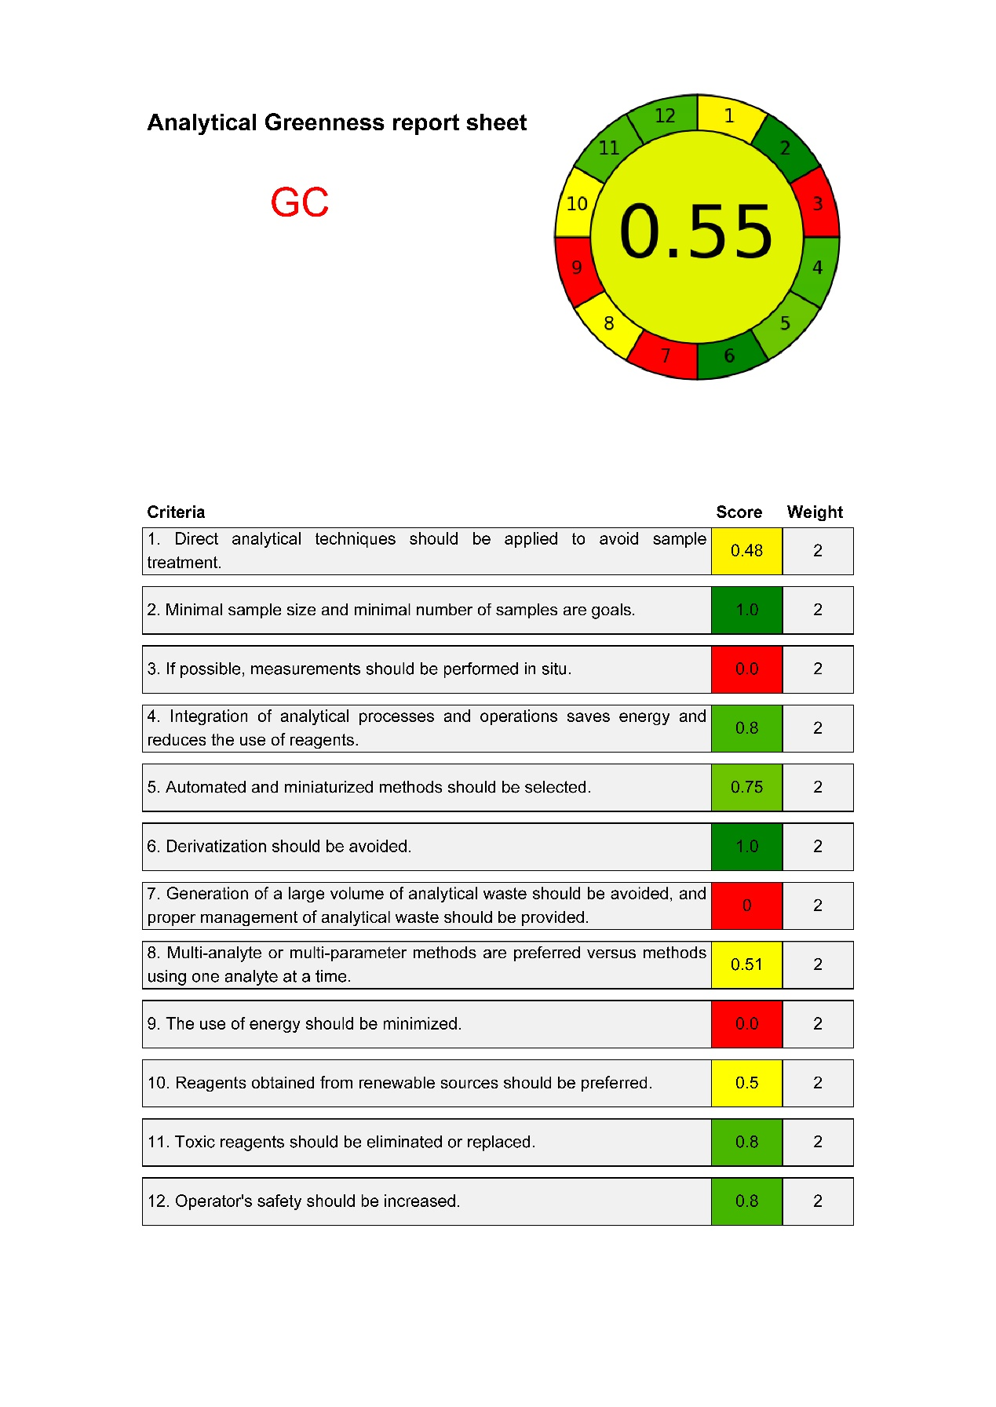
(2) AGREE report sheet of the GC method.

