Supporting information

Automated microfluidic systems facilitating the scalable and reliable production of lipid nanoparticles for gene delivery
Daekyeong Jung^{1,†}, Soojin Jang^{2,3†}, Donggeun Park^{4,†}, Nam Ho Bae¹, Chung Soo Han⁵, Seunghwa Ryu^{*,4}, Eun-Kyung Lim^{*,2,3,6}, and Kyoung G. Lee ^{*,1}
†These authors contributed equally to this work.
¹Center for Nano Bio Development, National NanoFab Center (NNFC), 291 Daehak-ro, Yuseong-gu, Daejeon 34141, Republic of Korea
²Bionanotechnology Research Center, Korea Research Institute of Bioscience and Biotechnology (KRIBB), 125 Gwahak-ro, Yuseong-gu, Daejeon 34141, Republic of Korea
³Department of Nanobiotechnology, KRIBB School of Biotechnology, UST 125 Gwahak-ro, Yuseong-gu, Daejeon 34113, Republic of Korea
⁴Department of Mechanical Engineering, Korea Advanced Institute of Science and Technology (KAIST), 291 Daehak-ro, Yuseong-gu, Daejeon 34141, Republic of Korea
⁵Research and Development Center, KRON Corporation, 46 Hangaul-gil, Hwaseong-si, Gyeonggi-do 18260, Republic of Korea
⁶School of Pharmacy, Sungkyunkwan University, Suwon 16419, Republic of Korea

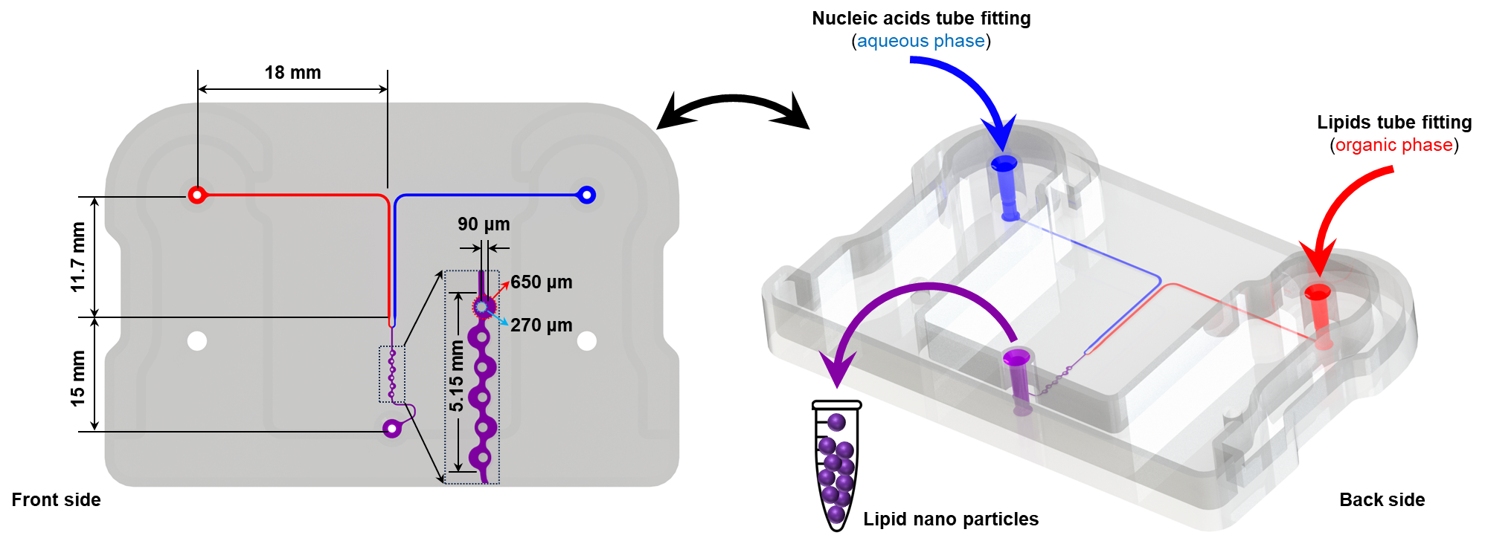
Fig. S1. The detail dimension of LNP cartilage

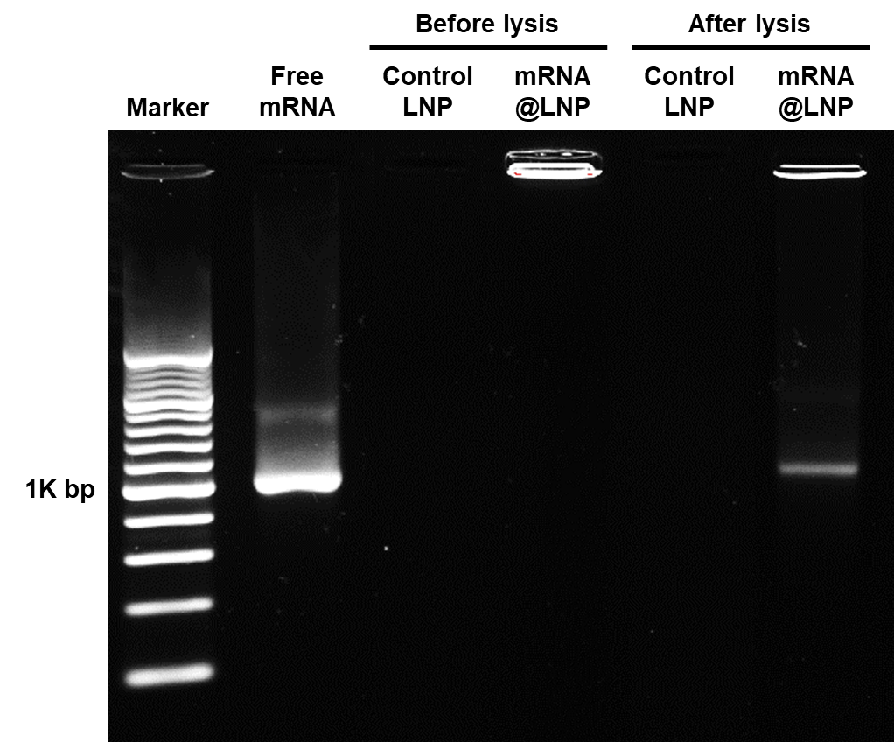
Fig. S2. Gel retardation assay using agarose gel electrophoresis of mRNA, control LNP, and mRNA@LNP before and after lysis with 20% Triton X-100 solution for 1min.

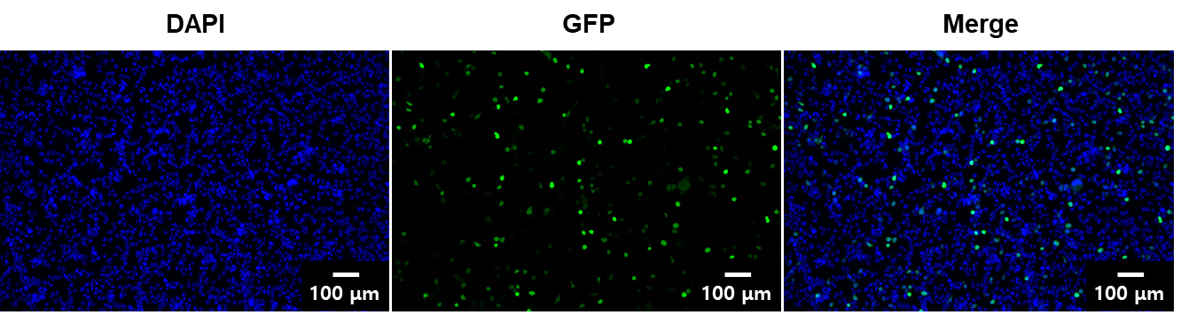
Fig. S3. Fluorescence microscopy image of EGFP mRNA transfection with Lipofectamine 3000.

