<Supplementary Materials>

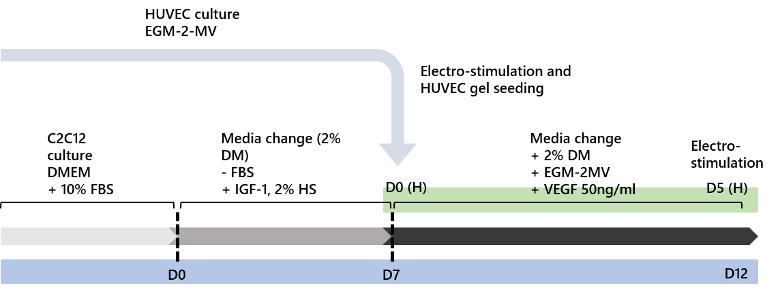
S1. Fabrication method design of the vascularized muscle tissue. Preparation process and bi-layered seeding method of muscle and vascular cells. D0 on the blue timeline indicates the seeding of C2C12, and D0 on the green timeline indicates the start point of co-culture. The point separated by the dotted line presents the time of change in the culture media.

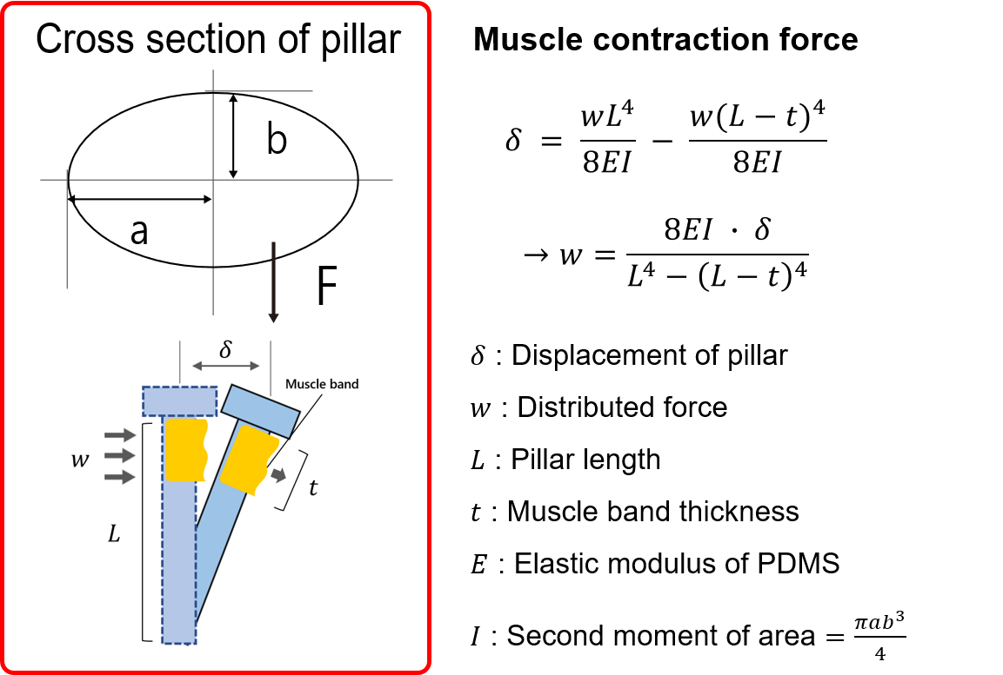
S2. Measurement of muscle contraction force. Muscle contraction force was assumed to exert a distributed force on the pillars and was calculated by measuring the displacement of the pillars. The measured muscle band thickness and pillar cross-sectional values are used for the calculation.

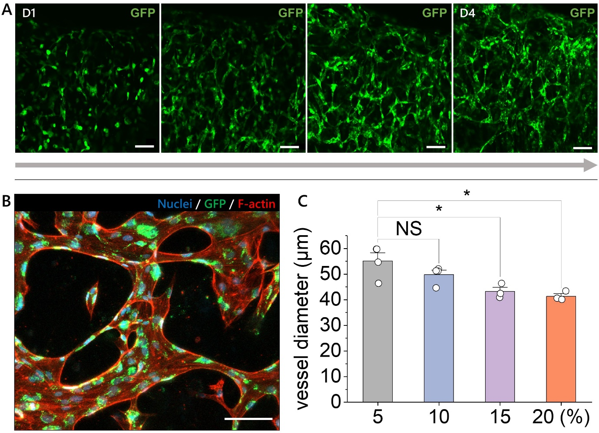
S3. Blood vessel formation according to modified gel composition. (A) Day-by-day vasculogenesis for verification of blood vessel formation in the 10% fibrin-Matrigel (4mg/ml fibrin gel with 10% Matrigel concentration) from D1 to D4 and (B) vasculature image. Scale bar, 100μm. (C) Vessel lateral diameter under the 5, 10, 15, and 20% Matrigel concentration.

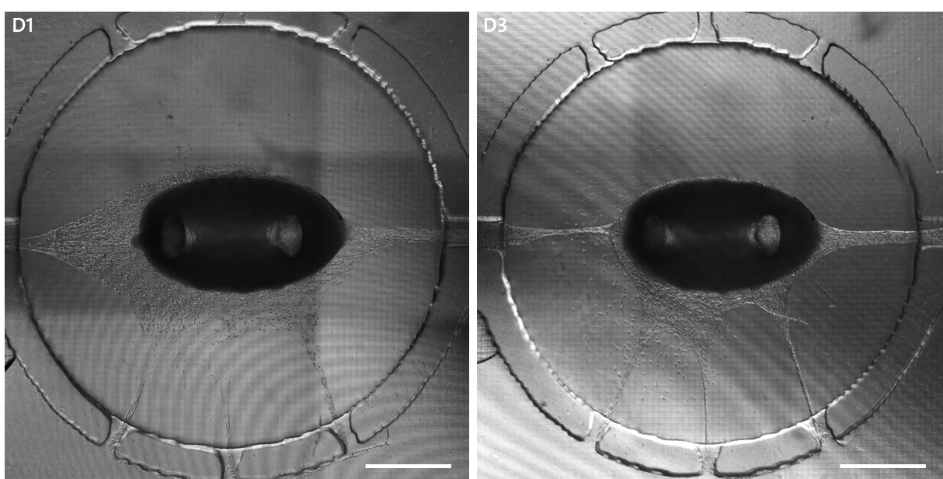
S4. Vessel gel shrinkage analysis. Phase image under the co-culture condition using 2.5mg/ml fibrin gel as a vascular gel at D1 and D3. Scale bar, 500μm.

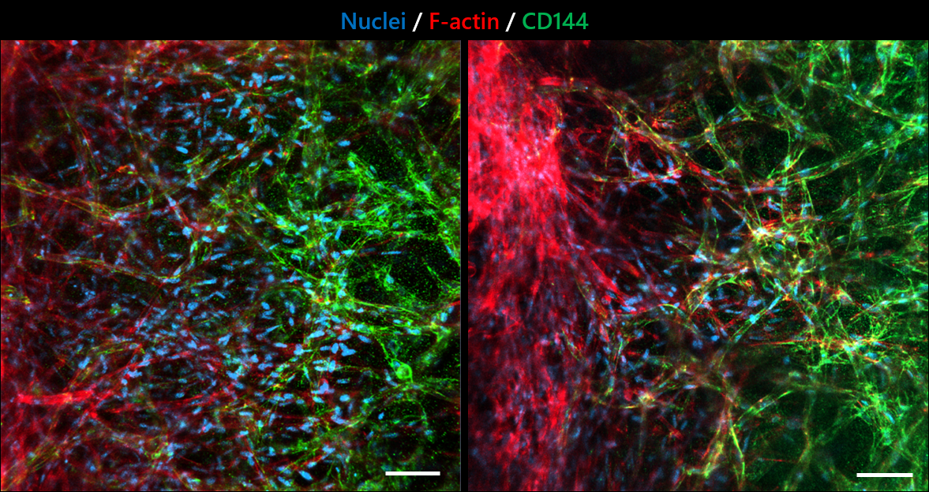
S5. Connection between muscle and blood vessel. The boundary between muscles and blood vessels. When imaging CD144, we used high intensity to discriminate muscle and blood vessels. Scale bar, 100μm.

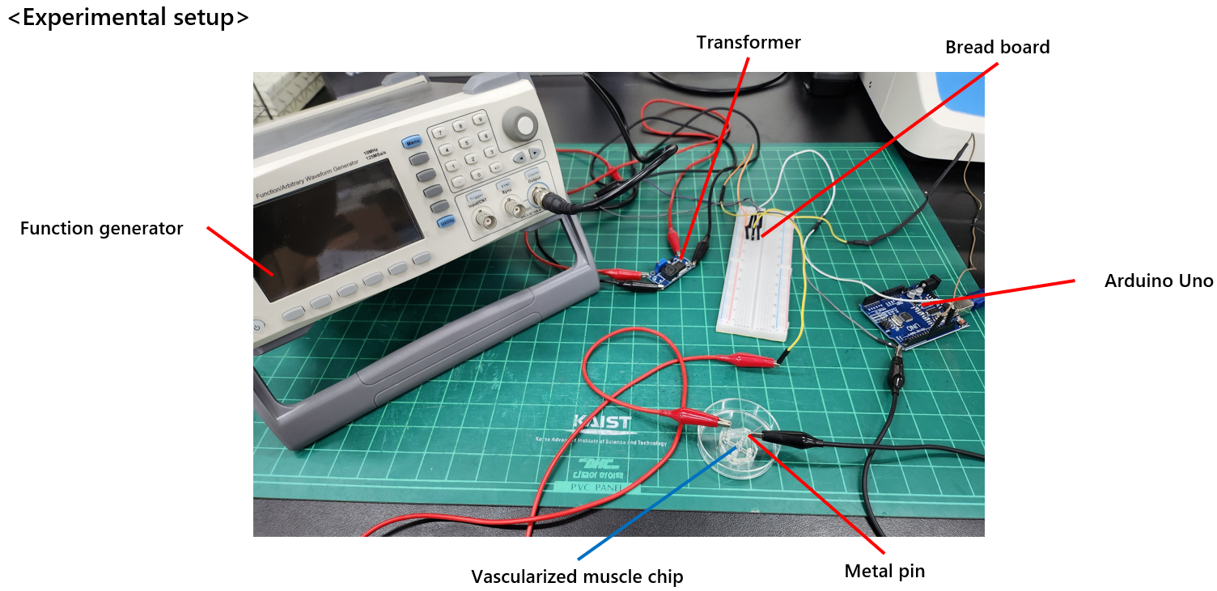
S6. Electrical stimulation setup. Muscle electrical stimulation setup using Arduino and a transformer. The voltage is amplified to 15V by the function generator.

