Supplementary Information
Eric Y. Du^{a, b}, H.T. Kim Duongª, M.A. Kristine Tolentino^{a, b}, Jacinta L. Houng^{a, b}, Panthipa S Eric Y. Du^{a,b}, H.T. Kim Duong^{a,b}, M.A. Kristine Tolentino^{a, b}, Jacinta L. Houng^{a, b}, Panthipa Suwannakot^{a,b}, Kristel C. Tjandraª, Duyen H.T. Nguyen^{a,b}, Richard D. Tilley^{a, c}, J. Justin Gooding^{a, b}*
ª School of Chemistry, The University of New South Wales, 2032
^{b} Australian Centre for Nanomedicine, The University of New South Wales, 2032
^{c} Electron Microscopy Unit, Mark Wainwright Analytical Centre, The University of New South Wales, 2032
* Corresponding author email address: justin.gooding@unsw.edu.au

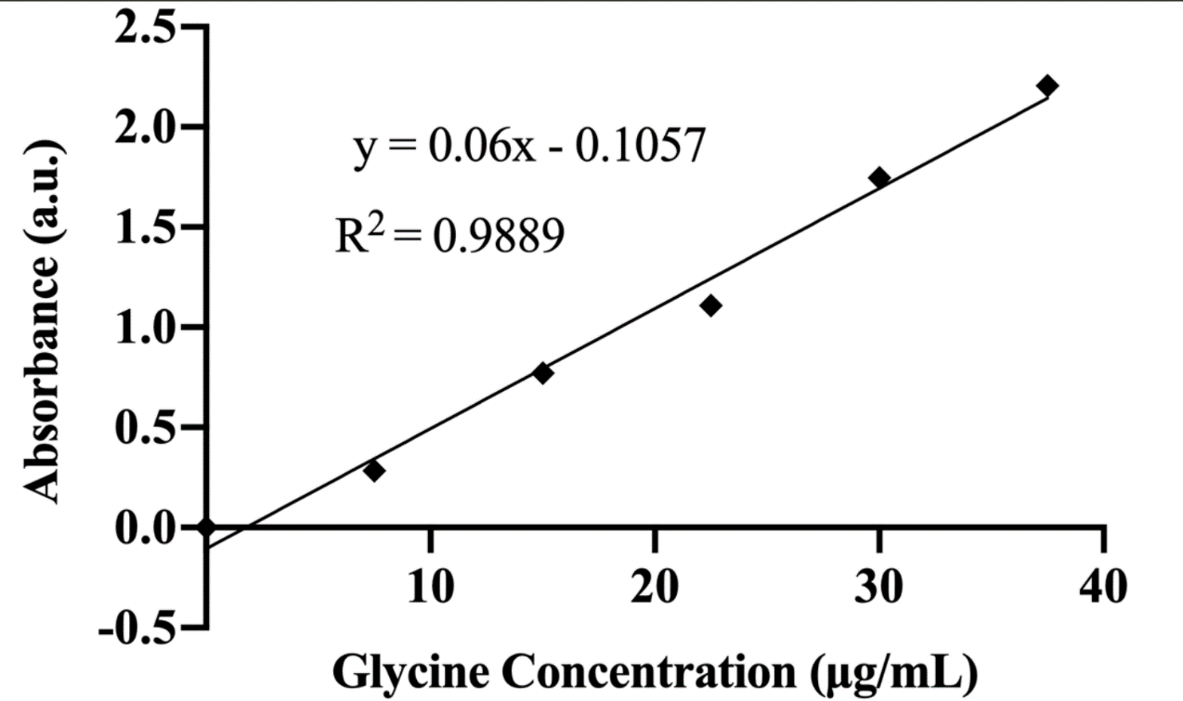
Figure S1. The calibration curve generated from glycine standard solution of different concentrations.

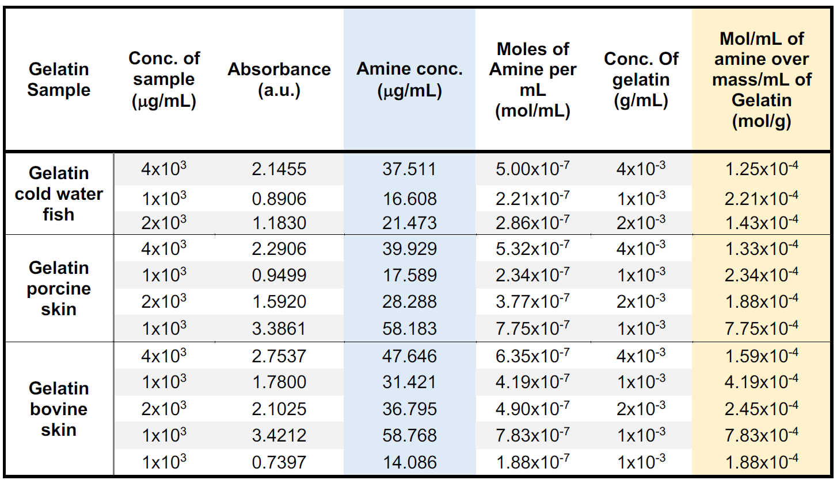
Table S1. Concentration of primary amine (mol/g) found in Gelatin Type B from different sources as determined using the calibration curve generated with glycine.

Table S2. Summary of CPADB conjugation reactions with gelatin type B (bovine skin)
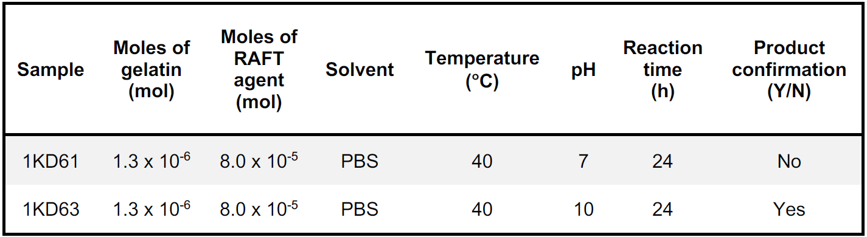
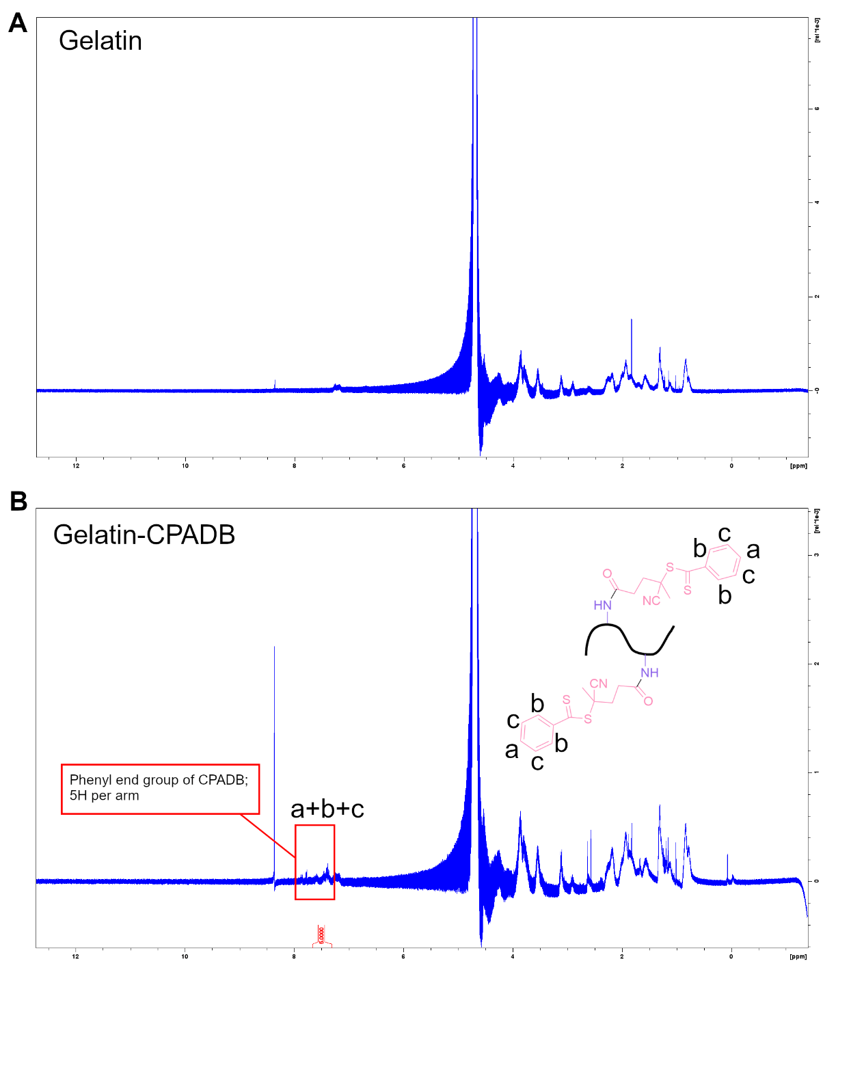
Figure S2. Stacked ¹H NMR (400 MHz, D₂O) of the CPADB conjugation reaction to gelatin performed at (A) pH 7 and (B) pH 10. The new peak at 7.6 (highlighted yellow) indicates the reaction was successful at pH 10

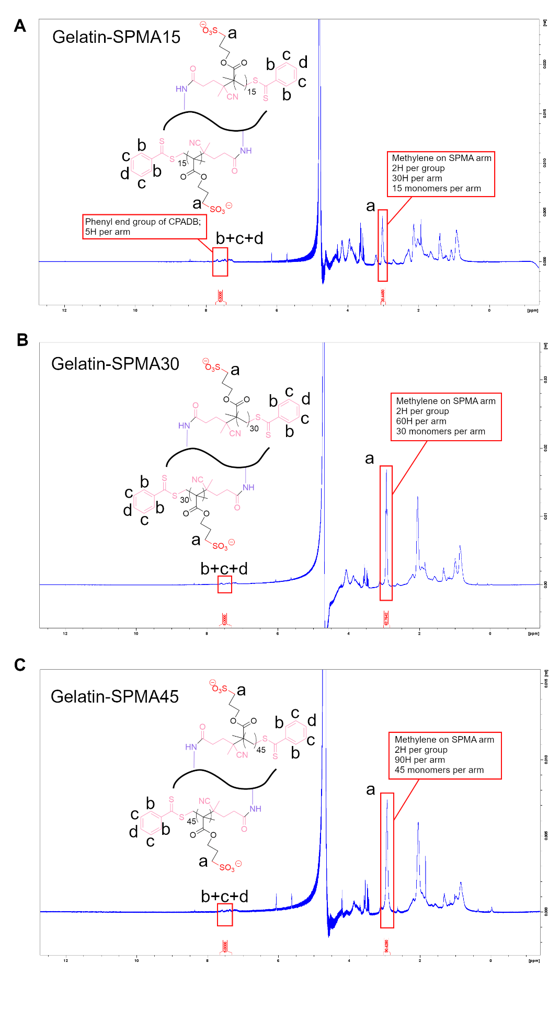
Figure S3. Stacked ¹H NMR (400 MHz, D₂O) of the A) Gel-SPMA15, B) Gel-SPMA30, and C) Gel-SPMA45. The methylene (CH₂) peak at 2.9 corresponds to the CH₂ next to the terminal sulphate group. This peak was used to determine the chain length.

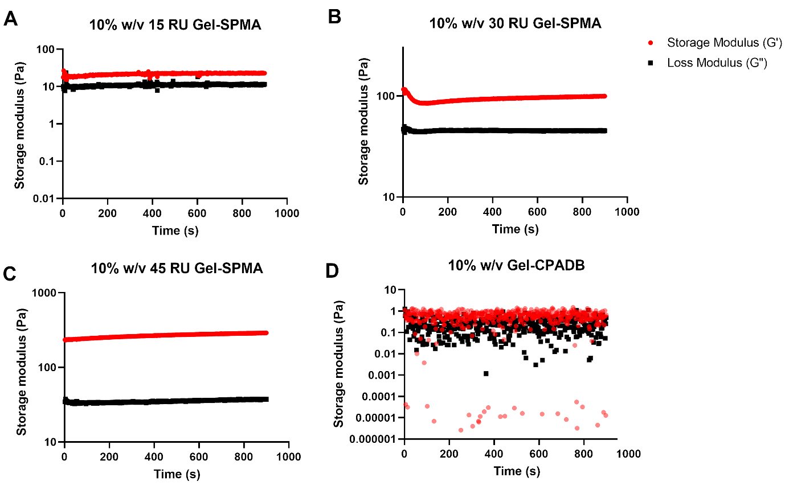
Figure S4. Time sweeps tested for 15 minutes for A) Gel-SPMA15, B) Gel-SPMA30, C) Gel-SPMA45, and D) GelCPADB. All polymers were prepared at 10% w/v and crosslinked with 10% w/v PEG-MAETMA.

$$E=2G"(1+v)$$
Equation S1. Formula for calculating Young’s modulus (E) from shear modulus (G”) where v is the Poisson’s ratio (assumed to be 0.5 for gelatin). Data was obtained in oscillatory rheology using a frequency of 0.1 Hz.

