An accelerated thrombosis model for computational fluid dynamics simulations in rotary blood pumps

Christopher Blumª, Sascha Groß-Hardt^{b}, Ulrich Steinseiferª, Michael Neidlin^{a,*}

Affiliations:
- Department of Cardiovascular Engineering, Institute of Applied Medical Engineering, Medical Faculty, RWTH Aachen University, Aachen, Germany
- enmodes GmbH, Aachen, Germany

*Correspondence:
Name: Michael Neidlin
Address: Institute of Applied Medical Engineering, Pauwelsstraße 20
52074 Aachen, Germany
Email address: neidlin@ame.rwth-aachen.de

Supplementary methods

Model structure
To get an overview of how all parameters and equations of the model are related to each other, the following Figure S1 is helpful. It shows the structure of the accelerated thrombosis model as well as the initial model developed by Taylor et al.:

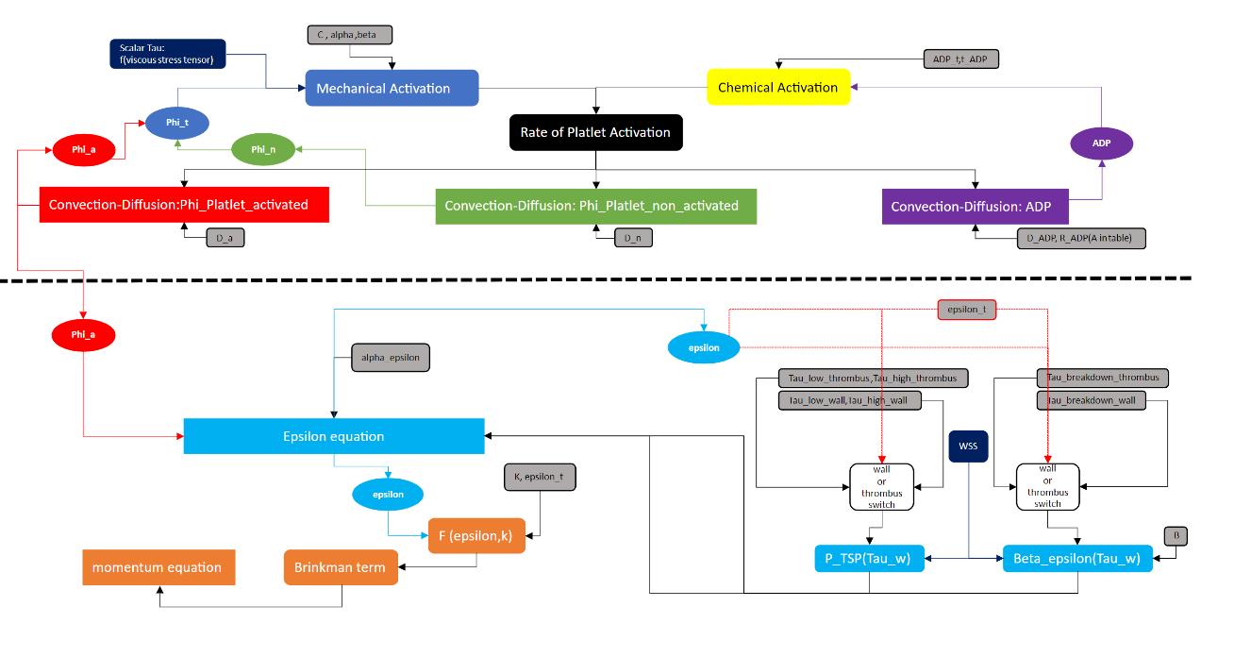
Figure S1: Overview of all equations and parameters involved in the Taylor model. Above dashed line: Structure and parameters of the accelerated thrombosis model

Equations are marked with square fields, species with oval fields and influence factors and parameters with rounded rectangular fields. Above the dashed dividing line in the middle of are the three convections diffusion equations and their influencing parameters. This area is therefore also the area of the accelerated thrombosis model.

Mesh sensitivity
Figure S2 shows a mesh independence study with respect to scaled volume averaged AP concentration. The AP concentrations in regions 1-4 for 3 different meshes between 4.2 million elements and 16.7 million elements are shown. The averaged percentage deviation across the four regions between the 4.2 million mesh and the 12 million mesh is 66.6% percent. Between the 12 million mesh and the 16.7 million mesh, this averaged deviation is only 2.3% percent. Since increasing the number of elements from 12 to 16.7 million yields to similar results compared to the 12 million element mesh in terms of AP distribution, the 12 million mesh is used for calculations in this manuscript.

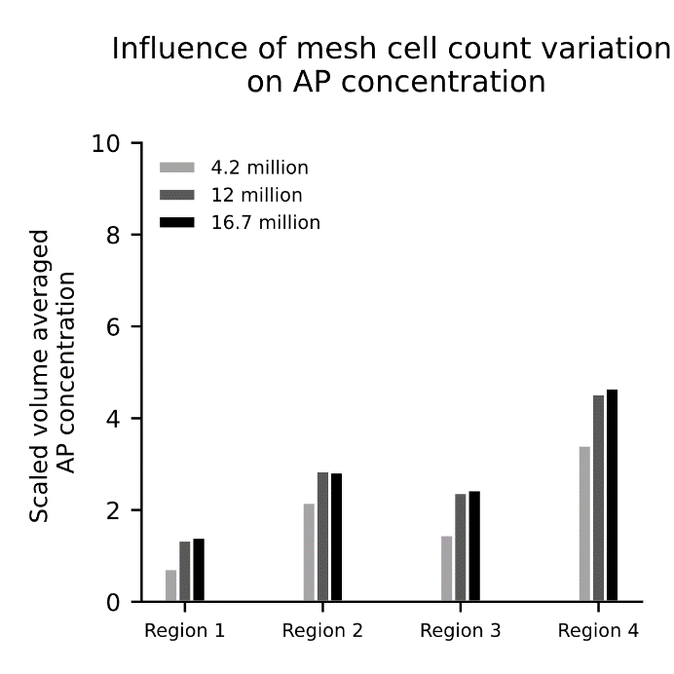
Figure S2: Mesh independence study of 3 meshes with element count form 4.2 million to 16.7 million elements with respect to scaled volume averaged AP concentration

Bearing representation
In the Figure S3 the bearing is shown oversized to visualize more clearly the way it is constructed. In the real geometry the distance between the two bearing shells is 0.05 mm and the bearing shell diameter is approx. 3 mm. The rear bearing is constructed in the same way.
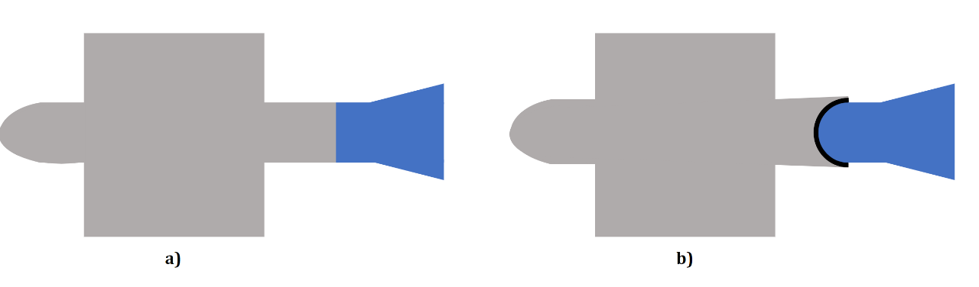
Contact bearing site
Impeller
Front stator
Figure S3: Cross-section of front area of the simplified Heartmate 2 without contact bearing (a) and of Heartmate 2 with modelled front bearing (b)

Supplementary results

Operating point analysis
The correlation between numerical and clinical data for different rational speeds and different flow rates is shown in Figure S4.
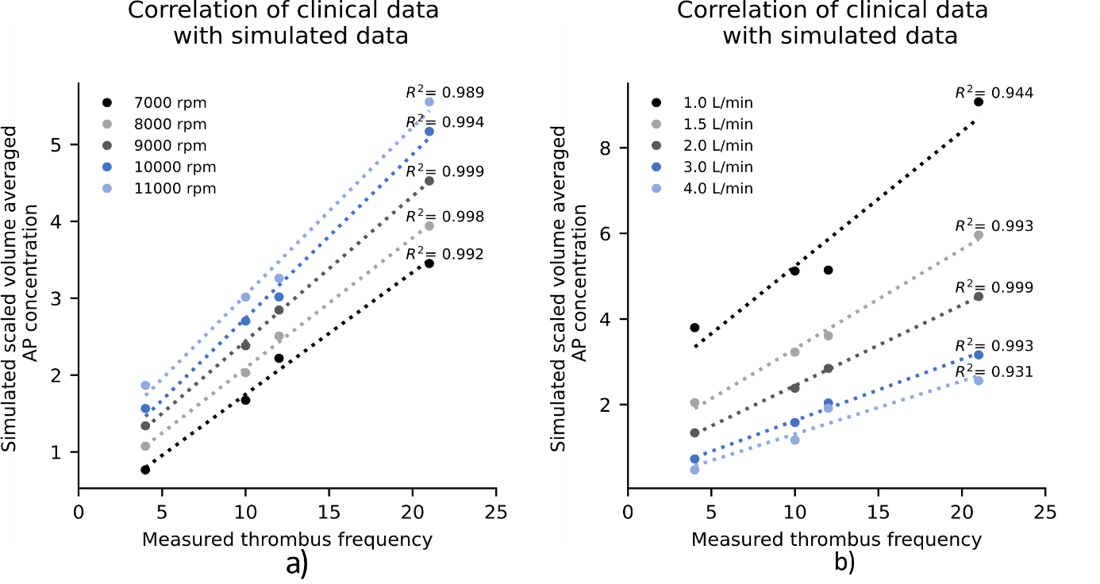
Figure S4: Correlation between normalized AP platelet concentration and measured thrombus frequency from the Rowlands et al. study for left – rpms ranging from 7000-11000 and right – flow rates ranging from 1-4 l/min

Shear stress power law model
Figure S5 again looks at the distribution of the AP concentration on the surface. The left side of the figure shows the results of the α perturbation simulations with the scale that has been used for the AP concentration contour plots in the main text. An adjustment of the scale for each of the three cases is done on the right side of the figure. The maximum value of the scale is adjusted in such a way that a similar distribution is obtained as in the baseline case with baseline α value. Changing the α value results in different AP concentration levels but does not change the final output of the simulation, because by adjusting the scale, very similar contour plots can be created on the surface.
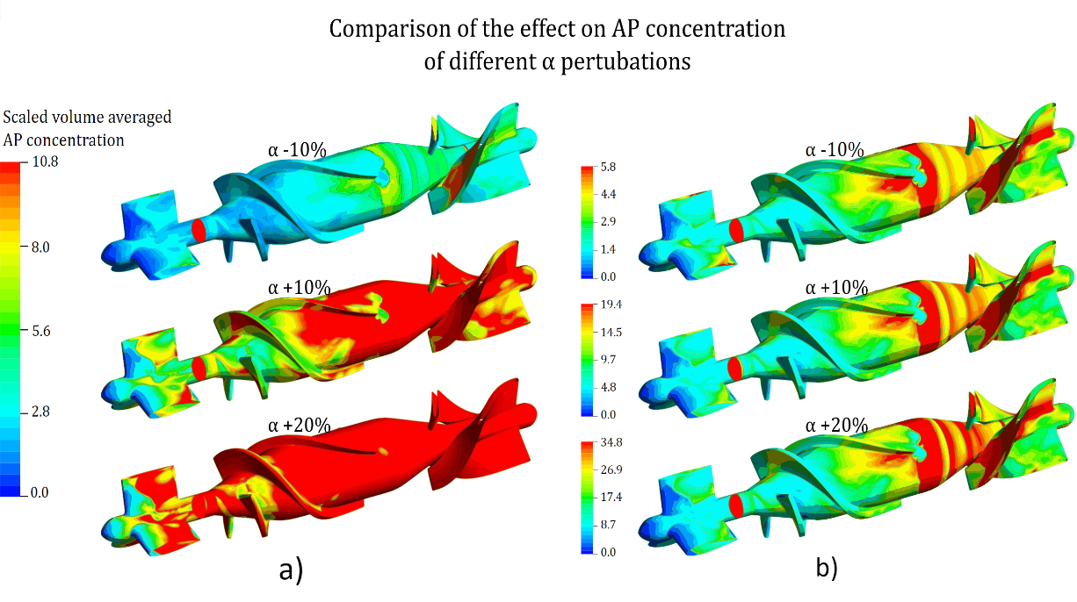
Figure S5: Comparison of different simulations with varying α parameter using contour plots of the AP variable with same scale (left) and different scales(right).

Influence of turbulence modeling
The effects of the turbulent approach on contour plots and volume renderings are shown in Figure S6. On the left side of the figure, the images of the baseline simulation with the laminar approach are shown for comparison purposes. The scale of the contour plot is again the same as described before and applies for both the laminar and turbulent contour plot. On the right-hand side of the figure the results for the turbulent case are shown. The volume rendering is created with the same threshold value as in the laminar case. This shows that after the bladed passage a higher AP concentration level is present in the entire flow due to platelet activation through the turbulent Reynolds stresses.

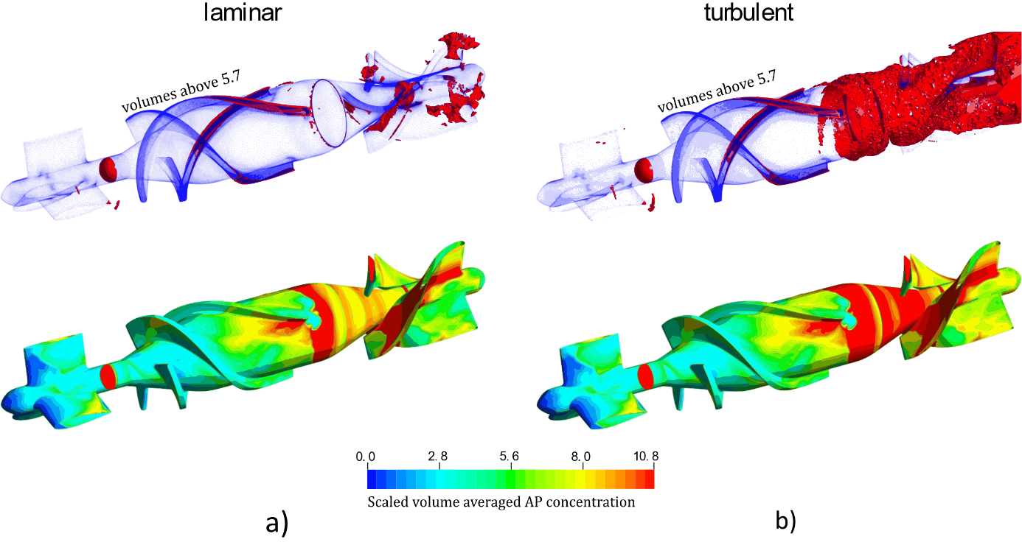
Figure S6: Comparison of laminar and turbulent shear stress simulations using contour plots and volume renderings of the variable Activated Platelets.
Influence of different background activation levels
Figure S7 shows the influence of the initial concentration of activated platelets on the results of the AP concentration distribution. The initial percentage distribution of 5% activated platelets to 95% non-activated platelets from the model of Taylor et al. is compared with simulations showing 1%, 10% and 20% pre-activation at constant total platelet number. The results are scaled in a) with the respective number of activated platelets. This means that the values cannot be visualized equally well on one y-axis scaling. As can be seen in b), c) and d) on different y-axis scalings, the number of initially activated platelets does not play a role in the concentration differences between the individual regions. The correlation to the data from the Rowlands et al study can be drawn for each initial concentration of activated platelets with similar accuracy.
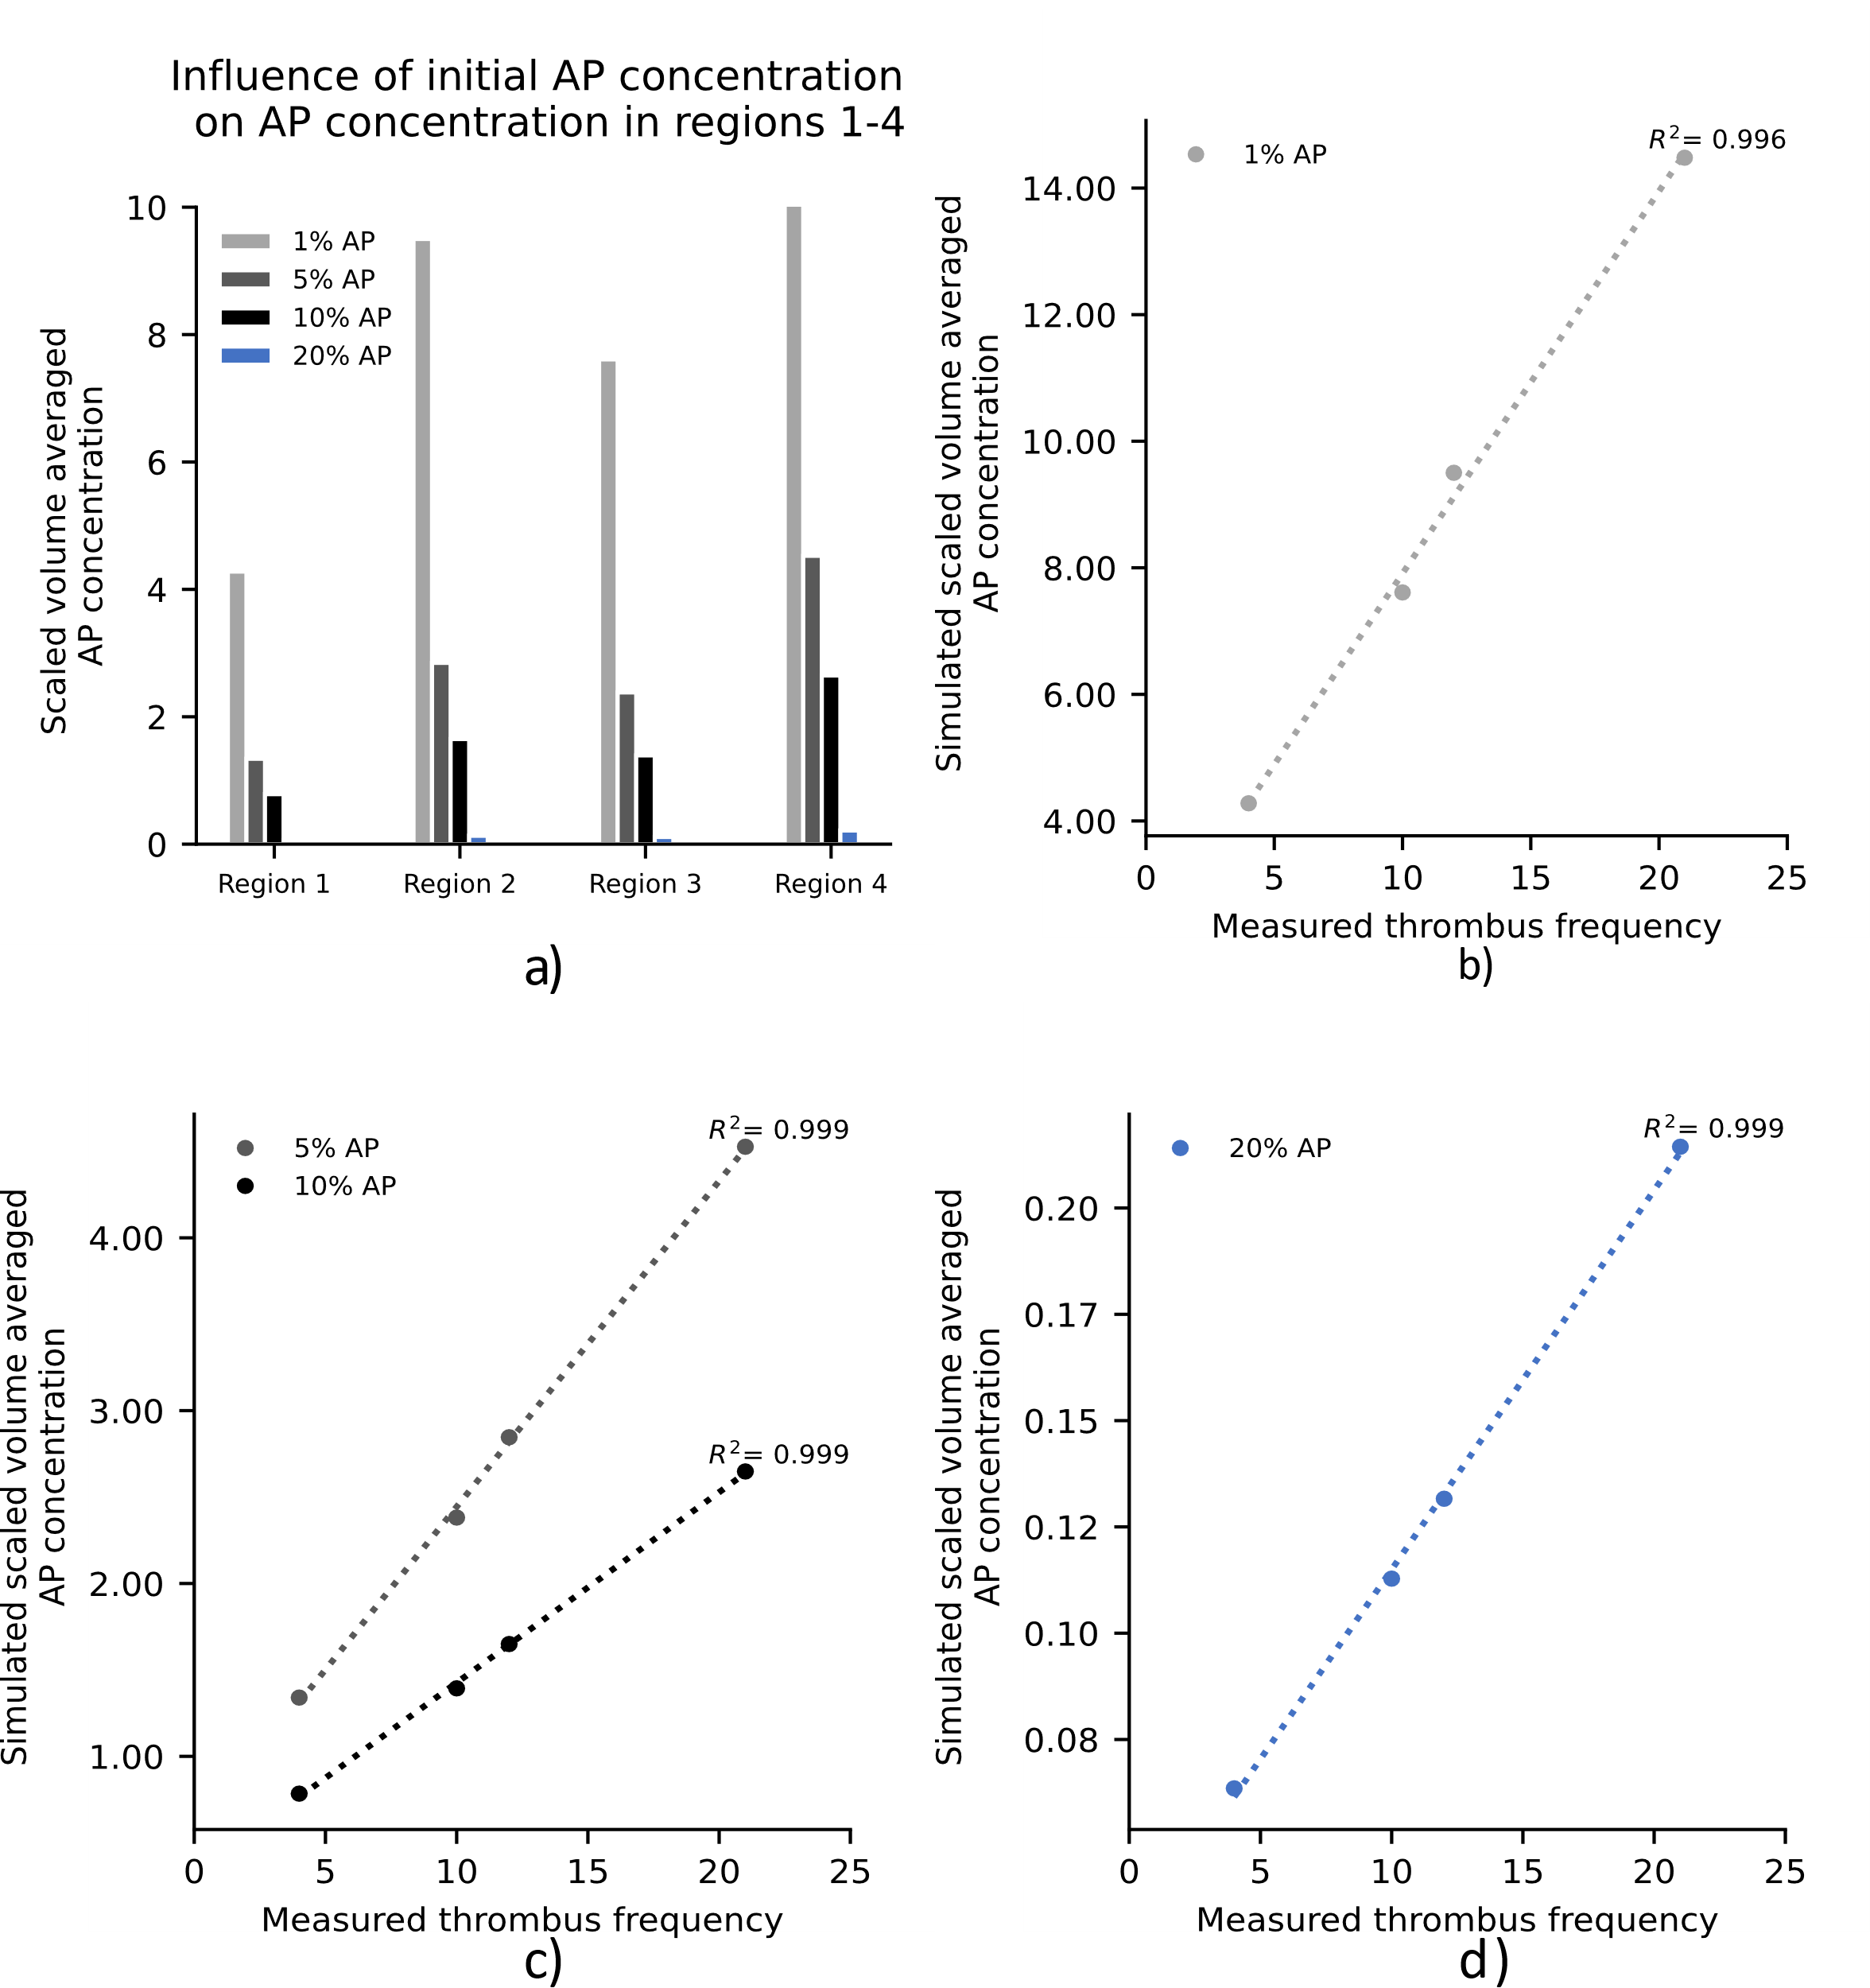
Figure S7: Influence of initial background activation levels ranging from 1 to 20 percent activated platelets of the overall platelet count

Influence of chemical activation
The results of the simulation with effective chemical activation (ADP_{t} = 1e-4 [mol m^-3] and activation t_{ADP} =100s) can be seen in Figure S8. The bar chart on the left shows that the simulation with the modified chemical activation produces substantially higher AP concentration values in region 2. On the right side of Figure S8, it can be seen from the contour plots that the AP concentration values in the regions of the bearings of the modified simulation are substantially higher than in the baseline simulation. Furthermore, the values in the areas around the bearings are also slightly elevated. The remaining regions remain unaffected by the change. In c) $A_{M}$ and $A_{C}$ are plotted respectively. These correspond to the components of the source term of the convection-diffusion equation for AP (eq.1). From this, it can be concluded where and in what intensity platelet activation occurs. This approach provides the user of the model not only with information about the location of thrombus deposition but also with information about the location of activation. (R#2.3)

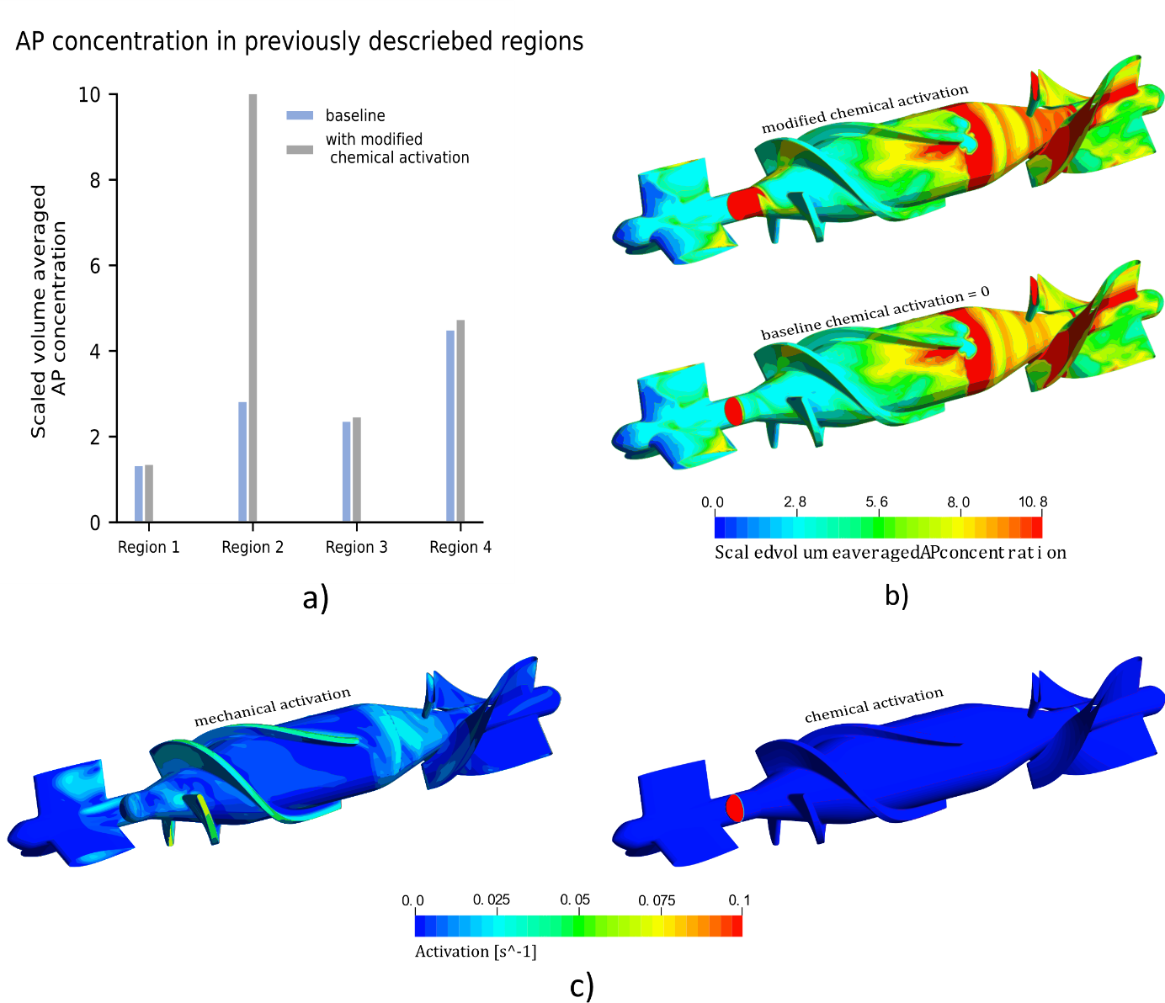
Figure S8: Comparison between the baseline simulation, which showed no chemical activation, and a modified variant of chemical activation using a) the variable AP in a bar chart and b) in a contour plot. In c) the source terms Am and Ac of eq.1 are plotted

Accelerated thrombosis model with DP3
In addition, the Medos DP3 geometry from the study by Groß-Hardt et al. [1] was taken to see how the model performs in an extracorporeal centrifugal pump. The meshed geometry is shown in Figure S9. The similar meshing strategy as was used in the HM2 geometry resulted in a mesh of approximately 7 million elements. To see how the model performs in another pump geometry, the accelerated thrombosis model was applied to the DP3 geometry at 5000 rpm and 1.5 l/min, a low-flow operating point known for bad hemocompatibility [1].
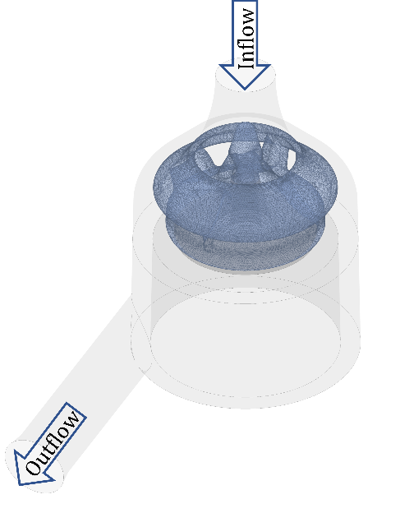
Figure S9: Geometry of the Medos DP3 pump with inflow and outflow
Figure S10 – a, illustrates the AP concentration distribution over the simulation domains on the left side. The AP concentration is initially low in the inlet section and then increases abruptly from the rotor domain onwards. The concentration is highest in the Secondary Gap region. In Figure S10 – b, it is possible to identify that the volumes with the highest AP concentration are located exactly at the bearing of the impeller.

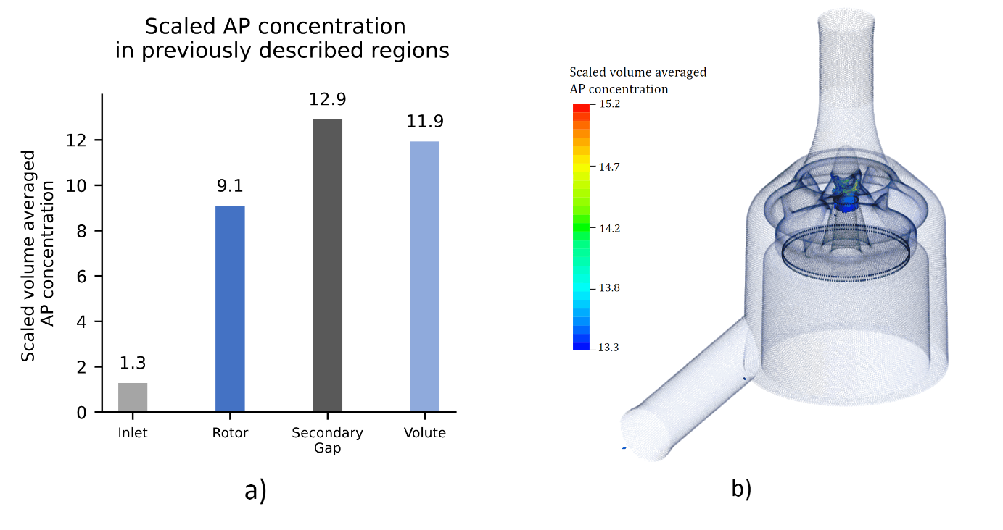
Figure S10: Application of the accelerated thrombosis model to DP3 geometry at 5000rpm and 1.5 L/min and the resulting AP concentration

References:

[1] Gross-Hardt S, Hesselmann F, Arens J, Steinseifer U, Vercaemst L, Windisch W, et al. Low-flow assessment of current ECMO/ECCO2R rotary blood pumps and the potential effect on hemocompatibility. Crit Care. 2019;23:348.

