Estimator of agreement with covariate adjustment
Supplementary Materials

A. Mathematical details for writing $κ_{M}$ as a function of sub-population kappas in the context of disease prevalence. Recall that each probability in the marginal table is a function of the corresponding conditional probabilities:
$$π_{ij}=π_{ij}^{A}ψ_{A}+π_{ij}^{B}(1-ψ^{B})$$

Marginal Table
 |  | Rater 2
 |  | + | -
Rater 1 | + | $$π_{11}$$ | $$π_{12}$$ | $$π_{1+}$$
Rater 1 | - | $$π_{21}$$ | $$π_{22}$$ | $$π_{2+}$$
 |  | $$π_{+1}$$ | $$π_{+2}$$ | 1

Conditional Tables
Group A |  |  |  |  |  | Group B
 |  | Rater 2 |  |  |  |  |  | Rater 2
 |  | + | - |  |  |  |  | + | -
Rater 1 | + | $$π_{11}^{A}$$ | $$π_{12}^{A}$$ | $$π_{1+}^{A}$$ |  | Rater 1 | + | $$π_{11}^{B}$$ | $$π_{12}^{B}$$ | $$π_{1+}^{B}$$
Rater 1 | - | $$π_{21}^{A}$$ | $$π_{22}^{A}$$ | $$π_{2+}^{A}$$ |  | Rater 1 | - | $$π_{21}^{B}$$ | $$π_{22}^{B}$$ | $$π_{2+}^{B}$$
 |  | $$π_{+1}^{A}$$ | $$π_{+2}^{A}$$ | 1 |  |  |  | $$π_{+1}^{B}$$ | $$π_{+2}^{B}$$ | 1

The observed probability of agreement is:
$$π_{o}=π_{11}+π_{22}$$
$$=π_{11}^{A}ψ_{A}+π_{11}^{B}\left(1-ψ_{A}\right)+π_{22}^{A}ψ_{A}+π_{22}^{B}\left(1-ψ_{A}\right) \\ =\left(π_{11}^{A}+π_{22}^{A}\right)ψ_{A}+\left(π_{11}^{B}+π_{22}^{B}\right)\left(1-ψ_{A}\right) \\ =π_{o}^{A}ψ_{A}+π_{o}^{B}\left(1-ψ_{A}\right)$$
The expected probability of agreement (for $κ_{M}$ when there are two groups) is:
$$π_{e}^{M}=π_{1+}^{A}π_{+1}^{A}ψ_{A}+π_{+2}^{A}π_{2+}^{A}ψ_{A}+π_{1+}^{B}π_{+1}^{B}(1-ψ_{A})+π_{+2}^{B}π_{2+}^{B}(1-ψ_{A})$$
$$π_{e}^{M}=π_{e}^{A}ψ_{A}+π_{e}^{B}\left(1-ψ_{A}\right)$$Note that kappa within each group is:
$$κ_{A}=\frac{π_{o}^{A}-π_{e}^{A}}{1-π_{e}^{A}}→ψ_{A}\left(1-π_{e}^{A}\right)κ_{A}=ψ_{A}\left(π_{o}^{A}-π_{e}^{A}\right) \\ κ_{B}=\frac{π_{o}^{B}-π_{e}^{B}}{1-π_{e}^{B}}→\left(1-ψ_{A}\right)\left(1-π_{e}^{B}\right)κ_{B}=\left(1-ψ_{A}\right)\left(π_{o}^{B}-π_{e}^{B}\right)$$
Therefore, $κ_{M}$ is:

$$κ_{M}=\frac{π_{o}-π_{e}^{M}}{1-π_{e}^{M}} \\ =\frac{π_{o}^{A}ψ_{A}+π_{o}^{B}\left(1-ψ_{A}\right)-\left[π_{e}^{A}ψ_{A}+π_{e}^{B}\left(1-ψ_{A}\right)\right]}{1-\left[π_{e}^{A}ψ_{A}+π_{e}^{B}\left(1-ψ_{A}\right)\right]} \\ =\frac{\left(π_{o}^{A}-π_{e}^{A}\right)ψ_{A}+\left(π_{o}^{B}-π_{e}^{B}\right)\left(1-ψ_{A}\right)}{1-\left[π_{e}^{A}ψ_{A}+π_{e}^{B}\left(1-ψ_{A}\right)\right]} \\ =\frac{ψ_{A}\left(1-π_{e}^{A}\right)κ_{A}+\left(1-ψ_{A}\right)\left(1-π_{e}^{B}\right)κ_{B}}{1-\left[π_{e}^{A}ψ_{A}+π_{e}^{B}\left(1-ψ_{A}\right)\right]} \\ =\frac{\left(1-π_{e}^{A}\right)}{1-\left[π_{e}^{A}ψ_{A}+π_{e}^{B}\left(1-ψ_{A}\right)\right]}ψ_{A}κ_{A}+\frac{\left(1-π_{e}^{B}\right)}{1-\left[π_{e}^{B}ψ_{A}+π_{e}^{B}\left(1-ψ_{A}\right)\right]}\left(1-ψ_{A}\right)κ_{B}$$

Special case where $κ_{A}=κ_{B}=κ^{*}$:

$$κ_{M}=\frac{\left(1-π_{e}^{A}\right)}{1-\left[π_{e}^{A}ψ_{A}+π_{e}^{B}\left(1-ψ_{A}\right)\right]}ψ_{A}κ^{*}+\frac{\left(1-π_{e}^{B}\right)}{1-\left[π_{e}^{B}ψ_{A}+π_{e}^{B}\left(1-ψ_{A}\right)\right]}\left(1-ψ_{A}\right)κ^{*} \\ =κ^{*}\left[\frac{\left(1-π_{e}^{A}\right)}{1-\left[π_{e}^{A}ψ_{A}+π_{e}^{B}\left(1-ψ_{A}\right)\right]}ψ_{A}+\frac{\left(1-π_{e}^{B}\right)}{1-\left[π_{e}^{B}ψ_{A}+π_{e}^{B}\left(1-ψ_{A}\right)\right]}\left(1-ψ_{A}\right)\right]$$

$$=κ^{*}\left[\frac{\left(1-π_{e}^{A}\right)ψ_{A}+\left(1-π_{e}^{B}\right)\left(1-ψ_{A}\right)}{1-\left[π_{e}^{A}ψ_{A}+π_{e}^{B}\left(1-ψ_{A}\right)\right]}\right] \\ =κ^{*}\left[\frac{ψ_{A}-ψ_{A}π_{e}^{A}+1-π_{e}^{B}-ψ_{A}+π_{e}^{B}ψ_{A}}{1-\left[π_{e}^{A}ψ_{A}+π_{e}^{B}\left(1-ψ_{A}\right)\right]}\right] \\ =κ^{*}\left[\frac{1-\left[ψ_{A}π_{e}^{A}+π_{e}^{B}\left(1-ψ_{A}\right)\right]}{1-\left[π_{e}^{A}ψ_{A}+π_{e}^{B}\left(1-ψ_{A}\right)\right]}\right] \\ =κ^{*}$$
Using these formulas, we plotted the value of $κ_{M}$ and $κ_{C}$ as a function of disease prevalence under 4 scenarios: 1) Kappa = 0.7 in Group A (Diseased) and Group B (Healthy); 2) Kappa = 0.7 in Group A (Diseased) and Kappa = 0.3 in Group B (Healthy); 3) Kappa = 0 in Group A (Diseased) and Group B (Healthy); 4) Kappa = 0 in Group A (Diseased) and 0.7 in Group B (Healthy) (Supplemental Figure 1). Here, the probability of a positive response among the diseased group (Group A) was 0.8 $(θ_{Aj}=0.8)$ and the probability of a positive response among the healthy group (Group B) was 0.2 $(θ_{Bj}=0.2)$.
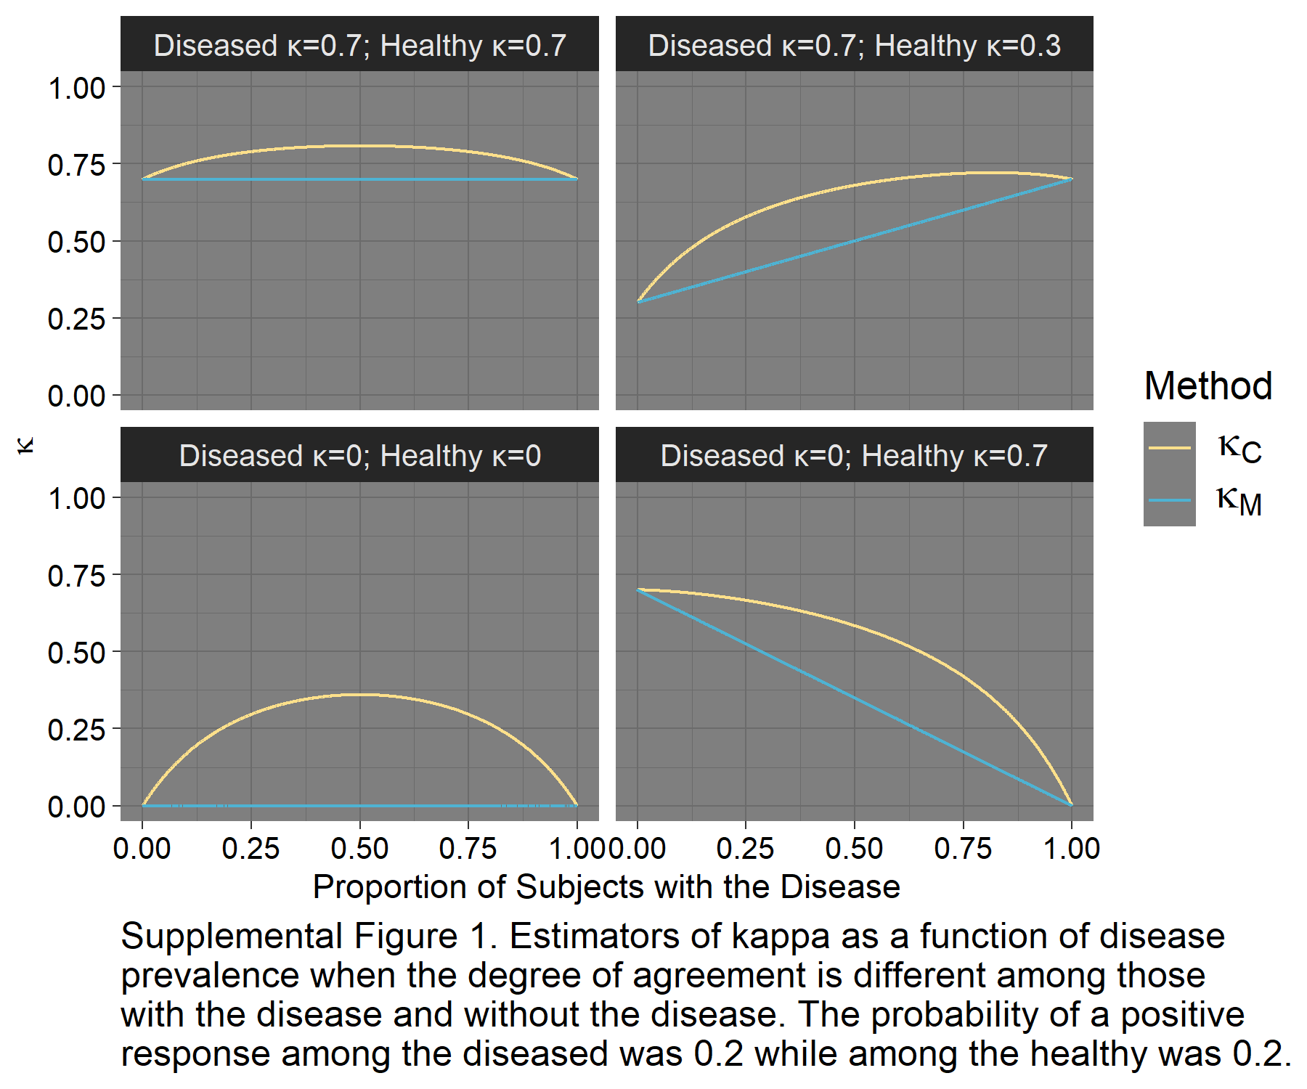

B. The algorithm for determining the probability of a positive response when kappa is greater than 0 is provided. The usual hypothesis was that when kappa=0 (raters independent, subjects independent, and under the model structure $M_{1}$, where $M_{1}≡logit\left(θ_{ij}\right)=β_{0}+β_{1}\left(Rater=2\right)+β_{2}(Group=B)$), the probability each rater gives a positive evaluation does not affect the probability the other rater gives a positive evaluation. However, under the alternative hypothesis there is a dependency between the raters. Therefore, the definition of conditional probability was used to update the probability rater 2 gave a positive evaluation based on rater 1’s evaluation: $P\left(Y_{i2}=1 | Y_{i1}=1\right)=\frac{P(Y_{i1}=1,Y_{i2}=1)}{P\left(Y_{i1}=1\right)}$.
Within each group, the following steps were completed to find $P\left(Y_{i2}=1 | Y_{i1}=1\right)$:
- The probability of a positive evaluation, $P\left(Y_{i1}=1\right)=θ_{i1}$ and ${P\left(Y_{i2}=1\right)=θ}_{i2}$, and kappa were specified.
- The expected probability of agreement was calculated: $π_{e}=\frac{1}{n}\sum_{i=1}^{n}{[{θ_{i1}θ}_{i2}+\left(1-θ_{i1}\right)\left(1-θ_{i2}\right)]}$
- The sum of the observed agreement, $π_{o}$ , was calculated:
$$κ=\frac{π_{o}-π_{e}}{1-π_{e}} →π_{o}=κ\left(1-π_{e}\right)+π_{e}$$
- The following equations were used to calculate $P\left(Y_{i1}=1,Y_{i2}=1\right)$:
a) $P\left(Y_{i1}=1,Y_{i2}=1\right)+P\left(Y_{i1}=1,Y_{i2}=0\right)=P\left(Y_{i1}=1\right)=θ_{i1}$
b) $P\left(Y_{i1}=1,Y_{i2}=1\right)+P\left(Y_{i1}=0,Y_{i2}=1\right)=P\left(Y_{i2}=1\right)=θ_{i2}$
Adding a) and b):
$$θ_{i1}+θ_{i2}=2P\left(Y_{i1}=1,Y_{i2}=1\right)+P\left(Y_{i1}=1,Y_{i2}=0\right)+P\left(Y_{i1}=0,Y_{i2}=1\right) \\ → P\left(Y_{i1}=1,Y_{i2}=1\right)=\frac{θ_{i1}+θ_{i2}-(1-π_{o})}{2}$$
because $1-π_{o}=P\left(Y_{i1}=1,Y_{i2}=0\right)+P\left(Y_{i1}=0,Y_{i2}=1\right)$
- Therefore, $P\left(Y_{i2}=1 | Y_{i1}=1\right)=\frac{P(Y_{i1}=1,Y_{i2}=1)}{θ_{i1}}$ where $P(Y_{i1}=1,Y_{i2}=1)$ is defined in step 4.

Note also that $P\left(Y_{i2}=1 | Y_{i1}=0\right)=1-P\left(Y_{i2}=0 | Y_{i1}=0\right)=1-\left[\frac{P(Y_{i1}=0,Y_{i2}=0)}{1-θ_{i1}}\right]$ where $P\left(Y_{i1}=0,Y_{i2}=0\right)=π_{o}-P(Y_{i1}=1,Y_{i2}=1)$.

Hence, the probability rater 2 gives a positive evaluation can be adjusted depending on rater 1’s evaluation. After all samples are drawn, the estimate for Cohen’s kappa can be calculated for the marginal table, within each group and under the proposed methodology.

C. Logistic regression results from Section 6: Application to Alzheimer’s Disease.

$$κ$$ | Logistic Regression Model | Estimates (SE) |  | p
$$κ_{C}$$ | $$M_{0}=β_{0}+β_{1}(Rater=3)$$ | $$b_{0}$$ | -0.865 (0.298) | 0.004
$$κ_{C}$$ | $$M_{0}=β_{0}+β_{1}(Rater=3)$$ | $$b_{1}$$ | -0.185 (0.430) | 0.668
$$κ_{M}$$ | $$M=β_{0}+β_{1}\left(Rater=3\right)+β_{2}(SUVR<1.1)$$ | $$b_{0}$$ | 0.486 (0.405) | 0.230
$$κ_{M}$$ | $$M=β_{0}+β_{1}\left(Rater=3\right)+β_{2}(SUVR<1.1)$$ | $$b_{1}$$ | -0.295 (0.545) | 0.588
$$κ_{M}$$ | $$M=β_{0}+β_{1}\left(Rater=3\right)+β_{2}(SUVR<1.1)$$ | $$b_{2}$$ | -3.716 (0.778) | <0.001

