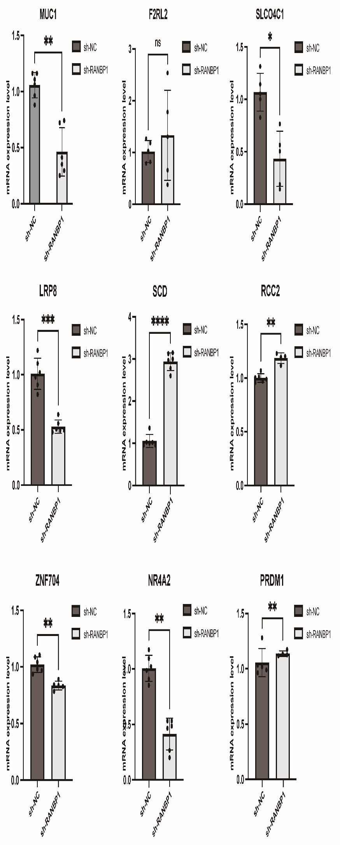
Figure S1: (A) q-RTPCR analysis detects the genes expression of two groups. * p < 0.05, ** p < 0.01, *** P < 0.001, **** P < 0.0001

