Supplementary Material:

Flash Glucose-Sensing Technology as a Replacement for Blood Glucose Monitoring for the Management of Insulin-Treated Type 2 Diabetes: a Multicenter, Open-Label, Randomized Controlled Trial.
Haak T, Hanaire H, Ajjan R A, Hermanns N, Riveline JP, and Rayman G

Figure S1: Study Design
SMBG = self-monitoring of blood glucose
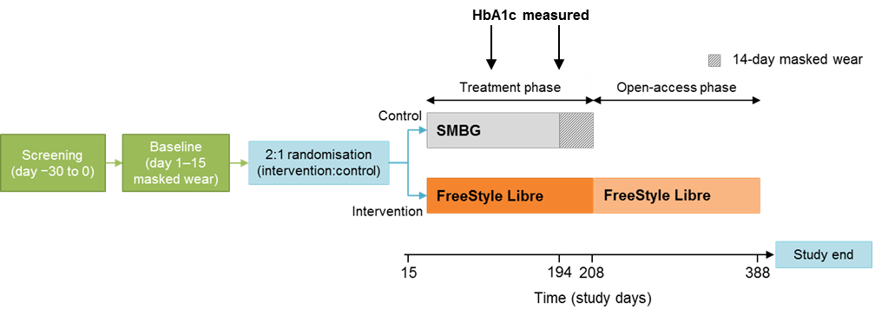

Intervention group visits (TC=telephone call):

Visit Type | Screen | Baseline and Randomisation |  |  | Treatment phase |  |  |  |  |  |  |  | Open-Access phase
Visit number | 0 | 1 | TC #1 | 2 |  | TC #2 | TC #3 | 3 | 4 | 5 | 6 | 7 | 8 | 9
Visit day | -30 to -1 | 1 | 2 | 15 |  | V2 +3 | 31 | 45 | 75 | 105 | 194 | V6+  14 | 284 | 388

Control group visits

Visit Type | Screen | Baseline and Randomisation |  |  | Treatment phase
Visit number | 0 | 1 | TC #1 | 2 |  | 5 | 6 | 7
Visit day | -30 to -1 | 1 | 2 | 15 |  | 105 | 194 | V6+  14

Table S1: HbA1C, Time in range, hypoglycaemic, and hyperglycaemic measures for patients <65 years

Glycemic Measure | Baseline Mean (SD) |  | Study End Mean (SD) |  | Difference in adjusted means in intervention vs control (SE) | Difference in intervention vs control (%) | p-value
Glycemic Measure | Intervention  (n=95) | Control  (n=47) | Intervention  (n=95) | Control  (n=47) | Difference in adjusted means in intervention vs control (SE) | Difference in intervention vs control (%) | p-value
mmol/L (70-180 mg/dL) in h
HbA1c (mmol/mol) | 72.8 (11.5) | 74.1 (11.7) | 68.1 (9.6) | 70.5 (13.5) | -3.6 (1.63) | N/A | 0.0300
HbA1c (%) | 8.81 (1.06) | 8.93 (1.08) | 8.38 (0.88) | 8.60 (1.24) | -0.33 (0.149) | N/A | 0.0301
Time with glucose 3.9-10.0 mmol/L (70-180 mg/dL) (h) | 13.3 (4.7) | 12.7 (5.3) | 13.3 (4.8) | 12.7 (5.1) | 0.3 (0.76) | N/A | 0.6777
Glucose <3.9 mmol/L (70 mg/dL) within 24 h
Events | 0.58 (0.59) | 0.55 (0.59) | 0.39 (0.50) | 0.50 (0.50) | -0.12 (0.083) | -22.1 | 0.1516
Time (h) | 1.17 (1.60) | 0.98 (1.41) | 0.64 (0.95) | 0.96 (1.08) | -0.37 (0.168) | -35.4 | 0.0279
AUC (h x mg/dL) | 17.88 (29.57) | 12.34 (19.94) | 8.27 (14.65) | 12.80 (17.13) | -5.76 (2.64) | -39.6 | 0.0305
within 24 h
Glucose <3.1 mmol/L (55 mg/dL)
Events | 0.31 (0.45) | 0.22 (0.31) | 0.15 (0.27) | 0.24 (0.30) | -0.11 (0.048) | -40.5 | 0.0221
Time (h) | 0.52 (0.92) | 0.33 (0.60) | 0.22 (0.45) | 0.34 (0.52) | -0.15 (0.081) | -38.2 | 0.0604
AUC (h x mg/dL) | 5.19 (10.28) | 2.83 (5.38) | 2.01 (4.65) | 3.27 (6.05) | -1.70 (0.90) | -43.7 | 0.0600
Glucose <2.5 mmol/L (45 mg/dL) within 24 h
Events | 0.16 (0.30) | 0.10 (0.18) | 0.07 (0.16) | 0.10 (0.17) | -0.04 (0.03) | -33.8 | 0.1842
Time (h) | 0.27 (0.56) | 0.13 (0.27) | 0.10 (0.25) | 0.17 (0.34) | -0.10 (0.05) | -48.3 | 0.0570
AUC (h x mg/dL) | 1.30 (2.82) | 0.57 (1.24) | 0.44 (1.35) | 0.82 (1.80) | -0.50 (0.27) | -50.4 | 0.0660
Glucose <2.2 mmol/L (40 mg/dL) within 24 h
Events | 0.11 (0.22) | 0.07 (0.14) | 0.05 (0.15) | 0.07 (0.15) | -0.03 (0.03) | -32.1 | 0.3309
Time (h) | 0.19 (0.42) | 0.08 (0.18) | 0.06 (0.21) | 0.12 (0.28) | -0.08 (0.04) | -51.1 | 0.0718
Glucose >10.0 mmol/L (180 mg/dL) within 24 h
Time (h) | 9.5 (5.3) | 10.3 (5.9) | 10.1 (5.1) | 10.3 (5.6) | 0.1 (0.83) | 0.5 | 0.9467
Glucose >13.3 mmol/L (240 mg/dL) within 24 h
Time (h) | 3.5 (3.5) | 4.4 (4.9) | 3.7 (3.9) | 4.2 (4.3) | -0.1 (0.63) | -1.9 | 0.9063
at night (23.00-06.00) within 7 h
Glucose >16.7 mmol/L (300 mg/dL) within 24 h
Time (h) | 0.99 (1.80) | 1.53 (2.59) | 1.10 (1.99) | 1.33 (2.25) | -0.06 (0.34) | -4.9 | 0.8651

Table S2: HbA1C, Time in range, hypoglycaemic, and hyperglycaemic measures for patients ≥65 years

Glycemic Measure | Baseline Mean (SD) |  | Study End Mean (SD) |  | Difference in adjusted means in intervention vs control (SE) | Difference in intervention vs control (%) | p-value
Glycemic Measure | Intervention  (n=54) | Control  (n=28) | Intervention  (n=54) | Control  (n=28) | Difference in adjusted means in intervention vs control (SE) | Difference in intervention vs control (%) | p-value
mmol/L (70-180 mg/dL) in h
HbA1c (mmol/mol) | 67.9 (9.5) | 68.7 (7.7) | 67.9 (8.0) | 62.9 (8.6) | 4.8 (1.76) | N/A | 0.0081
HbA1c (%) | 8.36 (0.86) | 8.44 (0.71) | 8.36 (0.73) | 7.90 (0.79) | 0.44 (0.161) | N/A | 0.0081
Time with glucose 3.9-10.0 mmol/L (70-180 mg/dL) (h) | 14.9 (4.1) | 14.9 (4.8) | 14.2 (4.2) | 14.0 (4.5) | 0.3 (0.89) | N/A | 0.7476
Glucose <3.9 mmol/L (70 mg/dL) within 24 h
Events | 0.76 (0.68) | 0.75 (0.76) | 0.35 (0.35) | 0.56 (0.71) | -0.21 (0.106) | -36.7 | 0.0513
Time (h) | 1.53 (2.06) | 1.26 (1.83) | 0.49 (0.52) | 1.03 (1.61) | -0.60 (0.220) | -55.9 | 0.0083
AUC (h x mg/dL) | 24.14 (43.43) | 16.92 (34.81) | 5.40 (6.29) | 14.91 (29.36) | -10.86 (3.85) | -70.9 | 0.0061
Glucose <3.1 mmol/L (55 mg/dL) within 24 h
Events | 0.39 (0.57) | 0.35 (0.60) | 0.12 (0.14) | 0.23 (0.46) | -0.12 (0.058) | -53.5 | 0.0357
Time (h) | 0.72 (1.42) | 0.46 (1.13) | 0.13 (0.18) | 0.41 (0.92) | -0.33 (0.120) | -78.0 | 0.0075
AUC (h x mg/dL) | 7.49 (17.26) | 4.36 (13.39) | 0.99 (1.54) | 4.31 (10.54) | -3.84 (1.36) | -88.8 | 0.0060
Glucose <2.5 mmol/L (45 mg/dL) within 24 h
Events | 0.23 (0.47) | 0.19 (0.51) | 0.05 (0.08) | 0.14 (0.36) | -0.10 (0.04) | -77.0 | 0.0225
Time (h) | 0.40 (0.99) | 0.24 (0.82) | 0.05 (0.08) | 0.23 (0.59) | -0.21 (0.07) | -93.2 | 0.0066
AUC (h x mg/dL) | 1.90 (5.03) | 1.11 (4.02) | 0.19 (0.37) | 1.11 (2.85) | -1.04 (0.37) | -96.6 | 0.0059
Glucose <2.2 mmol/L (40 mg/dL) within 24 h
Events | 0.17 (0.42) | 0.15 (0.47) | 0.03 (0.06) | 0.12 (0.30) | -0.09 (0.04) | -83.1 | 0.0189
Time (h) | 0.29 (0.77) | 0.18 (0.67) | 0.03 (0.06) | 0.17 (0.43) | -0.15 (0.06) | -95.9 | 0.0072
Glucose >10.0 mmol/L (180 mg/dL) within 24 h
Time (h) | 7.6 (4.3) | 7.8 (5.3) | 9.3 (4.4) | 9.0 (4.9) | 0.4 (0.98) | 4.2 | 0.7131
Glucose >13.3 mmol/L (240 mg/dL) within 24 h
Time (h) | 2.4 (2.6) | 3.0 (3.8) | 3.2 (3.2) | 3.4 (3.9) | 0.1 (0.71) | 3.7 | 0.8791
at night (23.00-06.00) within 7 h
Glucose >16.7 mmol/L (300 mg/dL) within 24 h
Time (h) | 0.52 (1.15) | 0.85 (1.56) | 0.86 (1.84) | 0.81 (1.39) | 0.25 (0.36) | 39.8 | 0.4806
Analysis based on ANCOVA model with treatment group and study centre (pooled per country for <5 subjects/centre) as fixed effects and the baseline measurement as covariate.
n=number of subjects with non-missing 14-day baseline and 14-day treatment-phase values; NA=not applicable; SD=standard deviation; SE=standard error.

Table S3: Hypoglycaemic measures
Glycemic Measure |  | Baseline Mean (SD) |  | Study End Mean (SD) |  | Difference in adjusted means in intervention vs control (SE) | Difference in intervention vs control (%) | p-value
 |  | Intervention (n=149) | Control (n=75) | Intervention (n=149) | Control (n=75) | Difference in adjusted means in intervention vs control (SE) | Difference in intervention vs control (%) | p-value
Glucose  <3.9 mmol/L (70 mg/dL)  within 24 h | Events | 0.64 (0.63) | 0.63 (0.66) | 0.38 (0.45) | 0.53 (0.59) | -0.16 (0.065) | -27.7 | 0.0164
Glucose  <3.9 mmol/L (70 mg/dL)  within 24 h | Time (h) | 1.30 (1.78) | 1.08 (1.58) | 0.59 (0.82) | 0.99 (1.29) | -0.47 (0.134) | -43.1 | 0.0006
Glucose  <3.9 mmol/L (70 mg/dL)  within 24 h | AUC (h x mg/dL) | 20.15 (35.21) | 14.05 (26.35) | 7.23 (12.35) | 13.59 (22.31) | -7.80 (2.20) | -51.1 | 0.0005
Glucose  <3.9 mmol/L (70 mg/dL)  during day (06.00-23.00)  within 17 h | Events | 0.49 (0.54) | 0.44 (0.51) | 0.29 (0.37) | 0.34 (0.44) | -0.08 (0.05) | -21.6 | 0.1179
 | Time (h) | 0.74 (1.08) | 0.59 (0.99) | 0.35 (0.49) | 0.47 (0.75) | -0.16 (0.08) | -30.7 | 0.0374
 | AUC (h x mg/dL) | 10.81 (20.21) | 7.42 (16.11) | 4.07 (7.00) | 6.26 (12.58) | -2.98 (1.21) | -41.1 | 0.0148
Glucose  <3.9 mmol/L (70 mg/dL)  at night (23.00-06.00)  within 7 h | Events | 0.25 (0.28) | 0.27 (0.32) | 0.14 (0.20) | 0.27 (0.33) | -0.12 (0.03) | -44.9 | 0.0003
 | Time (h) | 0.55 (0.84) | 0.49 (0.71) | 0.23 (0.43) | 0.51 (0.72) | -0.29 (0.08) | -54.3 | 0.0001
 | AUC (h x mg/dL) | 9.37 (18.08) | 6.60 (11.45) | 3.22 (6.95) | 7.27 (13.02) | -4.64 (1.33) | -58.6 | 0.0006
Glucose  <3.1 mmol/L (55 mg/dL)  within 24 h | Events | 0.34 (0.50) | 0.27 (0.44) | 0.14 (0.24) | 0.24 (0.36) | -0.12 (0.037) | -44.3 | 0.0017
Glucose  <3.1 mmol/L (55 mg/dL)  within 24 h | Time (h) | 0.59 (1.13) | 0.38 (0.83) | 0.19 (0.37) | 0.37 (0.69) | -0.22 (0.068) | -53.1 | 0.0014
Glucose  <3.1 mmol/L (55 mg/dL)  within 24 h | AUC (h x mg/dL) | 6.02 (13.23) | 3.40 (9.16) | 1.64 (3.85) | 3.66 (7.97) | -2.51 (0.76) | -60.3 | 0.0012
Glucose  <3.1 mmol/L (55 mg/dL)  during day (06.00-23.00)  within 17 h | Events | 0.23 (0.39) | 0.17 (0.34) | 0.10 (0.18) | 0.14 (0.28) | -0.07 (0.03) | -39.7 | 0.0205
 | Time (h) | 0.31 (0.66) | 0.20 (0.50) | 0.10 (0.22) | 0.17 (0.39) | -0.09 (0.04) | -44.3 | 0.0218
 | AUC (h x mg/dL) | 3.07 (7.19) | 1.80 (5.34) | 0.85 (2.20) | 1.60 (4.26) | -0.95 (0.41) | -50.5 | 0.0209
Glucose  <3.1 mmol/L (55 mg/dL)  at night (23.00-06.00)  within 7 h | Events | 0.15 (0.23) | 0.13 (0.20) | 0.06 (0.13) | 0.13 (0.21) | -0.07 (0.02) | -53.0 | 0.0012
 | Time (h) | 0.27 (0.58) | 0.18 (0.35) | 0.09 (0.22) | 0.19 (0.40) | -0.12 (0.04) | -58.1 | 0.0032
 | AUC (h x mg/dL) | 2.98 (7.39) | 1.58 (4.02) | 0.80 (2.17) | 2.02 (4.96) | -1.46 (0.48) | -65.6 | 0.0029
Glucose  <2.5 mmol/L (45 mg/dL)  within 24 h | Events | 0.19 (0.37) | 0.13 (0.34) | 0.06 (0.13) | 0.11 (0.25) | -0.06 (0.02) | -48.8 | 0.0098
Glucose  <2.5 mmol/L (45 mg/dL)  within 24 h | Time (h) | 0.32 (0.74) | 0.17 (0.54) | 0.08 (0.21) | 0.19 (0.45) | -0.14 (0.04) | -64.1 | 0.0013
Glucose  <2.5 mmol/L (45 mg/dL)  within 24 h | AUC (h x mg/dL) | 1.52 (3.77) | 0.77 (2.63) | 0.35 (1.11) | 0.93 (2.23) | -0.70 (0.22) | -66.7 | 0.0015
Glucose  <2.5 mmol/L (45 mg/dL)  during day (06.00-23.00)  within 17 h | Events | 0.13 (0.27) | 0.08 (0.23) | 0.04 (0.12) | 0.06 (0.18) | -0.03 (0.02) | -40.3 | 0.1037
 | Time (h) | 0.16 (0.40) | 0.09 (0.31) | 0.04 (0.12) | 0.08 (0.24) | -0.05 (0.02) | -55.7 | 0.0184
 | AUC (h x mg/dL) | 0.73 (1.91) | 0.42 (1.46) | 0.17 (0.64) | 0.39 (1.18) | -0.26 (0.12) | -56.7 | 0.0296
Glucose  <2.5 mmol/L (45 mg/dL)  at night (23.00-06.00)  within 7 h | Events | 0.08 (0.17) | 0.06 (0.14) | 0.03 (0.08) | 0.07 (0.16) | -0.04 (0.02) | -57.8 | 0.0086
 | Time (h) | 0.16 (0.42) | 0.08 (0.23) | 0.04 (0.12) | 0.11 (0.28) | -0.08 (0.03) | -68.3 | 0.0041
 | AUC (h x mg/dL) | 0.80 (2.27) | 0.35 (1.22) | 0.18 (0.58) | 0.53 (1.48) | -0.42 (0.14) | -71.7 | 0.0032
Glucose  <2.2 mmol/L (40 mg/dL)  within 24 h | Events | 0.13 (0.30) | 0.10 (0.30) | 0.05 (0.13) | 0.09 (0.22) | -0.05 (0.02) | -52.6 | 0.0199
Glucose  <2.2 mmol/L (40 mg/dL)  within 24 h | Time (h) | 0.22 (0.57) | 0.12 (0.43) | 0.05 (0.17) | 0.14 (0.34) | -0.10 (0.03) | -66.7 | 0.0020
Glucose  <2.2 mmol/L (40 mg/dL)  during day (06.00-23.00)  within 17 h | Events | 0.12 (0.29) | 0.09 (0.30) | 0.04 (0.14) | 0.06 (0.18) | -0.03 (0.02) | -36.6 | 0.2068
 | Time (h) | 0.15 (0.40) | 0.09 (0.34) | 0.04 (0.15) | 0.08 (0.25) | -0.05 (0.03) | -52.8 | 0.0550
Glucose  <2.2 mmol/L (40 mg/dL)  at night (23.00-06.00)  within 7 h | Events | 0.23 (0.53) | 0.16 (0.43) | 0.07 (0.24) | 0.19 (0.51) | -0.13 (0.05) | -66.3 | 0.0098
 | Time (h) | 0.41 (1.20) | 0.18 (0.69) | 0.09 (0.29) | 0.27 (0.79) | -0.22 (0.07) | -73.5 | 0.0038
*Analysis based on ANCOVA model with treatment group and study centre (pooled per country for <5 subjects/centre) as fixed effects and the baseline measurement as covariate.
n=number of subjects with non-missing 14-day baseline and 14-day treatment-phase values; NA=not applicable; SD=standard deviation; SE=standard error.

Figure S2: Nocturnal time in hypoglycaemic range during baseline and treatment phase (days 1–208), intervention group (per protocol)
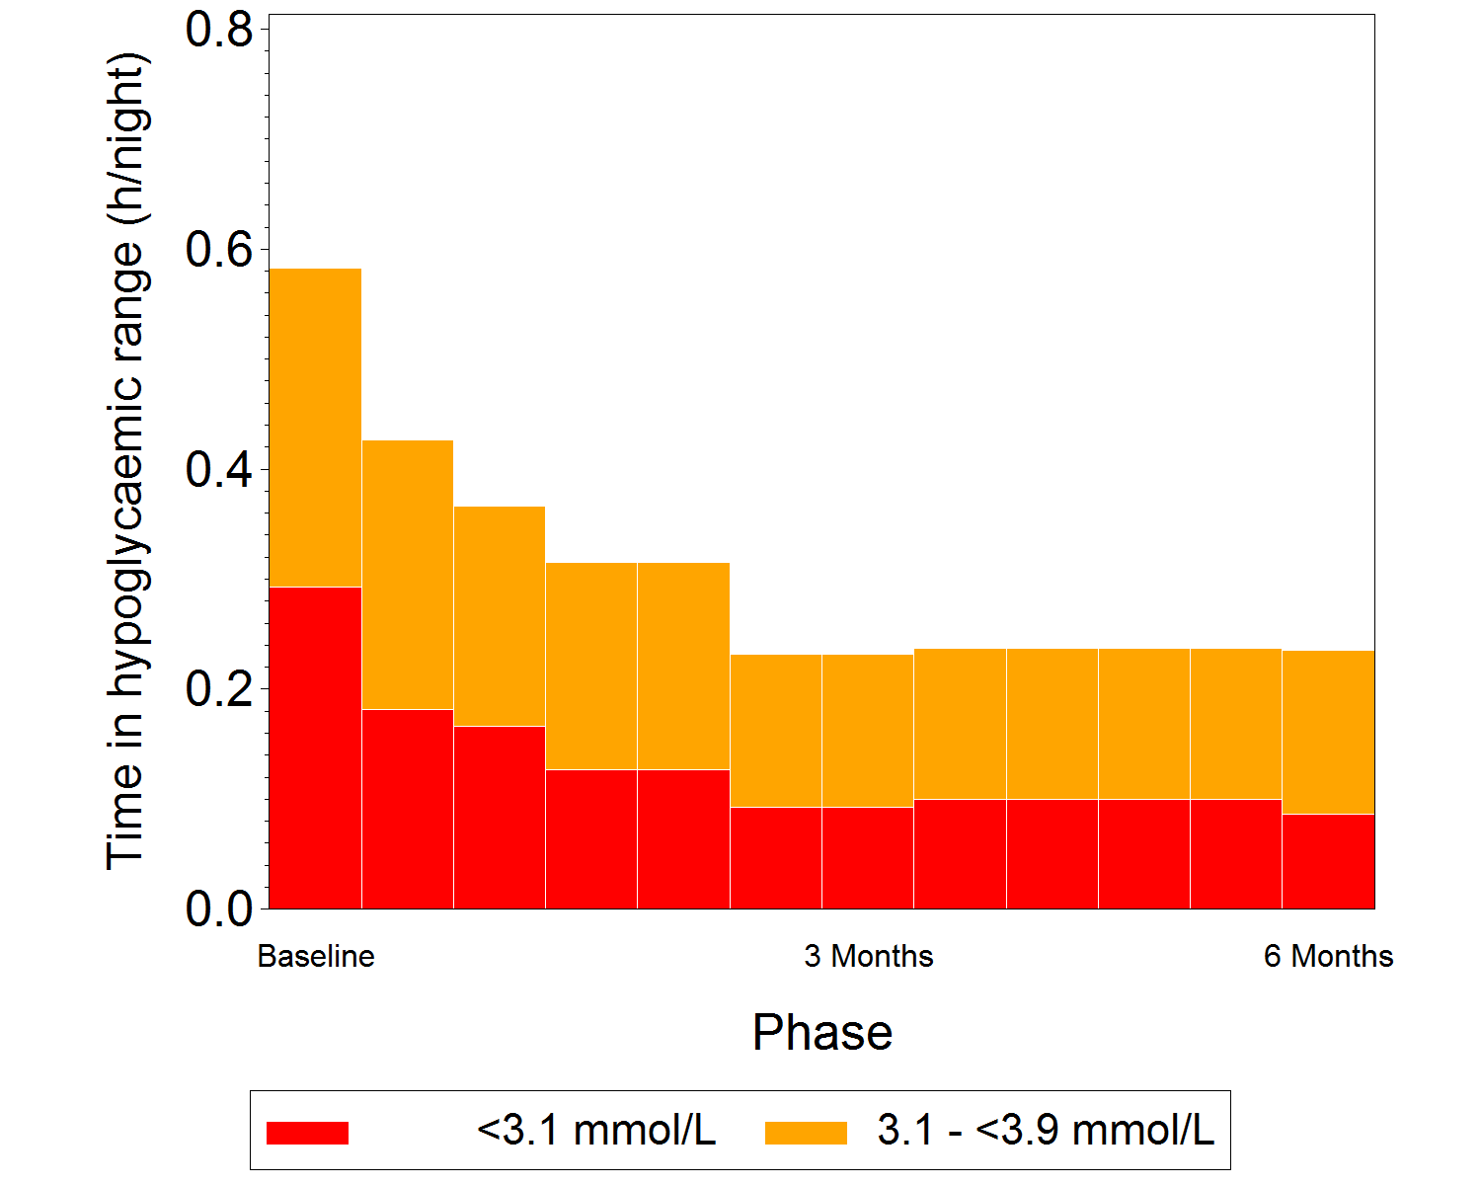
End of baseline / start of intervention
Grouped bars indicate analysis performed over multiple 2 week periods

Figure S3: Difference in groups for glycaemic measures at 6 months during day time (06:00–23:00) and night time (23:00–06:00)
Re-scaled CIs are CIs for the difference in the intervention group from the control group at 6 months expressed as a percentage of the control group adjusted mean. AUC=area under curve; CI=confidence interval.

Day: Night:
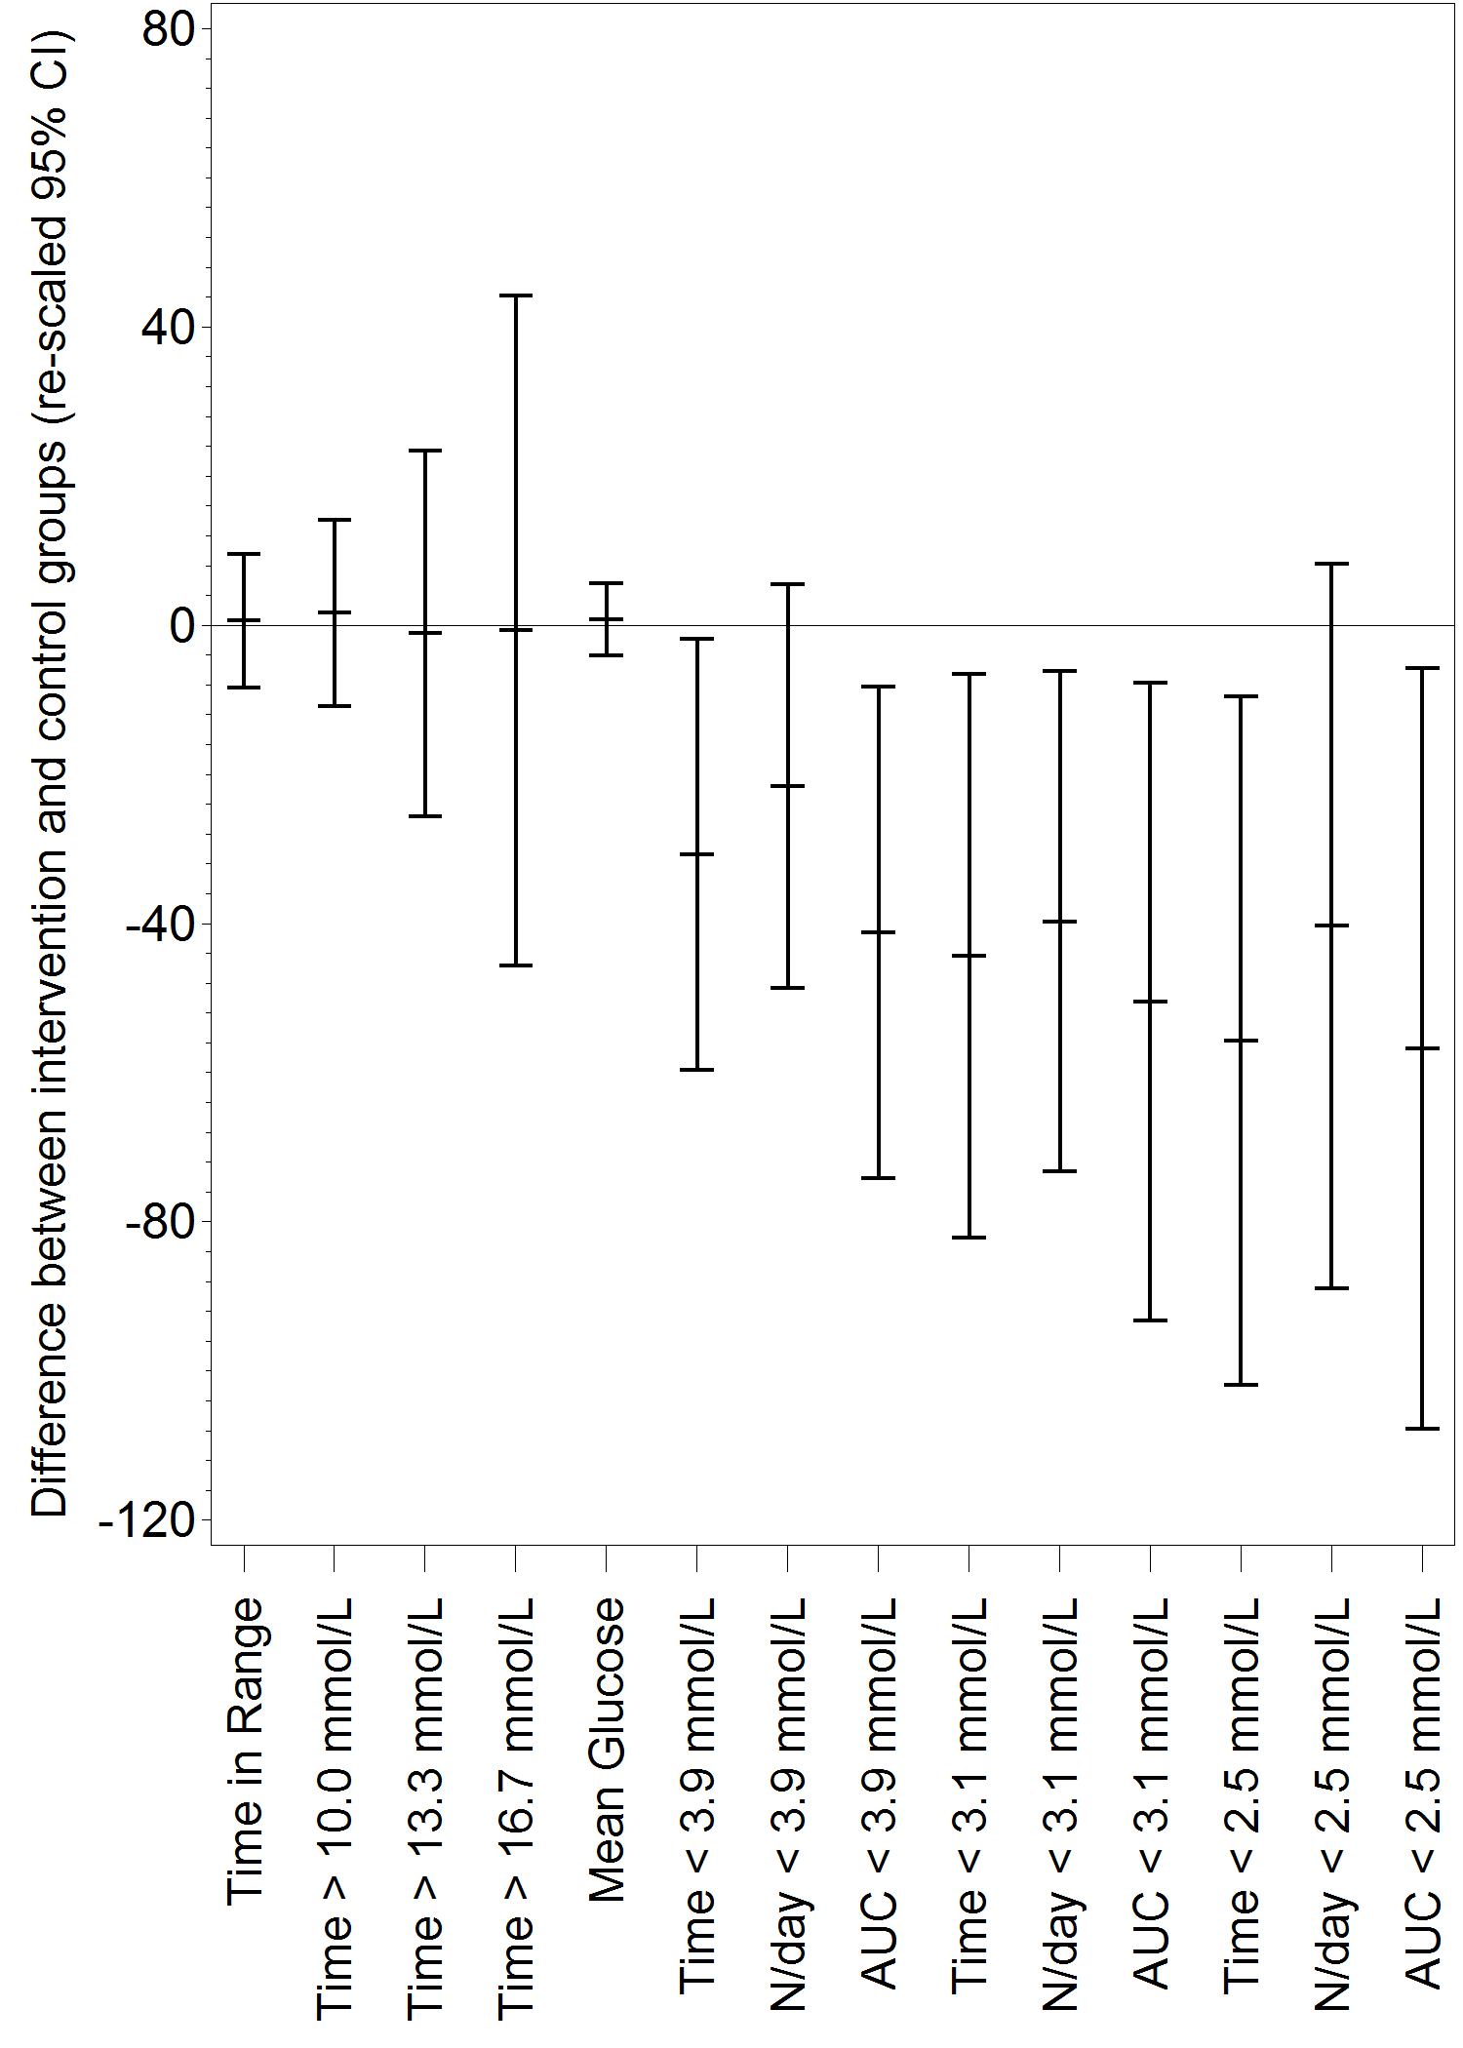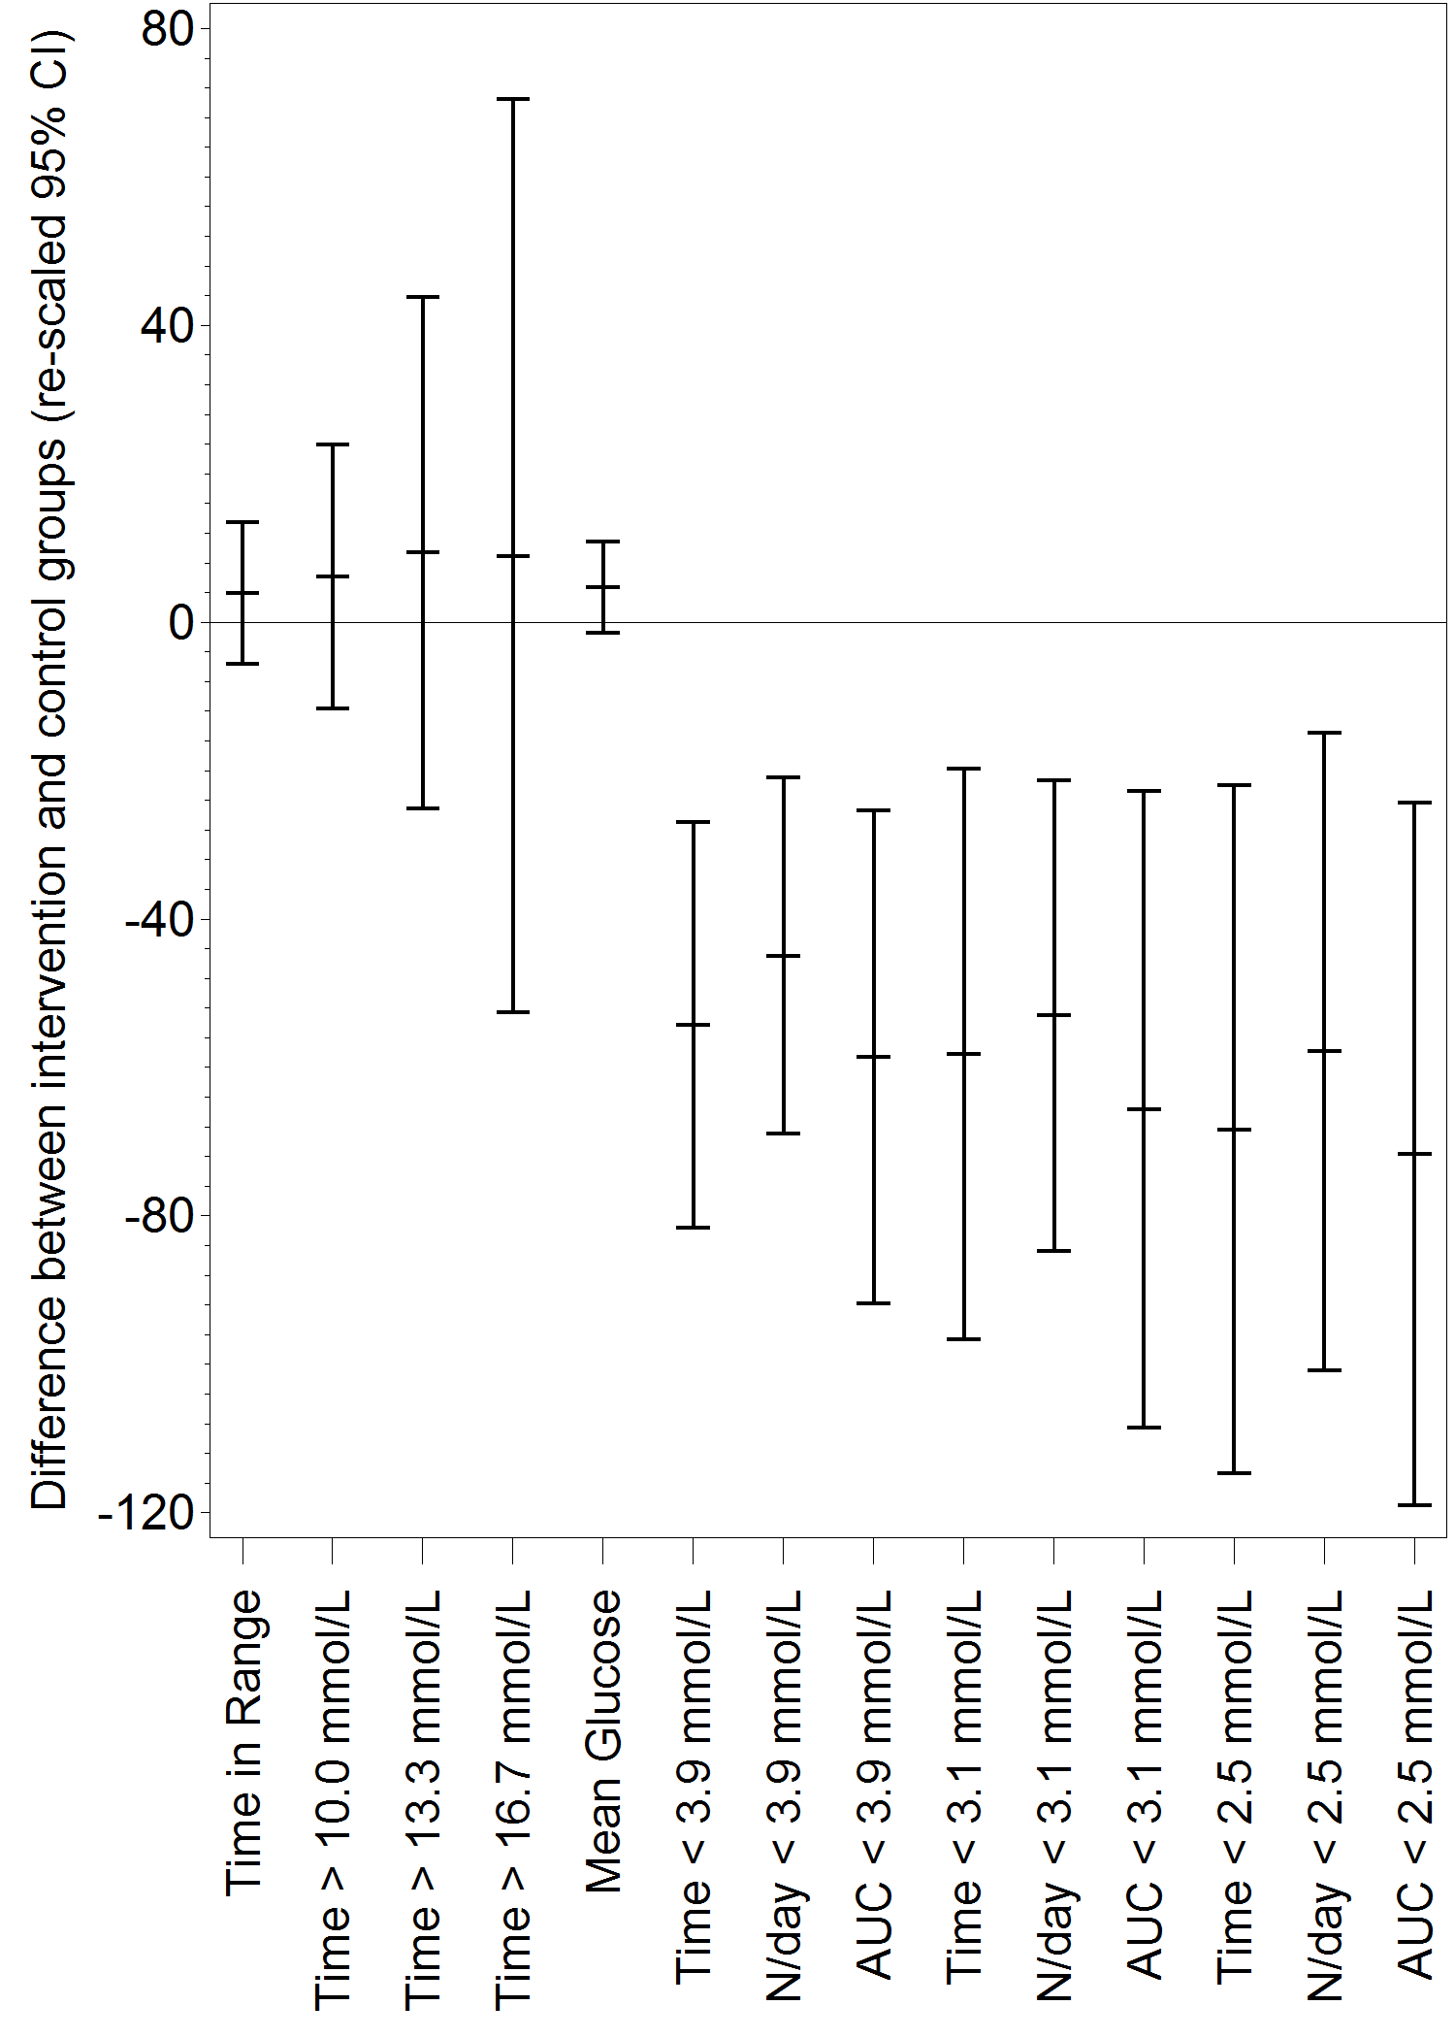

Table S4: Time in range, hyperglycaemic and glycaemic variability measures
Glycemic Measure | Baseline Mean (SD) |  | Study End Mean (SD) |  | Difference in adjusted means in intervention vs control (SE) | Difference in intervention vs control (%) | p-value
Glycemic Measure | Intervention  (n=149) | Control  (n=75) | Intervention  (n=149) | Control  (n=75) | Difference in adjusted means in intervention vs control (SE) | Difference in intervention vs control (%) | p-value
mmol/L (70-180 mg/dL) in h
Time with glucose 3.9-10.0 mmol/L (70-180 mg/dL) (h) | 13.9 (4.5) | 13.5 (5.2) | 13.6 (4.6) | 13.2 (4.9) | 0.2 (0.58) | N/A | 0.7925
Glucose >10.0 mmol/L (180 mg/dL) within 24 h
Time (h) | 8.8 (5.0) | 9.4 (5.8) | 9.8 (4.8) | 9.8 (5.4) | 0.3 (0.63) | 3.5 | 0.5970
Glucose >13.3 mmol/L (240 mg/dL) within 24 h
Time (h) | 3.1 (3.3) | 3.9 (4.5) | 3.5 (3.7) | 3.9 (4.2) | 0.1 (0.46) | 2.1 | 0.8729
at night (23.00-06.00) within 7 h
Glucose >16.7 mmol/L (300 mg/dL) within 24 h
Time (h) | 0.82 (1.61) | 1.27 (2.27) | 1.01 (1.93) | 1.14 (1.98) | 0.06 (0.25) | 5.6 | 0.8176
Glucose variability
Mean glucose (mg/dL) | 165 (34) | 171 (43) | 174 (33) | 174 (38) | 3 (4.3) | N/A | 0.4236
Standard deviation of glucose (mg/dL) | 56 (14) | 56 (15) | 54 (13) | 56 (15) | -1.67 (1.45) | N/A | 0.2538
CV glucose (%) | 34.1 (7.2) | 33.1 (6.7) | 31.4 (6.2) | 33.0 (8.0) | -2.26 (0.71) | N/A | 0.0017
MAGE (mg/dL; average) | 128 (29) | 131 (33) | 125 (29) | 131 (33) | -4 (3.3) | N/A | 0.1909
MODD (mg/dL) | 52 (15) | 53 (18) | 52 (15) | 55 (17) | -1 (1.6) | N/A | 0.3794
LBGI | 1.1 (1.3) | 1.0 (1.2) | 0.6 (0.7) | 0.9 (1.0) | -0.3 (0.11) | N/A | 0.0029
HBGI | 8.4 (5.5) | 9.4 (7.2) | 9.3 (5.8) | 9.6 (6.5) | 0.3 (0.74) | N/A | 0.7174
BGRI | 9.5 (5.1) | 10.4 (6.7) | 9.9 (5.6) | 10.5 (6.1) | 0.0 (0.70) | N/A | 0.9431
SD of glucose rate of change (mg/dL/min) | 0.76 (0.17) | 0.75 (0.15) | 0.77 (0.24) | 0.74 (0.13) | 0.04 (0.024) | N/A | 0.1178
CONGA 1 h (mg/dL) | 34 (8) | 34 (8) | 33 (7) | 34 (6) | 0 (0.7) | N/A | 0.5793
CONGA 2 h (mg/dL) | 49 (11) | 50 (14) | 47 (12) | 51 (11) | -3 (1.3) | N/A | 0.0385
CONGA 4 h (mg/dL) | 61 (16) | 61 (19) | 57 (18) | 64 (17) | -5 (2.2) | N/A | 0.0133
CONGA 6 h (mg/dL) | 63 (21) | 62 (22) | 58 (23) | 65 (23) | -8 (3.0) | N/A | 0.0046
Analysis based on ANCOVA model with treatment group and study centre (pooled per country for <5 subjects/centre) as fixed effects and the baseline measurement as covariate.
n=number of subjects with non-missing 14-day baseline and 14-day treatment-phase values; NA=not applicable; SD=standard deviation; SE=standard error.

Figure S4: Glycaemic variability after 6 months
BGRI=blood glucose risk index; CI=confidence interval; CONGAx= continuous overall net glycaemic action x hours; CV=coefficient of variation; HBGI=high blood glucose index; LBGI=low blood glucose index; MAGE=mean amplitude of glycaemic excursions; MODD=mean of daily differences; SD=standard deviation.
Re-scaled CIs are CIs for the difference in the intervention group from the control group at 6 months expressed as a percentage of the control group adjusted mean.

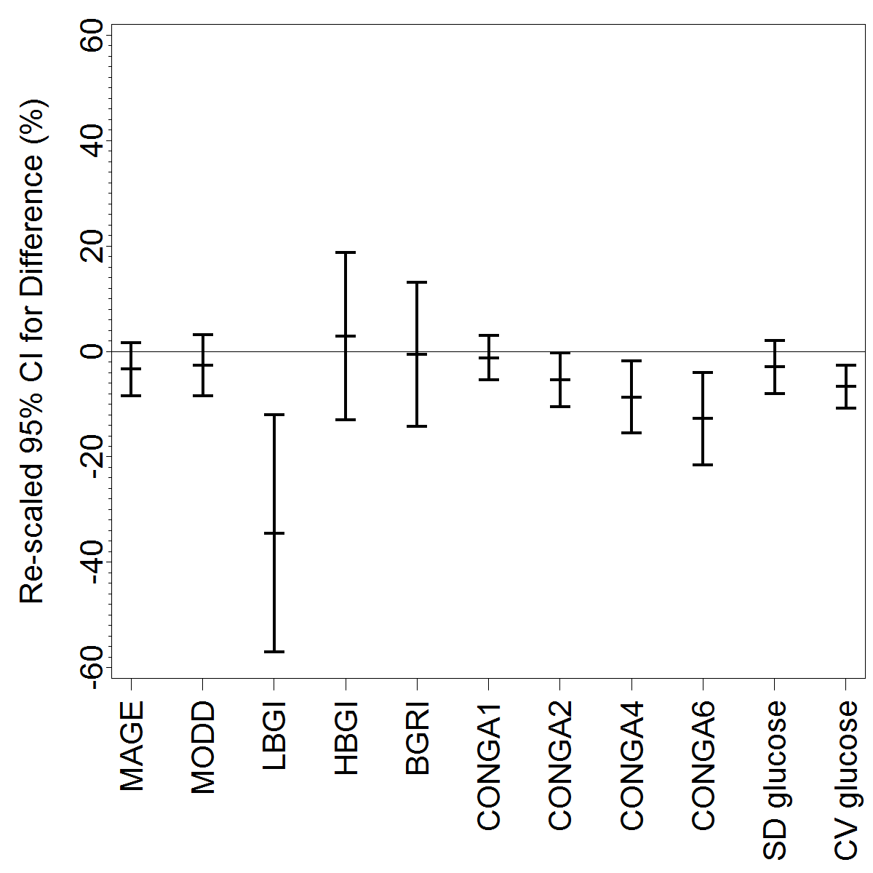
Figure S5: Diabetes Distress Scale
DDS scores range from 1 to 6. High scores indicate a very serious problem.
CI=confidence interval; DDS=Diabetes Distress Scale.

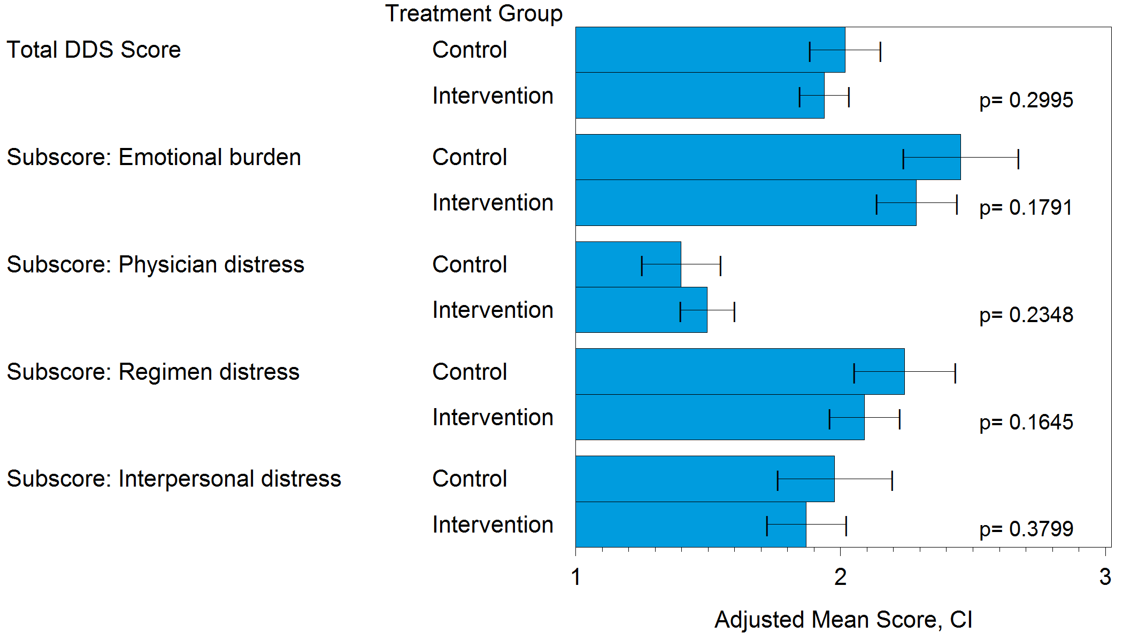

Table S5: User Questionnaire at 6 Months
Rate your level of pain experienced using the Sensor-based Glucose Monitoring system when… | % painless or almost painless
1. Getting glucose readings by scanning the Sensor | 118 / 120 (98%)
2. Applying the Sensor | 109 / 119 (92%)
Scale: Painless, Almost painless, Slight pain, Moderate pain, Severe pain

Indicate your level of agreement with the following statements: | % strongly agree or agree
3. The Sensor was comfortable to wear | 115 / 122 (94%)
4. Getting a glucose reading with a scan was easy | 121 / 123 (98%)
5. The Sensor was small and easy to wear | 112 / 123 (91%)
6. I was able to get glucose readings from the Sensor without people noticing | 114 / 123 (93%)
7. I believe that other people did not notice that I was wearing a Sensor | 108 / 123 (88%)
8. This System did not get in the way of daily activities | 119 / 123 (97%)
9. This System fits in well with my life | 120 / 123 (98%)
10. This System offered more information to act upon than a blood glucose meter | 121 / 123 (98%)
11. I found this System easy to use | 121 / 123 (98%)
12. Checking my glucose with this System was faster than with a blood glucose meter | 121 / 123 (98%)
13. This System reduced the hassle of glucose monitoring | 122 / 123 (99%)
14. This System helped me understand how my daily activities impacted upon my glucose levels | 121 / 123 (98%)
15. I felt more engaged in managing my diabetes using this System | 120 / 123 (98%)
16. This System will help me have a better discussion about my diabetes with my doctor/nurse | 119 / 123 (97%)
17. I would recommend this System to anyone who uses insulin | 121 / 123 (98%)
Scale: strongly agree, agree, neither agree or disagree, disagree, strongly disagree

Table S6: Device Related Adverse Events
Participant | Adverse event term | Severity | Action taken | Discontinuation from study?
1 | Erythema & itching at sensor insertion site | Mild | Drug therapy | No
2 | Sensor insertion site reaction | Moderate | Drug therapy | No
3 | Sensor site allergic reaction | Moderate | Drug therapy | No
3 | Necrosis at sensor insertion site | Severe | Drug therapy | No
4 | Infection at sensor site | Severe | Drug therapy | No
4 | Infection at sensor site | Moderate | NONE | No
5 | Rash at sensor site | Moderate | Drug therapy | No
5 | Rash at sensor site | Moderate | Drug therapy | No
6 | Sensor allergy | Moderate | Drug therapy | No

Table S7: Observed, anticipated sensor insertion site symptoms (not adverse events)
Total (N=302) | Intervention (N=149)  6 months system use |  | Control (N=75)  4 weeks system use (masked) |  | Not randomized (N=78) |  | Severity
 | Participants (n) | Events (n) | Participants (n) | Events (n) | Participants (n) | Events (n) | Mild | Moderate | Severe | Unspecified
Erythema | 23 (15.4%) | 54 | 1 | 1 | 1 | 1 | 32 | 14 | 9 | 1
Itching | 14 (9.4%) | 22 | 1 | 1 | 1 | 1 | 16 | 7 | 1 | 0
Rash | 8 (5.4%) | 16 | 1 | 1 | 2 | 2 | 9 | 10 | 0 | 0
Pain | 15 (10.1%) | 24 | 3 | 3 | 2 | 2 | 23 | 5 | 1 | 0
Bleeding | 8 (5.4%) | 11 | 2 | 2 | 0 | 0 | 11 | 2 | 0 | 0
Bruising | 4 (2.7%) | 4 | 0 | 0 | 0 | 0 | 3 | 1 | 0 | 0
Edema | 5 (3.4%) | 8 | 0 | 0 | 0 | 0 | 1 | 4 | 3 | 0
Induration | 3 (2.0%) | 4 | 1 | 1 | 0 | 0 | 3 | 2 | 0 | 0
Total | 41 (27.5%) | 143 | 6 | 9 | 3 | 6 | 98 | 45 | 14 | 1

List of study centres
26 study centres: ten in Germany, eight in France, and eight in the UK

Chief Investigator (Germany): Prof. Thomas Haak, Diabetes Zentrum Mergentheim, Bad Mergentheim, Germany
Other German investigators:
- Dr Wendisch, Gemeinschaftspraxis für Innere Medizin und Diabetologie, Hamburg
- Dr Rose, Institut für Diabetesforschung, Münster
- Dr Aigner, Versdias GmbH, Sūlzbach-Rosenberg
- Dr Schlecht, Diabetes Praxis Eisenach, Eisenach
- Dr Hilgenberg, Diabetes Schwerpunktpraxis Loccum, Dres. Rehburg-Loccum
- Prof. Matthaei, Diabetes Center Quakenbrück, Quakenbrück
- Dr Paschen, Diabetologische Schwerpunktpraxis, Hamburg
- Herr Maxeiner, Diabetologisch Hausärztliche Gemeinschaftspraxis, Bosenheim
- Dr Kroger, Zentrum für Diabetologie Hamburg Bergedorf, Hamburg

Country Lead Principal Investigator (France): Prof. Hélène Hanaire, Hôpital Rangueil, Toulouse
Other French investigators:
- Dr Belicar-Schaepelynck, Hôpital sainte Marguerite, Marseille
- Dr Chaillous, Hôpital Nord Laennec, Nantes
- Dr Riveline, Hôpital Lariboisière, Paris
- Prof. Catargi, Hôpital Saint-André, Bordeaux
- Dr Mosnier-Pudar, Hôpital Cochin, Paris
- Dr Renard, CHU Lapeyronie, Montpellier
- Dr Guerci, CHU Nancy, Vandoeuvre Les Nancy

Country Lead Principal Investigator (United Kingdom [UK]): Dr Gerry Rayman, The Diabetes Centre, Ipswich Hospital NHS Trust, Ipswich
Other UK investigators:
- Dr Abouglila, County Durham and Darlington NHS Foundation Trust, Durham
- Dr Ajjan, St. James University Hospital, Leeds Teaching Hospitals NHS Trust, Leeds
- Dr Robinson, Diabetes & Lipid Research, Royal United Hospital Bath NHS Trust, Bath
- Dr Franke, Rotherham General Hospital, Rotherham
- Prof. Vora & Dr Purewal, Royal Liverpool University Hospital, Liverpool
- Dr Collier, Diabetes Day Centre, University Hospital Ayr, Ayr
- Dr Narendran, Department of Diabetes, The Queen Elizabeth Hospital, Birmingham

