Supplementary Figure S1: The GesTIO protocol
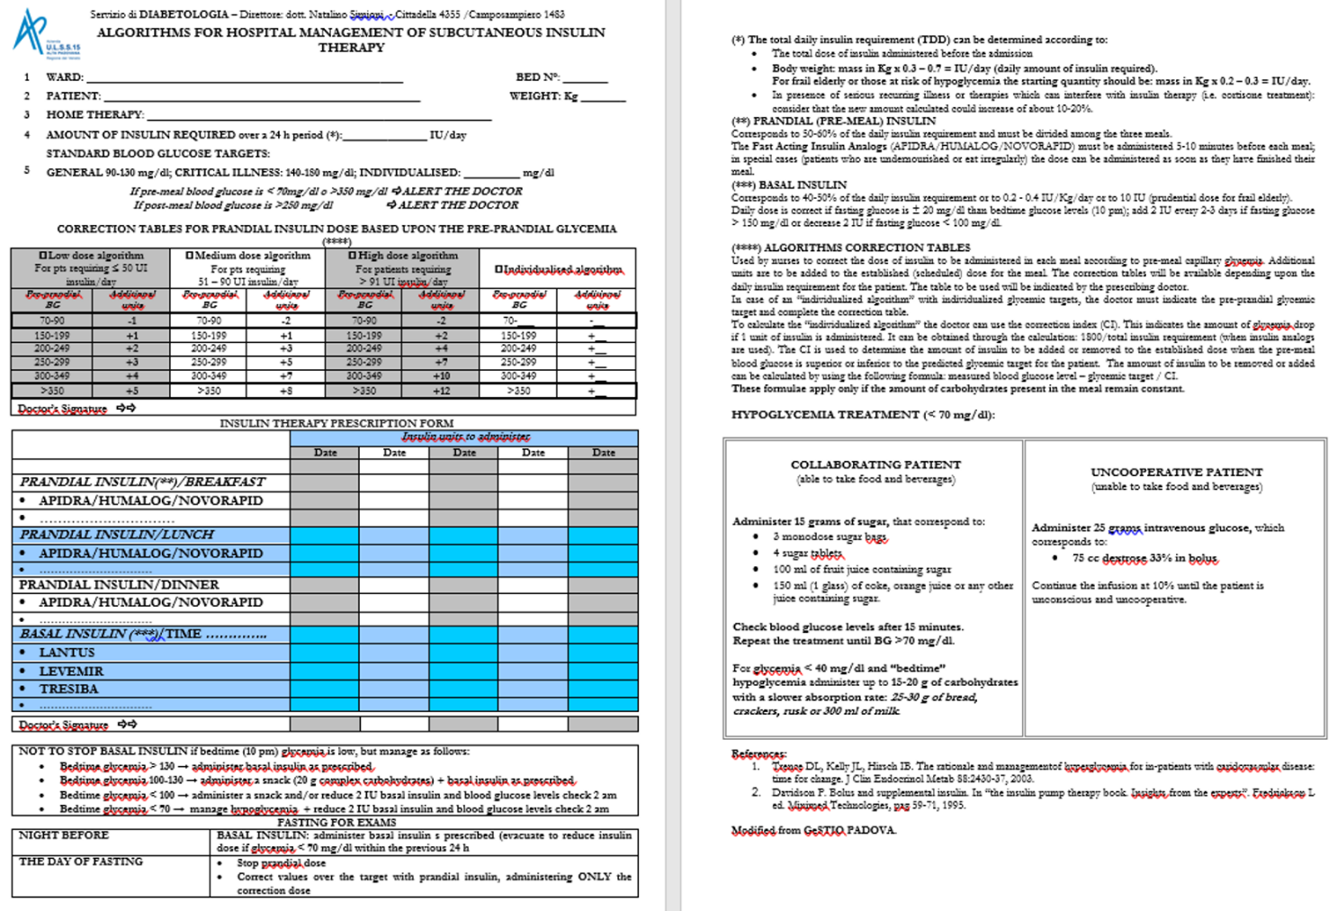
Supplemental Table S1: Baseline patient characteristics overall and by insulin treatment or length of stay in hospital.
VARIABLE | Category | Overall | Insulin  Naive | Switch | p-value | Short Stay  (<5 days) | Long Stay  (>=5 days) | p-value
N. Group |  | 52 | 21 | 31 |  | 18 | 33
Diabetes type | T1DM | 9.6 | 4.8 | 12.9 | 0.33 | 11.1 | 6.1 | 0.52
 | T2DM | 90.4 | 95.2 | 87.1 |  | 88.9 | 93.9
Diabetes duration (years) |  | 9.9±9.8 | 3.9±6.9 | 13.8±9.6 | 0.0007 | 10.4±11.0 | 9.5±9.5 | 0.87
Sex (%) | F | 42.3 | 33.3 | 48.4 | 0.28 | 55.6 | 36.4 | 0.19
 | M | 57.7 | 66.7 | 51.6 |  | 44.4 | 63.6
Age (years) |  | 69.4±16.3 | 69.7±15.5 | 69.3±17.1 | 0.86 | 67.4±17.8 | 71.5±14.8 | 0.41
Body weight (kg) |  | 79.7±19.9 | 76.8±17.8 | 81.5±21.3 | 0.52 | 76.1±22.0 | 81.7±19.0 | 0.22
BMI (kg/m²) |  | 31.0±14.7 | 26.9±5.3 | 32.9±17.2 | 0.53 | 33.6±20.2 | 29.4±8.3 | 0.78
HbA1c (%) |  | 10.0±2.8 | 10.5±3.2 | 9.7±2.5 | 0.53 | 10.2±3.1 | 9.9±2.7 | 0.66
GFR in classes (%) | 0-30 | 5.8 | 0 | 9.7 | 0.38 | 0 | 9.1 | 0.04
 | 30-60 | 28.8 | 23.8 | 32.3 |  | 44.4 | 21.2
 | 61-90 | 30.8 | 38.1 | 25.8 |  | 11.1 | 42.4
 | >90 | 34.6 | 38.1 | 32.3 |  | 44.4 | 27.3
Chronic obstructive pulmonary disease (%) |  | 19.2 | 14.3 | 22.6 | 0.46 | 22.2 | 18.2 | 0.73
Dementia (%) |  | 13.5 | 14.3 | 12.9 | 0.89 | 11.1 | 15.2 | 0.69
Myocardial Infarction (%) |  | 11.5 | 9.5 | 12.9 | 0.71 | 16.7 | 9.1 | 0.42
Cerebrovascular Disease (%) |  | 13.5 | 9.5 | 16.1 | 0.49 | 11.1 | 15.2 | 0.69
Peripheral Vascular Disease (%) |  | 23.1 | 19.0 | 25.8 | 0.57 | 16.7 | 27.3 | 0.39
Heart Failure (%) |  | 11.5 | 14.3 | 9.7 | 0.61 | 11.1 | 12.1 | 0.91
Liver Failure (%) |  | 1.9 | 0 | 3.2 | 0.41 | 0 | 3.0 | 0.46
Leukemia (%) |  | 1.9 | 0 | 3.2 | 0.41 | 0 | 3.0 | 0.46
Lymphoma (%) |  | 3.8 | 4.8 | 3.2 | 0.78 | 0 | 6.1 | 0.29
Connective Tissue Disease (%) |  | 7.7 | 4.8 | 9.7 | 0.51 | 0 | 12.1 | 0.12
Previuos basal insulin (%) |  | 59.6 | - | 100 | N/A | 55.6 | 60.6 | 0.73
Type of previous basal insulin (%) | Glargine | 83.9 | - | 83.9 | N/A | 80.0 | 85.0 | 0.87
 | Detemir | 6.5 | - | 6.5 |  | 10.0 | 5.0
 | NPL | 9.7 | - | 9.7 |  | 10.0 | 10.0
Previuos short-acting insulin (%) |  | 59.6 | 9.5 | 93.5 | <0.0001 | 55.6 | 60.6 | 0.73
Type of previous short-acting insulin (%) | Lispro | 41.9 | 0 | 44.8 | 0.47 | 20.0 | 55.0 | 0.22
 | Aspart | 16.1 | 50.0 | 13.8 |  | 20.0 | 10.0
 | Glulisine | 38.7 | 50.0 | 37.9 |  | 60.0 | 30.0
 | Human Regular | 3.2 | 0 | 3.4 |  | 0 | 5.0
Previous glucose lowering agents |  | 31.3 | 35.3 | 29 | 0.65 | 47.1 | 23.3 | 0.09
Data are absolute numbers (N), means ± standard deviations, or frequencies (%). Between-group differences were compared through Kruskall-Wallis test for continuous variables or chi-square test for categorical variables.
N/A = not applicable
Supplemental Figure S2: Distribution of patients by blood glucose target at discharge and mean blood glucose levels by blood glucose classes.

Supplemental Table S2: Incidence of hypoglycemic episodes (BG <70 mg/dl) during the hospitalization
Population | Hypoglycemia | Overall number of episodes | % of patients with at least 1 episode | Distribution of episodes (Median and range) | Incidence rate and 95% confidence intervals  (episodes per person/day)
Overall | daytime | 26 | 34.6 | 0 (0;4) | 0.07 (0.05;0.10)
 | nocturnal | 1 | 1.9 | 0 (0;1) | 0.00 (0.00;0.02)
 | total | 27 | 34.6 | 0 (0;4) | 0.07 (0.05;0.11)
Naive | daytime | 4 | 19.0 | 0 (0;1) | 0.03 (0.01;0.08)
 | nocturnal | 0 | 0 | 0 (0;0) | 0.00 (0.00;0.00)
 | total | 4 | 19.0 | 0 (0;1) | 0.03 (0.01;0.08)
Switch | daytime | 22 | 45.2 | 0 (0;4) | 0.10 (0.06;0.15)
 | nocturnal | 1 | 3.2 | 0 (0;1) | 0.00 (0.00;0.03)
 | total | 23 | 45.2 | 0 (0;4) | 0.10 (0.07;0.15)
Short Stay | daytime | 4 | 28.6 | 0 (0;1) | 0.08 (0.03;0.21)
 | nocturnal | 1 | 7.1 | 0 (0;1) | 0.02 (0.00;0.14)
 | total | 5 | 28.6 | 0 (0;2) | 0.10 (0.04;0.24)
Long Stay | daytime | 22 | 37.8 | 0 (0;4) | 0.07 (0.05;0.11)
 | nocturnal | 0 | 0 | 0 (0;0) | 0.00 (0.00;0.00)
 | total | 22 | 37.8 | 0 (0;4) | 0.07 (0.05;0.11)

Supplemental Table S3: Use of healthcare resources during the hospitalization
- SMBG test
Population | Overall number of SMBG tests | SMBG tests  (Median and range) | Incidence rate and 95% confidence intervals  (tests per person/day)
Overall | 1789 | 30 (7;84) | 4.8 (4.6;5.1)
Naive | 668 | 28 (9;84) | 4.9 (4.6;5.3)
Switch | 1121 | 36 (7;84) | 4.8 (4.5;5.1)
Short Stay | 341 | 18 (7;38) | 6.8 (6.1;7.6)
Long Stay | 1429 | 38 (20;84) | 4.5 (4.3;4.8)

- Length of stay
Population | Days  (Median and range)
Overall | 5 (1;24)
Naive | 5 (1;17)
Switch | 6 (2;24)
Short Stay | 3 (1;4)
Long Stay | 8 (5;24)

Supplemental Figure S3: Use of insulin degludec during the hospitalization (treatment scheme, administration time, concomitant glucose lowering agents, doses of basal and short-acting insulin before and during the hospitalization).

