Supplementary tables
Table S1: PICOS study selection criteria for SR
Criteria | Description
Population | Japanese adult subjects diagnosed with type 2 diabetes either:  - Inadequately controlled with metformin  - Inadequately controlled with 1–2 OADs  - Inadequately controlled on basal insulin (with or without OADs)
Interventions | Semaglutide 0.5 mg  Semaglutide 1.0 mg
Comparators | - Placebo  - Other GLP-1s  - Albiglutide 30 mg weekly  - Dulaglutide 0.75 mg and 1.5 mg weekly  - Exenatide 2 mg weekly  - Liraglutide 0.6 mg, 0.9 mg, 1.2 mg and 1.8 mg  - Lixisenatide 20 µg daily  - Taspoglutide 10 mg and 20 mg weekly  - Other treatments directly compared to a GLP-1 and/or semaglutide
Outcomes | Efficacy  - Proportion of patients achieving composite endpoint (<7% HbA_{1c}, no weight gain and no hypoglycemia)  - Change in HbA_{1c} from baseline  - Proportion of patients achieving ≤6.5%  - Proportion of patients achieving <7% HbA_{1c}  - Change in FPG from baseline  - Change in postprandial plasma glucose from baseline  - Change in weight from baseline  - Proportion of patients achieving ≥5% weight loss  - Proportion of patients achieving ≥10% weight loss  - Change in SBP from baseline  - Change in BMI from baseline | Safety  - Incidence of discontinuations due to adverse events  - Incidence of nausea  - Incidence of vomiting  - Incidence of diarrhoea  - Incidence of pancreatitis  - Incidence/rate of overall hypoglycemia  - Incidence/rate of severe hypoglycemia  - Incidence/rate of non-severe hypoglycemia  - Incidence/rate of nocturnal hypoglycemia
Study design | Randomized clinical trials with at least a 20-week duration
Other | English language  From 1994 to August 2017
Abbreviations: BMI, body mass index; FPG, fasting plasma glucose; GLP-1, glucagon-like peptide 1; HbA_{1c}, glycated hemoglobin; OAD, oral antidiabetic drug; SBP, systolic blood pressure; SR, systematic review.

Table S2: 52–56-week data reported from the trials included in the NMA
 | Kaku 2016 |  | Kaku 2018 |  |  | Odawara 2016 |  | Seino 2011
 | Liraglutide  0.9 mg QD | Additional OAD | Semaglutide 0.5 mg QW | Semaglutide 1.0 mg QW | Additional OAD† | Dulaglutide  0.75 mg QW | Liraglutide  0.9 mg QD | Liraglutide 0.9 mg QD | Liraglutide 0.6 mg QD | Placebo
Follow up, weeks | 52 |  | 56 |  |  | 52 |  | 52
Analysis | FAS |  | FAS |  |  | FAS |  | FAS
Number of patients analyzed | 240 | 120 | 239 | 241 | 120 | 280 | 137 | 88 | 88 | 88
HbA_{1c}
Mean baseline HbA_{1c}, % (SD) | 8.1 (0.8) | 8.1 (0.8) | 8.04 (0.89) | 8.14 (0.96) | 8.10 (0.89) | 8.15 (0.77) | 8.08 (0.89) | 8.61 (0.78) | 9.00 (0.91) | 8.85 (0.99)
Mean endpoint HbA_{1c}, % (SD) [SEM] | 6.8 (1.0) | 7.1 (0.8) | 6.35 [0.05] | 6.06 [0.05] | 7.43 [0.07] | 6.74 | 6.94 | 7.5 (0.1) | 7.8 (0.1) | 8.8 (0.1)
Mean change from baseline HbA_{1c}, % (SD) [SEM] | –1.21 | –0.94 | –1.74 [0.05] | –2.03 [0.05] | –0.67 [0.07] | –1.39 [0.06] | –1.19 [0.08] | NR | NR | NR
Mean treatment difference, % (95% CI) | –0.27  (–0.44; –0.09) | Comparator | –1.08  (–1.24; 0.91) (vs additional OAD) | –1.37  (–1.53;  –1.20) | Comparator | –0.20  (–0.39; –0.01) | Comparator | –1.33  (–1.62;  –1.04) | –0.96  (–1.25;  –0.67) | Comparator
N (%) achieving HbA_{1c} ≤6.5% | NR | NR | 169 (71) | 193 (80) | 18 (15) | 138 (49.3) | 56 (41.2) | NR | NR | NR
N (%) achieving HbA_{1c} ≤7.0% | (67.6) | (44.8) | 200 (84) | 220 (91) | 50 (42) | 190 (67.9) | 82 (60.3) | (39.1)‡ | (15.1)‡ | (4.5)‡
SBP
Mean baseline SBP, mmHg (SD) | NR | NR | 129.19 (12.73) | 129.37 (13.40) | 129.01 (12.61) | NR | NR | NR | NR | NR
Mean endpoint SBP, mmHg (SD) [SEM] | NR | NR | 127.28 [0.78] | 125.52 [0.81] | 129.40 [1.13] | NR | NR | NR | NR | NR
Mean change from baseline SBP, mmHg (SD) [SEM] | –4.00 | –3.91 | –1.95 [0.78] | –3.70 [0.81] | 0.17 [1.13] | 1.45 [0.64] | –1.58 [0.92] | NR | NR | NR
Treatment difference in SBP, mmHg (95% CI) | –0.10  (–2.54; 2.35) | Comparator | –2.12  (–4.81; 0.57) | –3.87  (–6.59;  –1.15) | Comparator | NR | NR | NR | NR | NR
Weight
Mean baseline weight, kg (SD) | 69.4 (14.2) | 68.2 (13.6) | 71.02 (15.41) | 71.71 (15.90) | 72.17 (14.86) | 71.3 (12.5) | 70.2 (12.5) | NR | NR | NR
Mean endpoint weight, kg (SD) [SEM] | NR | NR | 70.10 [0.24] | 68.35 [0.25] | 71.94 [0.35] | NR | NR | NR | NR | NR
Mean change from baseline weight, kg (SD) [SEM] | –0.85 | –0.50 | –1.43 [0.24] | –3.18 [0.25] | 0.41 [0.35] | –0.17 [0.16]§ | –0.13 [0.25]§ | NR | NR | NR
Mean treatment difference, kg (95% CI) | –0.35  (–0.99;  0.29) | Comparator | –1.84  (–2.67;  –1.01) | –3.59  (–4.43;  –2.75) | Comparator | NR | NR | NR | NR | NR
FPG
Mean baseline FPG, mmol/L (SD) | 8.66 (1.6)¶ | 8.94 (1.8)¶ | 8.87 (1.92) | 8.90 (2.11) | 8.97 (1.93) | 9.4 (1.9)†† | 9.0 (1.9)†† | NR | NR | NR
Mean endpoint FPG, mmol/L (SD) [SEM] | 7.17 (1.68) | 7.63 (1.58) | 6.59 (1.26) | 6.21 (1.20) | 8.05 (1.86) | 7.07 [0.1]§ | 7.16 [0.1]§ | 7.47 (0.2) | 7.79 (0.2) | 9.1 (0.2)
Mean change from baseline FPG, mmol/L (SD) [SEM] | –1.55 | –1.24 | –2.35 [0.08] | –2.72 [0.08] | –0.69 [0.12] | –2.16 (0.10) | –2.06 (0.14) | NR | NR | NR
Treatment difference in FPG, mmol/L (95% CI) | –0.3 (–0.6;  –0.03) | Comparator | –1.66  (–1.94;  –1.38) | –2.03  (–2.32;  –1.75) | Comparator | NR | NR | –1.68  (–2.2; –1.1)¶ | –1.35  (–1.9; –0.8)¶ | Comparator
Incidence of overall hypoglycemia
Definition | All ADA classified hypoglycemic events‡‡ |  | All ADA classified hypoglycemic events‡‡ |  |  | Blood glucose concentration of ≤3.9 mmol/l and/or symptoms and/or signs attributable to hypoglycemia |  | NR
Incidence, n (%) | 2 | 2 | 40 (16.7) | 51 (21.2) | 14 (11.7) | 8 (2.9) | 4 (2.9) | NR | NR | NR
Incidence of nocturnal hypoglycemia
Definition | NR |  | Nocturnal severe or blood glucose-confirmed symptomatic episode |  |  | NR |  | NR
Incidence, n (%) | 1 | 0 | 1 | 1 | 2 | 2 (0.7) | 1 (0.7) | NR | NR | NR
Abbreviations: α-GI, α-glucosidase inhibitor; ADA, American Diabetes Association; BID, twice-daily; CI, confidence interval; FAS, full analysis set; FPG, fasting plasma glucose; HbA_{1c}, glycated hemoglobin; NMA, network meta-analysis; NR, not reported; OAD, oral antidiabetic drug; QD, once-daily; QW, once-weekly; SBP, systolic blood pressure; SD, standard deviation; SEM, standard error of the mean; SU sulfonylurea; TZD, thiazolidinedione.
†Either of SU, glinide, α-GI, or TZD; ‡Reported as HbA_{1c} <6.9%; §Read from graph; ¶Calculated from mg/dL; ††Fasting serum glucose; ‡‡Includes, severe, documented symptomatic, asymptomatic, probably symptomatic and pseudo-hypoglycemia.

Table S3: NMA results – absolute values
Treatment | Absolute difference from baseline (95% CrI) |  |  |  | Likelihood (95% CrI)
Treatment | HbA_{1c}, % | FPG, mmol/L | Weight, kg | SBP, mmHg | HbA_{1c} <7% | Overall hypoglycemia
Semaglutide 0.5 mg QW | –2.00 (–2.29, –1.71) | –3.42 (–3.91, –2.93) | –1.62 (–2.78, –0.46) | –3.60 (–7.66, 0.47) | 78.4% (58.9%, 90.2%) | 5.2% (0.4%, 41.6%)
Dulaglutide 0.75 mg QW | –1.39 (–1.64, –1.14) | –2.16 (–2.60, –1.73) | –0.17 (–0.93, 0.59) | 1.45 (–1.39, 4.29) | 64.3% (45.5%, 79.5%) | 1.8% (0.3%, 10.2%)
Liraglutide 0.6 mg QD | –0.82 (–1.26, –0.38) | –1.73 (–2.55, –0.91) |  |  | 25.4% (11.2%, 47.3%)
Liraglutide 0.9 mg QD | –1.19 (–1.35, –1.03) | –2.06 (–2.34, –1.79) | –0.13 (–0.62, 0.36) | –1.58 (–3.39, 0.23) | 55.9% (40.1%, 70.7%) | 1.7% (0.5%, 5.7%)
Semaglutide 1.0 mg QW | –2.29 (–2.58, –2.00) | –3.79 (–4.28, –3.30) | –3.37 (–4.54, –2.20) | –5.34 (–9.43, –1.27) | 88.2% (74.0%, 95.3%) | 6.8% (0.5%, 48.8%)
Abbreviations: CrI, credible interval; FPG, fasting plasma glucose; NMA, network meta-analysis; QD, once-daily; QW, once-weekly; SBP, systolic blood pressure.

Supplementary figure legends
Figure S1: PRISMA flow diagram of the SR
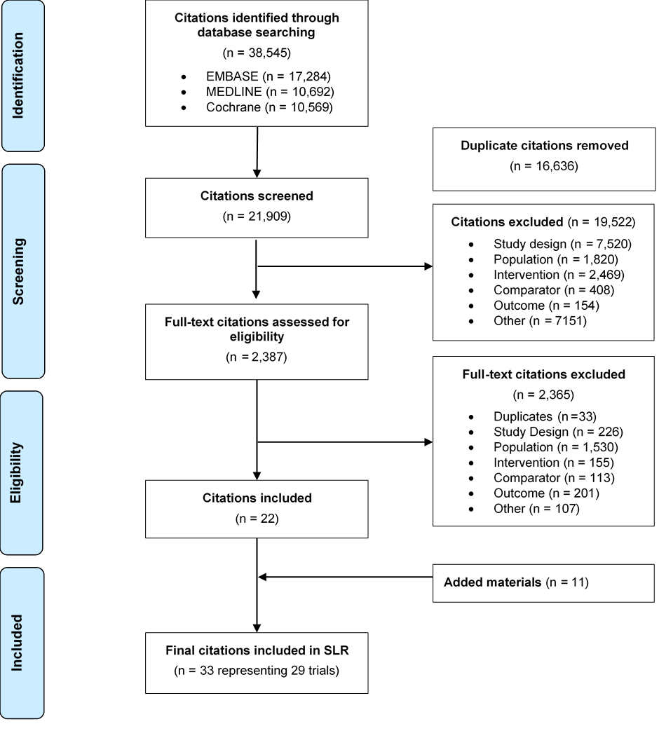
Abbreviations: SR, systematic review.
Added materials include data identified through supplementary searches (additional Japanese databases; conference searches).
Figure S2: Bias assessment of the four studies included in the NMA at 52–56 weeks
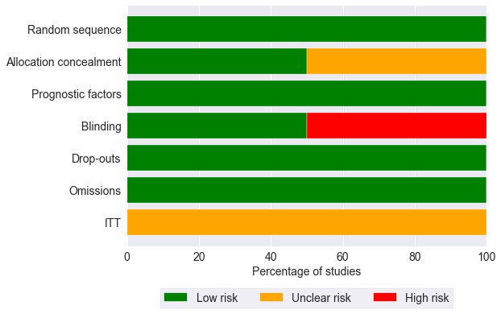
Abbreviations: ITT, intention-to-treat; NMA, network meta-analysis.

